Help for your Sony Reader or other eInk Reader
Compatible Formats: EPUB, OEPUB, PDF

Sony Wi-Fi (PRS T1): Library e-books from OverDrive and Freading can be downloaded directly on the Sony Wi-Fi, using the reader’s browser. See the handouts (*** / ***) for more information. If you are having problems using the wireless function of your Sony Reader Wi-Fi or if you do not have wireless internet at home, you can use the Adobe Digital Editions software to download library e-books to your computer and transfer them to your reader. Follow the instructions on this handout. Library e-books downloaded from OpenLibrary cannot be downloaded directly through the Reader’s browser. OpenLibrary e-books must be downloaded to your computer and transferred to your device, using the instructions in this handout.

All other Sony Reader models: Downloading items to your Sony Reader (or other eInk e-book reader) does require the use of a computer. You will need to download the item to your computer first, then add it to your reader using the free Adobe Digital Editions software. The instructions in this handout apply to library e-books from OverDrive, Freading, and OpenLibrary.

How to Download items for your Sony
1 | 2 | 3 | 4 | 5
Download Adobe Digital Editions.  Create an Adobe ID and authorize your computer. | Plug your Sony into your computer.  Authorize your Sony with your Adobe ID. | Search or browse one of the library’s e-book services for a title you are interested in. | Download. | Drag the book onto your Sony.

- Download Adobe Digital Editions (ADE) and install it on your computer. For more information on installing and using ADE, please see the “Adobe Digital Editions” handout.
In order to use ADE to transfer items to your e-reader, you will have to make an Adobe ID. This ID allows you to read a downloaded eBook on multiple devices, including e-book readers. For more information on how to set up Adobe Digital Editions with an Adobe ID, please see the “Adobe Digital Editions” handout.
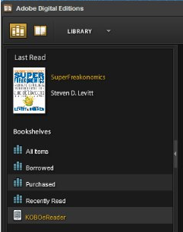 | - Plug your Sony into your computer using the USB cable that came with it.  When your e-book reader is successfully connected to your computer, it should show up at the bottom of the list of Bookshelves, as shown at left. (The exact name may vary depending on what version of Sony Reader you have.)
- Now you will be able to download eBooks. Return to the library website (http://www.sclibrary.ab.ca/download.htm) and find a title you are interested in on one of the e-book services the library offers. For more help with these services, see Help for OverDrive | Help for Freading | Help for OpenLibrary.
- Download the e-book you have chosen. If your computer prompts you what to do with the file, choose “open.”
When you select Open, Adobe Digital Editions will load with the book you just downloaded.
- Your selected eBook will download and load in Adobe Digital Editions. The book will automatically load in reading view. To switch back to an overview of all your items, click on the “Library” button (). The book you just downloaded should now appear on your “All Items” and “Borrowed” Bookshelves.
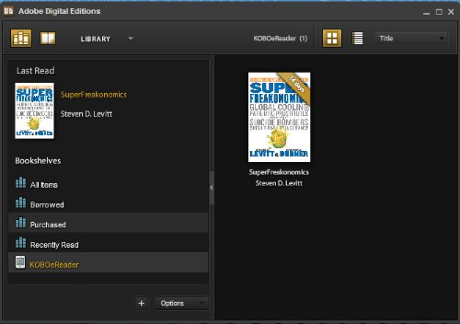
To add a borrowed eBook to your Sony, drag and drop the book from the main Library screen to “SonyeReader” (or whatever name your e-reader appears under). When your cursor is over the name of your reader, you will see it turn into a little green “plus” sign. This means that the book will be added to your Kobo. When you release the mouse button, you may see the item being transferred, although sometimes this happens so fast it is difficult to see.

Returning an Item Early
It is possible to return an item early in Adobe Digital Editions. If you have finished reading an OverDrive or Open Library e-book before its due date, you can return it early. This allows you to check out a new title (if you are at your limit of 5 checkouts) and also frees up the book for another patron to borrow. You do not need to return Freading e-books early.
To return an item early, go to your Library view, if you are not already there. (Click on the bookshelf in the top left-hand corner of the screen.) Hover over the title you want to delete, and an arrow will appear above its cover and to the left. Select the arrow next to the title you want to delete. Click on “Return borrowed item” on the sub-menu that appears.
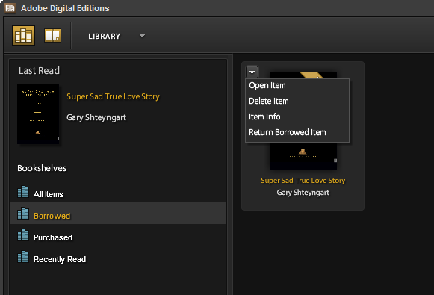
Note: This action cannot be undone. However, you are welcome to borrow that title from the library again in the future.

If you have any questions, please feel free to contact us:
Phone: 780.410-8601 | Email: info@sclibrary.ab.ca | or stop by one of our Information Desks
Last updated: May, 2012

