Help for your Sony Reader (using Reader for PC)
Compatible formats: EPUB, PDF
MP3 audiobooks can also be transferred to a Sony Reader using OverDrive Media Console

How to Download Items for your Sony Reader
Downloading items to your Sony Reader does require the use of a computer. You will need to download the item to your computer, then add it to your Sony Reader. This process can be done using the Reader for PC (or Reader for Mac) software available through Sony.

Overview
1 | 2 | 3 | 4 | 5
Download the Reader for PC (or Reader for Mac) software (if you haven’t done so already) | Use the Library Finder in the Sony Store to locate SCL | Search or browse for a title you are interested in, and check it out. | Download. When prompted how to open the file, choose “Reader for PC” | Move the title to your Sony Reader as you would with any other item in your Reader Library (by Syncing the device)

- Download the Reader for PC (or Reader for Mac) software app, if you have not already done so. You only need to do this once. This software is available from the Sony Reader Store (http://ebookstore.sony.com/download/). Follow the prompts to install Reader. You will need to create a Reader Store account (or sign in to your account if you already have one).

- Use the Library Finder in the Store to locate SCL. With Reader open, select “Store” from the top left hand corner. In the store, locate “Public Library” under “Featured Links.” The Public Library feature will load in your web browser. Search for “Strathcona County Library,” then select SCL from the resulting list. You will then be redirected to SCL’s e-book website.
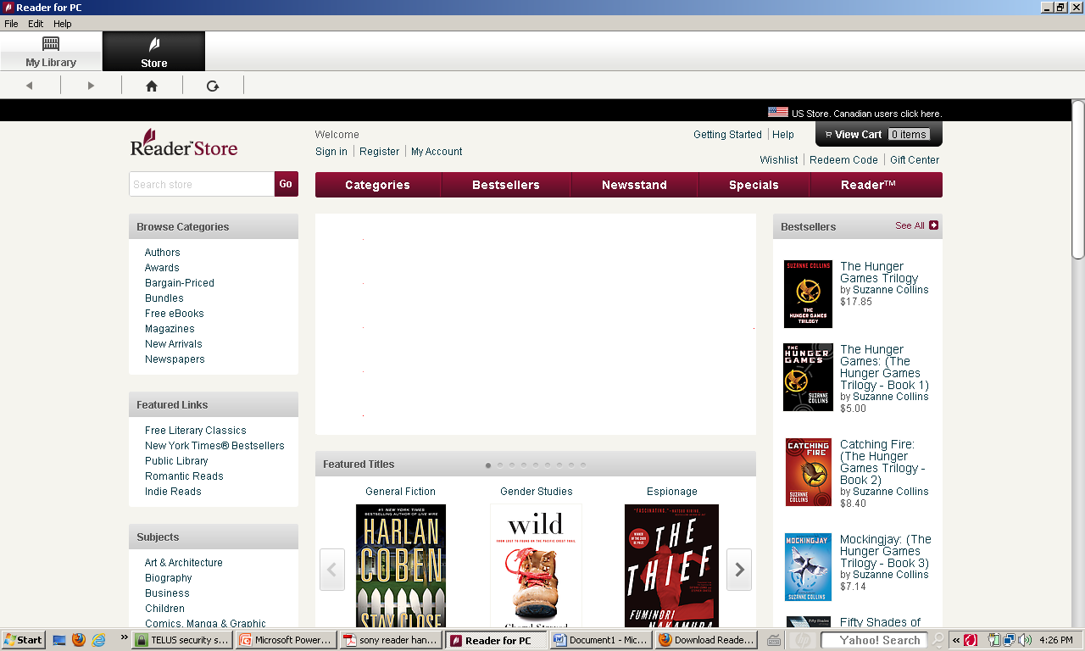

- Search or Browse for a title you are interested in. Follow the steps to check out the title.
- Download. When prompted to open the file, choose “Open” and make sure “Reader for PC” is the program your computer is going to use to open it. (This may come up automatically as the default).
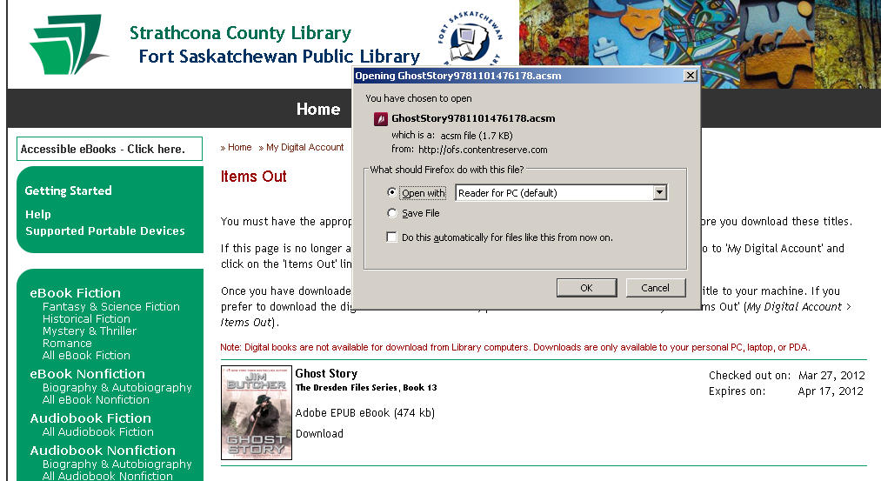
- When the title is downloaded, it will appear in Reader for PC under “My Library.”
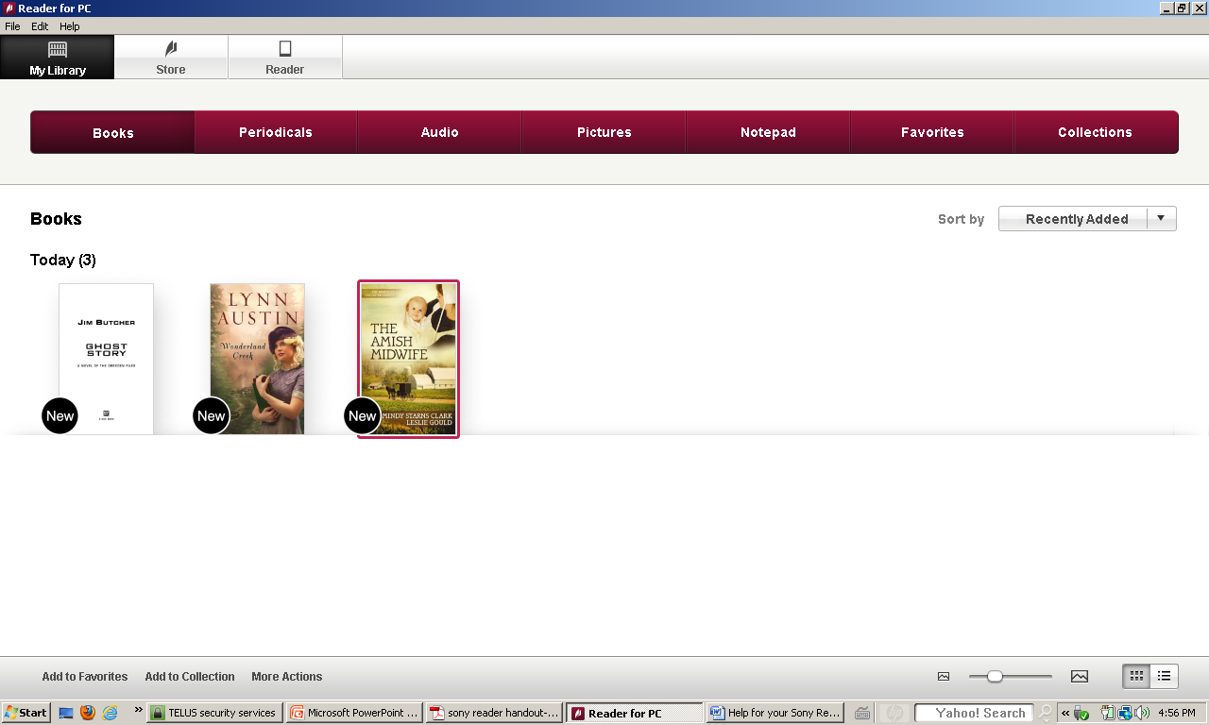

- To transfer items to your Sony Reader, select “Reader” from the top left menu. Then select “Sync” from the right side of the burgundy menu bar.

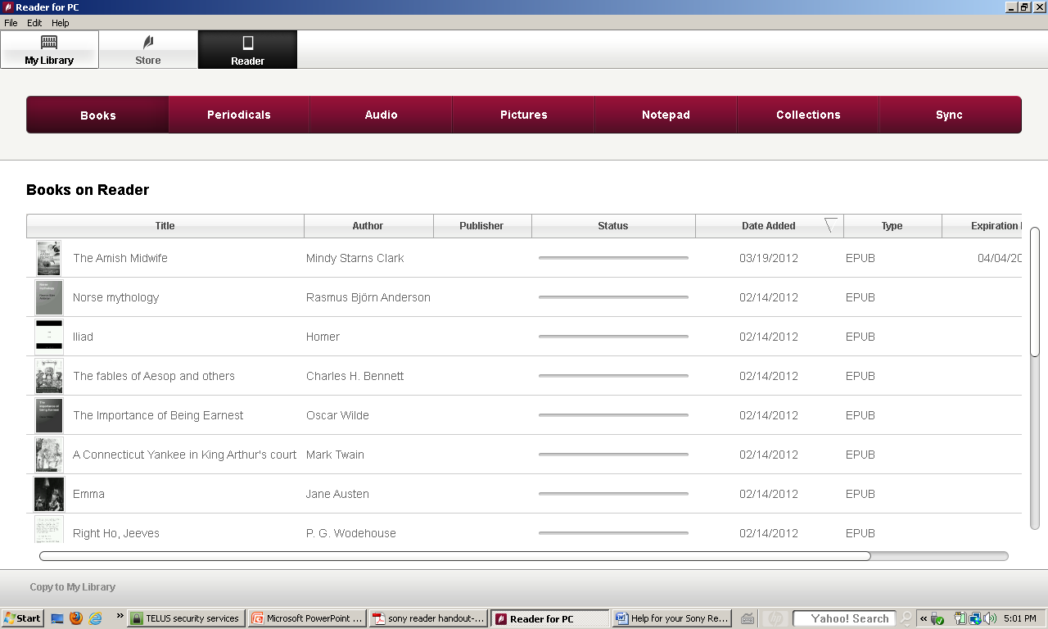

How to Return Items Early with your Sony Reader
Borrowed e-books from the library can be returned early if you are finished reading them.
- To return an item early, open Reader for PC (if it is not already open). Go to “My Library,” which shows all the titles in your collection.
- Select the cover of the library item you want to return (click on it once with the left mouse button), then click on “More Actions” at the bottom of your screen. This will bring up an options menu, where you can select “Return Borrowed Item.”

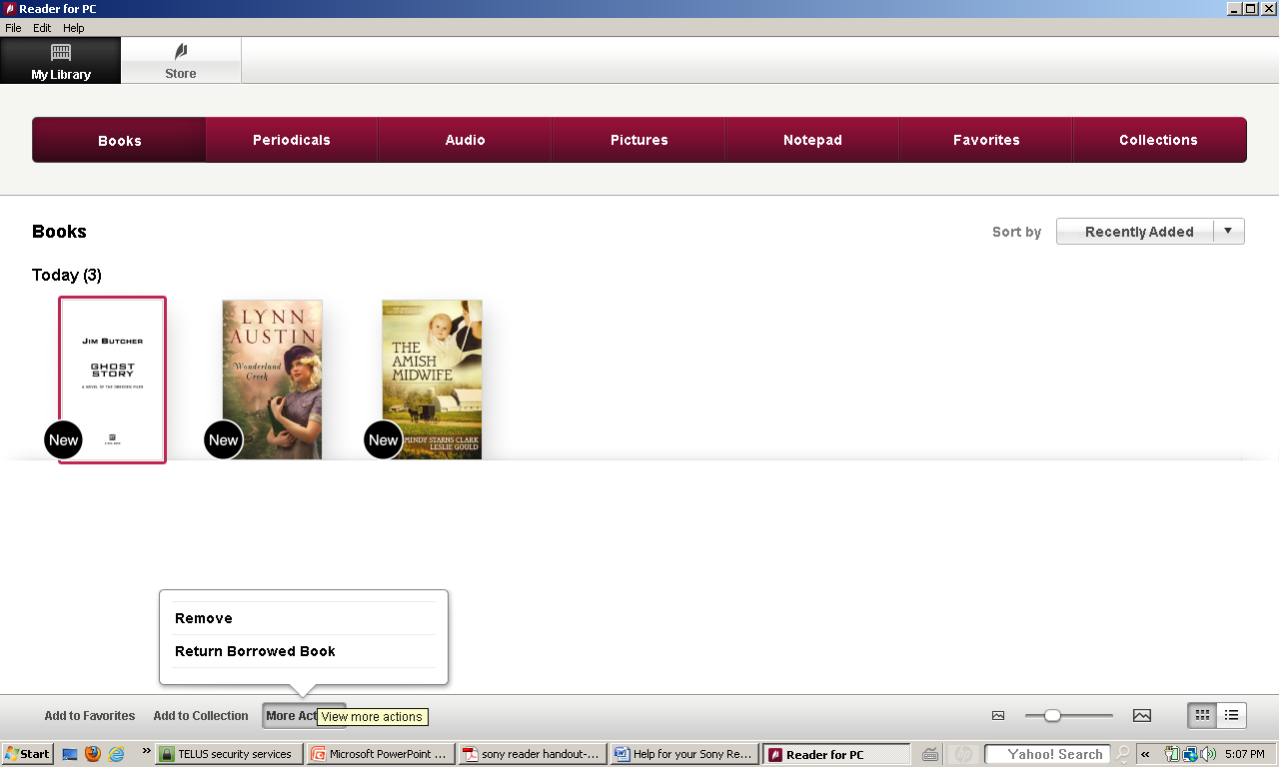

The returned item will appear in SCL’s digital collection again so others can download it, and it will also disappear from your Items Out. To delete the item without returning it (for example, if you want to keep reading it on another computer or device) select “Remove.”

If you have any questions, please feel free to contact us:
Phone: 780.410-8601 | Email: info@sclibrary.ab.ca | or stop by one of our Information Desks
Last updated: March, 2012

