OverDrive Help for your Kobo Vox/Arc
Compatible Formats: EPUB, OEPUB, MP3
How to Set up the OverDrive Media Console [OMC] app on your Kobo Vox

You only need to do this once.

1 | 2 | 3
Download and install OverDrive Media Console | Get an Adobe ID | Authorize your device with your Adobe ID
Kobo Vox
Before you start: Allow apps from Unknown Sources
If you have not already done so, go into your device’s Settings menu (you can find “Settings” in “All Apps”), and under Application settings, select the checkbox beside “Unknown sources.” A warning dialog will be displayed. Click OK. You are now able to download and run third-party apps including OMC.

- Make sure your Kobo Vox is connected to a strong Wi Fi network. Then install the app by doing one of the following:
If you have the Google Play Store set up on your device, look for the Play icon (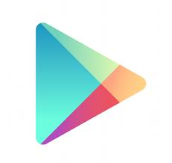) and tap it to enter the store. Search for “OverDrive Media Console” and install the app.
OR
If you do not have the Play store set up or you don’t know how to use it, manually install the app. Open your internet browser by tapping “All Apps” on your home screen, then selecting your browser from the menu. Navigate to this URL: http://www.overdrive.com/software/omc/AndroidEULA.aspx (OverDrive Media Console for Android™ Version 2.3). Agree to the terms at the bottom of the page and the download will start.

Once your download has finished, open your Notifications by dragging it down from the top bar, or tap the “Menu” button and then “Notifications.” You will see the downloaded file ODMediaConsoleSetup.apk. This is the installer. Tap it to select it and run the installer. Once the installation is complete, tap “Open” to run the app. (When the app first loads, you can tap “Close” in the “About OverDrive Media Console” window which will show on start-up.)

- To use OverDrive on your device you will need to get a free Adobe ID. Use your browser to navigate to https://www.adobe.com/cfusion/membership/index.cfm to get your Adobe ID. You may find it easier to complete this step on a computer.
You may want to record your Adobe ID here in case you need it again in the future.
Adobe ID (email):
Password:

- Open OverDrive by selecting it from your App Menu. Your Library screen will load. In the Library, tap the “Menu” button (), then “App Settings.” Scroll to “eBook Options”, then enter the Adobe ID and password which you set up in the last step. Select the “Authorize” button.

Your device is now authorized and you are ready to browse our ebook collection.

How to add items to your Library:

Anytime you are ready to download new items, you can do so directly on your Kobo.

1 | 2 | 3 | 4 | 5
Open the OMC app | - Go to “Get Books” and select Strathcona County Library | - Search or Browse for a title that interests you & Add To Cart | Proceed to Checkout > Login with your library card information | - Download. Your title will appear in your Library automatically.

- Open the OverDrive Media Console app on your device. You will find it under “All Apps.” (If you have not installed the app yet, see the previous page.)
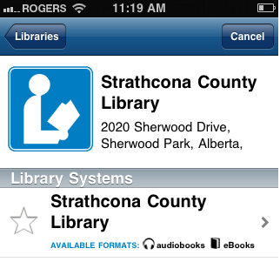
- Tap the “Menu” button (see below) on your Vox and select “Get Books.” Tap on “Add a Library.”

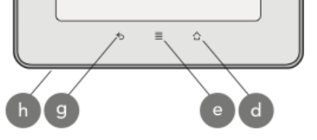
Menu
Button

Search for “Strathcona County” and select “Strathcona County Library” from the list. When “Strathcona County Library” comes up, tap the star to add it as one of your libraries. (You will only have to do this once. In future, SCL will appear when you go to “Get Books.”)

- To go to SCL’s digital collection, tap where it says “Strathcona County Library” (next to the star you just tapped). Search or Browse for a title that interests you, and then select “Add to Cart.” Or, if you would like to add an item you have already checked out to your Kobo, go to “My items
out” to access a list of items you have already checked out.
- Proceed to Checkout. Login with your library card information.
- Tap the Download button that appears next to your checked out title. As long as your OverDrive Media Console is authorized (see step 3 on the first page), your title will appear automatically in your Library. Some items may take several minutes to download, especially e-audiobooks.

How to return items early
1. On the Library screen, tap and hold the eBook you want to return. The title menu is displayed.
2. Tap 'Delete' to display the return options.
3. Tap 'Return and Delete'. The eBook is returned and deleted.
Some file types cannot be returned early
MP3 audiobooks and EPUB ebooks can be returned early.
OEPUB ebooks cannot be returned early. If you check out one of these books, set it to a shorter checkout period, or delete it from your device and then wait for it to expire from your account.

If you have any questions, please feel free to contact us:
Phone: 780.410-8601 | Email: info@sclibrary.ab.ca | or stop by one of our Information Desks
Last updated: January, 2013

