Freading & OpenLibrary
Help for your Kobo Vox
Compatible Formats: EPUB
How to Set up the OverDrive Media Console [OMC] app on your Kobo Vox

You only need to do this once. If you have used e-books from the library in the past, you may already have set up the OverDrive Media Console app on your Kobo, in which case you can skip ahead to the section called “How to Add Freading Items To Your Library.”

1 | 2 | 3 | 4
Download OverDrive Media Console | Install OverDrive Media Console | Get an Adobe ID | Authorize your device with your Adobe ID
Before you start: Allow apps from Unknown Sources
If you have not already done so, go into your device’s Settings menu (you can find “Settings” in “All Apps”), and under Application settings, select the checkbox beside “Unknown sources.” A warning dialog will be displayed. Click OK. You are now able to download and run third-party apps including OMC.

- Make sure your Kobo Vox is connected to a strong Wi Fi network. Open your internet browser by tapping “All Apps” on your home screen, then selecting your browser from the menu. Navigate to this URL: http://www.overdrive.com/software/omc/AndroidEULA.aspx (OverDrive Media Console for Android™ Version 2.3)
Agree to the terms at the bottom of the page and the download will start.

- Once your download has finished, open your Notifications by dragging it down from the top bar, or tap the “Menu” button and then “Notifications.” You will see the downloaded file ODMediaConsoleSetup.apk. This is the installer. Tap it to select it and run the installer. Once the installation is complete, tap “Open” to run the app. (When the app first loads, you can tap “Close” in the “About OverDrive Media Console” window which will show on start-up.)

- To use OverDrive on your device you will need to get a free Adobe ID. Use your browser to navigate to https://www.adobe.com/cfusion/membership/index.cfm to get your Adobe ID. You may find it easier to complete this step on a computer.

- Open OverDrive Media Console by selecting it from your App Menu. Your Library screen will load. In the Library, tap the “Menu” button (), then “App Settings.” Scroll to “eBook Options”, then enter the Adobe ID and password which you set up in the last step. Select the “Authorize” button.
How to add Freading items to your Library

Anytime you are ready to download new items, you can do so directly on your Kobo.

1 | 2 | 3 | 4 | 5
Open the browser and navigate to Freading | - Log in with your library card | Search or browse for a title you are interested in | Download the title | Open the book in OverDrive Media Console

- Open the Browser on your Kobo and navigate to http://www.sclibrary.ab.ca/download.htm. Select “Freading” from the list of e-book services.
- Log in with your library card number and PIN. Unless you have changed it, your PIN should be set to the last 4 digits of your phone number.
- Find a title you are interested in. Tap the cover. You will be taken to a page with more detail about the book. In the top left-hand corner of the cover is an indication of how many tokens the book requires. (Learn more about tokens.)
Note that PDF files will not load on the Kobo Vox. You may want to un-select the “PDF” option by tapping it, so that PDFs do not show up when you search.
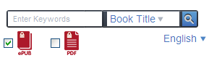

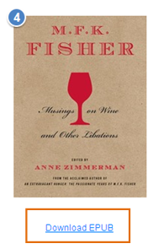 | - If you want to check out the book you are looking at, select the “Download EPUB” link that appears below the title (see left). The file will begin to download.  - Depending on how your Vox is set up, your file may open automatically, or you may be prompted on how to open the file. Open it using Adobe Digital Editions.  For more help with Freading, see the SCL website – Freading Help

How to add OpenLibrary items to your Library

Anytime you are ready to download new items, you can do so directly on your Kobo.

1 | 2 | 3 | 4 | 5 | 6
Open the browser and navigate to OpenLibrary | - Log in with your library card | Log in to your OpenLibrary account | Search or browse for a title you are interested in | Download the title | Open the book in OverDrive Media Console
- Open the Browser on your Kobo and navigate to http://www.sclibrary.ab.ca/download.htm. Select “OpenLibrary” from the list of e-book services.
- Log in with your library card number and PIN. Unless you have changed it, your PIN should be set to the last 4 digits of your phone number.
- Log in to your OpenLibrary account. Setting one up only takes a moment, but it does require some information, including an email address.
In the top right-hand corner of the page, click on “Sign up.” (In the future, you can use “Log in.”) Fill in the requested information.
- Search or browse to find a title you are interested in.
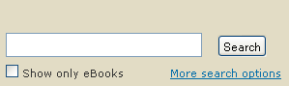 | The easiest way to find e-books that you can download is to always use the “Show only eBooks” checkbox when you search (see left). When you search for an author, title or keyword, you will see a list of search results like this:

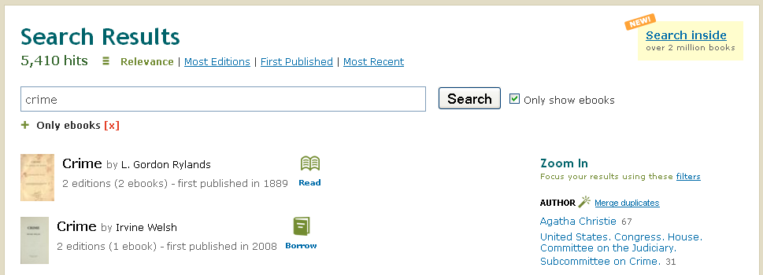

Find a title you are interested in. Tap the cover. You will be taken to a page with more detail about the book.

Once you see search results, check for books that are available to “Read” or “Borrow.” Look for these icons next to the book cover and title:
Read
This book can be read in your browser and sometimes downloaded. Books with the “Read” symbol are often older books that are out of copyright and can be freely distributed.
Borrow
This book is available for you to borrow as a patron of a library participating in OpenLibrary. You can read it in your browser or download it to read in an app.
Checked Out
This book has been checked out by another user. You can check back for it next time you visit the OpenLibrary site and see if it is available.
- Download the title. In the right hand column, you will see links related to borrowing that book. Click the “eBook” link.
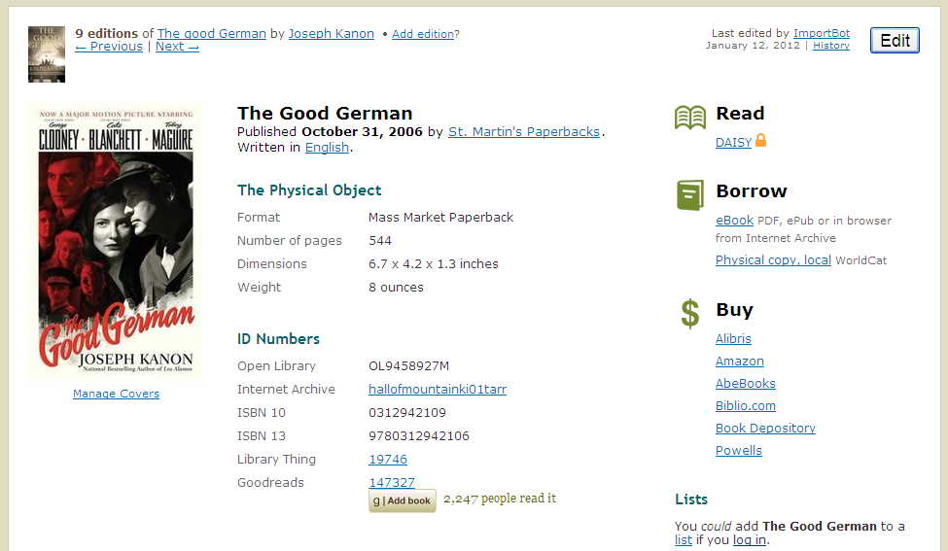
You will have to choose a reading/download option:
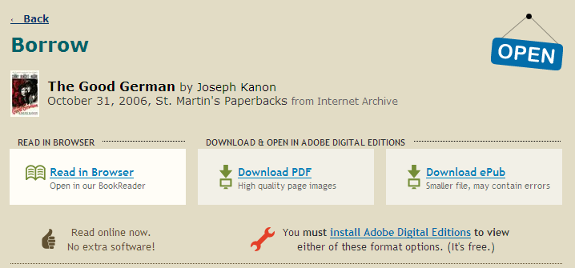
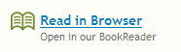
To read in your browser, without downloading the book, choose “Read in Browser.” (Note that once you select this option, you will not be able to download the book – it has to be read exclusively in-browser.) This is helpful if you don’t want to install any extra software on your computer.
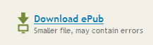To download the book, select the EPUB file format. On the Kobo Vox, only the EPUB version will work.

- Open the book in OverDrive Media Console. This step may happen automatically. If your device asks you to confirm what app to use to open the file, choose OverDrive Media Console.

For more help with OpenLibrary, see the SCL website – OpenLibrary Help

If you have any questions, please feel free to contact us:
Phone: 780.410-8601 | Email: info@sclibrary.ab.ca | or stop by one of our Information Desks
Last updated: May, 2012

