Getting Started with iPad Mini & iPod Touch
iPad Mini and iPod Touch are very similar devices with a few differences:
- iPad Mini is 134.7mm x 200mm; iPod Touch 5G is 58.6mm x 123.4mm
- iPad Mini can include a data plan as well as wifi; iPod Touch is wifi only
Any differences in display and camera lens are of personal preference.

Navigating with Hand Gestures
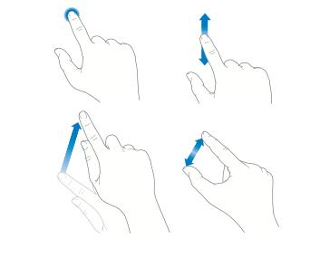
Swipe: to move the screen
Tap: to select or open

Drag: to move an item

Pinch: to make bigger or smaller

Part 1 POWER ON the iPad & iPod Touch, and log on to a wi-fi network.

To turn on the iPad/iPod Touch, press and hold the Sleep/Wake button on the top of the iPad/iPod until you see a white apple appear on the screen. Remove your finger from the button while the device starts up.
Tap the Settings button.
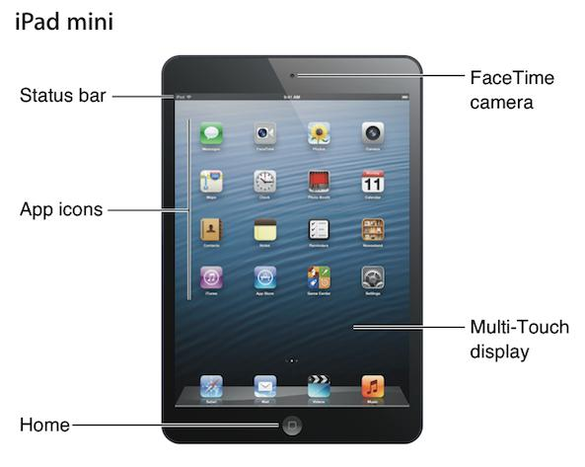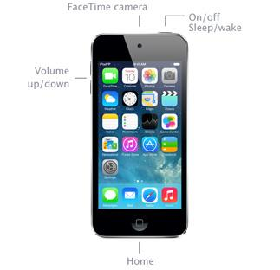

iPad Mini iPod Touch
Tap Wi-Fi. A list of available networks will appear. When inside Vancouver Public Library, click VPL.

On the left side list, tap Wi-Fi. A list of available networks will appear. When inside Vancouver Public Library, click VPL.

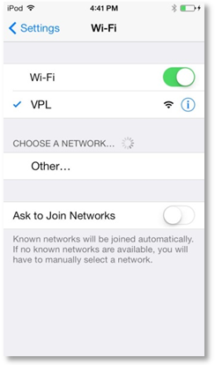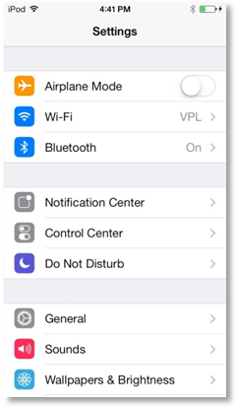
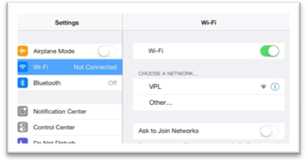

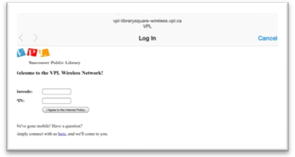

A login screen will pop up, asking for your library barcode number and PIN. Tap each space until the keyboard appears, and begin typing in your numbers. Click on I Agree to the Internet Policy when finished typing.
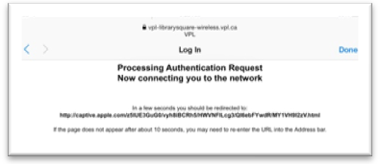
You will see an authentication screen.

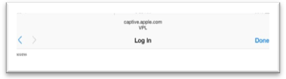When logged in, click Done.

Tap the Home button and tap Safari on the bottom of the screen to use the Internet.
Part 2 Creating an Apple ID
An Apple ID allows you to do everything Apple: shop in the iTunes store, download apps, use iCloud on your device, buy from the Apple store and get help from Apple Support.
https://appleid.apple.com/cgi-bin/WebObjects/MyAppleId.woa/
It is very important to remember your Apple ID because it is needed for all Apple products updates and new purchases.
Part 3 Applications Overview
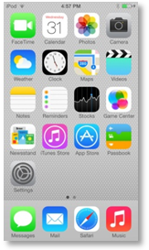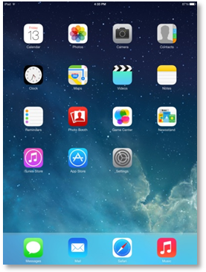Applications are software programs that cause a device to do specific tasks beyond just running the device. Many apps come standard with the iPad Mini and iPod Touch. A few of the basic ones:
- Calendar: set your schedule, with reminder alerts
- Photos: stores all photos you take with the iPad Mini/iPod Touch
- Camera: take still photos and videos
- Clock: includes alarm, stopwatch and timer, as well as setting multiple timezone clocks
- Maps: requires an internet connection, can give directions and store pre-planned maps
- App Store: allows you to download or purchase apps
- Settings: how to make adjustments to how the tablet operates
- Safari: the web browser from Apple, allows you to connect to the Internet

Part 4 Signing out of Apple ID
For devices that will be used by multiple people, either the same Apple ID should be used for all users or each person who enters their Apple ID must sign out before handing in the device.
To sign out of your Apple ID on the iPad Mini/iPod Touch: Settings > Store > Apple ID = Log out
To erase and clear all data previously added to the iPad Mini/iPod Touch using your Apple ID:
Settings > General > Reset > Erase all content and settings

Part 5 How to download apps
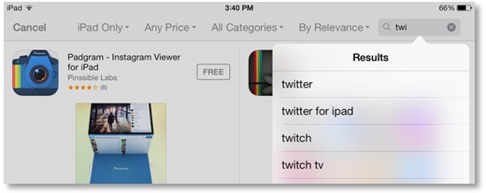Tap the App Store button. If you know the name of the app you would like, type it in the Search bar at the top right.

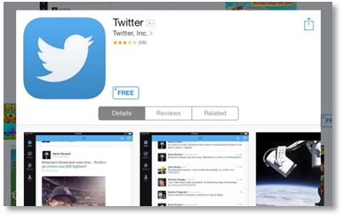

From the results, tap an app to see more information. To download the app, tap the FREE button (or, if there is a charge, the price button). It will switch to an Install button; tap it again to begin the download process.
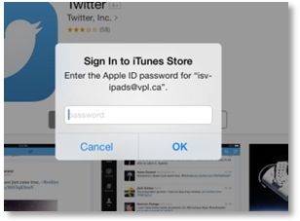A window asking for your Apple ID and password will pop up. Fill in the information and continue on to your download.
NOTE: There is a difference between iPod and iPad apps, but most apps are available for both devices. iPod Touch/iPhone apps can be used on an iPad (scaling up is required, which can distort some of the graphics), but iPad apps cannot be used on the iPod Touch.

Part 6 Downloading eBooks
As with other tablet devices, downloading eBooks to the iPad Mini or iPod Touch is relatively easy once the initial set up is done.
To set up the iPad Mini or iPod Touch: http://www.overdrive.com/help-videos/#iOS
To download eBooks from VPL to Go: http://guides.vpl.ca/tablets-and-smartphones

Part 7 How to charge the iPad Mini, how to tell when it needs to be charged
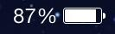On the top right corner, the battery life for the iPad Mini/iPod Touch is shown as a percentage with a battery. The iPad Mini/iPod Touch gives notifications to charge it at 20% and 10%.
To charge the iPad Mini, use the converter plug and plug into a secure power source. Many computers will not recognise the iPad if plugged into the USB port.
The iPod Touch can be plugged into a USB port on your computer. Cancel out of any prompt boxes asking to launch a photo program. Click “Trust” on iPod Touch for the computer. Do not attempt to register the device to a personal computer.
Part 8 How to take a picture
Tap the Camera button.
There are 3 options for images:
- Video
- Photo
- Square
Swipe on the camera options listed on the screen. To take a picture, press the white circle once. It will automatically save in your Photos app.
To record video, press the circle is red to begin recording; recording will stop when the red circle is pressed a second time.
For iPod Touch, the camera is only on the screen facing you. For the iPad Mini, you can use it as a regular camera or switch it to face you.

