Freading Help for your iPad/iPhone/iPod Touch
Available Formats: EPUB, PDF
Note for OverDrive Media Console users: If you have downloaded library e-books before using OverDrive Media Console, and you already have it installed on your device, you can use it to access Freading in addition to OverDrive. (However, you won’t be able to read PDF ebooks.) Skip ahead to the section called “How to Add Items To Your Library.”

How to set up the Freading app on your iPhone, iPad or iPod
1 | 2 | 3
Confirm Requirements | - Install OverDrive Media Console app | - Authorize the app with an Adobe ID

1. Confirm requirements—You need iOS version 4.0 or newer to use the e-book app. You may need to update your device’s software if you have not done so recently. To find out what version of the iOS you have, go to “Settings” (), then “About.” (For help with updating, you may need to check the support information for your device.)
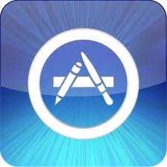 | - Install the Software –Go to the App Store on your device (look for the icon at left) and search for the free Freading app. Install it. You will need the password for your Apple/iTunes account to install the app.
- Authorize your app with a free Adobe ID. This lets you use the same digital account on multiple devices. You may be prompted to authorize your device the first time you use the app.
Many people find it easier to set up an Adobe ID using a computer rather than on a smartphone or tablet. Go to http://www.adobe.com/cfusion/membership/index.cfm to set up an Adobe ID.
To enter an Adobe ID manually, or to change your Adobe ID at any time, locate the Settings (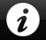) button on the bottom right side of your screen in the Freading app. Enter Username, Password, Account Type (Adobe ID), then click Activate.
Tokens
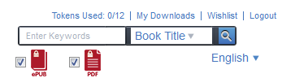
Tokens are the “virtual currency” you spend to get books in Freading. Your tokens are in the top right corner of the screen when you are logged in. Every week, you’ll be given a total of 6 tokens. After 4 weeks, your unused tokens disappear.
How to add items to your Library:
Anytime you are ready to download new books and audiobooks, you can do so directly on your device.
1 | 2 | 3 | 4
Navigate to Freading in your browser | - Login | - Search or Browse for a title that interests you | - Download.

- Open the Internet browser on your device and go to http://www.sclibrary.ab.ca/download.htm. Select Freading from the list of e-book services.
- Login with your library card and PIN. The first time you access the site, you’ll be shown an EZ 1-2-3 help for using Freading. You can choose to “Continue on to Freading” or “Always skip this page.”
- Search or browse for a title that interests you. Note the number of tokens the book costs (1,2 or 4) and the format (EPUB or PDF).
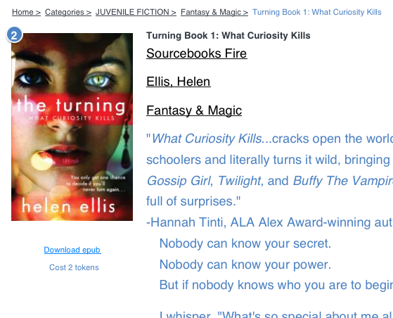
- Tap the “Download epub” or “Download pdf” link below the title you want.
If you have only 1 e-book app installed on your device, the download should open in that app automatically, and you can skip to the next section. If you have more than 1 e-book app on your device, you may see a new window like this one:
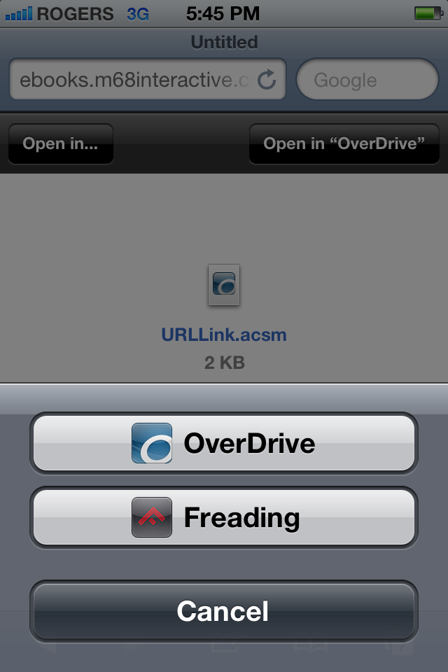
1. If Overdrive is your default reader, you will see “Open in Overdrive” in the top right corner. Click this, and your book will open in your Overdrive app.
2. If you are downloading a PDF, you will need to open the book with the Freading app (see step 3). To make Freading open, click the Open in… button in the top left. This will prompt the option to open in Overdrive or Freading.

Renewing Titles
Freading allows you to renew titles that are expired and re-download books that are still active on your account.
- Open your browser and navigate to Freading. Go to My Downloads in the top right (next to your tokens).
- In the list of your current and recent checkouts, the right hand column will state the status of each title.
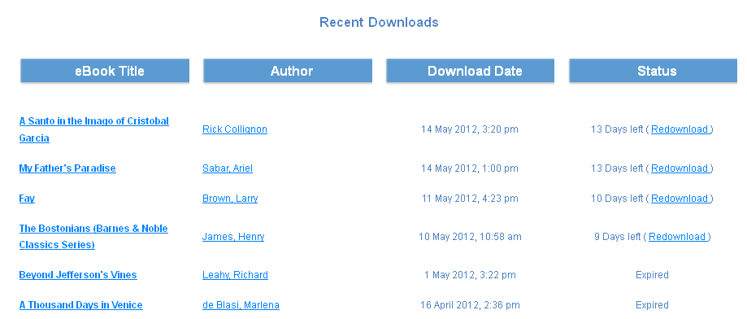
- To renew an older “Expired” title, click the title of the book and then click Download below the cover. Most titles are free to renew, depending on the original cost.

If you have any questions, please feel free to contact us:
Phone: 780.410-8601 | Email: info@sclibrary.ab.ca | or stop by one of our Information Desks
Last updated: October, 2012

