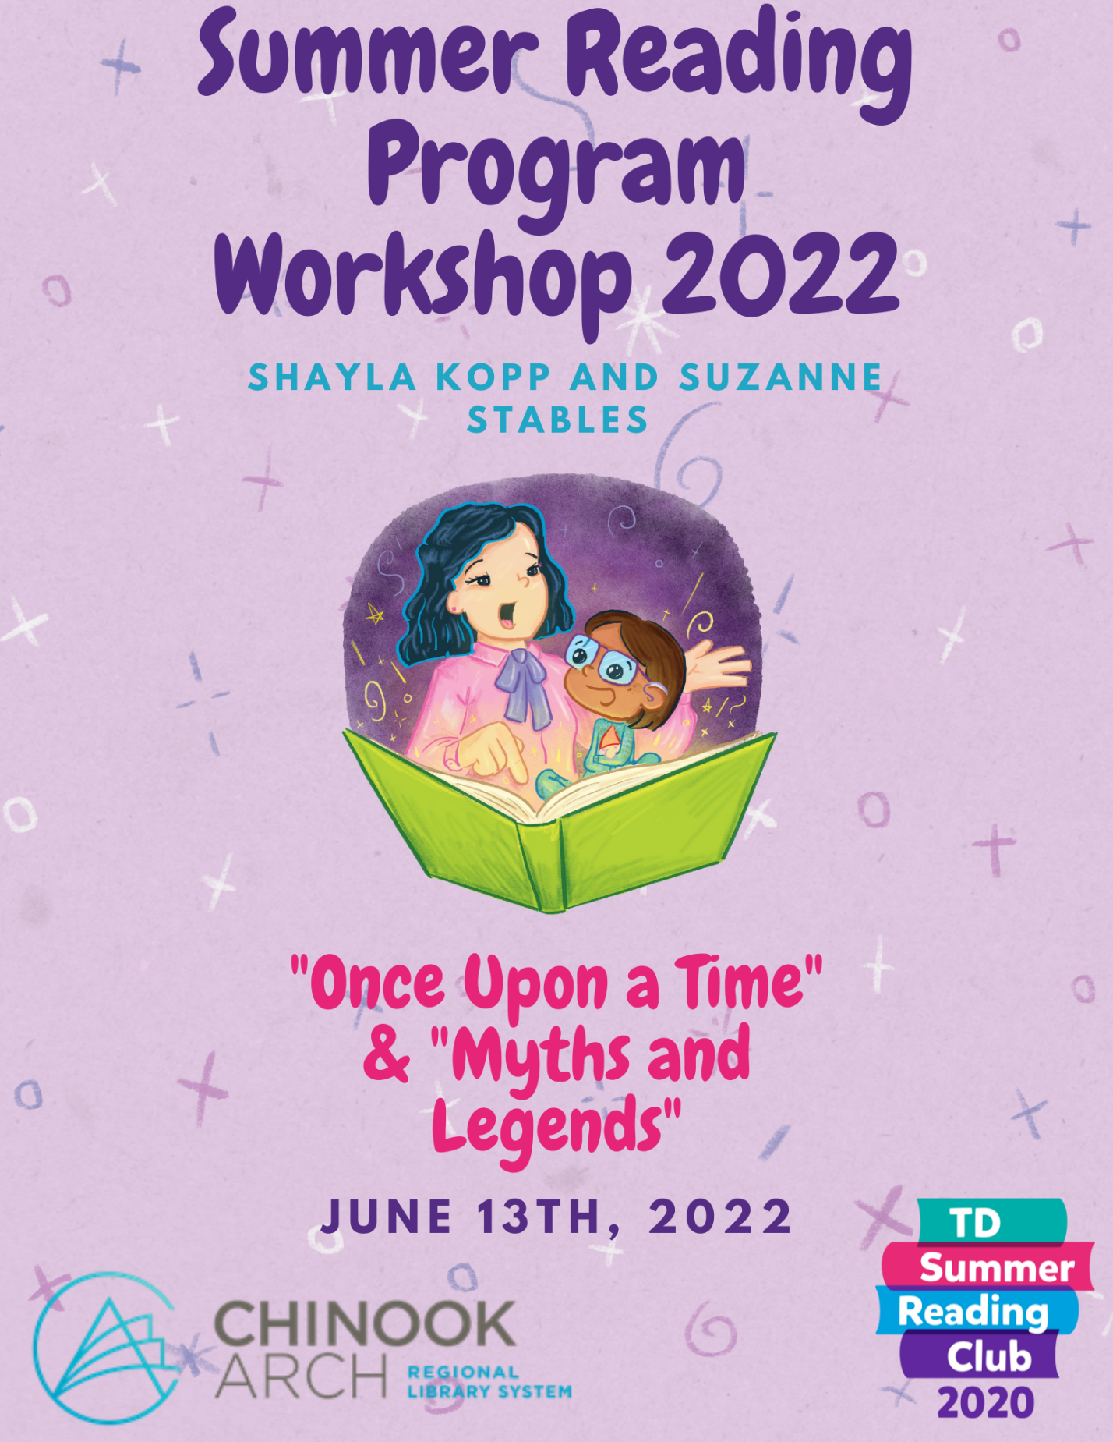

Why Summer Reading?
Summer reading is very important because come summer, kids don’t like to keep up on their reading. Who can blame them really, summer is for fun and kids often associate reading as work and no fun! This is why summer reading is so important for them! With the summer reading program, we can show them that reading can lead to a new world and help build their imaginations! With the TD Summer Reading program, not only do they get to read new and exciting books from genres they may not have thought of, but they get to make those books come to life with crafts and activities!

“Once Upon a Time” & “Myths and Legends”
This year is a very exciting theme, “Once Upon a Time” & “Myths and Legends”! As you can imagine, our imaginations have been skyrocketing ever since we started planning! Who doesn’t love imagining dragons, princesses, ogres and wizards! This year’s theme is hard to work with because the possibilities are endless! This theme reaches into children’s imagination and creates different worlds where they can get lost by having so much fun! This theme helps kids learn that anything is possible when you put your mind to work. As adults, it helps us remember that not everything in life has to be taken so seriously and that fun can be had at any age. This theme can help participants learn about old and new fairytales, myths and legends and monsters that they may hear of but never learned about!

Materials
Chinook Arch’s Materials
Chinook Arch’s SRP’s have made posters and bookmarks for all libraries to hand out and hang up at their discretion. Getting these materials is quite easy! All you have to do is fill out the quantities for the materials you want on the Library Visit Options Form (https://forms.office.com/r/5ZpY8u6Ewh) you were given on the day of the workshop. If you were unable to come to the workshop or would like to change your order, please email srp@chinookarch.ca.
TD Material
Your TD Materials are ordered and will be delivered to your library as soon as they arrive for those of you who wanted materials! The materials, just as a reminder, will be notebooks, stickers, web access code stickers, corner bookmarks, and promotional posters!

Chinook Arch’s Role
You might be asking what Chinook Arch’s role is during this summer and why do we keep hearing from them!? We are here to help your libraries run your TD Summer Reading programs and give your summer students a break once or twice. We are also here to be a resource for your library. Chinook Arch will be coming for library visits, making promotional materials and collecting all your statistics to send off to TD.
Library Visits
Much like every other year, we will be coming out to your libraries on the days and times you have selected to run two programs throughout the summer. The programs we run will be your choosing, but as a heads up, you might want to start thinking about which one you feel your participants will be most interested in. This year, our programs are Mythical Monsters, Wizards, Witches and Warlocks, Fractured Fairytales, Royal Rumble and Pirate Pandemonium. Our library programs will be for both age groups (pre-school and school age children) with age appropriate and engaging activities for all to enjoy. All supplies needed for these programs will be provided by us so there is little to no prep for your libraries.
This year, as a way to get adults more involved with reading, we will be offering passive programming! We will be offering Bookopoly and Book Bingo! With these two fun activities, teenagers and adults will have a chance to win prizes!
Before every visit, we will contact your specific contact person and confirm our bookings! At this time, we will confirm with you the number of people you expect, and if there are any special requirements that have not been previously discussed.

Parade Banner
The banner is here and ready for you to use! We have made a list for those of you who have requested the use of the banner and will get it sent out to your library in time for your celebrations!

Registration/Bookings
Member libraries in the past have offered two types of programming, drop in and registration-based programs. Both of these are perfectly acceptable as you are in control of your program! Whichever route you choose, something to remember is that the participants are under your care for the duration of the reading program hours, and therefore you must ensure all children are taken care of should an emergency arise.
TD has linked an excel spreadsheet to their website for you to put your participants information in as you receive it! The form calculates the statistics for you as information gets added. The forms from TD can be located under “RESOURCES” “PROGRAM FORMS”, or following the link https://www.tdsummerreadingclub.ca/staff/program-forms.

To help member libraries out, we have created a sample form for you to use if you wish for your registration. These forms contain emergency contacts, allergies as well as the additional information needed for registration purposes.
Booking SRP
Now, the big question, “how do we book the Chinook Arch SRP’s to come to our member library?” To book us, it is quite simple, you can put your top four dates along with the times on the Library Visit Program Options form we handed out and have linked here as well. https://forms.office.com/r/5ZpY8u6Ewh

Freedom of Information and Protection of Privacy (FOIP)
Social media is a great method to promote events at your library, and while libraries are public places where photos are permitted to be taken without permission, it is important to respect parents’ and participants’ right to privacy.
- Make it clear that you are a staff member taking photos for specific reasons. Verbally voice why you are taking photos and where these imagines might end up.
- If and when using names of participants in any print or social media posts, only use first names to ensure privacy of participants.
- If, when taking photos, a guest expresses concern, be sure to address any issues immediately.
For more information on FOIP, please visit: https://www.servicealberta.ca/foip/

Centre For Equitable Library Access (CELA)
The Centre for Equitable Library Access (CELA), works with the TD Summer Reading Club to support kids who have print disabilities. TD offers lots of online and other resources for libraries interested in planning for accessibility. This can be found on the Staff Site under “Run the Program” “Plan for Accessibility” or by the following link https://www.tdsummerreadingclub.ca/staff/plan-for-accessibility. If more information is needed, CELA can help make your summer reading more accessible.

Statistics
Statistics are very important when it comes to the summer reading programs because they help gauge how successful each club/library was. This is also a way to track feedback for TD and if people have suggestions or complaints. Tracking statistics is always a pain but TD has made it as care-free as possible by creating a downloadable and editable document for all to use! The link for this is https://www.tdsummerreadingclub.ca/staff/submit-statistics. Starting your stat tracker, the sooner is better!

What are the stats you should track?
- Registrant & Participant Statistics:
- 0-5 years old
- 6-8 years old
- 9-12 years old
- 13+ years old
- Total number of registrants/participants
- Whether the registrants/participants are new or joined the club in previous years
Program Statistics
- Number of programs/activities inside the library
- Number of program/activities outside the library in your community
  - Total number of club programs/activities
- Attendance of the programs/activities inside the library
- Attendance of the programs/activities outside the library in your community
  - Total attendance of all children in all programs
Promotional Statistics
- Where staff promotion occurred (ie: schools, day camps, childcare centres, other)
- The number of promotional visits by staff
  - The number of children in attendance (approx.) at each visit

**Watch for a link at the end of summer to submit all statistics**

Awards
TD Summer Reading Club Library Awards
First-prize winners in each language will receive:
- $8,000 to be invested in the children’s section of their public library branch
- an honorary plaque
- national recognition through a press release
- the opportunity to attend the awards ceremony
Second-prize winners in each language will receive:
- $4,000 to be invested in the children’s section of their public library branch
- an honorary plaque
- national recognition through a press release
- the opportunity to attend the awards ceremony
Third-prize winners in each language will receive:
$2,000 to be invested in the children’s section of their public library branch
- an honorary plaque
- national recognition through a press release

CELA Accessibility Award
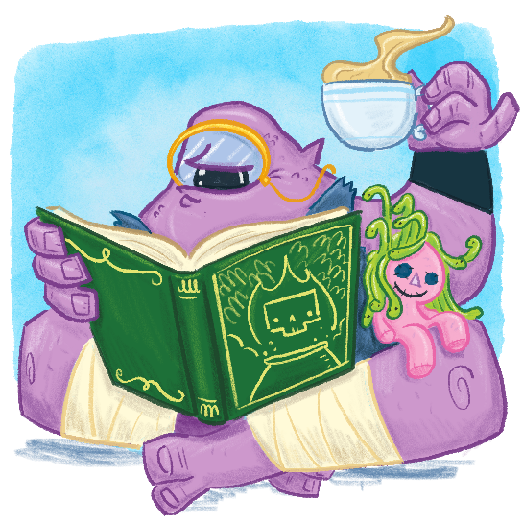
CELA and its partners offer an annual award to promote excellence in accessible programming and to celebrate the creativity of library staff who engage children with print disabilities in their TD Summer Reading Club. There is one award for English programming and another for French programming.
Book Quest
To follow our theme this year, the Book Quest is back with popular demand!! As Suzanne and Shayla travel around to the libraries in July and August, they will “bury” a book (plastic covering) in a well-known area in the member library town. Once the book is hidden, they will post pictures and or clues as to where the book is hidden on the SRP social media accounts, Facebook and Instagram. We will be asking the member library to cross-share the post and promote the quest. Our social media accounts are on all book marks so it will be easy for all parents to follow! The intentions are that the parents from the member library communities can see the posts, look for the book and also tag us when they find it! The purpose of the book hunt is for the kids to explore their communities while using their imaginations from what they have been learning from this year’s theme!
This year, as something new, we are going to be putting in a Book Crossing ID number. Whoever the lucky hunter is, will be able to take the ID number and search it up on www.bookcrossing.com. The participants can choose to keep the book or they can pass it on! Kids can use the ID number and follow along with the books’ journey throughout its adventures!

Prizes
Chinook Arch is doing prizes a little different this year! Analog Books has graciously donated book baskets for every library that is wanting us to visit and do a program. These baskets will include a branded tote, middle school appropriate book, $15 Analog Books gift card, Analog 10% discount coupon for in-store shopping, and publisher swag!
We will also be doing prize draws at the end of the summer! We will be collecting the names and phone numbers from the libraries this year of the kids who participated in our program and then at the end, we will be doing draws for prize winners. At every program, Shayla and Suzanne will be bringing one of the book baskets and a poster that shows the prizes that can be won! This will encourage kids to come back to the programs that your member libraries are offering! All prizes will be delivered by the end of programs by delivery vans. Each prize where a name was drawn will have the name of the library, the winner’s name, and phone number for the member library to contact.

Games, Crafts and Activities
For games, crafts, and activities, we wanted to give you all the resources to make your life easier. As you can see, there are no examples in this booklet, but that is because we have created a full booklet that has lots of ideas for your library to use as you wish!

TD SUMMER READING PROGRAM 2022
Child’s Name: _________________________ Age: __________ Grade Completed: _______________
Parent’s Name: ______________________________ Phone Number: ___________________________
Additional Emergency Contact (Name and Relation): _____________________________________
Phone Number: ____________________
Has your child participated in the TD Summer Reading Program before? _______________________________________________________________________________________
Does your child have any allergies/medical concerns? _______________________________________________________________________________________
Is there any additional important information we should know? _______________________________________________________________________________________
I hereby give / do not give (please circle) permission for the ______________________________ Library to take my child off-site for the Summer Reading Program.
Signature (Parent/Guardian): ____________________________________ Date: ______________

TD SUMMER READING PROGRAM 2022
Child’s Name: _________________________ Age: __________ Grade Completed: _______________
Parent’s Name: ______________________________ Phone Number: ___________________________
Additional Emergency Contact (Name and Relation): _____________________________________
Phone Number: ____________________
Has your child participated in the TD Summer Reading Program before? _______________________________________________________________________________________
Does your child have any allergies/medical concerns? _______________________________________________________________________________________
Is there any additional important information we should know? _______________________________________________________________________________________
I hereby give / do not give (please circle) permission for the ______________________________ Library to take my child off-site for the Summer Reading Program.
Signature (Parent/Guardian): ____________________________________ Date: ______________

