Working with Word 2007: An Overview
Microsoft Word is one of the most popular word processing packages available. You can use Word to create documents such as letters, memos, resumes and reports.
Opening the Word Program
If you are opening Word on a home computer you begin by clicking on Start icon, then on All Programs, then Microsoft Office and then click on Microsoft Office Word 2007 program.
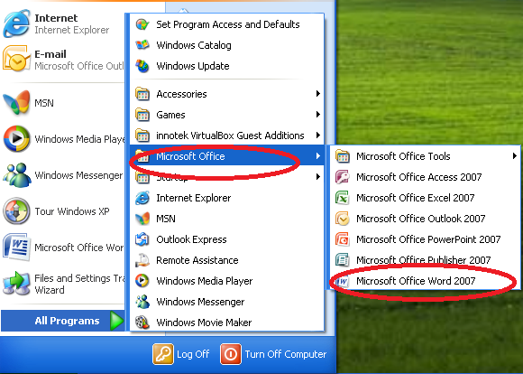
NOTE: On the library computers we can click on the Word icon from the desktop.

Creating, Saving and Printing Documents

The File menu is where you find the commands for creating a new document, saving a document and printing a document. Clicking on the Office Button in Word 2007 opens up this menu. [In Word 2010 Microsoft went back to using the “File” tab].
Word 2007 Word 2010
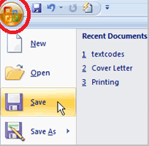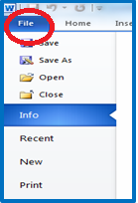
The Office Button in Word 2007 gets you to the File Menu.
In Word 2010 the term “File “is used.

Commands in the File Menu
- New: Allows you to create a new document or access templates that can set up your document in a pre-formatted layout.
- Open: Allows you to open documents from either files saved on your computer or other devices.
- NOTE: If you open a Word 2003 document in Word 2007 it will open the document only in “Compatibility Mode” and disable (or grey out ) the new features.
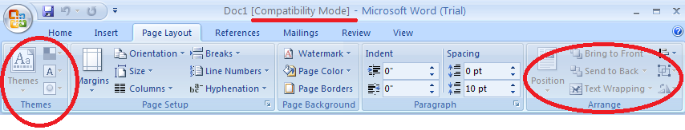
Note the grayed out new feature areas that are not accessible when the document is still in Word 2003 format.

- To make the Word 2003 document work with Word 2007 – click on the Office Menu button and then Convert. This will convert the document from a .doc to a .docx document.
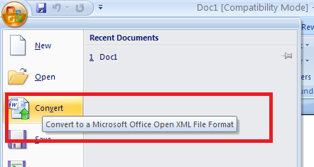

- Save As / Save:
TIP: the first time you save a document you should use Save As – so that you are aware where the computer is saving your document. Remember to do this also if you open up a document from your email (as it opens it only in a Read Only [Compatibility Mode]). Even when you click on Save –it is not really saving it any place. The document exists only as web page. When you close the document any changes to the document will be lost. You have to click on Save As – and then save it to My Documents or the desktop. After you have saved your document to a particular place on your computer– then you can click on Save and it will save changes it to your document.

You can also use the Save As function to save your Word 2007 document as a different type of document if necessary. For example if you need to save your Word 2007 document as a Word 2003 document – then you click on the Save as type in the Save As dialogue box and it will save the document in the format selected. You also have the option of saving your Word 2007 document as a PDF.
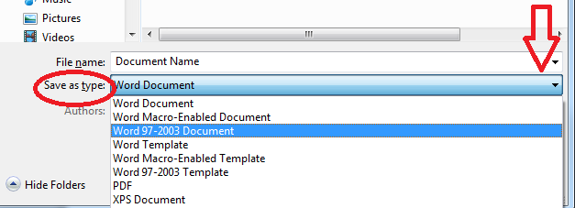
- Print Preview / Print: To save yourself time, aggravation, and money use Print Preview to view
how your document will print out before you select Print.
This menu will also list Recent Documents that you have saved in Word. (Not applicable on Library computers.)

Basic Word Document
Document Title Bar
Quick Access Toolbar

At the bottom of the document on the left hand side is information on the page you are on, the number of total pages and word count. On the right hand side is the page e view buttons.
Ribbon Tool Bar:
Note the Tabs that give access to specific function areas:
- Home (shown here);
- Insert;
- Page Layout;
- References; Mailings;
- Review, and
- View.

Office Button
Cursor
Rulers

Ribbons instead of Toolbars
Microsoft Word has changed from toolbars to “ribbons”. Here are the “ribbons” allows access to sets of related commands.

Home Ribbon:
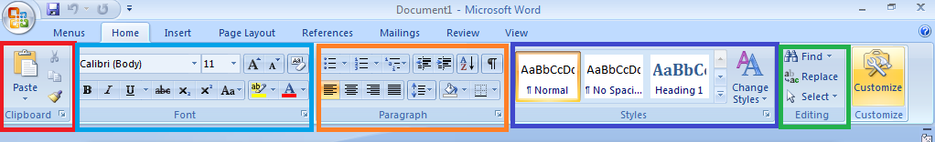
The Home ribbon gives access to the basic formatting commands including Styles. Many of the function boxes also have another link, called a dialogue box launcher, which opens up further commands. A small arrow in the bottom right hand corner indicates that there are more functions available for that set. [See the illustration below].
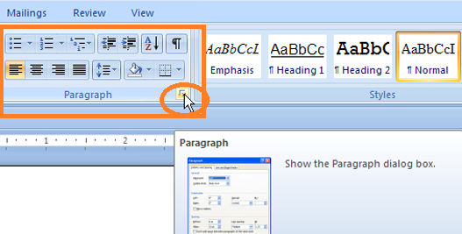

Here is that same paragraph box larger sized.
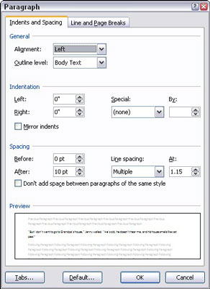
The names of the other ribbons gives you an indication of what commands are available on that ribbon.
Insert Ribbon:
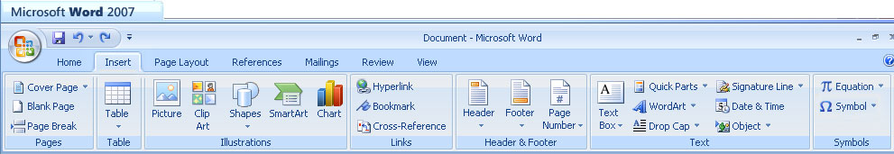
The Insert ribbon gives access to the commands that allow you to insert tables, shapes, pictures, charts, text boxes, Wordart, equations, or symbols into your document. You can also create headers and footers from this ribbon.

Page Layout Ribbon:
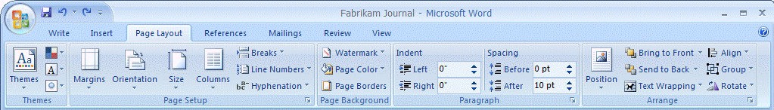
The page layout ribbon gives you access to those commands that deal with the page set-up and arranging graphics and text on the page.

References Ribbon:
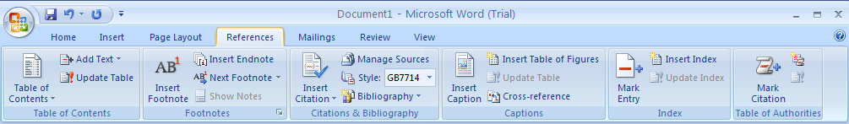
The Reference ribbon gives access to specialized functions such as inserting references into a document. Generally this is only used when creating research papers.

Mailing Ribbon:
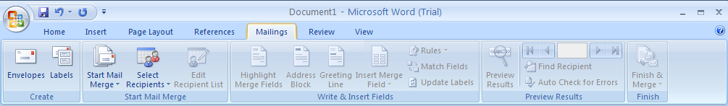
The Mailing ribbon gives access to the commands that allow the creation of envelopes, labels or setting up mail merges.
Review Ribbon:
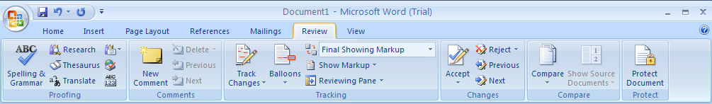The review ribbon gives access to the commands that show and track editing changes [which is especially helpful if you are co-authoring a document], allows you to insert comments for other reviewers to see, and helps to help proofread a document by checking spelling and grammar .
View Ribbon:
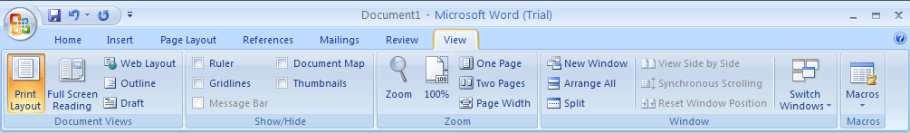
The View ribbon gives access to functions that allow you to change how you view your document. It allows you to view one or two pages at a time, show or hide rulers or gridlines, or view two documents at once.

Shortcuts for using Word
Pressing the Home key will take you to the start of the line.
Pressing the End key will take you to the end of the line.
Page Up will take you up one screen. (Only words in multi-page documents).
Page Down will take you down one screen. (Only words in multi-page documents).
CTRL + Page Up- up one page at a time
CTRL + Page Down-down one page at a time
CTRL + Home – takes you to the beginning of the document
CTRL + End –takes you to the end of the document.

Want to learn more?
There are many books in our library that will help you learn more about Word 2007.

There are also several good websites that are geared to teaching about Word software. Most of these sites provide help for both Word 2010 and Word 2013. Some also provide help for other Microsoft products such as Excel, Power Point and Access. Here are some good websites to get you started.
Microsoft Word 2007
Microsoft support offers more extensive help for Word 2007-2013 and other MS products.
http://office.microsoft.com/en-us/word-help/word-2007-training-courses-HA010215566.aspx?CTT=1

Addintools
Website provides tutorials on all Microsoft programs including Word, Excel, and PowerPoint up to 2010. . http://www.addintools.com/documents/index.html#word

Shauna Kelly – Making the Most of Word in Your Business
Information on Word 2007 – 2010. http://shaunakelly.com/topic/word/management

GCF Learn Free
Provides free tutorials on Word 2007-2013 plus other software products. http://www.gcflearnfree.org/word2007

