**All About Twitter**



Go to <https://twitter.com>, fill out all of the fields & click Sign up for Twitter

There are 4 things every other user on Twitter can see:

1. your profile picture
2. your background picture
3. your username (@myusername)
4. your name (you don’t have to use your real name)

Follow the prompts to get started. You will be given the option to SKIP steps (such as using your email to sign in – this will spam your contacts!).

Twitter will send you an email that contains a link you must open to confirm your account.

To skip following suggested accounts at sign up, go to your email and confirm your registration. You will be taken directly to your Home Screen.

Your Twitter feed: all the users you are following will appear here plus your own tweets.

At the bottom there is a list of options like Reply, Retweet, etc

Information about your Twitter account

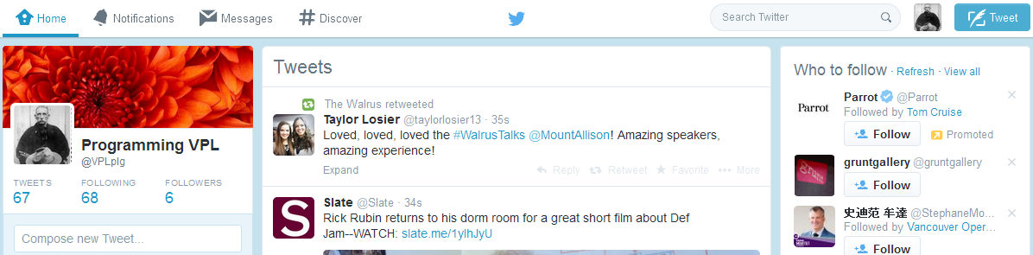

**Navigation**

* the main feed of tweets from all the people you follow plus your own tweets

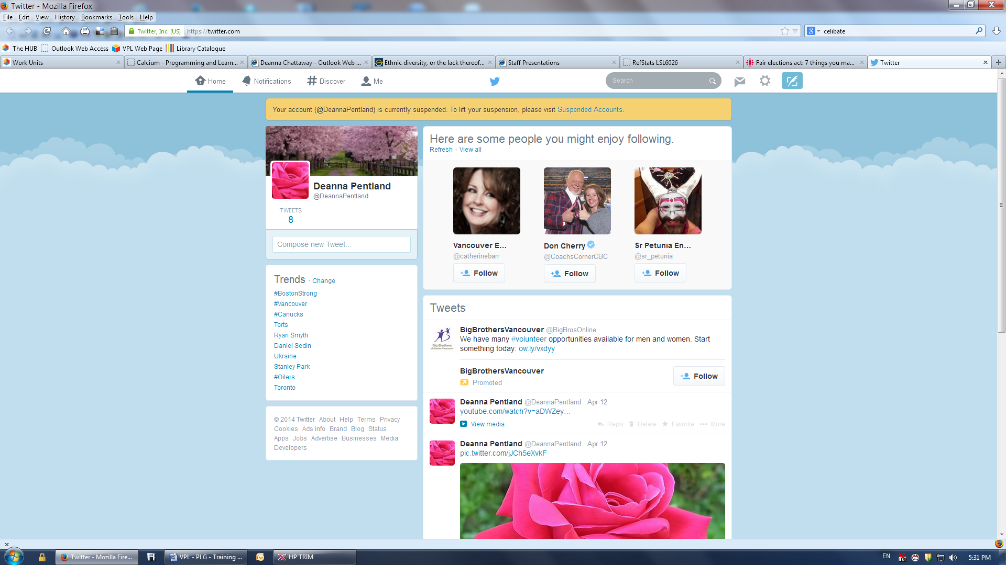

* shows who have tweeted to you & who has starting following you



***Mentions Tab*** shows activity on Twitter in which your **username** is tweeted.

* lets you privately message your followers. You cannot send a direct message to a user who is not following you!



* suggests people/interests based on what you currently follow. Find popular accounts based on subject or topic!



* **SEARCH** use keywords to find either subjects, people, and other users
* **PROFILE & SETTINGS** click on the small image of your profile (to the left of Tweet) to manage your lists, help, shortcuts, settings, & SIGN OUT. Privacy options are found here under “Security & Privacy”. The default for your tweets is public- check the “Protect My Tweets” to only allow your approved followers to view
* **Trending Topic**: Choose your specific city or area by clicking the “Change” option. Now you will see which topics are the most popular for that city/area. For example, a current election or celebrity wedding might be a trending topic.

**Tweeting**

You can post to a maximum of 140 characters. Click the Tweet button (top right). When done press “Tweet”. Your tweet will be visible on your feed **(profile)** and on your followers feed.



* **Adding links:** Copy a web link (Twitter will shorten any link over 22 characters)
* **Adding photos & video:** You can add photos or videos from sites such as YouTube
* **Replying:** Use the “Reply” link at the bottom right hand side of each tweet.
* **ReTweeting (RT):** If you want to share someone’s tweet with your followers click “Retweet”. When you retweet & add a comment to it, this is called a modified tweet.
* **Favorites:** If you like a single tweet, you can save it to Favorites by clicking the star under the tweet. Find your Favorites on your Profile page
* **… :** for more options including Share Via Direct Message, Embed Tweet, Mute @___ , and Block or report (see below)
* **@username :** Communicate directly with someone by putting the @ symbol and their username at the beginning of your tweet. This goes on your feed & your friend’s feed.
* **#hashtags:** The **#** symbol is used to mark keywords in tweets so that other users can search for tweets on that subject/keyword. If you want more people to find & follow you, use these tags in your tweets on specific topics, e.g. #libraries.

**Following & Followers**

To **Follow** someone on Twitter means to subscribe to their Tweets or updates. Each time they tweet it will appear on your Home page. They are notified when you start following them. You can follow or unfollow accounts at any time.

A **Follower** is another Twitter user who is reading (following) your tweets

**Lists:** if you are following many people you can organize them into groups. Go to your Following list & click on the gear icon, and select “Add or remove from lists”



**Blocking:** This means they will be unable to find or follow you on Twitter. Go to the person’s Twitter Profile, click on the gear icon, and choose “Block or Report”

