Introduction to Online Learning

Online Learning is a flexible way to learn anything you want, whenever and wherever you want.

All you need is:
- Access to a computer/tablet/smart phone
- Internet access
- Speakers or headphones may be necessary
- Your VPL card and PIN (to access online learning resources offered by VPL)

Is it free?
- Many of the eLearning resources are absolutely free!
- Some eLearning providers give you partial free access, but charge a fee for full functionality
- Each eLearning provider is different, so make sure you look through each resource to find the free content.

How to get started:
- Visit the VPL guide on eLearning to discover the many resources you can use to get started with eLearning at http://guides.vpl.ca/eLearning.

Resources offered by VPL:

http://www.vpl.ca/news/details/lynda_com  *Must be accessed through the VPL website | Lynda.com is an e-learning platform paid for by VPL that allows you to access hundreds of online tutorials using their library card.
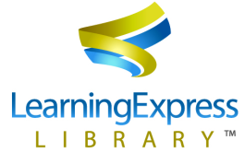  http://www.vpl.ca/electronic_databases/cat/C205 | Learning Express Library provides skill building for all levels from Grade 4 Elementary to Adult. Covers many standard courses, basic education, and general subjects: math, reading, writing, vocabulary, computer skills, and more.  *You need to create a login and password. Some titles are now available as downloadable ebooks in PDF format.
http://www.vpl.ca/electronic_databases/alpha/p | Pronunciator provides access to learning materials for 80 languages, with the interface available in 50 different languages for ESL and other language learning.

Resources that offer free, or partially free, access to university-level online courses:

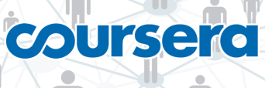  www.coursera.org | Coursera offers over 400 free courses available in a wide variety of languages. Topics span from the humanities & social sciences to medicine, biology, mathematics, business, computer science, and more.
www.edx.org | Free courses provided by MIT, Harvard and Berkeley. Students who complete assignments and honour deadlines can receive a “Certificate of Mastery”, but everyone is also welcome to participate in classes without committing to assignments.
www.futurelearn.com | FutureLearn is a U.K-based private company owned by the Open University featuring courses on topics that range from health to history, education and literature.
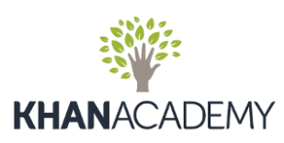  www.khanacademy.org | Khan Academy is a non-profit organization that hosts more than 4,000 free micro lectures on a variety of topics. Lectures are hosted by YouTube. Topics covered include chemistry, math, finance, art history, grammar, languages and more.
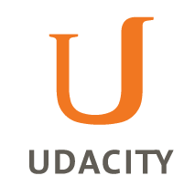  www.udacity.com | Udacity offers classes in computer science, programming languages like Python and Javascript, math, physics and business. Classes include supporting video lectures, quizzes and assignments.

Educational websites with lectures, videos, and tutorials you can access by browsing or searching for your topics of interest:

- National Geographic (www.nationalgeographic.com)
- PBS (www.pbs.org)
- YouTube (youtube.com)
- TED (www.ted.com)
- The Canadian Encyclopedia (http://www.thecanadianencyclopedia.ca/en/)

Need extra help?
- Join us at Tech Café! Tuesdays and Thursdays at Central Library on Level 3 at 2:00 pm.
- Feel free to contact VPL during library hours at 604-331-3603, by email at info@vpl.ca, or drop by your VPL branch.

