Getting Started with Instagram
Join in the fun of the Vancouver Summer of Learning photo challenges by using Instagram to take, share, and hashtag photos with #VanSummerLearning. Register for the Summer of Learning at any VPL Branch and learn more about the challenges, activities, and prize entries at: www.vancouverlearningcity.ca/
Download Instagram app & sign up
1. Make sure you are connected to the internet.

2. INSTALL: Go to your app store on your device (Apple = App Store, Android = Google Play), search for Instagram, click “Install” or “Get” and follow any prompts to install.

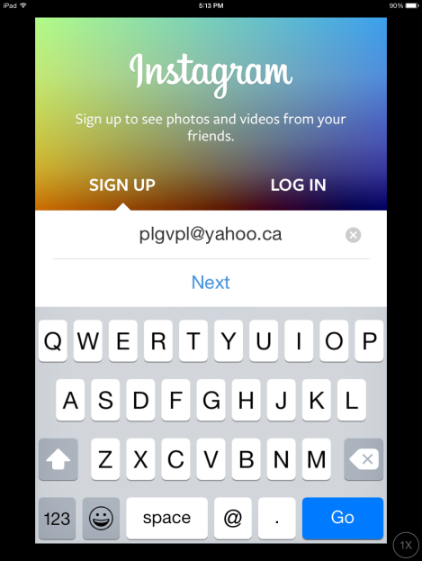
3. SIGN UP: Open the Instagram app by tapping the new Instagram icon on your device and follow the prompts to sign up for an Instagram account.

The sign-up will walk through a number of steps and requires:
- valid email address
- your name (anything you choose)
- password
- username: this is unique so you need to create one that no one else is using. Do not use spaces for the username
You can change any of this information later.

You can skip the following steps: (Friends, Contacts, Follow People and notifications). You can edit these later.
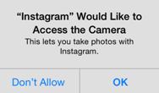
4. CAMERA ACCESS: Approve Instagram to access to your camera.

This message will appear during your set up - Instagram will ask your permission to access the camera in order to take photos.
Tap OK. If you don’t allow access, you won’t be able to use the app.

5. CONFIRM: Confirm your new Instagram account by checking your email inbox & following their link to activate!

Navigating Instagram
Home shows photos from the people you are following (like a Facebook newsfeed).
Instagram Direct (from Home) allows you to share a photo privately to any of your friends (followers). Tap the icon > + > take photo > add recipients from your list > send. This photo is now shared privately to the chosen recipients only.

Search When you type, Instagram will offer suggestions. You can search for:
People: Search by name or username
Places: Search by city, landmark, addresses
Tags: Search by terms and hashtags (a row of keywords: #vancouverpubliclibrary)
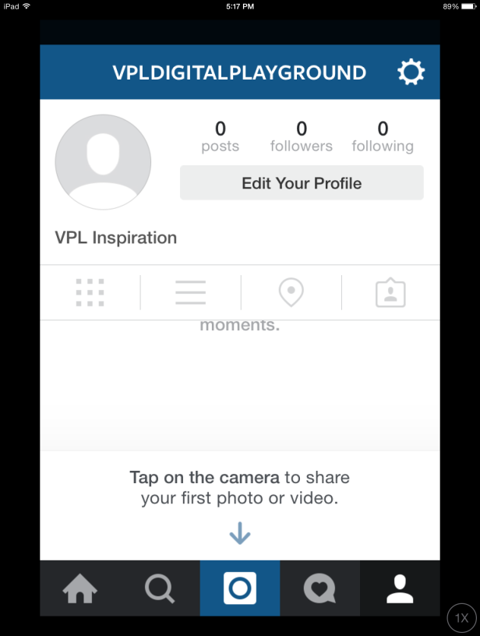
Camera allows you to take a photo and upload it to your account

Activity includes: when someone follows you, leaves a comment, likes your photo

Profile Shows your name, number of posts, followers, and who you follow. (Can also edit these here.) View your photos as a thumbnail
or scroll, view your photo map, and see who you’ve tagged.

Settings: From the icon in your profile, access account preferences, help,
privacy settings, and more:

Account: Edit profile, Change password, Posts You’ve Liked,
Private Account – set to private to share photos only with
users you’ve approved (they send a request to follow you)
Settings: Linked accounts like Facebook or Twitter, notifications,
data use, save original photos
Support, About, Clear Search History, Log Out

Complete a Summer of Learning photo challenge!
Once you have located the subject for your photo to use for one of the photo challenges, follow the steps below to add your photo as part of the Summer of Learning photo stream!

1. Connect to the Internet (or use your wireless data plan)

2. TAKE YOUR PHOTO: Click on the camera icon and take your photo!
Once you are satisfied with the photo, tap Next

3. ADD THE SUMMER OF LEARNING HASHTAG #VanSummerLearning:
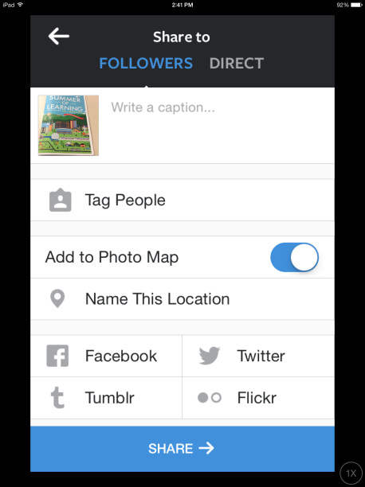
Write a caption – Tap inside this area to write about the photo and type the Summer of Learning hashtag: #VanSummerLearning

Other options:
Tag People – choose from your friends (followers) - the app will search for “faces” to tag
Add to Photo Map – this shows the location when you uploaded the photo (not necessarily where the photo was taken, for example, a photo taken earlier stored on your device)
Name This Location – Add the location of the photo
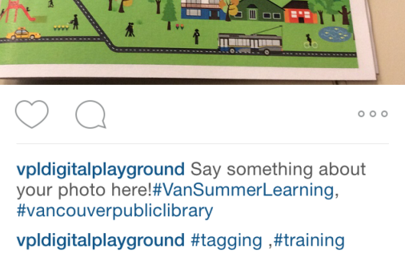
Add to other social media

4. SHARE: Tap share and your photo will now appear in your photostream as well as be found by anyone searching the #VanSummerLearning hashtag.

PRIVACY NOTE: To participate in the Summer of Learning challenges, your account must be public. You can set your
account to Private at any time so only your friends (followers) can see you photos.

More Instagram Resources & Help
Instagram help: Go to Profile > Settings and scroll down to “Help Center”
lynda.com course: “Sharing Photos on Instagram” (Access from vpl.ca/InspirationLab)
VPL Tech Café at Central Branch: Every Tuesday & Thursday from 2-3:30pm on Level 3

