WEB DESIGN ESSENTIALS: The Design Process

Description
An introductory class exploring the fundamentals of website design, including content strategy, aesthetics, accessibility and usability. Learners will brainstorm how to design a basic website site structure. Register here for other classes in the Web Design Essentials series. Each class must be registered for separately.

Learning Goals> OUTCOMES
Digital Fluency > Manage > Manage Digital Information & Data
- Devise, organize and communicate procedures and guidelines around the use and dissemination of digital information (eg: social media plan, communications plan, etc).
Digital Fluency > Create > Apply Design Principles & Processes
- Design the final product or purpose of a digital project, sequence the steps to completion, and draft mockups, wireframes, plans, or sketches of digital content.
- Integrate considerations of content strategy, accessibility, aesthetics and user experience into the design process.
- Assess the viability of the design through prototyping, using mockups, wireframes or pencil sketches/maps of digital content to be built.
- Apply problem solving techniques and collaborative processes (eg: test and debug the project, iterate, obtain feedback from audiences and peers to evolve thinking).
- Arrange and edit the project to provide the audience with cues for navigating and understanding it.

Preparation

Equipment Needed: | - Projector/Computer  - Internet access  - Sound
Materials Needed: | - PowerPoint on usb  - Handouts/evaluation forms (in case online evaluation is not possible) for learners  - Exercise forms  - Pencils, pens  - Sticky notes  - Printer paper, plain  - Ensure whiteboard or flipchart available at location.
Setup Procedures: | - Review the “Adult Teaching & Learning at VPL” teaching philosophy: http://hub.vpl.ca/content/85898  - Review the lesson materials  - Confirm that all necessary space and equipment has been booked
Background Reading | - See resources on Handout 1
# of Staff Required and/or Staff:Learner Ratio | - 12 learners (CEN); 5 learners (branches)  - For branch meeting room capacities, please see: http://hub.vpl.ca/content/64490

Opening
Before doors open:
- Write your name and programs@vpl.ca on the whiteboard (include phone number 604-331-3603 for more basic digital literacy classes)
- Distribute handouts, evaluation forms (if applicable)
- Test internet & speakers
- Log in to Lynda.com and load the videos in lesson plan/slides. Log in : 21383026295464 / 2013

Lesson

LEARNING ACTIVITIES |  |  |  | LEARNING OUTCOMES
Slideshow and/or Demo | Time | Trainer Does | Learners Do
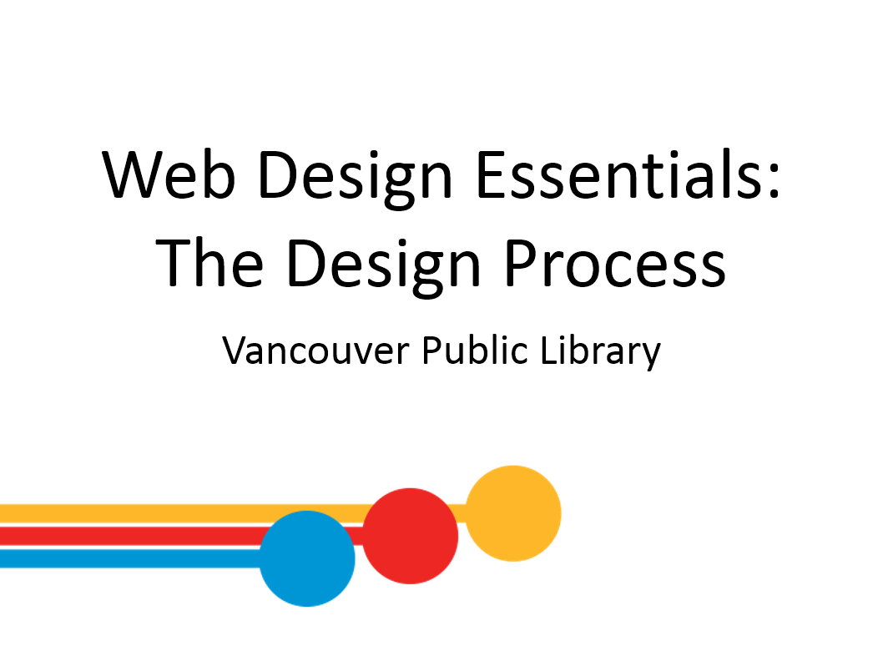 | 2 min | INTRODUCTION  Welcome students; introduce yourself and series  Remind learners of washroom locations; to turn off cell phones; etc.  Ensure everyone can hear you and see the front. | - Respond to instructor’s questions/prompts
 | 2 min | LEARNING OPPORUTNITIES AT VPL  - This is the 2nd class in a 3 part series on Web Design Essentials  - Don’t worry, you don’t have to take all the classes, and you don’t have to take them in order  - If you complete all 3, you will receive your certificate at the end of the last class in the series.  Encourage students to attend following class on Building a Website with WordPress. | - Listen to instructor  - Respond to prompts  - Ask questions
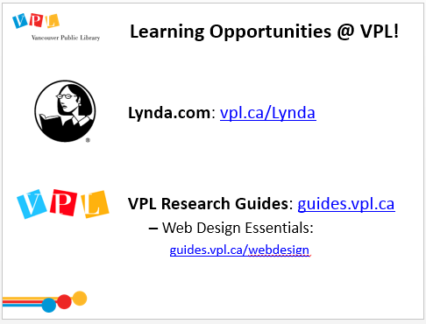 | 5 min | LEARNING OPPORTUNTITIES AT VPL  - There are several ways you can learn more about this topic. One way is through online learning at your own pace.  Lynda.com  - vpl.ca/lynda  - videos; various tech topics; basic to advanced  Navigate to Lynda.com via the VPL website. Show them how to login and access Lynda. Explain that we will review where to find the relevant Web Design class on Lynda at the end of class.  VPL Research Guides  - guides.vpl.ca  - Wide variety of topics; collected books & online resources  Show them how to find the Research Guides from the VPL website and how to navigate to the Web Design Essentials Guide. | - Listen to instructor  - Respond to prompts  - Ask questions
 | 1 min | LEARNING OPPORTUNTITIES AT VPL  - You can also get additional help from library staff.  - Drop in to any branch  - Tech Café at Central  - Call or email the library  Encourage students to reach out the library at a later date if they want some additional support with the subject matter. Explain that we aren’t web design experts, but we can help them find the resources they need. | - Listen to instructor  - Respond to prompts  - Ask questions
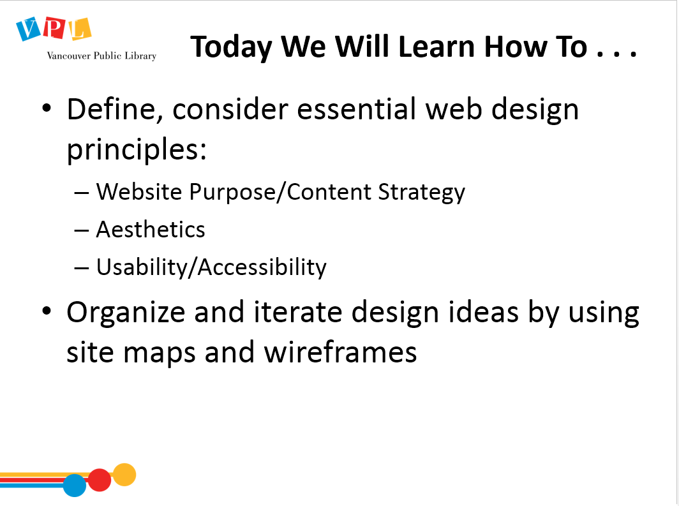 | 5 min | LEARNING OBJECTIVES  Review slide and read learning outcomes listed on slide  Ask:  - Any comments or questions about what we will be covering today?  - Is anyone registered in the next WordPress class? If so, this class will help plan your content and design for your WordPress site.  Lead a round where people introduce themselves and answer this question:  - Please share your name and what brings you here today. What are you hoping to learn from this class?  Ask:  - Has anyone designed a website before?  - Does anyone have a particular website in mind that they are currently designing? If so, what is the website for?  Share info about the class structure.  - First half of the class will be a presentation and discussion about the basics of the design for websites.  - Second half will be handsoff, and you’ll get to practice planning out a website | - Respond to instructor’s questions/prompts
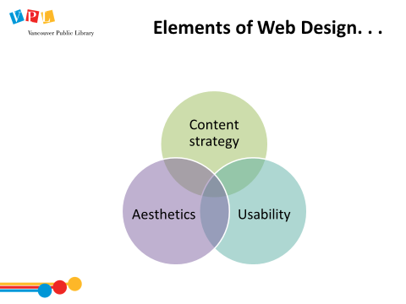 | 1 min | ELEMENTS OF WEB DESIGN  Review slide  - Three main elements of web design: content strategy, aesthetics and usability.  - Let’s look at each of these areas in more detail. | - Listen | - Integrate considerations of content strategy, accessibility, aesthetics and user experience into the design process.
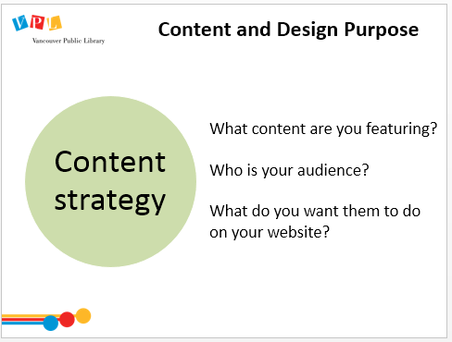 | 3 min | CONTENT AND DESIGN PURPOSE  [Note: this slide has animation. Click as you go to bring up listed questions]  - Before starting any design project there are some critical questions to ask about the purpose of the site.  - What content are you featuring?  - Who is your audience? Who is your website for?  - What do you want those who visit your website to do when they are there?  - Websites exist to promote a type of content – be it words, stories, photos, and so on. Let’s explore these key content questions by looking at VPL’s website.  Open www.vpl.ca  Review content, audience, purpose of VPL website  Ask:  - Who is the audience for the VPL website?  - Answer: General public, library patrons  - What content is most heavily featured?  - Answer: Main image carousel, logo, search box  - What is the purpose of the website? What do we want people to be able to do here?  - Answer: Explore collections, learn about events, manage account  - What is the user’s overall experience like?  - Answer: Very subjective! Hopefully it’s a simple and inspiring experience | - Listen to instructor  - Answer questions  - Ask questions | - Integrate considerations of content strategy, accessibility, aesthetics and user experience into the design process.
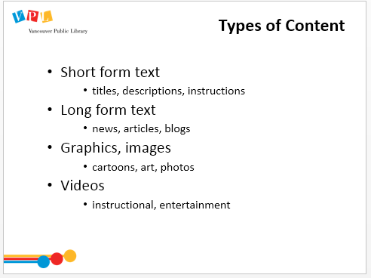 | 5 min | TYPES OF CONTENT  [Note: this slide has animation. Click as you go to bring up responses]  Ask for examples from each before showing the answers from the slide.  - Websites typically contain four major content types  - Short form text  - titles, headings, descriptions, instructions  - Long form text  - News, articles, blogs  - Graphics and images  - Cartoons, art, photos  - Videos  - Instructions, entertainment  Return to www.vpl.ca  Ask participants to identify different kinds of content.  - How do you know you’re looking at a Heading?  - [Larger text, different font, more white space, different colour background, might be in a table (like Contact US and Events Calendar)]  - What kind of information are we sharing with images versus text?  - [Images are related to text content, adjacent; text provides more detail; images may offer additional information: eg “Kids” button has a picture of a family, indicating that many events are targeting the whole family, not just children]  - How have we chosen to present our images?  - [Large image carousel & smaller thumbnails] | - Listen to instructor  - Ask questions based on prompts | - Integrate considerations of content strategy, accessibility, aesthetics and user experience into the design process.
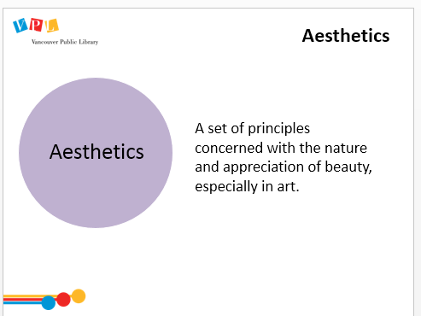 | 8 min | AESTHETICS – OVERVIEW  [Note: this slide has animation]  Ask:  - “How would you define Aesthetics?”  Write responses on whiteboard.  Click to animate/bring up definition on slide. Read definition:  - “a set of principles concerned with the nature and appreciation of beauty, especially in art.”  - Creating a website has lots of functional components, but you’re also creating something that has a look and feel, and will elicit feelings in your users.  Ask:  - What are some websites that you really like?  - What is it about them that you like?  Navigate to these website suggestions as they suggest them. | - Respond to instructor’s questions/prompts  - Help create list on board | - Integrate considerations of content strategy, accessibility, aesthetics and user experience into the design process.
 | 3 min | AESTHETICS – BAD  Ask:  - What are some websites you can think of that are unpleasant to look at?  - What makes them unpleasant?  Click on link in slide to navigate to site (www.007museum.com)  [Note: This site also has sound]  Ask:  - What are your first impressions of this website?  Write answers on white board. Fill in answers with below examples.  Examples of issues with this website:  - incoherent text and images  - small font (hard to read)  - too much white space  - poor formatting  - hard to navigate  - inconsistent picture sizes  - too much busy content, etc. | - Respond to instructor’s questions/prompts  - Help create list on board | - Integrate considerations of content strategy, accessibility, aesthetics and user experience into the design process.
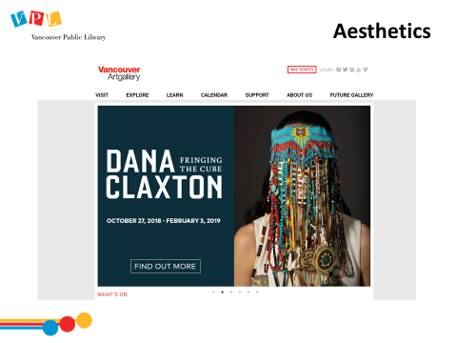 | 3 min | AESTHETICS – GOOD  Click on link in slide to navigate to site (www.vanartgallery.bc.ca)  Ask:  - What are your first impressions of this website?  - What do you think works well for this website relative to the last website we looked at?  Write answers on white board. Fill in answers with below examples  Possible answer:  - generous use of white space  - limited text  - clear navigation  - large font  - use of images  - Step to considering your design decisions:  - Consider your demographic/target audience: what do they need? What do they like?  - Can your audience do what you intend them to do and how does the design help that? | - Respond to instructor’s questions/prompts  - Help create list on board | - Integrate considerations of content strategy, accessibility, aesthetics and user experience into the design process.
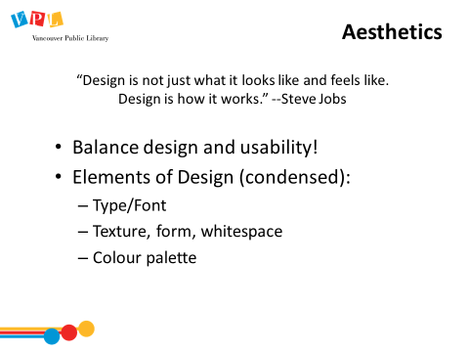 | 2 min | AESTHETICS  Read the quote:  - “Design is not just what it looks like and feels like. Design is how it works.” Steve Jobs  Review slide content  - Balance design and usability: can you think of an example of a website that’s very beautiful, but hard to use, or very functional, but unpleasant to look at?  - We will go into more detail about the 3 Elements of Design:  - Type/Font  - Texture, form, whitespace  - Colour palette | - Listen to instructor  - Respond to instructor’s prompts  - Ask questions | - Integrate considerations of content strategy, accessibility, aesthetics and user experience into the design process.
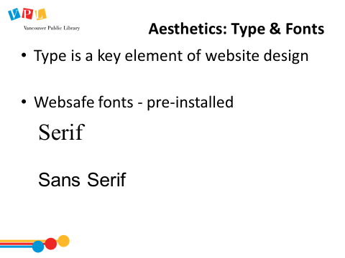 | 3 min | AESTHETICS: TYPE & FONTS  - Type otherwise known as “font” is a key design element on the web. They can be used to create visual effects as well as being functional.  Explain Websafe fonts  - It is important to know if the font you are using is “websafe.” Every device has its own list of fonts to display. If your font is too “unique” it might not display well everywhere. “Websafe” fonts work on most devices and browsers.  Explain Font Familes  - Serif and Sans–serif are the two main font types.  - Serif is typically used for print media because the “ticks” on the end of the letters create an effect of an underline visually.  - Sans-serif (“sans” meaning without) are used more often on websites and “chunked” content (like lists).  - If you are interested in learning learn you can go to Lynda to find a course by Sue Jenkins, Design Aesthetics for the Web. I’ll show you a short clip, but the whole course is very helpful (it’s on your handout!) | - Listen to instructor  - Ask questions | - Integrate considerations of content strategy, accessibility, aesthetics and user experience into the design process.
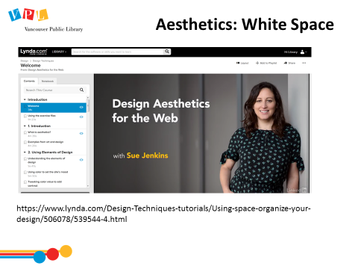 | 2 min | AESTHETICS AND USE OF SPACE  Show video from beginning to 1: 55 end of footer description.  - This Lynda.com video explains some key aspects of the use of white space for websites.  - This presenter offers much more detail on all design elements if you watch the full video. | - Watch video  - Ask questions | - Integrate considerations of content strategy, accessibility, aesthetics and user experience into the design process.
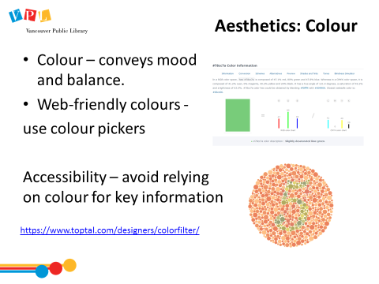 | 5min | AESTHETICS: COLOUR  - Colour is the final element we will look at more carefully.  - Colour is important in conveying mood, style, and balance  - When choosing colour you want to consider complimentary colours  - There are some colours that are more “webfriendly” than others meaning that they display well on most browsers  - Accessibility there are some issues with certain colours and you can find colourblind checkers online.  - There are a number of “colour” tools out there online to use  - Create a colour palette from a specific image to evoke its mood (Canva Colour Palette)  - Browse palettes (Hue Snap)  - Select a colour and get suggestions based of complementary shades (Colourco.de) | - Listen to instructor  - Ask questions | - Integrate considerations of content strategy, accessibility, aesthetics and user experience into the design process.
 | 5 – 7 mins | AESTHETICS EXERCISE  Review slide  Write feedback from learners on whiteboard | - Respond to instructor’s questions/prompts  - Offer suggestions to whiteboard list | - Integrate considerations of content strategy, accessibility, aesthetics and user experience into the design process.
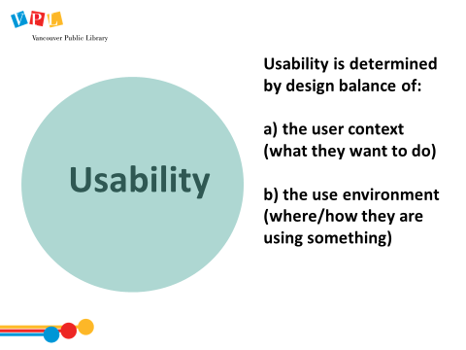 | 2 min | USABILITY  Ask: what does it mean to you when I say a website is very “usable”?  - Generally, “usability”:  - Is when we balance the effect of a website’s design with the user’s needs, abilities, interests, environment so they can easily execute the tasks they need and use the website with ease.  - Looks at  - The user context – what they want to do  - The use environment – where and how they are using the website | - Listen to instructor | - Integrate considerations of content strategy, accessibility, aesthetics and user experience into the design process.
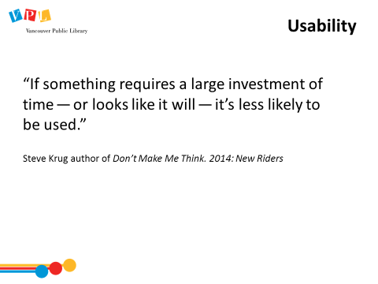 | 3 min | USABILITY  Read quote on slide.  Ask:  - Can you think of anything like this that you have encountered on the internet?  - Have you ever turned away from a product or company because the website was so hard to use? Can you remember why?  - Do you have to use a website that you find very difficult to navigate? | - Listen; respond; give answers/questions/examples as needed | See previous
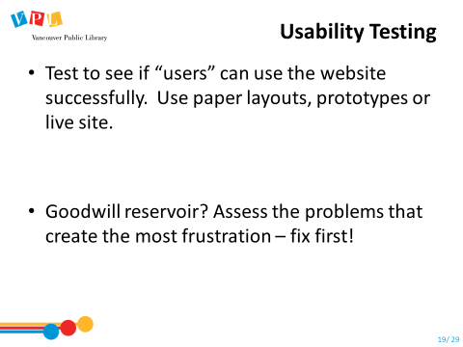 | 3 min | USABILITY TESTING  - Usability, is sometimes called User Experience or UX for short.  - It is defined by how easy something is to use: important to web design because there are many websites out there: people will leave your site if they can’t figure out how to find the information they are looking for quickly. The following video explores concept of testing your site for usability.  - There is a “goodwill reservoir” that most users have, there are usually some critical actions on a website that will affect how much goodwill they have. | - Listen to instructor | - Integrate considerations of accessibility, aesthetics and user experience into the design process.  - Apply problem solving techniques and collaborative processes (eg: test and debug the project, iterate, obtain feedback from audiences and peers to evolve thinking).
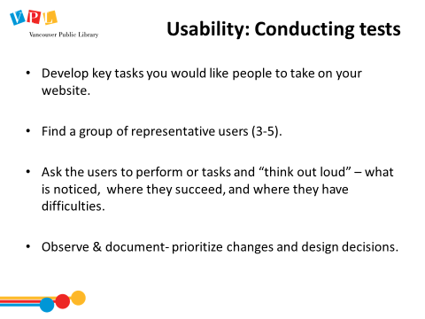 | 3 min | USABILITY – CONDUCTING TESTS  Recap steps to User Testing  - Explain that this is often done with paper prototypes, or simple slide shows – you don’t have to do a lot of detailed design work before you test out your site’s architecture – in fact you can save time if you prototype first – that’s what we’re going to practice in just a few minutes!  - Ask if anyone has questions or comments | - Listen; ask questions | - See previous  - Design the final product or purpose of a digital project, sequence the steps to completion, and draft mockups, wireframes, plans, or sketches of digital content.
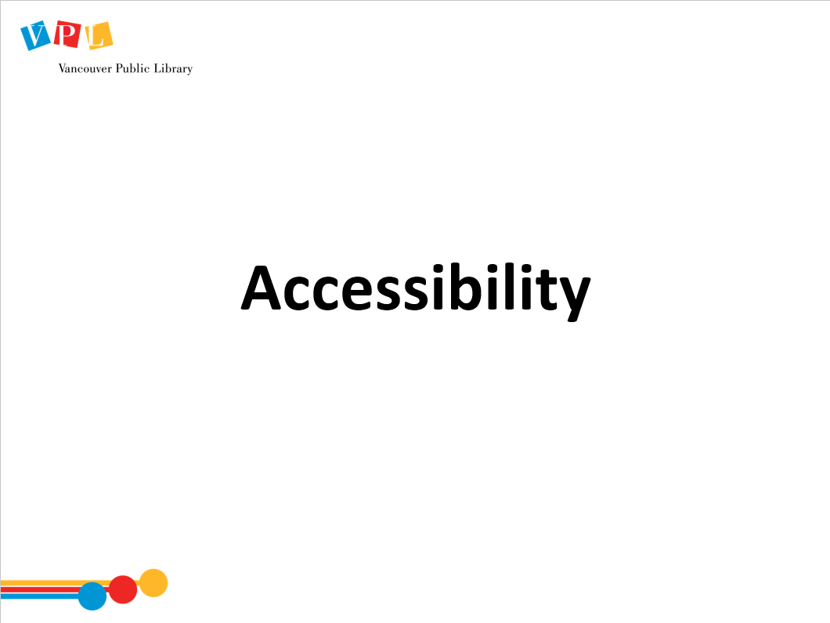 |  | Ask the group:  - What does “accessibility” mean to you, in a general sense?  - What are some considerations that might make a website “accessible”? | - Answer questions | - Integrate considerations of accessibility, aesthetics and user experience into the design process.
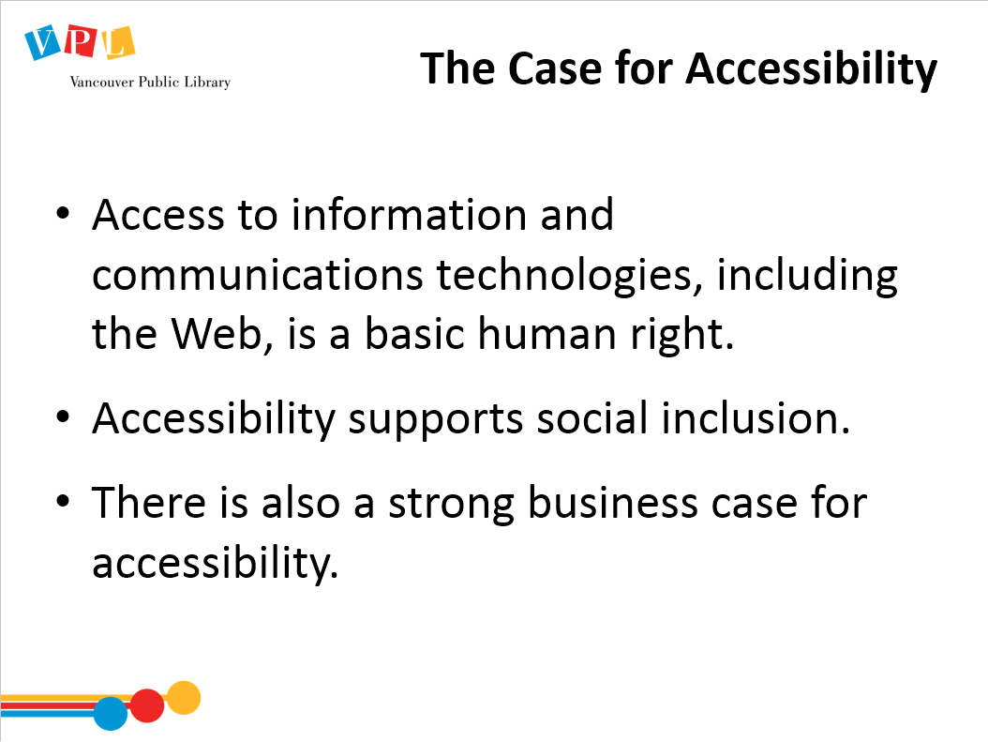 |  | Review slide  - “Accessibility”, in this context, is largely about ensuring people with disabilities, “including blindness and low vision, deafness and hearing loss, learning disabilities, cognitive limitations, limited movement, speech disabilities, photosensitivity and combinations of these” have access to the online you’re presenting (from Canadian Government’s Standard on Web Accessibility) | - Listen to instructor  - Ask questions | - Integrate considerations of accessibility, aesthetics and user experience into the design process.
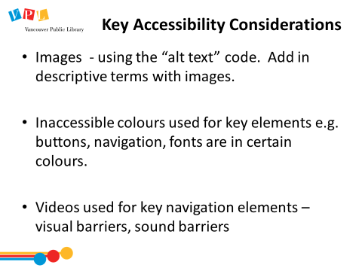 | 3 min | ACCESSIBILITY CONSIDERATIONS  Review slide and examples of Accessibility in Web Design  Alternative Text for Images  - Consider users with visual restrictions or print impairment; they may use a program that ‘reads’ the webpages out load, and alt text will allow this program to “read” images  - If the technology is unable to display the image (slow loading time, settings changes to NOT load images to lower bandwidth charges, people in a rural area with low bandwidth who turned off images to speed download, and others), users will still get the basic idea  - Alt text is available to technologies that cannot see the image, such as search engines.  Show a hover over and a source code on the VPL website  Don’t Rely on Colour  - Colourblindness  - Different monitors (eg don’t use closely related colours on top of each other)  - Designs shouldn't rely on color to communicate critical info: Eg: progress indicators: Don't just have a button or bar change color when the process is complete. Have other indicators of progress (%, #s, text).  - More information about accessibility guidelines for the web can be found at the W3C webpage listed on your handout. | - Listen to instructor  - Ask questions  - Refer to handout  Become aware of Lynda.com course | - Integrate considerations of accessibility, aesthetics and user experience into the design process.
 | 1min | RESPONSIVENESS  - Responsive design helps webpages look good on different sized devices from desktop computers to small mobile phones.  - It is the current standard for websites to respond to these different sizes in a dynamic way.  - It is assumed that all themes you select from website builders such as WordPress, Wix or Weebly, will be responsive. | - Listen to intructor
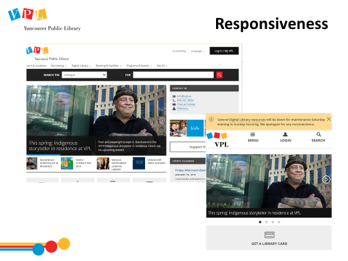 | 5 min | RESPONSIVENESS – VPL.CA  Navigate to www.007museum.com. Show the lack of responsiveness of this site by dragging the sides of the window smaller and larger.  Navigate to vpl.ca  Show responsiveness of the site by dragging the sides of the window smaller and larger.  - Notice that the menu changes and choices are made as to what is prioritized at the top of a smaller screen.  - Notice how much the images resize vs the text  Ask:  - What is at the top of the list (should be “get a library card” and “inspiration lab”)  - Why do you think these items are at the top? | - Discuss  - Explore, compare, resize.
 | 3 min | CREATE A SITE MAP  Explain what a site map is  - A sitemap is like a website blueprint  - It maps out the major sections of the website.  - Draw diagrams showing the hierarchy of the website and how the various sections relate to each other.  - You can use this method to decide on the basic hierarchy of your site, to make notes on aesthetics, accessibility, responsiveness before designing each page in detail  - You can also use this method to test out the basic navigation of your site with users – where would they go from your home page to perform a given task?  Present the exercise to students. That we will work on creating paper mockups for different site examples. | - Listen to instructor  - Ask questions | - Arrange and edit the project to provide the audience with cues for navigating and understanding it.
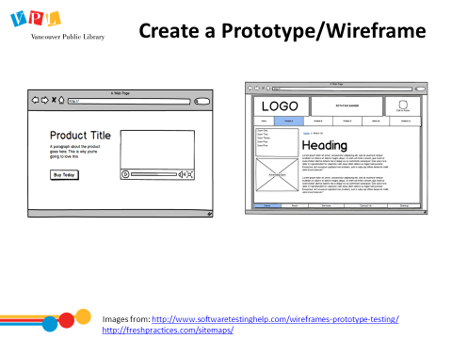 | 3 min | CREATE A PROTOTYPE/WIREFRAME  Explain what a wireframe is  - “A wireframe is a layout of a web page that demonstrates what interface elements will exist on key pages.” – Experience UX  - Here’s where you can get more detailed about design elements: aesthetics, accessibility, responsiveness.  - There are lots of online tools that can help you make great wireframes (see handout) | - Listen to instructor  - Ask questions | - Arrange and edit the project to provide the audience with cues for navigating and understanding it.
 | 5 min | BRINGING IT ALL TOGETHER IN YOUR DESIGN  - We’ve discussed:  - Content Strategy  - Aesthetics  - Usability + user testing  - As you may know – and as you’ll learn next week if you are here for WordPress – most online website providers will give you templates and individual design elements to choose from.  - But if you do the prework to figure out what you want your site to look, feel, and behave like, you’ll be much less overwhelmed by the choices because you’ll have a clear vision.  - Let’s talk about the handout in front of you, which you’ll be using in a group to try the design process. | - Refer to handout  - Listen to instructor  - Ask questions | - Design the final product or purpose of a digital project, sequence the steps to completion, and draft mockups, wireframes, plans, or sketches of digital content.  - Integrate considerations of accessibility, aesthetics and user experience into the design process.  - Assess the viability of the design through prototyping, using mockups, wireframes or pencil sketches/maps of digital content to be built.
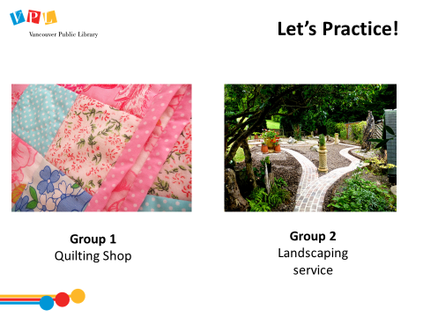 | 30 - 40 min  (end at least 15 min before end of class) | PRACTICING: WORKING ON DESIGN IDEAS IN GROUPS  Describe activity:  - We’re going to split into two groups, and practice considering the design elements of Aesthetics, Accessibility, Responsiveness, and Usability.  Hand out a couple copies of exercise sheets and post-its to each group.  - Group One: Quilting Shop  - Group Two: Landscaping  - Alternatively, if anyone in the group has an idea you’re currently passionate about, you can use that as a group!  - Work in your groups to fill out the Planning & Prototyping worksheet, and then grab some sticky notes and start visualizing your website!  - Don’t know where to start? Visit similar websites to get inspiration. | - Fill out the notes sections for each question on the handout  - Use computers to Google websites to find inspiration  - Use sticky notes and paper/pencil to begin prototyping  - Discuss applications of design considerations to the scenario at hand | See previous +  - Arrange and edit the project to provide the audience with cues for navigating and understanding it.
 | 10 min | SHARING DESIGN IDEAS  Bring class back together.  Ask each group to briefly share some of the decisions they made:  - who are their users?  - What will the website look and feel like?  - What were the decisions that were easy to make?  - What was difficult or controversial in your group? | - Refer to handout | See previous
 | 3 min | REVIEW: THE DESIGN PROCESS  Review the steps on the slide  Remind learners that it is on their handout. | - Listen to instructor  - Ask questions
 | 2 min | DID WE LEARN HOW TO?  Ask:  - Did we meet all of our goals today?  - Was there anything we didn’t cover?  - Do you have any other questions and/or comments  Refer learners to resources on the handout  Review how to search for more classes | - Reflect  - Ask questions
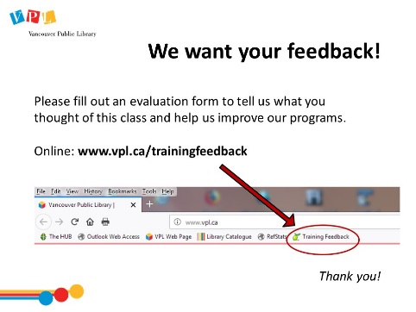 | 5 min | EVALUATION FORMS  Ask them to take some time to fill out the evaluation form. If possible, have them fill out the form online. If not, provide them with the paper forms:  - We would like your feedback! Please take some time to fill out an evaluation form to let us know what you enjoyed and what could be improved.  - There is a bookmark link to the form on all computers.  - You can also access the link by going to http://www.vpl.ca/trainingfeedback | - Listen to instructor  - Ask questions  Fill out evaluation form
 | 5 min | Time for practice, questions, etc

Closing
- Thank learners for coming

