Web Design Essentials: Basic Coding

Description

This hands-on, introductory class introduces learners to the three most important programming languages for building websites. Learn how to write basic HTML, how the look of your web page is altered using CSS and get a brief overview of JavaScript. Prior knowledge of these coding languages is not required. Basic ability to use a computer and mouse is required. Register here for other classes in the Web Design Essentials series. Each class must be registered for separately.

Learning Goals>OUTCOMES
Digital Proficiency > Operate > Understand the Web
Learners will be able to . . .
- Identify the ways that code underlies how websites are built and changed (2017: recognizes basic HTML tags and their effects, etc).

Digital Fluency > Manage > Present Digital Information & Data
Learners will be able to . . .
- Understand and apply appropriate code to manipulate and display information & data (2017: open data sets; application design, tbd)

Digital Fluency > Create > Apply Design Principles & Processes
Learners will be able to . . .
- Capture, generate or assemble content using available creative tools.
- Recognize and select appropriate file formats for saving ongoing projects and for exporting final work.

Preparation

Equipment Needed: | - Computers for learners  - Projector/laptop  - Internet access  - Sound
Materials Needed: | - Web Design Essentials: Basic Coding PowerPoint  - Handouts for learners (3 Handouts – HTML, CSS, General)  - Refer to Digital Literacy Classes HUB page for class preparation resources: https://hub.vpl.ca/content/86022, particularly the Preparation, Setup & Closing Checklist
Setup Procedures: | - Review the “Adult Teaching & Learning at VPL” teaching philosophy: https://hub.vpl.ca/content/64490  - Review the lesson materials  - Confirm that all necessary space and equipment has been booked
Background Reading (books, websites, articles for staff to get familiar with the lesson topics) | - https://www.w3schools.com/html/default.asp  - https://www.w3schools.com/css/default.asp  - https://www.w3schools.com/js/default.asp  - https://www.lynda.com/HTML-tutorials/HTML-Essential-Training/170427-2.html?org=vpl.ca  - https://www.lynda.com/CSS-tutorials/CSS-Fundamentals/417645-2.html?org=vpl.ca  - https://www.lynda.com/JavaScript-tutorials/JavaScript-Web-Designers-2016-Q3-REVISION/461841-2.html?org=vpl.ca
# of Staff Required | - 1-5 learners: 1 instructor  - 6-12 learners: 2 instructors  - For branch meeting room capacities, please see: http://hub.vpl.ca/content/64490

Opening
Before doors open:

- Write your name and programs@vpl.ca on the whiteboard (include phone number 604-331-3603 for more basic digital literacy classes)
- Distribute handouts, evaluation forms (if applicable)
- Test internet & speakers
- Turn the computers for learners on before the class starts
- Log in to Lynda.com and load the videos in lesson plan/slides: 21383026295464 Password / 2013
- Open the https://www.w3schools.com link on the learners’ computers ahead of time (you can get them to Google instead)

Lesson

LEARNING ACTIVITIES |  |  |  | LEARNING OUTCOMES
Slideshow and/or Demo | Time | Trainer Does | Learners Do
 | 1 min | INTRODUCTION  Welcome students; introduce yourself; introduce the class and series  Remind learners of washroom locations; turn off cell phones; etc.  Ask if everyone can hear you. | - Listen to instructor
 | 2 min | LEARNING OPPORUTNITIES AT VPL  - Before we get started on the content I want to let you know that this one of many learning opportunities at the library.  - Today’s class is meant to be an introduction to the topic – there are lots more ways to delve deeper.  - You can work toward a certificate for each series. If you attend all classes in a series, you will receive your certificate at the end of the last class in the series.  - Encourage students to attend following class on Web Design concepts | - Listen to instructor  - Respond to prompts  - Ask questions
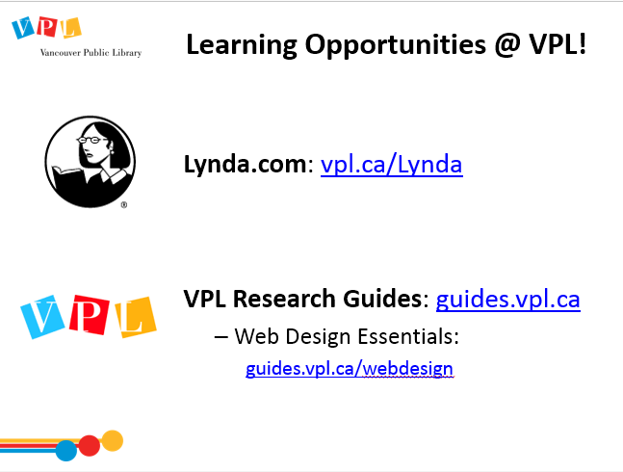 | 5 min | LEARNING OPPORTUNTITIES AT VPL  - There are several ways you can learn more about this topic. One way is through online learning at your own pace.  Lynda.com  - vpl.ca/lynda  - videos; various tech topics; basic to advanced  Navigate to Lynda.com via the VPL website. Show them how to login and access Lynda. Explain that we will review where to find the relevant Web Design class on Lynda at the end of class.  VPL Research Guides  - guides.vpl.ca  - Wide variety of topics; collected books & online resources  Show them how to find the Research Guides from the VPL website and how to navigate to the Web Design Essentials Guide. | - Listen to instructor  - Respond to prompts  - Ask questions
 | 1 min | LEARNING OPPORTUNITIES AT VPL  - This is one of many learning opportunities at the library.  - Today’s class is meant to be an introduction to the topic – there are lots more ways to delve deeper.  - There are many other ways to learn and get help on this and other topics at the library  - Drop in to any branch  - Tech Café at Central  - Call or email the library | - Listen to instructor  - Respond to prompts  - Ask questions
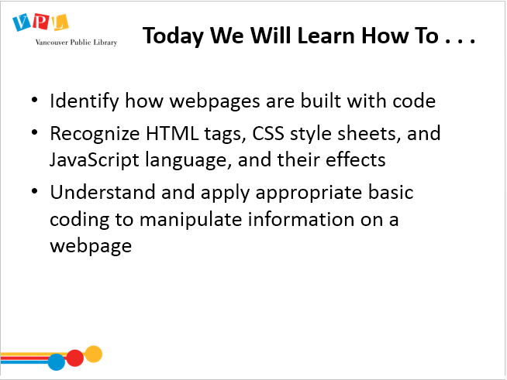 | 7 min | LEARNING OBJECTIVES  Review slide and read learning outcomes listed on slide  - Today we are going to learn how to  - Identify how webpages are built with code  - Recognize HTML, CSS style sheets, & Javascript language  - Understand and apply appropriate code to create or manipulate webpage content  Ask:  - Any comments or questions about what we will be covering today?  - Today we will not be hand coding an entire website -- we will be learning how to do basic coding so that we can understand how coding works, what it looks like, and what it does. This will help you understand how websites are built and help troubleshoot potentials problems when working on a website through a platform such as WordPress. | - Listen to instructor  - Respond to instructor’s questions  - Participate in round  - Ask questions
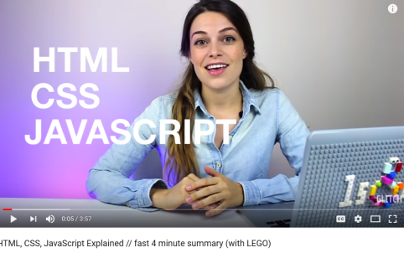  https://www.youtube.com/watch?v=gT0Lh1eYk78 (play to 1:55 if beginners; if some are advanced play to 3:36) | 2 -5 min | VIDEO: HTML, CSS, JAVASCRIPT  Introduce video: 3 Core Languages: HTML, CSS, JS  Watch video. (Note different play lengths for different estimated class skill levels)  Review video content  - HTML provides the essential structure for web pages (most important of these 3 languages)  - CSS controls how a page looks (needs HTML to work)  - JavaScript controls interactive elements, buttons, search boxes, and other interactivity (needs HTML to work). This is a programming language that functions via a web browser (such as Firefox). | - Watch video  - Ask questions | - Identify the ways that code underlies how the web is built and changed (2017: recognizes basic HTML tags and their effects, etc).  - Understand and apply appropriate code to manipulate and display information & data (2017: open data sets; application design, tbd)
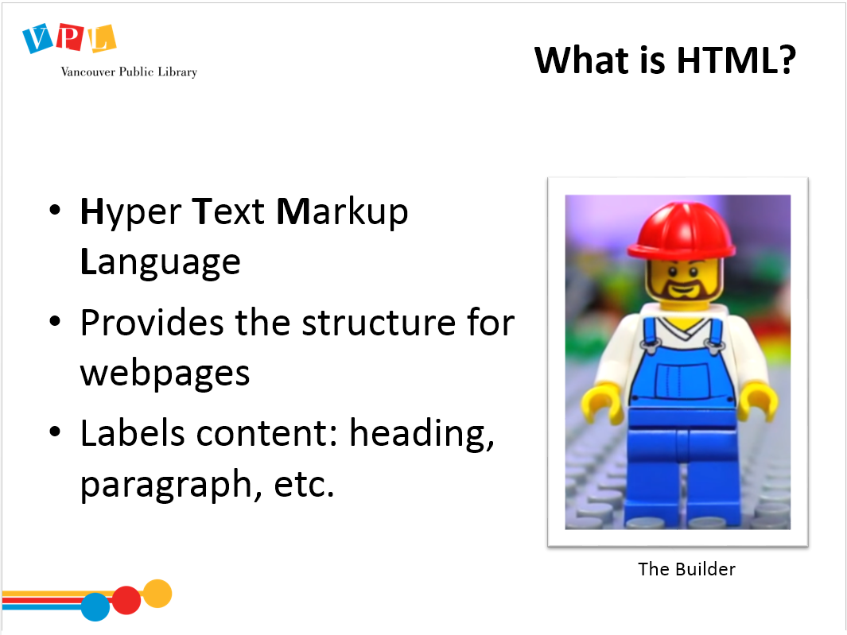 |  | HTML  - HTML stands for Hyper Text Mark Up Language  - The coding literally “marks up” text to give it particular effects, such as bold, italicize, hyperlinks and other formatting  - This is the what provides the structure to a web page  - It “marks up” up content | - Review HTML Cheatsheet  - Ask questions | - See previous
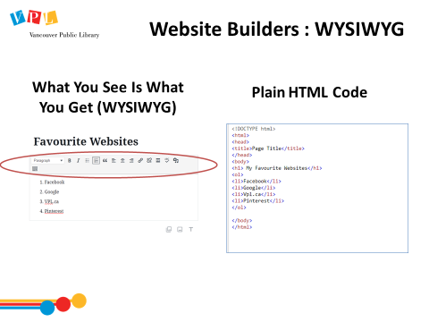 |  | WEBSITE BUILDERS  - Most people don’t code website from scratch: they use website builders such as Weebly, Wix, Squarespace, or WordPress (in two weeks we will be going into more depth about how to set up a basic website in WordPress). These tools will do all the coding for you.  - These website builders use “What You See Is What You Get” (WYSIWYG [pronounced WIH-ZEE-WIG]) editors. You use a visual interface to design your webpage, and these editors create the code in the background. The WYSIWYG provides formatting buttons (much like a word processor program)  - format text  - create lists (with numbers or bullets)  - Insert images  - Add hyperlinks  - Other options that they make available.  - Sometimes you will get an effect you don’t want and in these cases it is important to learn coding so you can edit the code manually. | - Listen to instructors  - Respond to prompts  - Ask questions | - Understand and apply knowledge about code and how it manipulates and displays information & data (2017: open data sets; application design, tbd)
 |  | HTML VIDEO  [Note: Be sure to open and load Lynda.com prior to presentation.]  Watch video: “The Importance of HTML” (from Lynda.com)  Ask if there are questions/comments about the video. | - Watch video  - Ask questions | - Identify the ways that code underlies how the web is built and changed (2017: recognizes basic HTML tags and their effects, etc).  - Understand and apply appropriate code to manipulate and display information & data (2017: open data sets; application design, tbd)
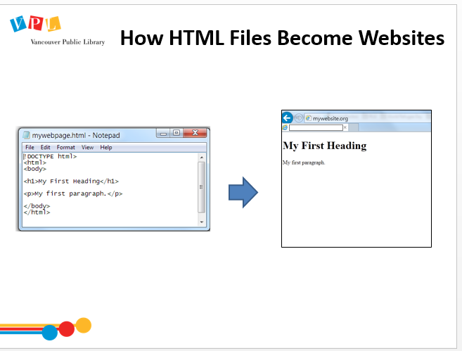 |  | HOW DO HTML FILES BECOME WEBSITES?  - HTML documents are saved as files, often with .html as their document ending (instead of .txt or .doc)  - These files are uploaded to a server that then is associated with your website address. This is what makes it “live”.  - For ease, most people use a web hosting company such as GoDaddy. The web hosting company stores your website files (i.e. html files) which form the basis of your website.  - If you’re interested in how Websites work, I encourage you to attend our WordPress class in this series, which goes into further detail. | - Listen to the instructor | - Identify the ways that code underlies how the web is built and changed (2017: recognizes basic HTML tags and their effects, etc).  - Understand and apply appropriate code to manipulate and display information & data (2017: open data sets; application design, tbd)
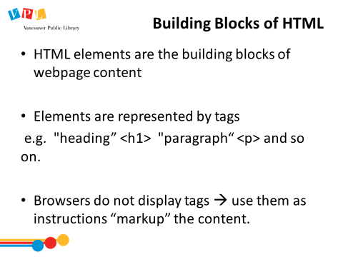 |  | BUILDING BLOCKS OF HTML  - HTML elements are the building blocks of webpages  - HTML elements are represented by tags  - HTML tags label pieces of content such as "heading", "paragraph", "table", and so on  - Browsers do not display the HTML tags, but use them to render the content of the page | - Listen to the instructor | - Identify the ways that code underlies how the web is built and changed (2017: recognizes basic HTML tags and their effects, etc).  - Understand and apply appropriate code to manipulate and display information & data (2017: open data sets; application design, tbd)
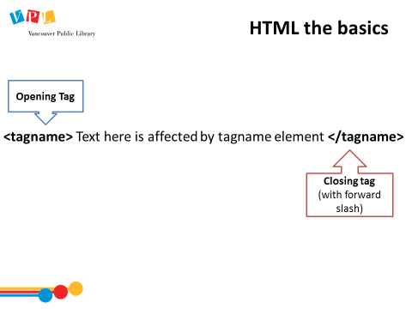 |  | HTML BASICS  - We will be doing some HTML coding today  - All html is structured via a basic tagging system which is what “marks up” the text.  Explain how opening and closing tags interact  - Tags are normally in pairs  - The first tag in the pair is the opening tag  - The opening tag is structured with a left angle bracket, followed by the tag name represent the element that we want the text to be affected by, followed by a right angle bracket.  - The second tag is the closing tag, which is the same as the opening tag with one important different. There is a forward slash inserted </> after the right angle bracket.  - This forward slash is the key way to know the difference between the tags.  - The text between the opening and closing tag will be given the effect dictated by the element/tag name, such as bold or italics.  - It is essential to always make sure you have the closing tag. Only having the opening tag without the closing tag, will create problems. The most common error this creates is that the formatting from the html tag/element is applied to the rest of the document.  Refer learners to HTML Handout. | - Listen to the instructor and ask questions. | - Identify the ways that code underlies how the web is built and changed (2017: recognizes basic HTML tags and their effects, etc).  - Understand and apply appropriate code to manipulate and display information & data (2017: open data sets; application design, tbd)
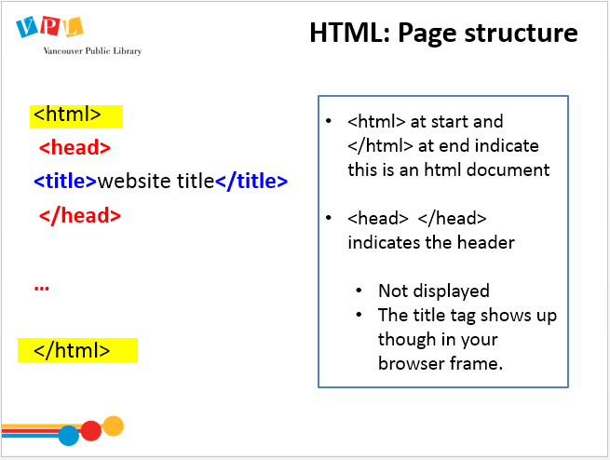 |  | FEATURES OF BASIC HTML  - Let’s first look at tags that are essential to all HTML pages that structure the page.  [Note – technically you need to start with <! DOCTYPE HTML> but since this is usually handled by the web builder only talk about it if someone asks.]  - A page script always starts with <html> in angle brackets to communicate that the page contains html. And at the very end of the document/page there is a closing </html> tag. Notice that you can tell this is a closing tag it contains the forward slash.  Explain HTML headers  - Every HTML script starts with a “head” that provides description and style elements of the document. Information within the “head” is not displayed.  - The <title> tag is required in all HTML documents and it defines the title of the document. It is not displayed on the page but it does:  - Put a title in the browser toolbar  - Display the page title in search-engine results | - Listen to the instructor | - Identify the ways that code underlies how the web is built and changed (2017: recognizes basic HTML tags and their effects, etc).  - Understand and apply appropriate code to manipulate and display information & data (2017: open data sets; application design, tbd)
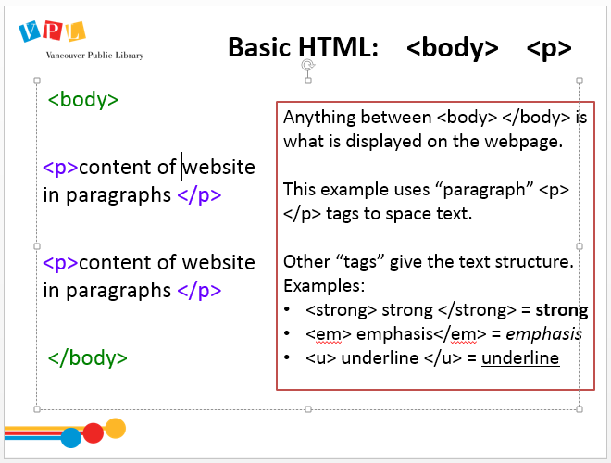 |  | BASIC HTML <body> <p>  Explain HTML body  - Next we’ll look at the “body” in an html document  - The text in the body is anything the opening and closing body tags i.e. <body> </body>  - The text within the body tags is actually displayed on the webpage, visible to website viewers.  Explain paragraph and text tags  - The paragraph <p> </p> tags are commonly used to space text into paragraphs. This adds in a blank line between texts of paragraphs – each paragraph needs to be tagged with its own paragraph tags – refer to your handout for more.  - Other “tags” give selected text structure e.g. <strong> (or <b>)for bold, <em> (or <i>) for italics, <u> for underline  - You use HTML to tell the browser which text is “strong”, but the CSS will dictate what “strong” looks like (we’ll get to CSS in a moment). | - Listen to the instructor  - Ask questions | - Identify the ways that code underlies how the web is built and changed (2017: recognizes basic HTML tags and their effects, etc).  - Understand and apply appropriate code to manipulate and display information & data (2017: open data sets; application design, tbd)
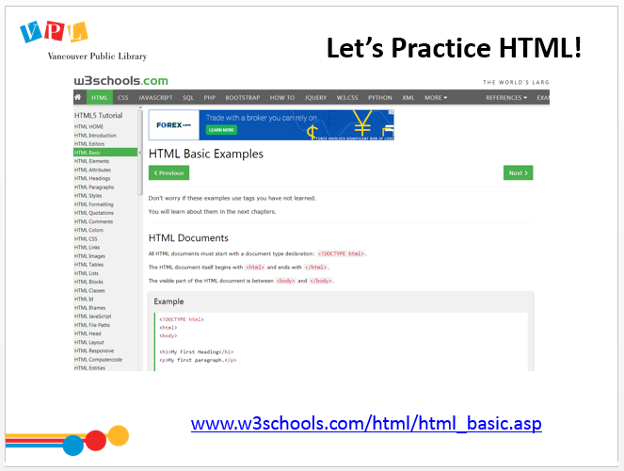 | 20 min | HTML PRACTICE  Guide learners to W3 site to begin to practice. Follow the link on the slide (or click the image).  Review information about the W3 site with learners  - This site allows you to practice changing or adding code and previewing the end result as it would appear on a website.  Review each tag in the 1st Example  - These are some of the essential tags that are required to create a basic webpage.  - The <!DOCTYPE html> declaration defines this document to be HTML5  Explain to students that HTML5 is the most recent version of HTML that helps load visual and dynamic elements much more easily than previous versions.  - The <html> element is the root element of an HTML page  - The <body> element contains the visible page content  - The <h1> element defines a large heading  - The <p> element defines a paragraph  Explain that you are going to demonstrate first, then they will have time to practice and tinker. Encourage them to listen and watch your screen.  Click “Try it Yourself” on first example, and compare code to display.  Return to the example page and scroll to the Headings section; click “Try it Yourself”. Type something between the <h1> tags; click “Run”.  Return to the example page and scroll to next Paragraph section: click “Try it Yourself”. Type something between the <p> tags; click “Run”.  Return to the example page and scroll to links: click “Try it Yourself”. Where they have a link delete it and enter http://www.vpl.ca in between the quotation marks. Click run (use http://realtor.ca if vpl.ca doesn’t work)  Return to the example page and scroll to Images: discuss the attributes source file (src); alternative text (alt); width, and height.  [Note: if you’re not sure how “img src” or image paths work, review this video as part of background research https://www.youtube.com/watch?v=yfS3rxxyEaw ]  Inform students that it is time for them to practice (“you do”)  Assist learners to open W3 webpage.  Let learners play around with HTML headings, paragraphs, links, images, using the cheat sheet for assistance  Assist learners as needed. | - Locate the site  - Watch/listen to instructor  - Practice editing HTML headings, paragraphs, links, images, using the cheat sheet for assistance  - Ask questions | See previous
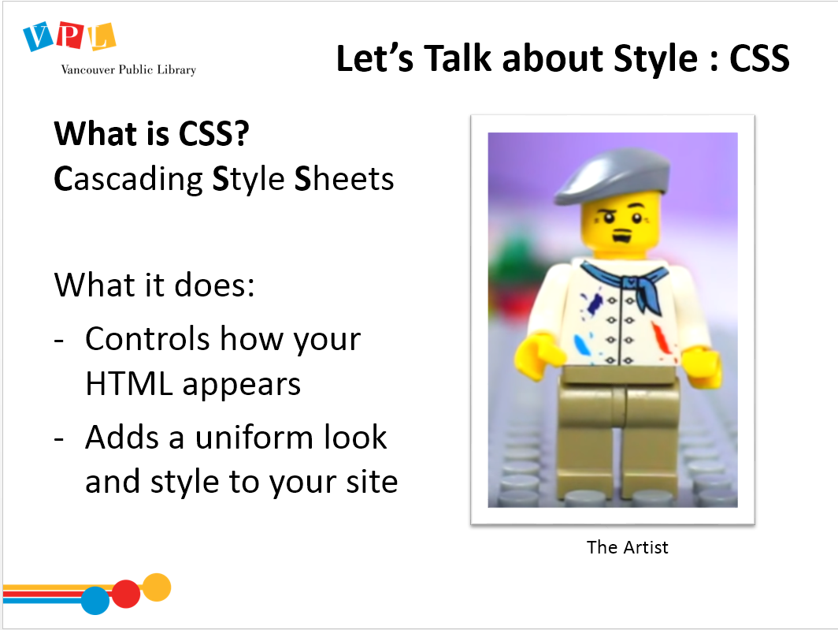 | 2 min | WHAT IS CSS?  Read slide/discuss  - CSS is a markup language  - CSS stands for Cascading Style Sheets  - CSS describes how HTML elements are to be displayed on screen, paper, or in other media  - CSS saves a lot of work. It can control the layout of multiple web pages all at once  - External stylesheets are stored in CSS files  - Point out differences from html structure (we may do some CSS coding if we have time)  Refer learners to CSS Cheatsheet | - Review CSS Cheatsheet  - Watch video  - Ask questions | See previous
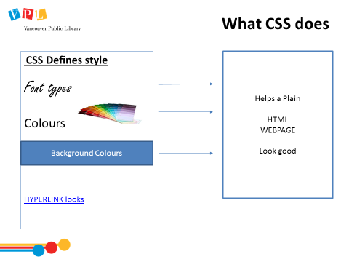 | 2 MIN | WHAT CSS DOES  Explain:  - CSS often sits on another page (outside the HTML files) and provides a centralized guide of how to put style or design to your HTML elements  - It is almost like a guide sheet of all the aesthetic choices you want on your site, plus the instruction of what HTML code will use what choice.  - The most similar analogy would be if you’re doing interior design for your house and before you change everything you decide – “all the walls will be grey, all the trim will be white, the floors will be wood, and the drapes will be floral” – then in every room of your house you carry this theme for consistency. | - Listen  - Ask questions | See previous
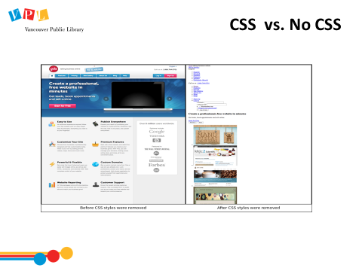 | 1 min | CSS VS. NO CSS  Show how different the various parts of the page look with (and without) CSS styles. | - Listen  - Ask questions | See previous
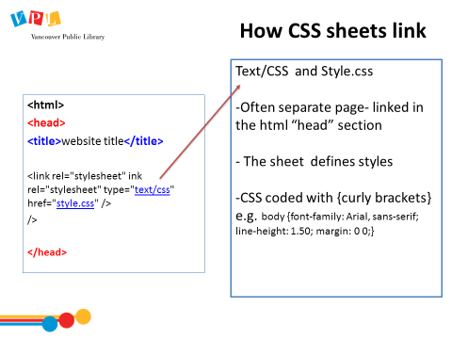 | 5 min | HOW CSS SHEETS LINK  - Let’s revisit the HTML head  - Remember how the head does not show any content on the page? It’s also used to refer to external style sheets and other descriptive elements of the HTML page  - The CSS sheets are linked here, but they sit external to the HTML in another sheet  - It is possible to define CSS within the HTML file, usually though this is more to edit something locally on that page and it doesn’t apply to the whole site. | - Listen  - Ask questions | - See previous
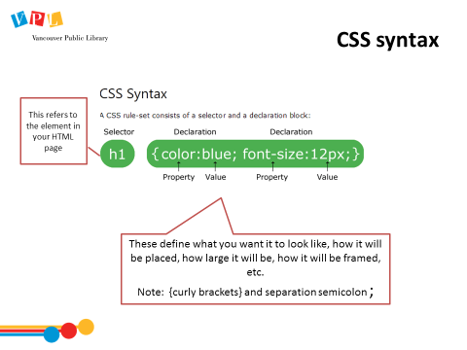 | 5 min | CSS SYNTAX  Navigate to www.w3schools.com/css/css_syntax.asp  Explain that the html selectors in the CSS e.g. H1 – points to and applies the style to those same tags in your html code.  - CSS selectors can find and alter pieces of your webpage across the board such as:  - Elements (i.e. all paragraphs)  - ID elements (i.e. all paragraphs that have an ID ‘name’ within the html to distinguish them from other paragraphs)  - Classes of elements (i.e. all paragraphs that are ‘classed’ with centered alignment)  - Selectors have a start tag, content, and an end tag, but do not “nest” in the same way that HTML tags do.  - It stands on its own at the beginning of the coding and applies to any coding that follows (in this case, every HTML <p></p> tag. Making changes to your style much easier! | - Listen to instructor  - Refer to CSS Cheatsheet  - Navigate to W3 Schools pages as directed  - Ask questions | - See previous
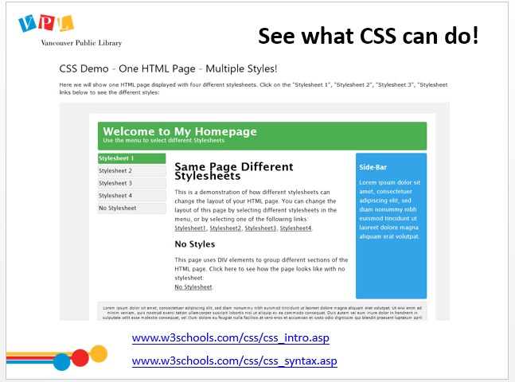 | 10 min | CSS DEMO AND PRACTICE: See What CSS Can do!  Go to www.w3schools.com/css/css_intro.asp and refer learners to the same link.  Click on the different “stylesheet” examples to show the different styles you can apply to the same text and html.  Go to The CSS Syntax page on the W3 CSS page.  www.w3schools.com/css/css_syntax.asp  Navigate to (scroll down to) the Element Selector  Click button that says “Try it yourself”  Type in “blue” instead of “red” and click “Run”  Ask learners to practice changing colours and then alignment – (right, center, left) and testing out how it changes the style (by clicking “Run”).  Show them headers by adding in h1 {color: blue; text-align: right} in the head. Go to the HTML body and add an in some text surrounded by <h1> tags. Click “Run”.  Ask them to try this on their own. | - Listen to instructor  - Follow along
 | 6 min | WHAT IS JAVASCRIPT?  - JavaScript is computer programming language and can take much longer to learn, so we’re going to watch video which gives us an overview.  - There are many tutorials online & in Lynda that can teach you this language in depth  Watch video: “What is Javascript?” (Click link on slide to go to video) | - Watch video  - Ask questions | - See previous
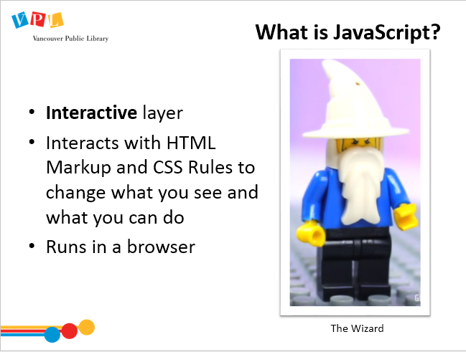 | 3 min | WHAT IS JAVASCRIPT?  Review key concepts from video  - JavaScript is the third language, and although it’s not “necessary” to create a very basic website, it’s very common. It adds interactive elements, and can affect how the HTML and CSS display and behave. | - Listen to instructor  - Ask questions | - See previous
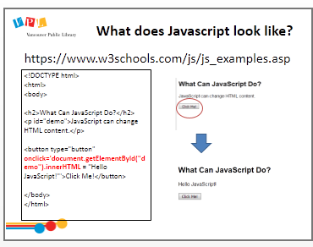 | ? | [OPTIONAL - if learners are more advanced and there is time left]  - W3 also provides the same practice window for Javascript.  - Many web-builder services like WordPress offer “widgets” (which are features you can add on) that likely use Javascript  - Most of these functions will require more advanced programming skills so we will just run through their examples but not manipulate them.  - This review will help you to, at minimum, to be able to identify JavaScript when you see it on a webpage to help understand what is happening with the code.  - Let’s see what JavaScript looks like and some examples of how it changes HTML and CSS.  Go to (and have class also go to) W3 Schools page on Javascript: https://www.w3schools.com/js/js_examples.asp  Ask them to open up these different examples and test them out:  - “JavaScript can change HTML content” (be sure to click on “Click Me”)  - “JavaScript can change HTML attributes” (be sure to click on “Turn on/off light”)  - “JavaScript can change CSS style”
No slide [OPTIONAL PRACTICE TIME] | ? | [OPTIONAL - if learners are more advanced and there is time left]  Let learners practice creating a basic webpage using a text editor (such as Notepad; save as .html file extension and then open in browser to preview)  Suggest they copy and paste the basic html coding from w3schools and add a heading, paragraph, image, and link. | - Practice creating a basic webpage using a text editor  - Refer to html and css handouts as needed  - Refer to w3schools website as needed | - Identify the ways that code underlies how the web is built and changed (2017: recognizes basic HTML tags and their effects, etc).  - Understand and apply appropriate code to manipulate and display information & data (2017: open data sets; application design, tbd)  - Recognize and select appropriate file formats for saving ongoing projects and for exporting final work.
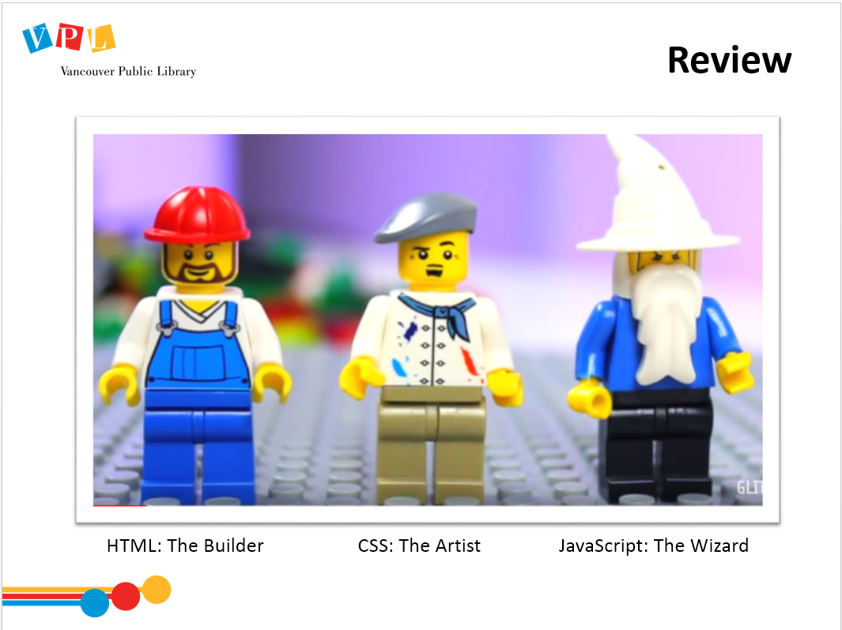 | 5-10 min | Review key concepts, or any areas that seem to have caused confusion  Ask:  - In your own words, what does HTML do?  - What does CSS do?  - What does Javascript do?  - Do you have any questions about how they work, or interact? | - Listen to instructor  - Respond to prompts  - Ask questions | - See previous
 | 1 min | Remind learners of the resources we’ve used to practice so far.  Show them how to login into Lynda and find the Web design class. Steps:  - Navigate to Lynda.com via the VPL website.  - Show them how to login and access Lynda.  - Explain that we will review where to find the relevant Web Design class on Lynda at the end of class  Point out the resources on the general handout. | - Listen to instructor  - Ask and answer questions  - Refer to handout
 | 2 min | DID WE LEARN HOW TO?  Ask:  - Did we meet all of our goals today?  - Was there anything we didn’t cover?  - Do you have any other questions and/or comments  Refer learners to resources on the handout  Review how to search for more classes | - Listen to instructor  - Ask and answer questions  - Refer to handout
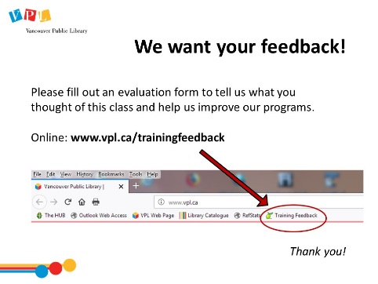 | 5 min | EVALUATION FORMS  Ask them to take some time to fill out the evaluation form. If possible, have them fill out the form online. If not, provide them with the paper forms:  - We would like your feedback! Please take some time to fill out an evaluation form to let us know what you enjoyed and what could be improved.  - There is a bookmark link to the form on all computers.  - You can also access the link by going to http://www.vpl.ca/trainingfeedback | - Listen to instructor  - Ask questions  - Fill out evaluation form
 | 15 min | Time for practice, questions, etc | - Ask questions  - Practice

Closing
- Thank learners for coming

