Let’s Talk About open data

Description
Governments, organizations and companies generate vast quantities of data which are free and accessible to all of us. Learn what open data is, what types of data are available and how you can use it to support knowledge sharing and innovation in this introductory, discussion-based class.

Learning GOALS > OUTCOMES
Digital Proficiency > Navigate > Read Information in Digital Formats
- Read and interpret information presented in common media, multimedia and transmedia formats (2017: text, still image, moving image, audio, video, hyperlinks, tagging).
- Identify and locate common types of digital information sources (2017: websites, databases, ebooks, search engines, social media/crowd sourced, open data portals).

Digital Proficiency > Navigate > Navigate Search Tools & Results
- Define an information need and determine the best information sources to meet it.
- Distinguish between information license types (2017: open access, purchase, subscription, digital locks, etc) and determine the impact on information access.

Digital Proficiency > Secure > Understand & Shape Online Identity
- Examine and assess the consequences of sharing data online.

Digital Fluency > Connect > Communicate Effectively Online
- Recognize, criticize, and participate in online philanthropy, activism, and civic engagement.
- Discover and share information and resources via social networks.

Digital Fluency > Manage > Manage Digital Information & Data
- Identify the benefits and limitations of different data and information management tools.
- Create, maintain and interpret records, spreadsheets and databases for personal and professional purposes.
- Find, use and interpret social media and web analytics to measure use and answer questions.

Digital Fluency > Manage > Present Digital Information & Data
- Assemble information from various digital sources to solve problems or explain concepts.
- Analyze data to evaluate quality, sort, find patterns, and use it to answer questions.

Digital Fluency > Create > Effectively Share Creative Works Online
- Identify and reflect on how the open and public nature of the web informs decisions about what to share and where.
- Apply copyright and “copyleft” permissions to new creative work.

Preparation

Equipment Needed: | - Projector/computer  - Internet access  - Sound
Materials Needed: | - PowerPoint on usb  - Handouts/evaluation forms for learners  - USB PPT Clicker (if desired)
Setup Procedures: | - Review the “Adult Teaching & Learning at VPL” teaching philosophy: http://hub.vpl.ca/content/85898  - Review the lesson materials  - Confirm that all necessary space and equipment has been booked
Background Reading | - Open Data 101 http://open.canada.ca/en/open-data-principles  - Open Data Online Modules: https://www.europeandataportal.eu/elearning/en/#/id/co-01  - The Open Definition http://opendefinition.org/  - Why Open Data? http://opendatahandbook.org/guide/en/why-open-data/  - What is Open Data? http://opendatahandbook.org/guide/en/what-is-open-data/
# of Staff Required and/or Staff: Learner Ratio | - 1-5 learners: 1 instructor  - 6-12 learners: 2 instructors  - For branch meeting room capacities, please see: http://hub.vpl.ca/content/64490

Opening
- Write your name and contact info (optional) somewhere visible
- Distribute handouts

Lesson

LEARNING ACTIVITIES |  |  |  | LEARNING OUTCOMES
Slideshow and/or Demo | Time | Trainer Does | Learners Do
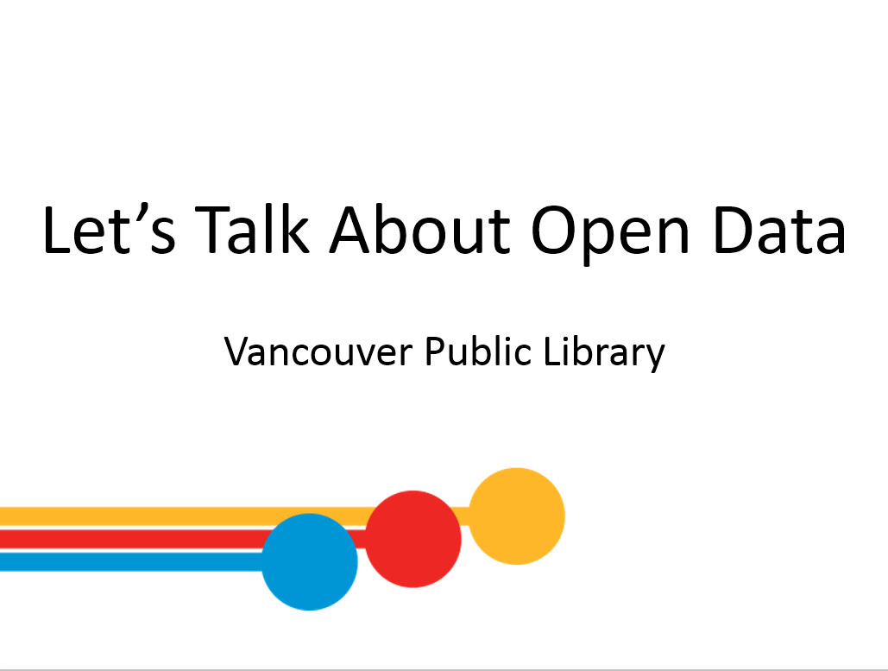 | 2 min | - Welcome  - Remind learners of washroom locations; turn off cell phones; etc  - Do a round of intros. Learners can say their name and any experience they have with open data | - Respond to instructor’s prompts
 | 5 min | Before we get started…  - This is one of many learning opportunities at the library.  - Today’s class is meant to be an introduction to the topic – there are lots more ways to delve deeper.  - Work toward a certificate for each series – when you take the final class, we’ll award it to you.  - 2nd Open Data class is next week, “Working with Open Data” and at that class we will delve into downloading a data set and working with it | - Listen to instructor  - Ask questions
 |  | Online learning at your own pace…  - Lynda.com  - vpl.ca/lynda  - videos; various tech topics; basic to advanced  - Show class how to find courses on “open data” (i.e. search “open data” in searchbar)  - Learning Express Library  - vpl.ca/digital-library/learning-express-library  - basic computer skills; job skills; exam preparation  - VPL Research Guides  - guides.vpl.ca  - Wide variety of topics; collected books & online resources | - Listen to instructor  - Ask questions
 |  | - Drop in to any branch  - Tech Café at Central | - Listen to instructor  - Ask questions
 | 2 min | Today We Will Learn How to . . .  - Discuss lesson scope; set expectations  - Ask questions e.g.  - Any comments or questions about what we will be covering today?  - Ask questions  - Has anyone used open data before? | - Respond to instructor’s prompts
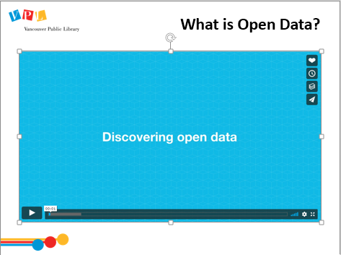 | 4 min | What is Open Data?  - Play video: https://vimeo.com/266308637  “Discovering Open Data” (2:56)  - Ask: Any questions from the video? | - Watch video  - Ask questions | - Understand the basic definition of open data; what makes data open; why do we need open data  - Understand the difference between data, information and knowledge
 | 5 min | Types of Data  - Data is presented in different formats  - Ask:  - What types of data do we use or have access to?  - What types of data do you think people may want to share?  - Use the whiteboard or flip chart to record the learner’s answers  - Data examples to add to class brainstorms: spreadsheets, databases, emails, word documents, pdf’s, maps, photos, videos, audio files, etc. | - Provide examples | - Identify and locate common types of digital information sources
 | 5 min | - Ask: What Does the Word “Open” Mean to You?  - Use the whiteboard or flip chart to record the learner’s answers  - Refer to the slide for definition to add to the discussion | - Brainstorm | - Understanding the definition of open data
 | 5 min | What Data Should Be Shared?  - Ask: What data should be shared or kept private?  - Use whiteboard or flipchart to brainstorm.  - Then click on slide to review answers on slide (set for each line to appear with a new click)  - Public/Open Data  Data that make up any community, whether it's a town, city, state, region, or country, e.g. housing, energy, complaints, or elections.  - Private/Closed Data  Some data is protected such as medical, criminal, or financial records; sensitive business information established through non-disclosure agreements or “trade secrets”; and classified government information which may, if publicly known, cause harm to national interests and/or security. | - Respond to instructor’s prompts | - Examine and assess the consequences of sharing data online
 | 2 min | What is Open Data?  - Read definition on slide  - Much of the world’s open data comes from governments (datasets):  - Garbage collection schedules, housing prices, crime rates, allocation of budgets.  - There is also an increasing movement towards open data sharing in scientific research, and among non-profits and businesses.  - Governments, organizations, and business usually publish their open datasets on their websites, on what are called open data portals, which are basically websites where you can download the data  - Now, let’s take a look at the different types or kinds of data that are openly shared . . . | - Listen to instructor  - Ask questions | - Identify and reflect on how the open and public nature of the web informs decisions about what to share and where
 | 5 min | Kinds of Data Openly Shared  - Any organisation can share data: corporations, universities, NGOs, startups, charities, community groups and individuals.  - Cultural works: generally collected and held by galleries, libraries, archives and museums.  - Scientific: produced as part of scientific research from astronomy to zoology.  - Financial: government accounts (expenditure and revenue) and information on financial markets (stocks, shares, bonds etc).  - Statistical: produced by statistical offices such as the census and key socioeconomic indicators.  - Environmental: types of data used to understand and predict the weather and climate, the presence and level of pollutants, or the quality and rivers and seas. | - Listen to instructor  - Ask questions | - Discover and share information and resources via social networks  - Assemble information from various digital sources to solve problems or explain concepts
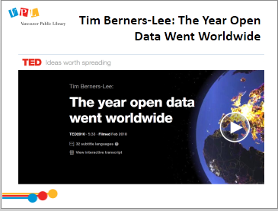 | 7 min | Show video: The Year Open Data Went Worldwide (click on link on slide)  Note: Turn the volume to max and turn on subtitles as the video is quiet.  Intro: Tim Berners-Lee, is a computer scientist who speaks a lot about the internet, as he was one of the people who helped develop the original World wide Web. AT TED2009, he called made a call out for “raw data now” -- for governments and institutions to make their data openly available on the web. This video is from 2010, a year after his original call out and he reports on the changes to the open data landscape since his original call for “raw data now”.
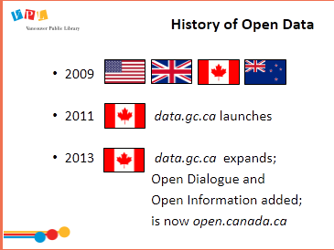 | 3 min | History of Open Data  - In 2009, Open Data became visible in the mainstream, with various governments, including the USA, UK, Canada, and New Zealand, announcing new initiatives towards opening up public information.  - In 2011, the Government of Canada launched its first-generation Open Data Portal (data.gc.ca).  - In 2013, the second-generation Open Government Portal was launched in Canada with additional functionality to highlight Open Information and Open Dialogue.  - The goal of Open information is to provide easy access to all of the Government of Canada’s information to increase transparency of government programs, activities, publications and spending  - Open Dialogue is focused on “ways to participate in government policy and program development, and explore resources to support effective public engagement.”  - The government of Canada Open Data resource is now open.canada.ca | - Listen to instructor  - Ask questions | - Identify and reflect on how the open and public nature of the web informs decisions about what to share and where
 | 1 min | Open Data around the World  - Open Data has been a global movement in the past 10 years and there are now thousands of open data portals all over the globe. This is a map of more than 2600 geo-tagged intergovernmental organization open data portals in the world as of 2015. | - Listen to instructor  - Ask questions | - Define an information need and determine the best information sources to meet it  - Recognize, criticize, and participate in online philanthropy, activism, and civic engagement  - Discover and share information and resources via social networks.  - Identify the benefits and limitations of different data and information management tools  - Find, use and interpret social media and web analytics to measure use and answer questions
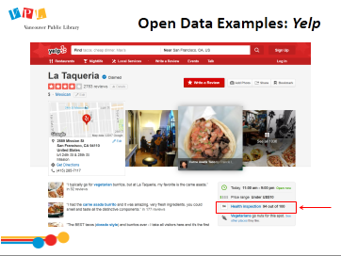 | 2 min | Open Data Examples: Yelp (USA)  - Yelp is a popular US-based online resource destination whose purpose is to connect people with local businesses  - Yelp is probably most commonly known for finding good local restaurants. For example it includes information on open and closing times, the menu, and price range.  - On Yelp in the US, you can also find out health information published by the local government health authority (i.e. recent health inspections) in an open data format. | - Listen to instructor  - Ask questions | - See previous
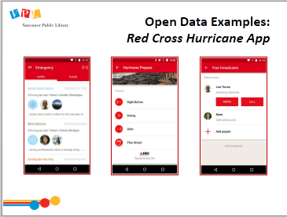 | 2 min | Open Data Examples: Red Cross Hurricane App  - The Red Cross Hurricane App was developed during a 90-day Safety Datapalooza challenge. The Datapalooza brought together NGOs, developers, businesses, & governments to brainstorm ways to put government data to use to improve people’s lives.  - This app that was designed to help people find safe ways to move around during hurricanes.  - The app has several features. One of the features combines open data from the Department of Transportation and National Weather service to document both the weather and which mode of transportation was up and running, to help people navigate themselves before, during and after a Hurricane.  - This app was effectively used during Hurricane Sandy in 2012 to help people navigate services and transportation during the storm. | - Listen to instructor  - Ask questions | - See previous
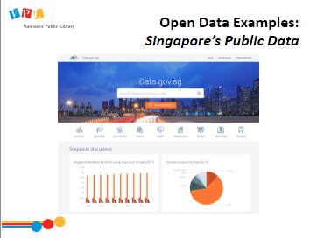 | 1 min | Open Data Examples: Singapore’s Public Data  - Open data portals are online from governments and institutions around the world.  - Singapore’s Government has this online portal for anyone to be able download data. (https://data.gov.sg/)  - Part of their portal is focused on making real-time data easily accessible and available to be pulled automatically and used in apps that use data in real-time.  - These are some global examples of how Open Data is being used, let’s focus in and look at Open Data in Canada. . . | - Listen to instructor  - Ask questions | - See previous
 | 10 min | Canada’s Open Data Principles  - Canada has a set of Principles that guide their Open Data. These principles are a good example of all the elements that make Open Data, truly open and true to the intent of the idea of open data.  - Refer learners to the handout (pages 3-4) & read/summarize the different principles, OR allow them time to read the principles on their own. Summary:  - Completeness – should be complete and be the entirety of what is recorded  - Primacy - should come from a primary source and be the original info  - Timeliness – released as quickly as possible  - Ease of Physical and Electronic Access - as accessible as possible  - Machine Readability – should be in widely-used formats such as CSV, XML  - Non-discrimination – as few barriers as possible  - Use of Commonly Owned Standards – available in freely available file formats (not ones for proprietary software)  - Licensing – Open Govt Licence - Canada  - Permanence – finding info online over time  - Usage Costs – data is free of charge  - Write the following on the whiteboard or flip chart: “Open data should be highly organized or structured data that is machine-readable, freely shared, and used and built on without restrictions. “  - Let’s take a closer look at some of these points, starting with structured and machine readable data. . . | - Refer to handout | - Distinguish between information license types  - Create, maintain and interpret records, spreadsheets and databases for personal and professional purposes  - Identify and reflect on how the open and public nature of the web informs decisions about what to share and where
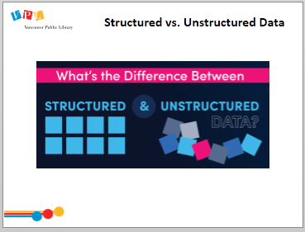 | 3 min | Structured vs. Unstructured Data  Data can be broadly organized into structured data and unstructured data. Let’s explore the difference between the two types of data  Structured Data  - Data that is highly organized.  - Data most IT workers are used to is structured.  - It is written in a format that’s easy for machines to understand, though it baffles most people unless they’re programmers.  - Easily searchable by basic algorithms.  - Examples include spreadsheets, databases, and data from machine sensors.  Unstructured Data  - Is more like human language.  - doesn’t fit nicely into many databases  - Searching it based on the old algorithms ranges from difficult to completely impossible.  - Examples include emails, text documents (Word docs, PDFs, etc.), social media posts, videos, audio files, and images.  Source: https://blog.samanage.com/insights/whats-the-difference-between-structured-and-unstructured-data | - Listen to instructor  - Ask questions | - Read and interpret information presented in common media, multimedia and transmedia formats  - Identify the benefits and limitations of different data and information management tools
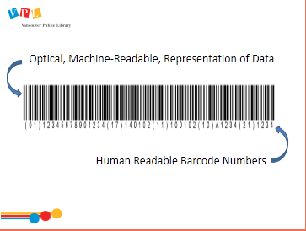 | 2 min | Machine-Readable vs. Human Readable  - Most data can be broadly organized into two general formats: Human Readable Text and Machine Readable Binary.  - Human Readable text has the advantage of being easily understood by a human being reading it.  - Machine readable binary is a format that is much easier/faster for a machine to encode/decode.  Note:  - Don’t confuse digitally accessible with machine readable. A digitally accessible document may be online, making it easier for a human to access it via a computer, but unless the relevant data is available in a machine readable format, it will be much harder to use the computer to extract, transform and process that data.  - For example, an email, a word document, and a pdf are all examples of formats that are digitally accessible on your computer. However, they are not machine readable because a computer would struggle to access the tabular information. | - Listen to instructor  - Ask questions | - See previous
 | 2 min | City of Edmonton’s Open Data Portal  https://data.edmonton.ca  - Many municipalities and cities have their own open data portals.  - For example, the City of Edmonton's Open Data Portal maintains a wide range of datasets and visualizations available to the public. The data is related to municipal issues such as roadways maintenance, locations of schools, types of trees, municipal elections data and more.  - Click on slide and it will take you to https://data.edmonton.ca  - From there select “Citizen Dashboard” (https://dashboard.edmonton.ca/)  - The Citizen Dashboard presents data about how municipal services are performing. | - Listen to instructor  - Ask questions | - See previous
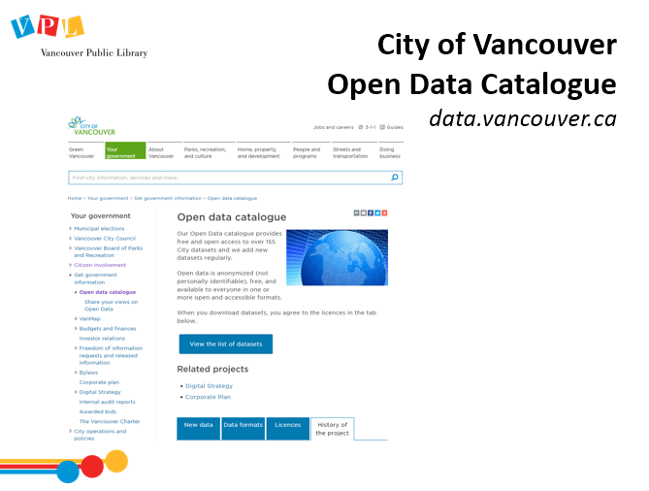 | 2 min | City of Vancouver Open Data Catalogue  - The City of Vancouver has an Open Data catalogue provides free and open access to over 155 City datasets, with new datasets being added regularly. Some examples of the data include:  - Council expenses  - Public washroom data  - Drinking fountain locations  - Crime data  - Historical business licenses  - Elevation  - Election results  - Allows citizens to learn about our own community, revealing trends and patterns, providing needed information in digestible form that is easy to manipulate.  - Website is: data.vancouver.ca | - Listen to instructor  - Ask questions | - Define an information need and determine the best information sources to meet it  - Discover and share information and resources via social networks  - Identify the benefits and limitations of different data and information management tools  - Find, use and interpret social media and web analytics to measure use and answer questions
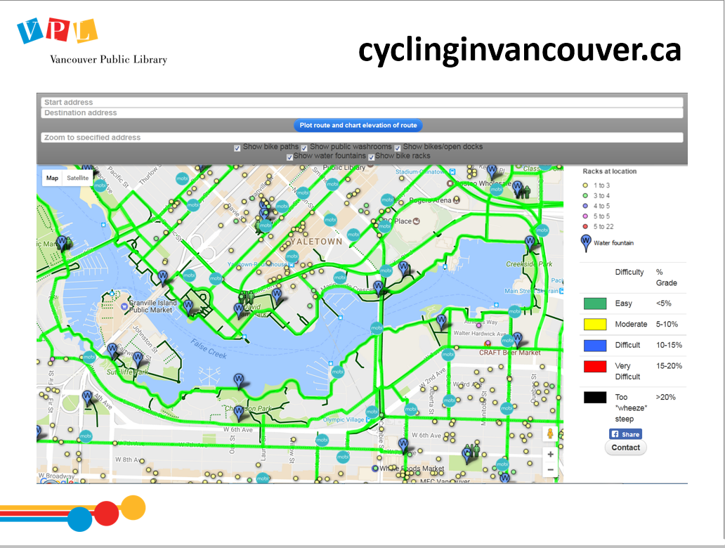 | 2 min | cyclinginvancouver.ca  - Using data from the City of Vancouver open data portal, developers created this website, cyclinginvancouver.ca.  - Elevation data is combined with roadmap information, bike rack locations, and water fountain locations to create this map to help you navigate the city on a bicycle.  - Optional: Either demonstrate (clicking on image on slide will get you to the website) or have students navigate to site to show how it is used. | - Listen to instructor  - Ask questions | - See previous
 | 5 min | What Are You Allowed to Do With Open Data?  - When you are on an open data portal, you will usually find a section to describe what kind of licence the data comes with.  - In Canada, most governments use a form of the Open Government Licence. With this licence you are free to:  - Copy, modify, publish, translate, adapt, distribute or otherwise use the Information in any medium, mode or format for any lawful purpose, but you must:  - Acknowledge the source of the Information by including any attribution statement specified by the Information Provider(s) and, where possible, provide a link to this licence.  - If the Information Provider does not provide a specific attribution statement, or if you are using Information from several information providers and multiple attributions are not practical for your product or application, you must use the following attribution statement  “Contains information licensed under the Open Government Licence – Canada.”  - The licence does come with some exemptions, meaning you don’t have the right to use such things as logos, personal info, information that trademarked etc.  Source: http://open.canada.ca/en/open-government-licence-canada | - Listen to instructor  - Ask questions | - Distinguish between information license types  - Apply copyright and “copyleft” permissions to new creative work
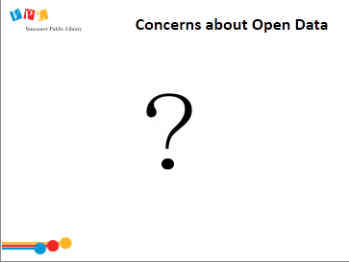 | 3 min | - Ask: What do you think some concerns might be over open data? | - Listen to instructor  - Ask questions | - Identify the benefits and limitations of different data and information management tools
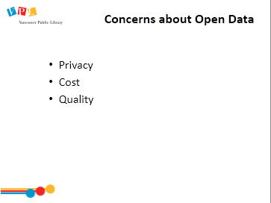 |  | Concerns:  - Privacy - Not all data should be shared publicly (personal information, national security, etc.). So access to certain datasets is limited to specific users or to sub-sets of the data.  - Cost - Collecting, cleaning, publishing, and maintaining open data are typically labour- and/or cost-intensive processes. Who pays for this?  - Quality - There are no processes in place to ensure that open datasets are reliable, accurate, useful, or maintained. Data available in datasets, therefore, may be out of date, incomplete, or just inaccurate.
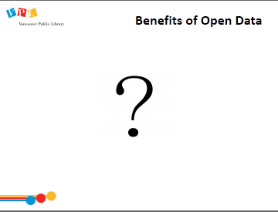 | 5 min | Benefits of Open Data  - Use whiteboard or flipchart to brainstorm.  - Then run through the 2 slides (click brings up one line at a time)  - Support for innovation Access to knowledge supports innovation in the private sector by reducing duplication and promoting reuse of existing resources. The availability of data in machine-readable form allows for creative mash-ups that can be used to analyze markets, predict trends and requirements, and direct businesses in their strategic investment decisions.  - Advancing government's accountability and democratic reform Increased access to government data provides greater insight into government activities, service delivery, and use of tax dollars.  - Leveraging public sector information to develop consumer and commercial products - Unrestricted access to scientific data for public interest purposes, particularly statistical, scientific, geographical, and environmental information, maximizes its use and value, and the reuse of existing data in commercial applications improves time-to-market for businesses. | - Brainstorm | - Identify the benefits and limitations of different data and information management tools  - Recognize, criticize, and participate in online philanthropy, activism, and civic engagement  - Examine and assess the consequences of sharing data online
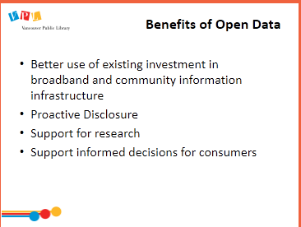 | 5  min | - Better use of existing investment in broadband and community information infrastructure - Canada has invested in information and communications networks in the form of technical infrastructure and community services, such as libraries and social service agencies. This investment will continue to add value-for-money for Canadians by extending Web technology from one-way communications medium to collaborative environment.  - Proactive Disclosure – proactively providing data that is relevant to Canadians reduces the amount of access to information requests, e-mail campaigns and media inquiries. This greatly reduces the administrative cost and burden associated with responding to such inquiries.  - Support for research - Access to federal research data supports evidence-based primary research in Canadian and international academic, public sector, and industry-based research communities. Access to collections of data, reports, publications, and artifacts held in federal institutions allows for the use of these collections by researchers  - Support informed decisions for consumers - Providing access to public sector service information to support informed decision-making; for example, real-time air travel statistics can help travelers to choose an airline and understand the factors that can lead to flight delays. Giving Canadians their say in decisions that affect them and the resulting potential for innovation and value (builds trust and credibility)  - Source: http://open.canada.ca/en/open-data-principles | - Brainstorm | - See previous
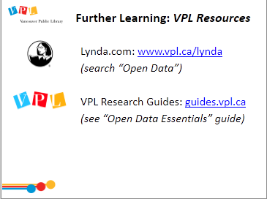 | 5 min | Further Learning: VPL Resources  - Lynda.com  - vpl.ca/lynda  - Show class how to find courses on “open data” (i.e. search “open data” in searchbar)  - VPL Research Guides  - guides.vpl.ca  - Open Data guide should be ready by early Nov |  | - Discover and share information and resources via social networks  - Recognize, criticize, and participate in online philanthropy, activism, and civic engagement
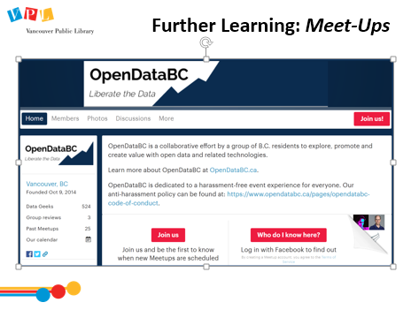 | 2 min | Further Learning: Meet-Ups  - OpenDataBC is a collaborative effort by a group of B.C. residents to explore, promote and create value with open data and related technologies.  - They schedule regular meetups including hackathons, show and tells, info sessions, and mixers.  - Find more info here (can click on link on slide): http://www.opendatabc.ca/ |  | - See previous
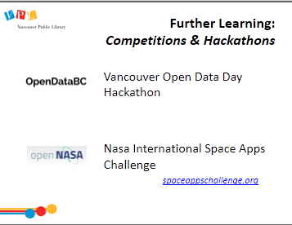 | 2 min | Open Data Competitions & Hackathons  Vancouver Open Data Day Hackathon  - Hosted by Code for Canada and the Open Data Society of BC  - Happens in March each year  - Mashing up one or more Open Data sets, create a meaningful open data app or visualization that citizens can use, creating a prototype to be demoed at the end of the day.  - https://www.opendatabc.ca/pages/events  Nasa International Space Apps Challenge  - This is an example of a challenge where people use open data to solve a specific problem. In the case of the International Space Apps Challenge people work with open data to solve challenges to support NASA’s ongoing missions.  spaceappschallenge.org |  | - See previous
 | 2 min | Did we learn how to…?  - Ask:  - Did we meet all of our goals today?  - Was there anything we didn’t cover?  - Do you have any other questions and/or comments  - Refer learners to resources on the handout  - Review how to search for more classes | - Listen to instructor  - Ask questions
 | 2 min | Time for practice, questions, etc

Closing
- Thank learners for coming
- Ask them to take some time to fill out the evaluation form (vpl.ca/feedback) – link is bookmarked on computers

