Let’s Talk About Online Privacy

Handout

PROTECTING YOUR PERSONAL DATA
- Provide only essential personal information online
  - If you are asked for a birth date, address or other personal information, consider why and how it will be used.
  - Provide only what is necessary (a red asterisk * will usually mark required information; leave all other fields blank).
  - Check the website’s authority (is it legitimate? Do they provide valid contact information) and their privacy policy before entering personal information.
- Do not give out your passwords, or if you must give your password to someone change it afterwards.
- Delete accounts you no longer use.
- Be diligent when online shopping
  - Use a secured network
  - Look for the lock symbol and the “s” after the http i.e. https://) when transmitting personal information.
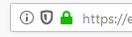
  - Always log out after you are finished using your account.
  - Use a pre-paid credit card, or a payment gateway, such as PayPal, that hides your card number.
    - Using PayPal is more secure than giving less known websites your credit card information.

PROTECTING YOUR PRIVACY
- Manage your software and computer
  - Keep your software updated (this makes it as secure as possible)
  - Use trusted antivirus software
  - Check your software and computer privacy and security settings regularly
- Use 2-step verification as a second layer of protection to your accounts.
- Manage your browser cookies
  - For Firefox click the three line menu icon in the top right of the browser window, select Options Privacy & Security Scroll down to Cookies and Site Data Clear Data or Manage Data.
- Manage your browsing history
  - For Firefox click the three line menu icon in the top right of the browser window, select Options Privacy & Security Scroll down to History.
  - Consider using a “private browsing window” if you do not want your history recorded.
    - Go to File (top left) and select Open in New Private Window
  - This only affects what is remembered by your browser. It does not prevent websites or search engines from tracking your online activity.
- Use browser extensions (also called add-ons) to increase privacy and security
  - Some recommended extensions are Privacy Badger, disconnect.me, www.ghostery.com and https Everywhere.
  - Consider the “Recommended” tag and search for online reviews when selecting browser extensions.
- Use alternative search engines that do not track your searching, such as DuckDuckGo.
- Use browsers that have strong security features, such as Firefox.

CREATING STRONG PASSWORDS
- Have a unique password for each account.
  - If someone discovers your password for one account, all of your other accounts will be vulnerable.
- Use a longer password.
  - Your password should be at least 8 characters long, although for extra security it should be even longer.
- Never use personal information for a password
  - Don’t use your name, birthday, user name, or email address.
- Make your password hard to guess
  - Include numbers, symbols, and both uppercase and lowercase letters.
  - Avoid using words that can be found in the dictionary.
- Random passwords are the strongest.
  - If you're having trouble creating one, use a free online password generator.
- Use a password manager to manage all your passwords to ensure secure passwords and reduce stress related to remembering passwords.
  - Some popular online password managers are 1Password, LastPass, KeepassX and Dashlane.

avoidING scams
- Be aware of phishing emails and online ads which are trying to trick you into sharing personal information with those with malicious intent
  - Go to accounts directly to log in and check for alerts (don’t click on a link in an email).
  - Never submit financial/personal information through a link sent to you.
  - Never call a phone number sent by email – contact the company directly.

TRACKING VS IDENTIFY THEFT

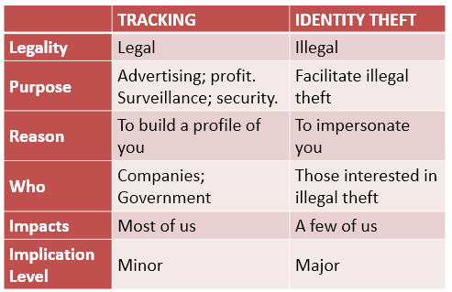

ASSESSING THE SECURITY OF YOUR ACCOUNTS
Write down all the accounts you remember, and check off how much security they have.
Note: Many accounts have steps you can take if you no longer have the password (this usually involves sending you an email to the email they have on record).
Name of account  (e.g. email; Apple ID; banking; etc.) | Is this account still in use?  If not, consider deleting it. | Is the password secure?  (see pg. 2 of handout) | If 2-step verification an option? If so, is it enabled? | Is my “Forgot my password question” one that people won’t easily guess?

LEARN MORE

VPL Events Guide | For days, times and locations, check out the “Computer & Technology” category in our Events Calendar. You can also look in the paper brochure “VPL Classes & Workshops”. | www.vpl.ca/events
VPL Computer Practice Drop-In | A drop-in to practice new skills with information staff assistance. | Central Library  Tuesdays & Thursdays  2:00 - 3:00 pm
VPL Information Services | We are here to help!  If you have any further questions, please ask us! | Phone: 604-331-3603 Email: info@vpl.ca
VPL Research  Guides | Computer Survival Guide  Information and self-directed practice activities on introductory computer and Internet topics. | guides.vpl.ca/computers
GCFLearnFree.org tutorials | Free online tutorials for learning a range of essential skills including computer, technology and internet skills. | www.gcflearnfree.org  Go to “Technology” and browse “Internet”; “Computers” and “Online Safety”
DigitalLearn | Online hub for digital literacy support and training. Great video-based modules with narration for basic digital skills learning. | www.digitallearn.org
Electronic Frontier Foundation (EFF) | Surveillance Self-Defense – a guide to help protect you from online tracking and surveillance. EFF is an independent non-profit working to protect online privacy. | https://ssd.eff.org

