Get to know the internet

Description

Learn what the Internet is and how to navigate it in this hands-on, introductory class. Explore websites and browsers (Firefox and Internet Explorer) and become familiar with VPL's online resources. Basic ability to use a keyboard and mouse is required. Register by phone for this or other classes in the Internet Essentials series. Each class must be registered for separately.

Learning Goals > LEARNING OUTCOMES
Digital Proficiency > Operate > Understand the Internet
Learners will be able to…
- Compare and contrast wired and wireless Internet connections, as well as Wi-Fi and mobile data
- Differentiate between connecting a computer or device to Wi-Fi or wired or data internet connections
Digital Proficiency > Operate > Understand the Web
Learners will be able to…
- Recognize and differentiate major components and features of the Internet and the World Wide Web
- Identify and use the common features of web browsers
- Identify and navigate common features of web sites and other online resources
- Recognize common web terms
- Apply web knowledge to operation of digital library resources and services
Digital Proficiency > Navigate > Read Information in Digital Formats
Learners will be able to…
- Read and interpret information presented in common media, multimedia and transmedia formats
- Identify and locate common types of digital information sources

Preparation

Equipment Needed: | - Computers for learners  - Projector/laptop  - Internet access  - Sound
Materials Needed: | - PowerPoint on usb  - Evaluation forms for learners
Setup Procedures: | - Review the “Adult Teaching & Learning at VPL” teaching philosophy: http://hub.vpl.ca/content/85898  - Review the lesson materials  - Confirm that all necessary space and equipment has been booked
Background Reading | - Internet Basics – What is the internet: http://www.gcflearnfree.org/internetbasics/what-is-the-internet/1/  - Connecting to the internet: http://www.gcflearnfree.org/internetbasics/connecting-to-the-internet/1/  - Domain Extensions: https://www.lifewire.com/most-common-tlds-internet-domain-extensions-817511
# of Staff Required and/or Staff:Learner Ratio | - 1-5 learners: 1 instructor  - 6-12 learners: 2 instructors  - For branch meeting room capacities, please see: http://hub.vpl.ca/content/64490

Opening
Before doors open:
- Write your name and programs@vpl.ca on the whiteboard (include phone number 604-331-3603 for more basic digital literacy classes)
- Distribute handouts, evaluation forms (if applicable)
- Test internet & speakers
- Turn the computers for learners on before class starts
- Open any relevant websites needed for lesson.

As learners enter
- Welcome learners

Lesson

LEARNING ACTIVITIES |  |  |  | LEARNING OUTCOMES
Slideshow and/or Demo | Time | Trainer Does | Learners Do
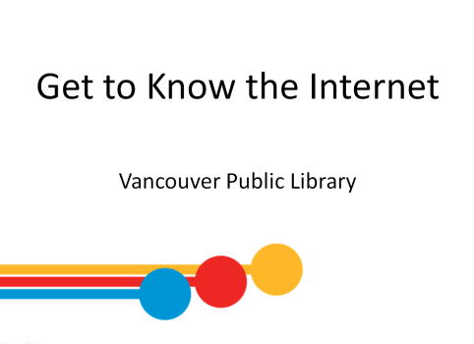 | 2 min | INTRODUCTION  Welcome students; introduce yourself; introduce the class and series  Remind learners of washroom locations; turn off cell phones; etc.  Ask if everyone can hear you. | - Listen to instructor  - Respond to instructor’s questions
 | 5 min | LEARNING OPPORTUNITIES AT VPL  - This is one of several Digital Essentials series offered for free here at the library.  Click on the link in slide to navigate to vpl.ca Digital Essentials page and show learners other classes.  - You can work toward a certificate for each series. If you attend all classes in the series, you will receive a certificate in the last class in the series. | - Listen to instructor  - Ask questions
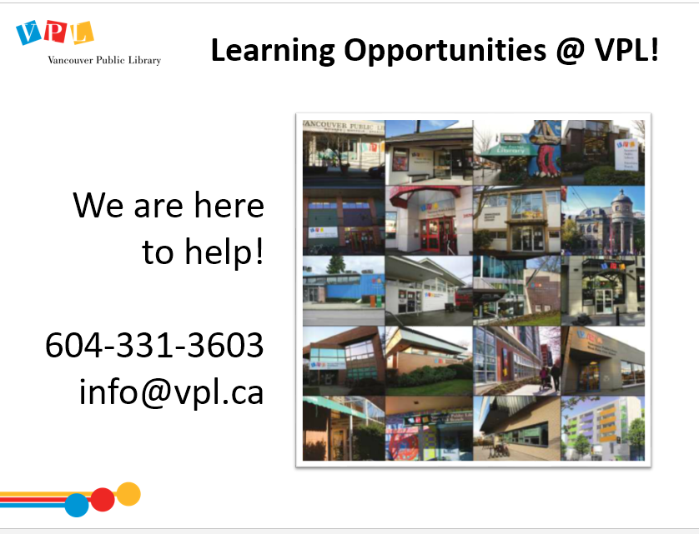 |  | LEARNING OPPORTUNITIES AT VPL  - This is one of the many learning opportunities at the library.  - Today’s class is meant to be an introduction to the topic – there are lots more ways to delve deeper.  - There are many other ways to learn and get help on this and other topics at the library.  - Drop-in to any branch  - Computer Practice Drop-In at Central  - Call or email the library | - Listen to instructor  - Ask questions
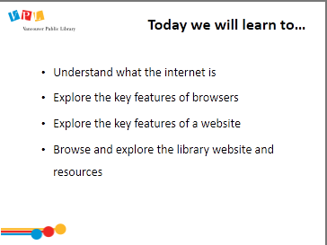 | 3 min | LEARNING OBJECTIVES  Review slide and read learning outcomes listed on slide  Ask: Any comments or questions about what we will be covering today?  Lead a round where people introduce themselves and answer this question:  - Please share your name and what brings you here today. What are you hoping to learn from this class? | - Listen to instructor  - Respond to instructor’s questions
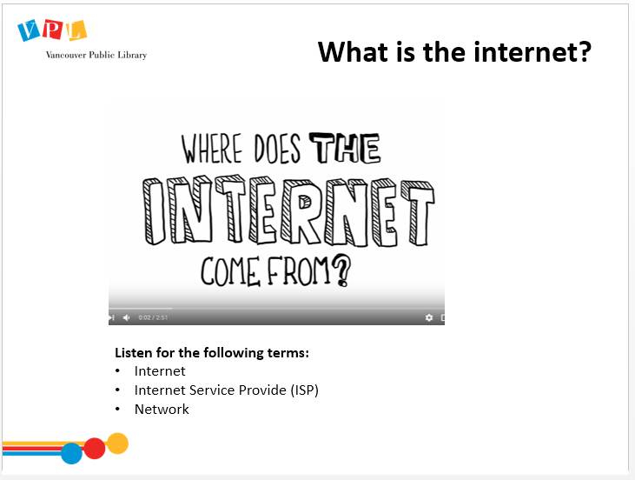 | - min | WHERE DOES THE INTERNET COME FROM?  Play video at reduced speed (under settings cog to 0.75)  linked in slide: Where does the Internet come from?  [https://www.youtube.com/watch?v=jKA5hz3dV-g (end it at 2:37)] | - Explore handout  - Watch video  - Ask questions | - Recognize and differentiate major components and features of the Internet and the World Wide Web  - Recognize common web terms
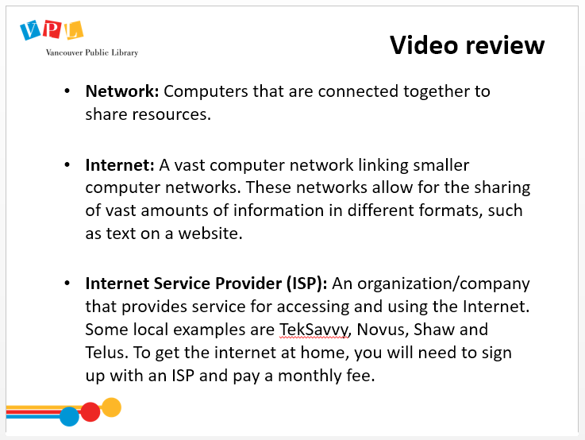 |  | VIDEO REVIEW  Review slide  Indicate definitions on handout  Ask if there are any questions about what the internet is | - Explore handout  - Ask questions | - See previous
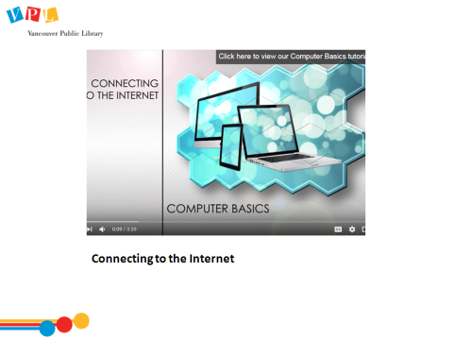 | 5 min. | CONNECTING TO THE INTERNET  Play video: Computer Basics: Connecting to the Internet by GCFLearn.org [https://www.youtube.com/watch?v=hMX6dVa61t0 (3:39)]  Direct attention to handout glossary  Mention that the Wireless Network name will be public (i.e. be seen by others looking for wireless networks) | - Explore handout  - Watch video  - Check off words covered by the video  - Ask questions | - Compare and contrast wired and wireless internet connections, as well as wifi and mobile data  - Differentiate between connecting a computer or device to wifi or wired or data internet connections  - Recognize common web terms
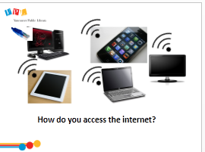 | - min | HOW DO YOU ACCESS THE INTERNET?  Ask learners  - What different devices have you used to connect to the internet?  Explain what wifi symbol means & where to access free wifi  Ask learners to identify connection type often used for each computer type – click to unveil each connection.  - Answers:  - Desktop usually uses wired network connection  - Tablet and laptop usually use wifi  - Smartphone usually uses a data connection (might say 3G, 4G, LTE—don’t worry about what kind of data it is). You can also connect to the internet with wifi if you’re near a “hotspot”, such as at home, a café, or the library. You will usually need a password to log in to the wifi.  - Smart devices, like TVs usually uses Wifi | - Listen to instruction  - Discuss  - Ask questions | - Compare and contrast wired and wireless internet connections, as well as wifi and mobile data  - Differentiate between connecting a computer or device to wifi or wired or data internet connections
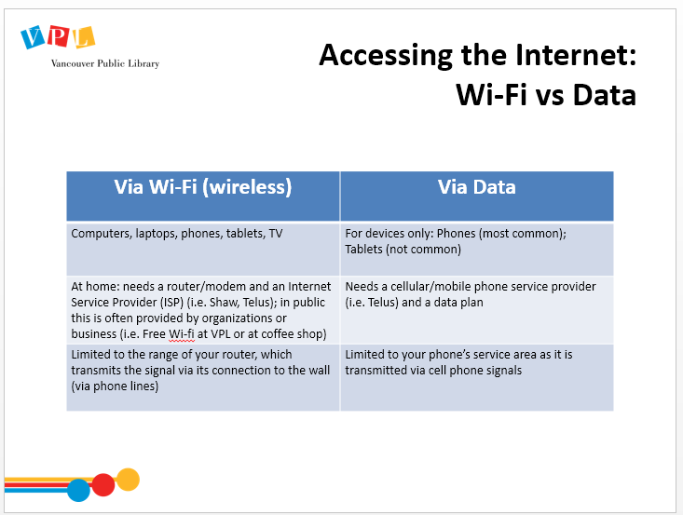 | 2 min | ACCESSING THE INTERNET  Review mobile data vs. wifi chart  Ask:  - How are they similar and how are they different? | Discuss similarities and differences | - See previous
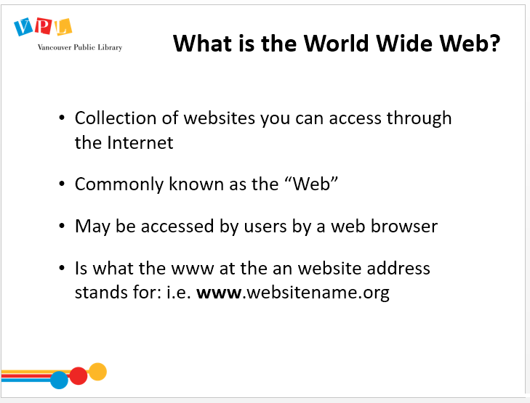 | - min | WHAT IS THE WWW?  Review Slide. Describe the World Wide Web (WWW) and what part it plays on the internet.  Refer to handout (glossary): definition of WWW (pg 3) & discuss differences with the internet (deftn pg 2 of handout).  - Internet is vast computer network linking smaller networks. These networks allow for the sharing of vast amounts of information in different formats, such as text on a website.  Ask learners what would allow them to browse/move around the world wide web?  - Answer: browser | - Listen to trainer  - Explore handout  - Ask questions | - Recognize and differentiate major components and features of the Internet and the World Wide Web  - Recognize common web terms  - Identify and locate common types of digital information sources
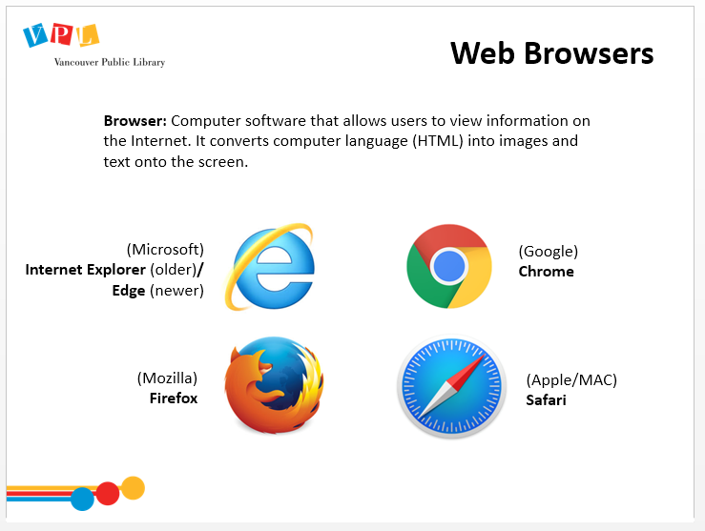 | - min | WEB BROWSERS  Discuss definition of a web browser. Read definition on slide.  Indicate and describe different browsers – Internet Explorer, Chrome, Firefox and Safari  Stress the similar functionality across different browsers.  - Here’s an example analogy: when you get a new TV remote, it will look different and have different buttons, and they might even be called different things, but all TV remotes do essentially the same functions.  Open Firefox browser. Ask learners to follow along as you go through the steps to open a browser.  Explain “homepage”, which you can set for your browser to open automatically when you open your browser (in Firefox, go to the menu on the right and select “Options” to set homepage) | - Listen to trainer  - Explore handout #2  - Open Firefox browser on computer they are using | - Identify and use the common features of web browsers  - Identify and navigate common features of web sites and other online resources  - Identify and locate common types of digital information sources
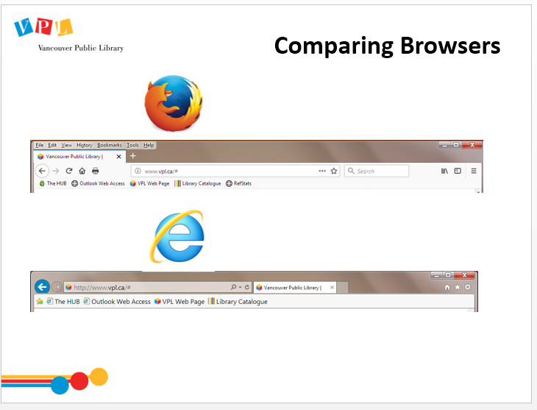 | 5 min | COMPARING BROWSERS  Return to slide, and show the two top parts of Firefox and IE browser. Pick three features (settings, search bar location and fwd/back/refresh buttons) and show the differences  Recommend Firefox, which we will use for the rest of our examples today  - We recommend Firefox and use it in our classes because it is:  - Non-profit  - Independent  - Stable  - Works with most websites  - Protects your privacy better than other browsers.  Mention IE3 class that focuses on online privacy class in this series | - Match icons to definitions on handout Match the definition to the picture  - Try the different buttons out on the computers | - Identify and use the common features of web browsers  - Identify and locate common types of digital information sources
[No slide] | 10 min | ACTIVITY  Ask learners to complete handout pg. 3 “Match the definition to the picture”  Allow learners 3-5 minutes to fill out handout  Review handout together – ask learners to name different features of a browser | - Listen to instructor  - Complete activity  - Ask questions | - See previous
[No slide] | 5 min | WINDOW MANAGEMENT  Indicate minimize, maximize and close symbol along top of browser  Demonstrate the functionality of each button, and how to retrieve a minimized window  Show on the slide that these symbols are consistent across browsers  Ask learners to try the buttons on their computers. Assure users they cannot break anything by clicking the wrong thing.  Walk around to check in and see if there are questions.  Indicate scrollbar, and how to move down the page  Demonstrate that the wheel in the center of the mouse can also allow them to scroll  Optional: show how holding “ctrl”+scroll wheel will allow them to zoom in and out easily. If they do not have a mouse on their computer, zooming is also available in the browser options. | - Listen to trainer  - Ask questions  - Experiment with browser | - Identify and use the common features of web browsers
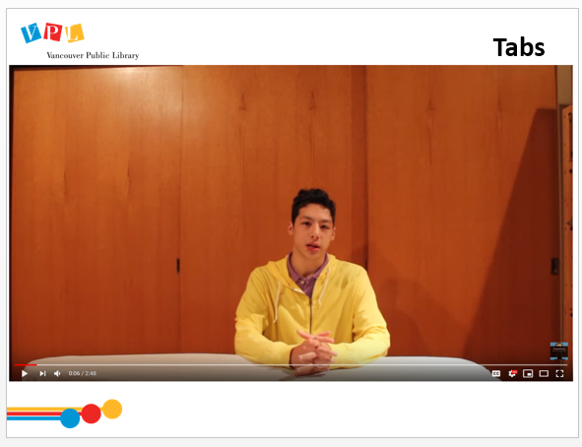 |  | TABS  Play video, “Browser Tabs & Windows” [2:48] by clicking on video image on slide.  Ask:  - In your own words, what is a tab? How does it compare to a window?  - Did the binder analogy make sense to you? Can you think of a different analogy?  - In what scenario would you prefer a second window over a tab?  Demonstrate how to open a new tab in Firefox (+ button)  Ask learners to open and close new tabs  Optional: Show learners how to right click and “Open Link in New Tab” | - Watch video  - Respond to instructor’s prompts  - Ask questions | - See previous
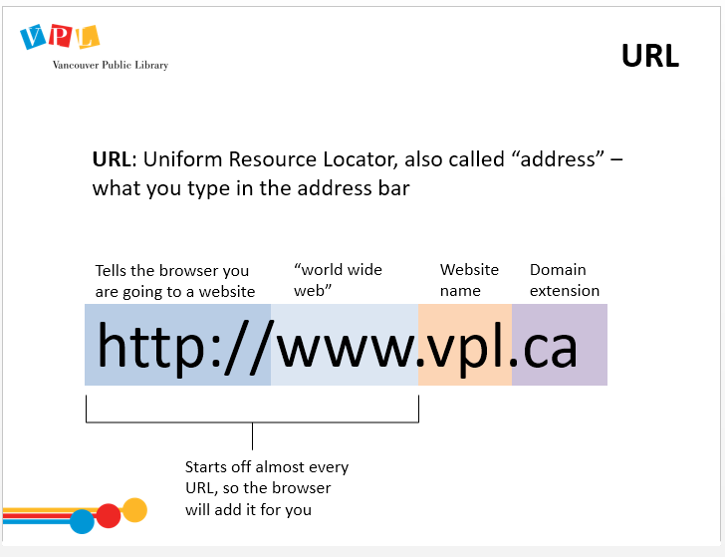 | 10 min | URL  Explain “URL”  - “URL” stands for Uniform Resource Locator  - It is a unique web address, as displayed in the address bar  - It allows you to go to a specific website  Show address bar, and type in www.vpl.ca  - It’s like a mailing address: you need to get it right or you won’t end up in the right place. This mean that spelling counts.  - You can often omit the ‘www’ & can almost always omit the ‘http:// ‘  Demonstrate how some browser address bars act as search boxes (show difference between IE & Mozilla)  - If you’re interested in learning more about how to use search engines, I recommend the next class in this series  Have learners type in www.vpl.ca. Breakdown address using whiteboard:  - www = world wide web  - .vpl = name of the webpage  - .ca = Canada – This is a type of website extension for Canadian sites.  Ask:  - What other extensions have you heard of? | - Listen to trainer  - Follow along | - Apply web knowledge to operation of digital library resources and services  - Read and interpret information presented in common media, multimedia and transmedia formats
No Slide - DOMAIN EXTENSIONS | 2 min | DOMAIN EXTENSIONS  Have learners type in www.vpl.com  Lead discussion about the differences between vpl.ca and vpl.com  - Answer: VPL.com is not a valid site, so the browser will not be able to load it. It’s like sending a letter to an address that doesn’t exist: it won’t get there! You got the street address right, but  Stress the importance of double checking a website address if the results you find are unexpected | - Listen to trainer  - Follow along | - Identify and use the common features of web browsers  - Identify and locate common types of digital information sources  - Read and interpret information presented in common media, multimedia and transmedia formats
No Slide -  WEBSITE FEATURES; SEARCHING WEBSITES | 2 min | WEBSITE FEATURES  Ask learners to return to www.vpl.ca  Explain common features of a website  - The logo is a link to take a user home  - Links are usually text that is unlined, blue, or in a box/button. It can be clicked to quickly visit another part of the website or new site  - Run your cursor over the text to see if something is a link: if it’s a link the mouse will turn from a pointer into a hand  Explain that on the VPL page, and on many other websites, the site search lets you search the website  - On the VPL site you also have options to search the catalogue or the events calendar.  Demonstrate using the VPL website’s site search feature.  - Sample searches: “music”, “inspiration lab” | - Listen to trainer  - Follow along | - Recognize common web terms  - Identify and locate common types of digital information sources  - Apply web knowledge to operation of digital library resources and services
No Slide  -SEARCHING VPL RESEARCH GUIDES | 4 min | RESEARCH GUIDES  Go to research guides: https://www.vpl.ca/researchguides  Ask learners to follow along, and lead them through the site search in the research guides  Navigate to Computer Essentials and Internet Essentials Guides, and the links there to GCF Learn Free. | - Listen to trainer  - Follow along | - See previous
No Slide  -SEARCHING VPL CATALOGUE | 10 min | SEARCHING VPL CATALOGUE  Ask learners to return to www.vpl.ca by clicking on the logo  Demonstrate how to search catalogue. Search for “Landline” by Rainbow Rowell (this should bring up one title, with several formats [along with one season of New Girl])  Use results to acquaint learners with functions of library catalogue. Review the catalogue results webpage:  - Search results – title, author, publication date, etc.  - Filter options – filter  - Availability  - Hold process  - Sort by  Practice searching the catalogue if the interest is there.  - Example search: Harry Potter | - Listen to trainer  - Follow along | - Identify and locate common types of digital information sources  - Apply web knowledge to operation of digital library resources and services
No Slide  -EXPLORE DIGITAL LIBRARY | 8 min | EXPLORE DIGITAL LIBRARY  Explain where to find some how-to databases  - Answer: Digital Library> Online Resources  Talk about usage restrictions (eg library card, residency)  Refer learners to Tech Cafe or Info Staff if they want to learn more about the Digital Library | - Listen to trainer  - Follow along  - Potential to sign up with assistance if they have their card/PIN | - Read and interpret information presented in common media, multimedia and transmedia formats  - Apply web knowledge to operation of digital library resources and services
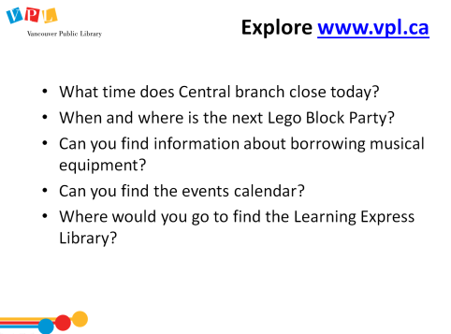 | 15 min | EXPLORE VPL.CA  Ask learners for guidance on where they might find information on VPL webpage. Do the first couple together, then let them continue while you rove and help  Questions:  - What time are we closing today?  - Can you find the events calendar?  - When is the next Lego Block Party?  - Can you find info on borrowing Musical Instruments?  - Where would you go to find: the Lynda.com database? | - Respond to trainer’s prompts | - See previous
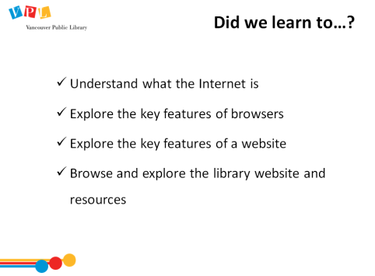 | 3 min | DID WE LEARN HOW TO…?  - Ask: Did we meet all of our goals today?  - Was there anything we didn’t cover?  - Do you have any other questions and/or comments  Refer learners to resources on the handout  Review how to search for more classes | - Listen to instructor  - Ask and answer questions
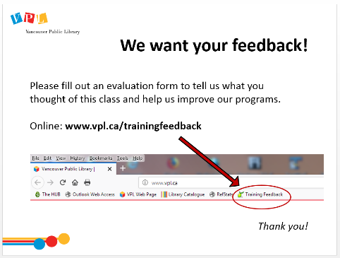 |  | EVALUATION FORMS  Ask them to take some time to fill out the evaluation form. If possible, have them fill out the form online. If not, provide them with the paper forms:  - We would like your feedback! Please take some time to fill out an evaluation form to let us know what you enjoyed and what could be improved.  - There is a bookmark link to the form on all computers.  - You can also access the link by going to http://www.vpl.ca/trainingfeedback
 | 25 apx | Time for practice, questions, etc – Encourage learners to explore the VPL website, review the handout, check out the Computer Survival Guide and the GCF Learn Free website.

Closing
- Thank learners for coming
- Ask them to take some time to fill out the evaluation form

