Get the Most out of Internet Searching

Handout

SEARCHING

Define your question

Set your expectations
- When I find the answer, what do I think it will look like?

Identify search terms + synonyms
- Use keywords, not sentences
  - “weather Vancouver tomorrow” vs. “what will the weather be like in Vancouver tomorrow?”
- Use nouns and verbs
- Use at least 3 words if possible
- Spell out abbreviations

Narrowing your search using words and symbols:
- Search for an exact match: put a word or phrase inside quotes.
  - Ex: “coble boat”
- Search for wildcards or unknown words: put a * in your phrase where you want to leave a placeholder.
  - Ex: “diabetic * diets”
- Exclude words from your search: put - in front of a word you want to leave out.
  - Ex: cookie recipe -chocolate (to look for a cookie recipe that doesn’t have chocolate in it)

Evaluate Results
- Use the CRAAP test, and check for Fake News

Adapt your search
- Would this search benefit from additional keywords? Using a synonym instead?
- Most search engines will offer a list of search suggestions while typing in the search box– this can give you ideas for search terms that you may not have thought of

Keep searching!
- Find more sources, cross-reference, refine your skills and get the best answer possible

READING A WEBSITE
Locate the main content. This is usually the most relevant part of the page. On most pages it's easy to find, although you may sometimes have to scroll down.
Make sure you're on the right webpage. If you don't see any relevant information, use the navigation bar or search box to find a different page.
Use headings to help skim the page. Many online articles have a heading at the beginning of each section. If the heading doesn't seem relevant, skip that section.
Don't read every word. With most websites, you can skim the page to find what you're looking for. Read the first sentence of each paragraph.
Ignore ads. Ads are often embedded in an article or disguised as links. They may look like they're relevant, but they usually won't help you find what you're looking for.
Use the back button. If you've clicked on a link that isn't helpful, you can go back to the previous page by clicking your browser's back button. If the link was opened in a new window or tab, you may need to close it instead.
CTRL+F. Use CTRL + F to find a particular word on a webpage.

EVALUATING A WEBSITE – CRAAP GUIDELINES
Currency: The timeliness of the information
- When was the information published or posted?
- Has the information been revised or updated?
- Is the information current or out-of date for your topic?
- Are the links functional?

Relevance: The importance of the information for your needs
- Does the information relate to your topic or answer your question?
- Who is the intended audience?
- Is the information at an appropriate level (i.e. not too basic or advanced)?
- Have you looked at a variety of sources before deciding this is one?

Authority: The source of the information
- Who is the author/publisher/source/sponsor?
- Are the author's credentials or organizational affiliations given?
- What are the author's qualifications to write on the topic?
- Is there contact information, such as a publisher or e-mail address?
- Does the URL reveal anything about the author or source?

Accuracy: The reliability, truthfulness, and correctness of the content
- Where does the information come from?
- Is the information supported by evidence?
- Has the information been reviewed or referred?
- Can you verify any of the information in another source or from personal knowledge?
- Does the language or tone seem biased and free of emotion?
- Are there spelling, grammar, or other typographical errors?

Purpose: The reason the information exists
- What is the purpose of the information? To inform? Teach? Sell? Entertain?
- Do the authors/sponsors make their intentions or purpose clear?
- Is the information fact? Opinion? Propaganda?
- Does the point of view appear objective and impartial?
- Are there political, ideological, cultural, religious, institutional, or personal biases?

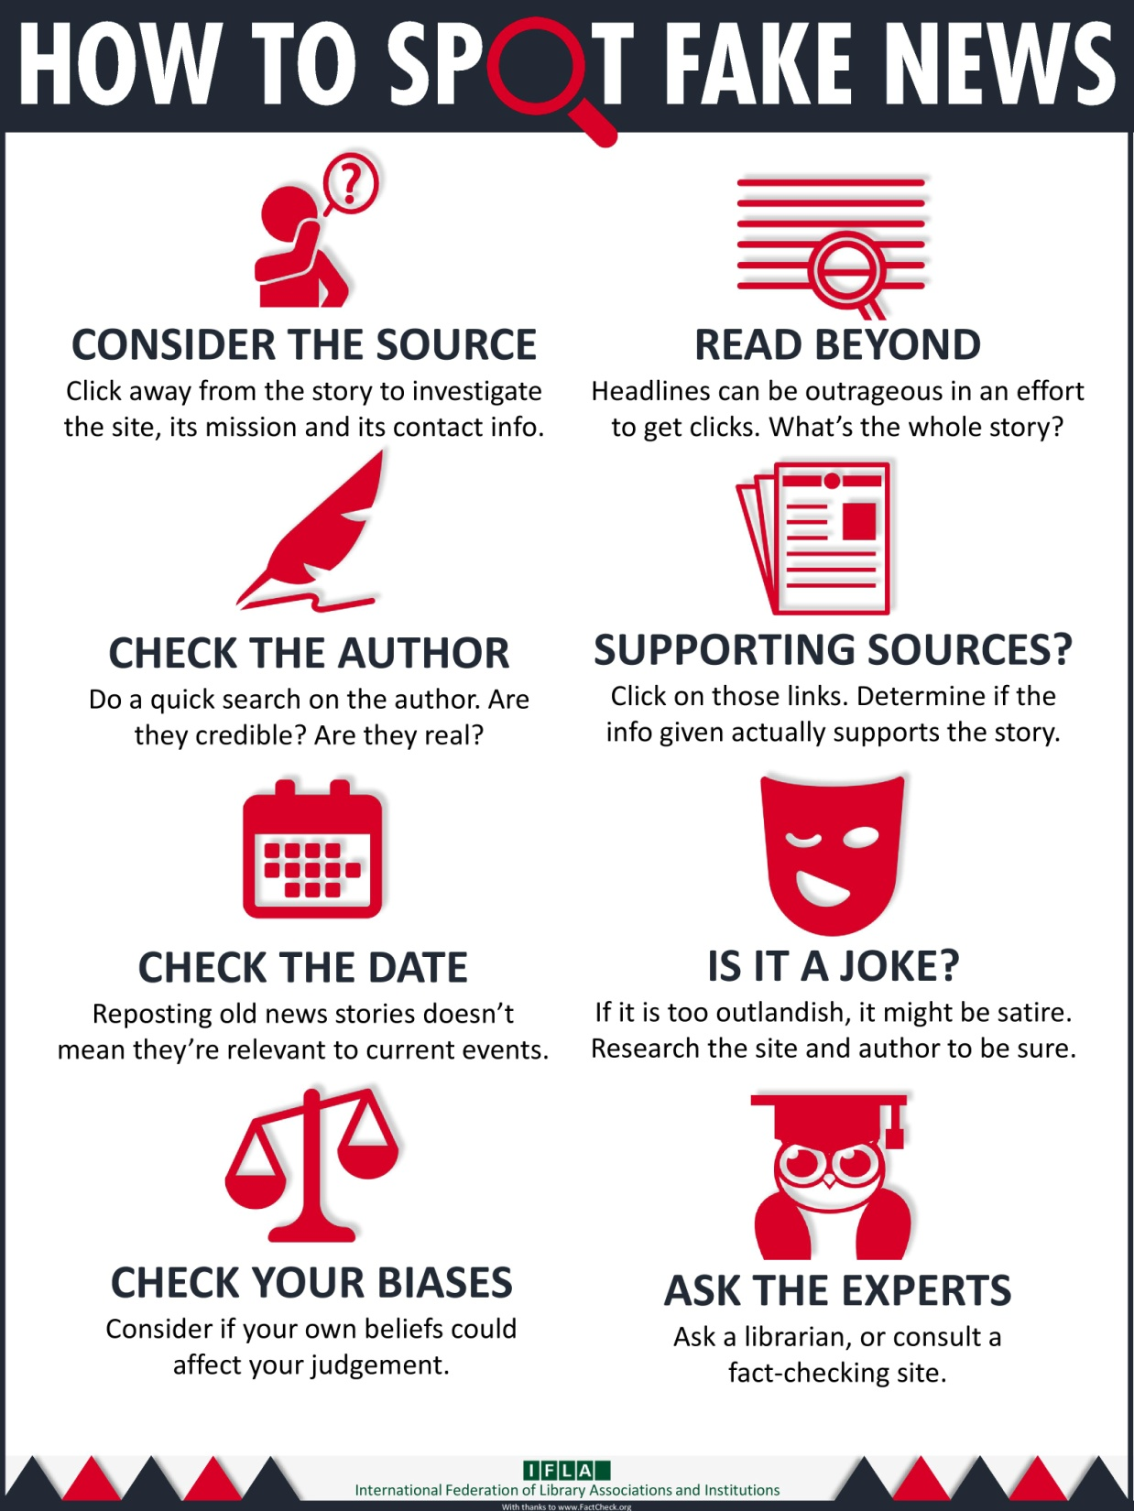

FACT CHECKING WEBSITES
- Assess the truthfulness or facts behind a claim
- Often focused on politicians
- May also address online hoaxes and myths
Examples
- Factscan.ca: nonpartisan fact-checker on Canadian federal politics
- Factcheck.org: monitors the factual accuracy of what is said by major U.S. political players
- Snopes.com: U.S.-based; broader focus than just assessing politicians’ claims
- Fullfact.org: U.K.’s independent fact-checking charity

LEARN MORE
VPL Events Guide | For days, times and locations, check out the “Computer & Technology” category in our Events Calendar. You can also look in the paper brochure “VPL Classes & Workshops”. | www.vpl.ca/events
VPL Computer Practice Drop-In | A drop-in to practice new skills with information staff assistance. | Central Library  Tuesdays & Thursdays  2:00 - 3:00 pm
GCFLearnFree.org tutorials | Free online tutorials for learning a range of essential skills including computer, technology and internet skills. | www.gcflearnfree.org
DigitalLearn | Online hub for digital literacy support and training. Great video-based modules with narration for basic digital skills learning! | www.digitallearn.org
VPL Information Services | We are here to help!  If you have any further questions, please ask us! | Phone: 604-331-3603 Email: info@vpl.ca
VPL Research  Guides | Computer Survival Guide  Information and self-directed practice activities on introductory computer and Internet topics. | guides.vpl.ca/computers

