AT THE LIBRARY
Go to this link
http://www.lexilogos.com/keyboard/index.htm
which will give you the option to type in foreign languages on a Surrey Libraries computer.

You must use the link above (or another keyboard website) if you wish to type in foreign languages on a Surrey Libraries computer. The other method of typing in foreign languages shown below only works on your laptop or personal computers at home, NOT with our public computers!

ON YOUR OWN COMPUTER
Instructions for adding a foreign language keyboard, and for adding an on-screen keyboard (p.5)

- Click on the Start button, and go to the Control Panel.
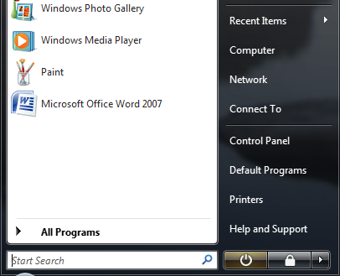

- Click on Change keyboards or other input methods under Clock, Language, and Region.
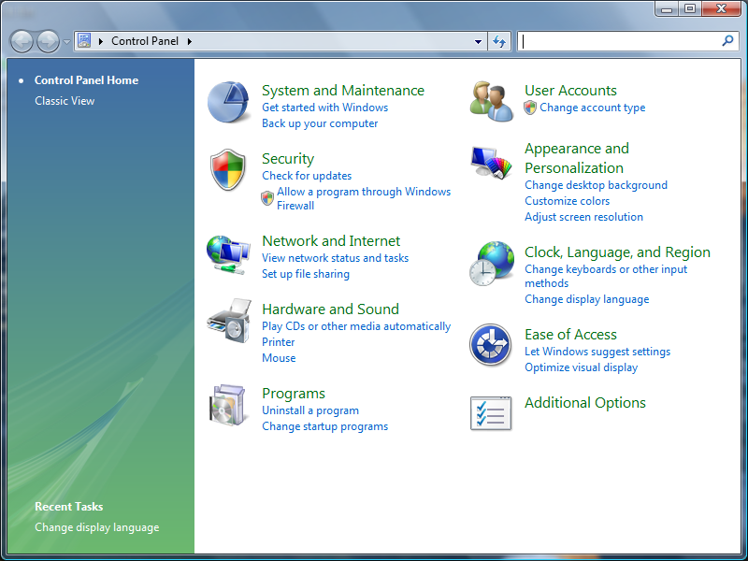

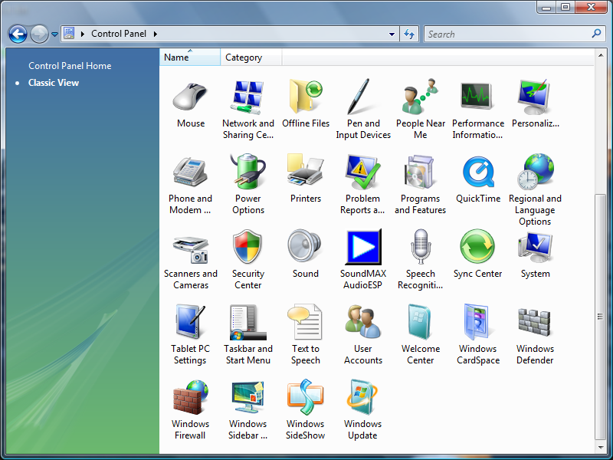
If the Control Panel is set under Classic view, click on Regional and Language Options.

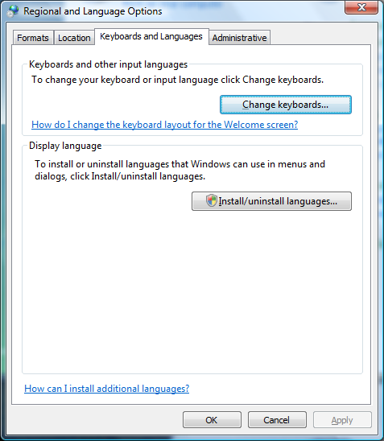
- Click on Change Keyboards.

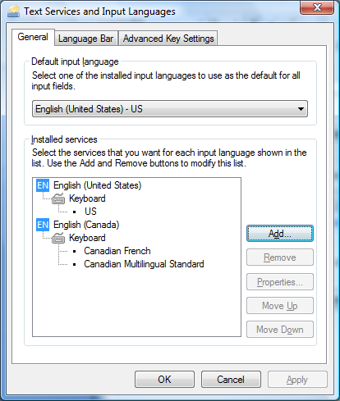
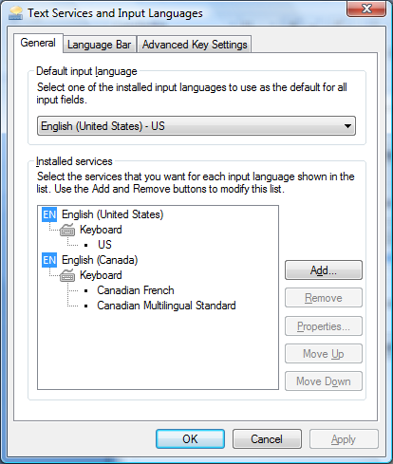
- The following window displays the keyboards currently installed on your computer. To add a new keyboard, click Add.
This window shows you the keyboards currently installed on your machine.
You can set the default input language here.

Upon selection of a particular keyboard, these buttons will stop being greyed out and be able to be clicked.
Remove will get rid of a keyboard. Properties will bring up a set of options to customize the keyboard.
Move up will shift a keyboard upwards and change the order that the keyboards appear in the language bar (see below). Move down will shift a keyboard downwards.

- Choose the keyboard(s) you wish to install, and click OK. Most languages contain multiple keyboards that each have their own unique layouts and properties. Try installing several different keyboards to discover which one you prefer.
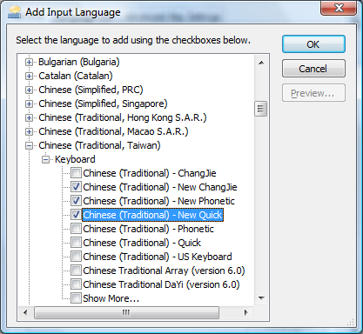

These are 3 keyboards I want to install. Click the squares on the left side and check marks will come up, indicating that you wish to install a particular keyboard.

- You will be taken back to the Text Services and Input Languages window, and you will see the language that you just installed. Click Apply then OK to activate the new language.
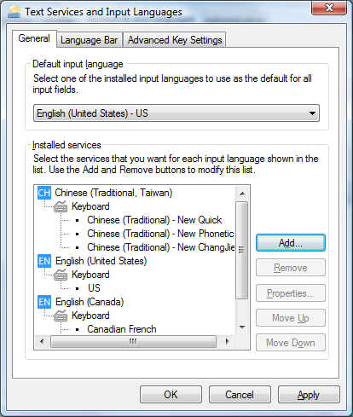

Here is the language that I just installed, including the 3 keyboards that I chose in step 6.

- Now, you should see an EN pop up on the right side of the taskbar. This is the Language Bar, and you can click on it to switch between input languages…
Language Bar

Choose which language you want to use by clicking on it.

…and you will see the options available in the Language Bar for the language you have chosen.
Switch between half shape and full shape*
Switch between keyboards
*Half shape: English text remains the same width as when English is the input language
e.g. 你好
Hello
Full shape: English text is stretched to the same width as Chinese characters
e.g. 你好
Ｈｅｌｌｏ

Tool Menu – Click to display more options for the chosen input language
Switch between English and Chinese character sets
Switch between input languages

Please keep in mind that each input language has its own unique set of properties and options, thus the menu options may be different than what is displayed above.

- To view more options, click the Tool menu.
Option to handwrite Chinese characters
Displays the keyboard on the desktop as a reference

Includes more specific customization options, including keyboard shortcuts, dictionaries, and changing the keyboard layout (e.g. Hanyu Pinyin)
Displays a keyboard to insert special symbols

- And now you are ready to start typing!

ALTERNATE OPTION – ON SCREEN KEYBOARD

Some languages don’t include an option to display a software keyboard in the language bar. Instead, you can use this method to access an on-screen keyboard.

- Click on the Start Button, and click on All Programs.

- Click on Accessories.
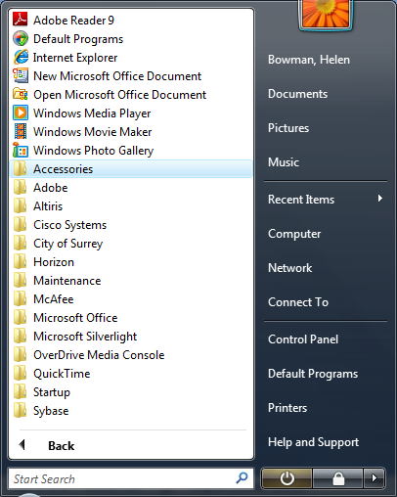

- Click on Ease of Access.
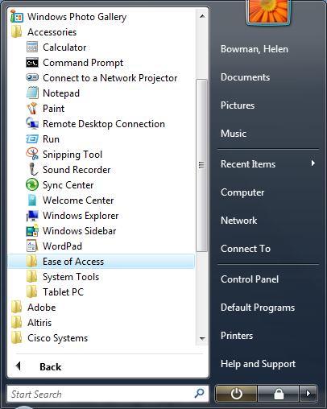

- Click on On-Screen Keyboard.
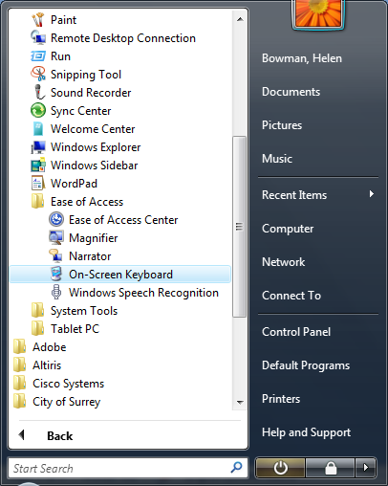

- Now, you should see this keyboard on your screen.
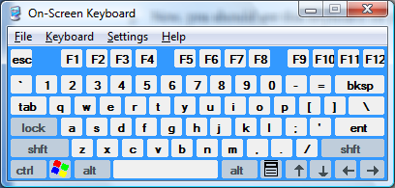

- If you want to change the language being displayed, you will need to select the specific input language and/or keyboard that you would like to see. Here, I will change it to Punjabi. Keep in mind that, in order for this to work, you need to change the language settings while the On-Screen Keyboard is the selected program.
Select the keyboard that you would like to use.
Select the input language that you want to use.

- Now you should see the On-screen keyboard displayed in your language.

