如何使用Google搜索
How to Search with Google

Google is a great website for searching or looking up something you are interested in. To search on Google:
Google 是一个对于搜索非常有利的网页。若想在Google上搜索：
- Open your internet browser (e.g. Internet Explorer, Google Chrome, Mozilla Firefox, Safari, etc.)
开启您的网络浏览器 (例如Internet Explorer, Google Chrome, Mozilla Firefox)。
- Click on the address bar (where the website is) once.
按一下网址栏 (显示网址的地方)。

- Type google.ca in the address bar, and press ‘Enter’ on your keyboard.
在网址栏输入google.ca，并且按Enter键。

- The Google website will load with a blank search box – it should look like this:
Google的网页会显示出一个空白的搜索兰。

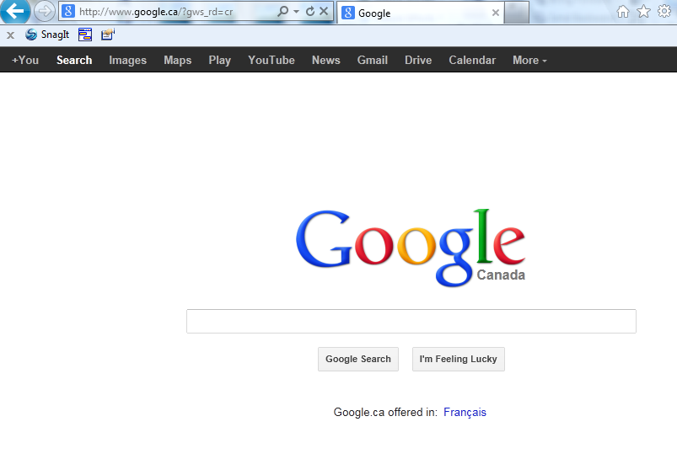
Click on the search bar and type in whatever you want to look for (eg, Canadian Passport Application form)
按一下搜索兰并且输入您想找的资讯(例如，加拿大护照申请表)。

- In the blank search bar, type in 2 or 3 words describing what you’re looking for in the empty search box. Then click on Google Search or press Enter on your keyboard.
在空白的搜寻栏里输入您想找的资讯或形容词，并且按Google Search或Enter键。
For example, you can try the following searches:
您可以输入类似以下的搜索：
- 素里工作
- 魔戒的评论
- 北温日式餐厅
- 蛋糕食谱
- Jobs in Surrey
- Lord of the Rings review
- Japanese Restaurants in North Vancouver
- Cake Recipes
- After you click the search button, a list of results matching what you typed in will appear. Generally, the ones which more closely match your words will appear first.
Google会列出搜索结果。比较合您输入的搜索关键词的网页会率先列出来。
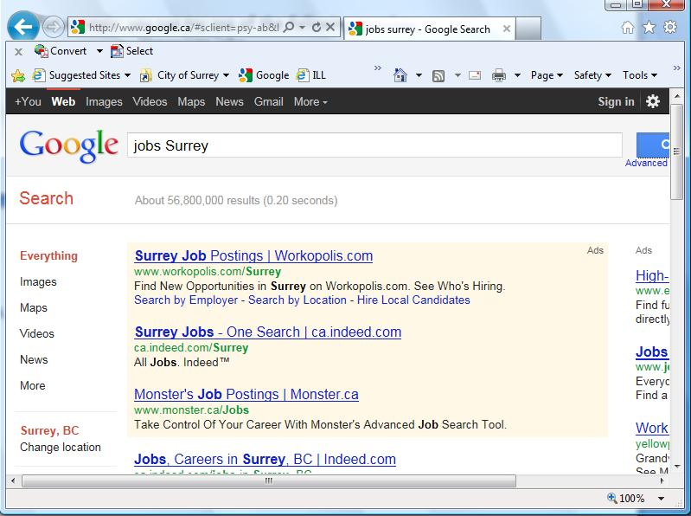
Use these scroll bars to go up and down on the page and view all results
您可以用网页边边的滚动条来观看所有的搜索结果（网页下面通常还有更多结果）。

- Read the brief descriptions of the results displayed and if you feel that one of them may contain information relevant to what you searched for, click on the hyperlink of the page
搜索结果下会有简介。若有看到任何您觉得符合您要找的咨讯就按下那结果的超链接。
- If none of the pages listed on the first page of results match your criteria, you can scroll down to the bottom and click on Next, or 2 to go to the next page containing results. Many web pages are generated by a general search, but the relevant ones are usually found in the first couple of pages.
若您觉得搜索结果第一页列出的网页都不是您所想要的，那您可以向下滚动您的网页并且按下一页或2来移动到下一个搜索结果的网页；通常相应您输入的关键词的网页会在第一页。
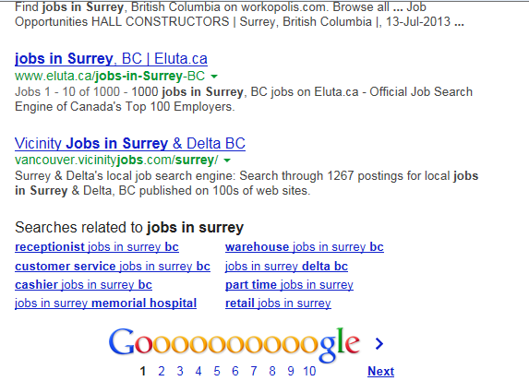
Click here to see more results.
按这就会显示下一页的搜索结果。
- If you click on a link and feel it doesn’t satisfy your search criteria, use the back button to go back to the results page to find another page. Or, you can scroll up to the top and try modifying your search by changing some words in the search box and then hitting ‘Google search’, or pressing the ‘Enter’ key again.
若您按了一个链接然后发现它不是您想要的，您可以用上一页的按钮回到搜索结果页并且再寻找您所想要的网页。您也可以试着更改搜索栏里的关键词好修饰您的搜索结果。

