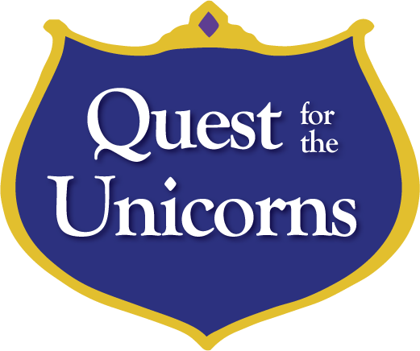
Welcome to the Enchanted Kingdom, where magical creatures live! As part of the royal family you must go on a quest to find the unicorns and play them a song. Help magical creatures along the way, and they will give you music notes. Let’s find the unicorns!

Bienvenue au Royaume Enchante, ou vivent des creatures magiques! Puisque vous etes un membre de la famille royale, tu dois aller sur une quete pour trouver les licornes et ils joueront une chanson. Aidez les creatures magiques tout au long de ton voyage et ils vont te donner des notes de musique. Allons-y trouver les licornes!

Collect music notes (coloured dot stickers) from around the Enchanted Kingdom as you complete your royal quest.

Swamp (Le Marais)
The swamp gnome is hungry. Carry his food across the swamp by stepping on the rocks. Don’t fall in!

Le gnome du marais a faim! Aide- lui a transporter sa nourriture a travers le marais par seulement marche sur les roches. Ne tombe pas!

Players pick up the pieces of food and carry them one by one across the swamp area, only stepping on the rocks cold-laminated to the floor. Put food into basket beside gnome after crossing the swamp.

Mountains (Les Montagnes)
The Yeti loves fancy snowflakes. Put his favourite snowflakes in order from smallest to biggest before the wind blows them away!

Le Yeti aime les flocons de neige joli. Met les flocons de neige favoris en ordre du plus petit jusqu’au plus grand, avant que le vent les disperses!

Snowflakes are magnetized around the mountains area; players find them and put them in order on magnets by the Yeti.

Forest (Foret)
The pixies are all mixed up! Match the wings and the crowns to the right pixies.

Les lutins sont tous melanges! Associe les ailes et les couronnes avec leurs propres lutins.

Wings and crowns are on magnets all over the forest area. Players find them and put them on the correct pixies based on colour.

Castle (Chateau)
The baby dragons are flying for their first time! Find all of the dragons flying in the sky around the Enchanted Kingdom.

Les bebes dragons volent pour leurs premiers fois! Trouve tous les dragons qui volent dans le ciel autour le royaume enchante.

Walk around the preschool game area, counting the dragons. Player may need hints.

Village (Village)
The elves in the village need music for their festival! Play a song on the drums.

Le village besoin de la musique pour leur festival! Joue une chanson sur le tambour.

Shapes on the wall coordinate to the shape of the drums. Players play the song by matching these shapes.

Pond (Etang)
The rainbow fish got lost! Fish them out so they can find their families.

Les poissons arc-en-ciel sont perdus! Fait la peche pour qu’ils peuvent retourner a leurs familles.

Use magnetic fishing rod to get the fish into the “water bucket” by their mother.

Troll Bridge
The troll needs some flowers to decorate his house. If you match his flowers, he will let you cross his bridge.

Le troll a besoin de decorer sa maison avec des fleurs. Si vous etes capables de correctement associer les fleurs, il va te laisser traverser son pont.

Players group the flowers by color or by number of petals, magnetized to the wall next to the bridge. Player walks across the bridge after completing the task.

Final Room
Players are brought to the Unicorns room at the back of the school-age game area, where they play the xylophone song based on the music notes on their file card. Then they receive a sticker, a certificate, and an activity book.

