Pokémon and the Library

What is Pokémon?
This is a game that was originally released in 1995 as a gameboy game, and has been popular ever since. The element of collection and competition, plus the cute graphics, makes it quite compelling.

What is this Pokémon Go game?
An earlier mapping game was used to create the points of interest in Pokémon Go, and then the creatures and interactive elements were added on. As a result, all over the world there are Pokémon, PokéStops and Gyms. The main goal of the game is for people to collect and level up creatures, which can only be done by walking (biking, skateboarding) around. People download the app, and then the app tracks their location, and also uses the camera to show the Pokémon in the real world (augmented reality). The game is wildly popular at the moment (the CBC can’t seem to stop talking about it) but it is a drain on phone batteries.
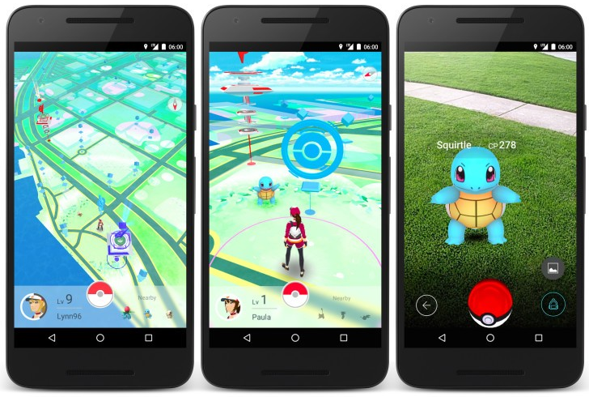

Jargon of Note
- PokéStops: Places to collect supplies.
- Gyms: Places to get rewards (prestige, improving their creatures) for “battling” your Pokémon against other players. This involves being at the location while battling.

What does the library have to do with it?
Libraries as public spaces are often sites of PokéStops or Gyms. This means that players will be hanging around. They will typically be teens and young adults.
Locations of interest near the library
- The “West Vancouver Memorial library” sign at the front of the library
- The Memorial plaque at the base of the flag

Related local stops are:
- The Memorial library placard on the seawall
- And there are 5 stops in Memorial park (signs, placards, plaques on trees).

If you get asked about:
- Accessing non-public areas: let the person know that the area they are interested in isn’t public, but if they stand nearby that might be enough.
- How people are using it: downloading it from the App store for Apple or Android.
This is a great chance to welcome people to the library and let them use our Wi-Fi and loan them device chargers. We can also let people know about our collection of Pokémon materials (fiction, non-fiction and DVDs) as well as local trails, travel and history.
Further Reading:
- School Library Journal “Pokémon GO: What Do Librarians Need To Know?” http://www.slj.com/2016/07/technology/applications/pokemon-go-what-do-librarians-need-to-know/
- “Everything Librarians Need To Know About Pokémon Go!” http://galaxybookjockey.tumblr.com/post/147240001718/everything-librarians-need-to-know-about-pokemon
- “Why Pokémon Go and The Library is a perfect partnership” | ALSC blog http://www.alsc.ala.org/blog/2016/07/pokemon-go-library-perfect-partnership/
- Learn the basics
- How to play pokemon go:
- Why is everyone talking about it?:
- How Canadians are playing P:G pre-release

