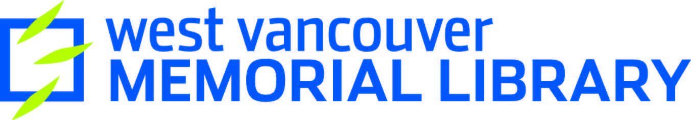
Draw with Code

What is Python?

Python is a widely used high-level, general-purpose, dynamic programming language. Its design philosophy emphasizes code readability, and its syntax allows programmers to express concepts in fewer lines of code than possible in other coding languages.
The Turtle module allows us to code in a visual manner, making art and drawing pictures with commands like: forward, backwards, right, left, color, shape.
Today we’ll be practicing using this website: https://trinket.io

Activity 1

import turtle
wn = turtle.Screen()
tommy = turtle.Turtle()
tommy.shape("turtle")
tommy.forward(50)
tommy.right(90)
tommy.forward(50)
tommy.right(90)
tommy.forward(50)
tommy.right(90)
tommy.forward(50)

Activity 2

mabel = turtle.Turtle()
mabel.shape("arrow")
mabel.right(180)
mabel.forward(80)
mabel.right(120)
mabel.forward(80)
mabel.right(120)
mabel.forward(80)
mabel.right(120)
mabel.forward(39)
Activity 3

tommy = turtle.Turtle()
tommy.shape("turtle")
tommy.color("purple")
for i in [0,1,2,3]:
tommy.left(90)
tommy.forward(50)

Activity 4

d = turtle.Turtle()
d.shape("turtle")
d.color("red")
d.circle(50)

Activity 5

e = turtle.Turtle()
e.shape("turtle")
e.color("green")
e.up()
e.forward(100)
e.down
for i in range(5):
e.forward(50)
e.right(144)

Challenges!

See if you can make some turtles draw:
- Olympic Rings
- Name
- Smiley face
- Many sided shape

Learn More

Online Resource List: http://wvml.ca/code-art
Python Turtle Library: https://docs.python.org/3/library/turtle.html
Code Academy https://www.codecademy.com/
Hour of Code & Code.org https://code.org/
Paul Ford “What is Code” http://www.bloomberg.com/graphics/2015-paul-ford-what-is-code/

