Using OpenLibrary on your Sony Reader
(Wi-Fi and non-Wi-Fi models)
Compatible Formats: EPUB, PDF
OpenLibrary is a project created by The Internet Archive, which is a non-profit organization. This site contains information about 20 million books, with new ones being added every day. Some of the books on this site are available as e-books you can download. Others are just listings of the book information, with a link to how you can find that book in a library. This makes the OpenLibrary site a bit confusing, so if you are new to library e-books, you may want to start with OverDrive or Freading instead.
Within the OpenLibrary collection are some titles that have been donated by partner libraries. Libraries send in one or more books to be scanned and added to the OpenLibrary, and that pool of books can only be borrowed by members of those libraries. Strathcona County Library has joined this project and our patrons have access to this collection. OpenLibrary books are in EPUB or PDF format. OpenLibrary calls these books “In-Library Loans.”
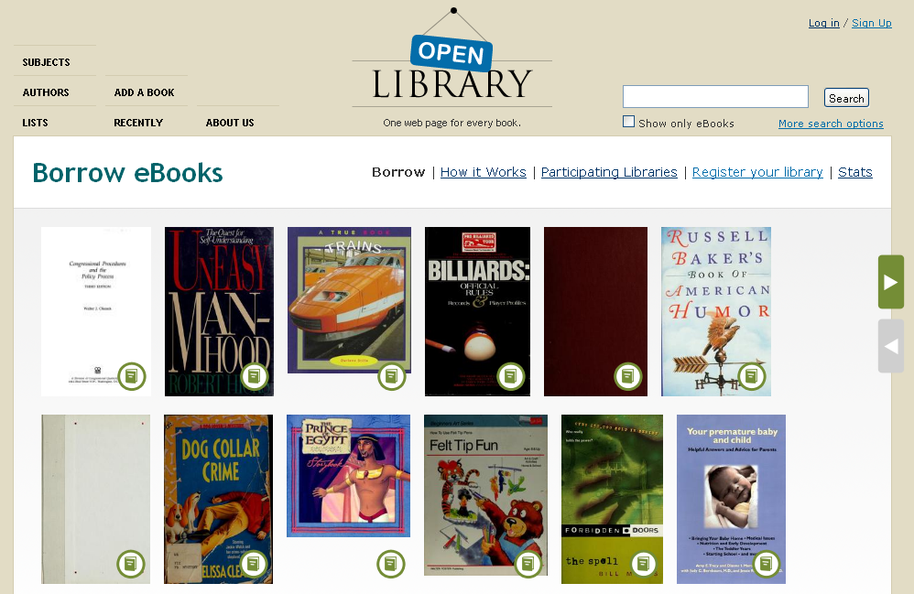
What’s Required
OpenLibrary e-books must be downloaded to a computer and transferred to your Sony Reader (note that OpenLibrary e-books cannot be downloaded through the Sony Reader Wi-Fi browser).
You need to have two pieces of free software installed on your computer, Adobe Digital Editions and Sony’s Reader for PC.
- Adobe Digital Editions is available for download at: http://www.adobe.com/products/digitaleditions/ . See the “Help for Adobe Digital Editions” handout for more information.
In order to use ADE to transfer items to your e-reader, you will have to make an Adobe ID. This ID allows you to read a downloaded eBook on multiple devices, including e-book readers. For more information on how to set up Adobe Digital Editions with an Adobe ID, please see the “Help for Adobe Digital Editions” handout.
- Reader for PC is available for download at: http://ebookstore.sony.com/download/ See the “Help for your Sony Reader using Reader for PC” handout for more information. You may have already installed this software if you have synced your Sony Reader with your computer before.
Getting Started
In order to get to OpenLibrary books, you will need to either (a) be in the library, using our wireless; or (b) log in via the library website. On your computer, go to www.sclibrary.ab.ca/download.htm to get started, and then click on the link to OpenLibrary. If you are not in the library, you will be asked to log in with your library card and PIN (the last 4 digits of your phone number).
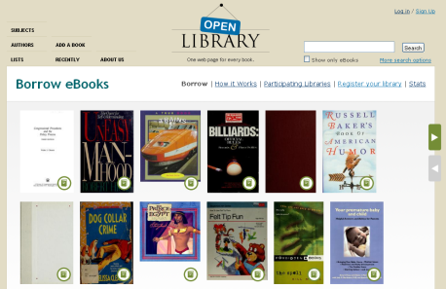
When you click on the link from SCL’s website to OpenLibrary, you will see a page with many book covers (shown to the left).
The OpenLibrary site can be confusing because it contains many listings for books, some of which are actual e-books that you can download, and others of which are only links to help you find the book in a library.
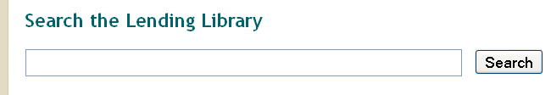
The easiest way to find e-books that you can download is to always use the “Search the Lending Library” search (see left).
When you search for an author, title or keyword, you will see a list of search results like this:
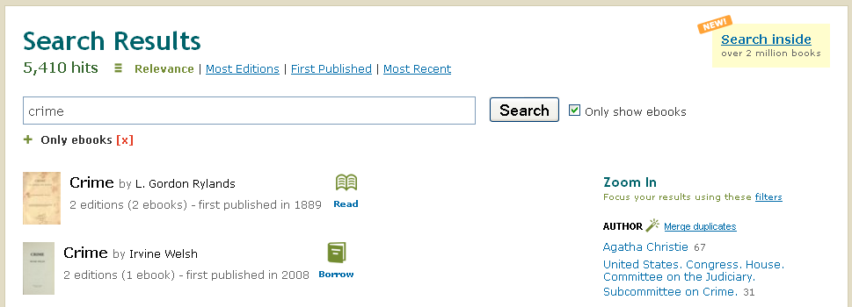
Once you see search results, check for books that are available to “Read” or “Borrow.” Look for these icons next to the book cover and title:
Read
This book can be read in your browser and sometimes also downloaded. Books with the “Read” symbol are often older books that are out of copyright and can be freely distributed.
Borrow
This book is available for you to borrow as a patron of a library participating in OpenLibrary’s Lending Library. You can read it in your browser or download it to read in an app.
Checked Out
This book has been checked out by another user. You can check back for it next time you visit the OpenLibrary site and see if it is available.
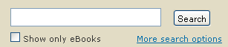
If you use the search in the top right-hand corner of OpenLibrary (shown at left), you will find a greater variety of titles. But not all of those books will be available to read/download. To make sure you only see titles that are available, only use the Lending Library search.
To get back to the main Lending Library page, direct your browser to the URL http://openlibrary.org/borrow. If you get lost in the site, you may need to type this URL in to your browser to return there.
How to Download
When you find a book you would like to borrow, click on the title to go to the detailed information page. In the right hand column, you will see links related to borrowing that book. Click the “eBook” link.
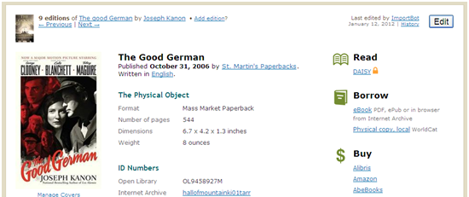
You will be asked to log in to your OpenLibrary Account, if you have not already done so.
You will have to choose a reading/download option, as shown here:
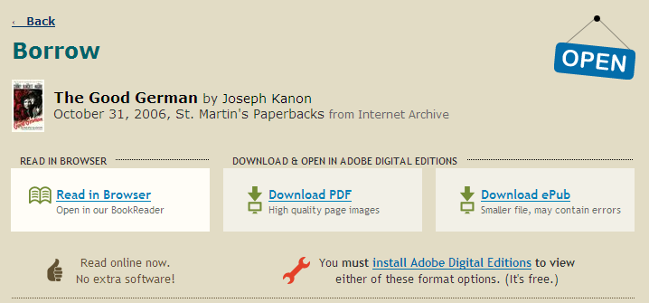
To download the book and transfer it to your reader, select either PDF or EPUB file format.
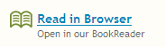 | Read in Browser will allow you to read an OpenLibrary book in your browser, although you may find the text hard to read. Sony WiFi only.
 | PDF files are higher quality because they are scans of the original book. These files take up more space on your computer or device. Not all devices can open PDF files.
 | EPUB files are lower quality, but they also take up less space. They may contain errors sometimes because they are automatically transcribed from the original scans.
Once you select a format, your download will start. When the file finishes downloading, you will be prompted on what you want your computer to do with it.
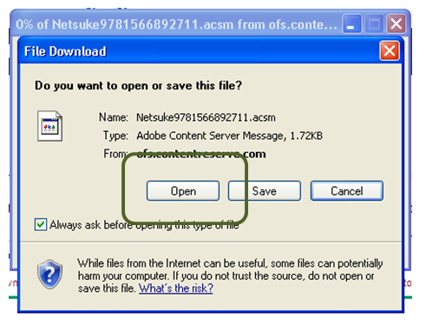Choose “Open” or “Open with Adobe Digital Editions” (see left). Depending on how your computer is configured, Adobe Digital Editions may already be selected for you. If not, you may have to find it on the list of available programs.
When you select OK, Adobe Digital Editions will load with the book you just downloaded. You can now transfer this item to a Sony Reader following one of the processes below.

Transferring to a non-Wi-Fi Sony Reader
Plug your Sony Reader in to your computer using the USB cable. When your Sony Reader is successfully connected to your computer, it should show up at the bottom of the list of Bookshelves (as shown below, except it will say Sony Reader, or something similar, instead of KOBOeReader).
The book will automatically load in reading view. To switch back to an overview of all your items, click on the “Library” button (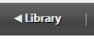). The book you just downloaded should now appear on your “All Items” and “Borrowed” Bookshelves.
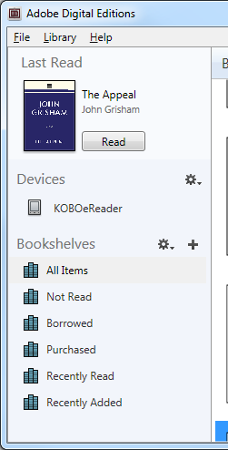To add a borrowed eBook to your Sony, drag and drop the book from the main Library screen to your e-reader, which should show up under “Devices” in the left-hand menu of Adobe Digital Editions. (See left.) Drag the book cover onto the name of your reader in the left-hand menu. When your cursor is over the name of your reader, you will see it turn into a little green “plus” sign. This means that the book will be added to your Sony. When you release the mouse button, you may see the item being transferred, although sometimes this happens so fast it is difficult to see.
You can now disconnect your Reader and read the OpenLibrary e-book.

Transferring to a Sony Reader Wi-Fi
Plug your Sony Wi-Fi in to your computer, using the USB cable. Make sure your Sony is in Data Transfer Mode by pressing the “Date Transfer Mode” option on the touch screen- if this option does not automatically come up, unplug the USB cable and plug it back in.
Close Adobe Digital Editions (if you have not already done so) and open Reader for PC.
You need to import the file from Adobe Digital Editions to Reader for PC. Under the File menu (in the top left corner) choose “Import Files”:
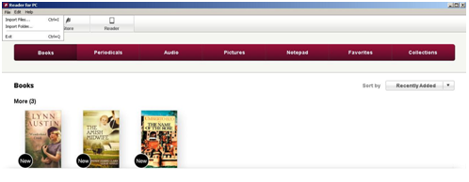
The OpenLibrary e-book files will be found under Documents/My Digital Editions/title of the book. Click on the title of the e-book you want to import, then click “Open.” The e-book file will be imported to Reader for PC.
Next, go to “Reader” in the top menu bar.
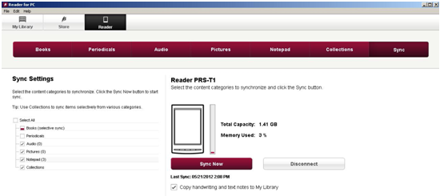
Once there, click on “Sync Now” to transfer the e-book to your Sony Reader Wi-Fi. Then click on “Disconnect” to safely disconnect your Reader. You can unplug the Reader from your computer and read the OpenLibrary e-book.
Returning an Item Early
It is possible to return an OpenLibrary e-book early in Adobe Digital Editions. This allows you to check out a new title (if you are at your limit of 5 checkouts) and also frees up the book for another patron to borrow.
To return an item early, go to your Library view, if you are not already there. (Click on the “Library” button in the top left corner: 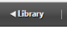). Right click on the title you want to delete, and a menu will appear. Click on “Return borrowed item”.
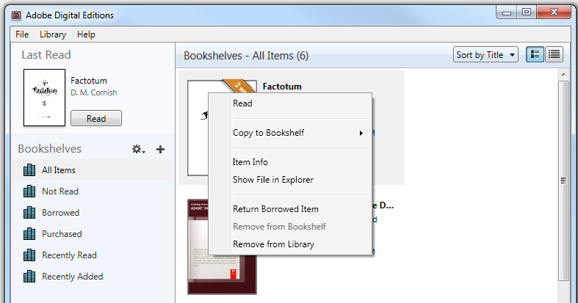
Note: This action cannot be undone. However, you are welcome to borrow that title from the library again in the future.

If you have any questions, please feel free to contact us:
Phone: 780.410-8601 | Email: info@sclibrary.ab.ca | or stop by one of our Information Desks
Last updated: October, 2012

