Using OneClickdigital

Creating an Account
From the OneClickdigital home page click on: Create New Account

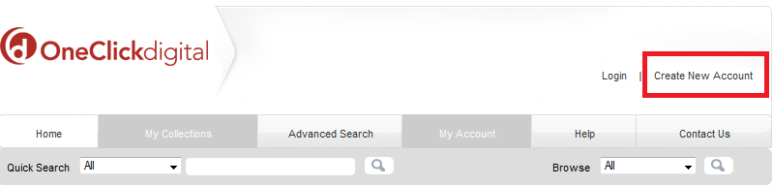
Fill in:
- Your library card number
- Your first and last name
- Postal Code
- Email Address
- Username (not your email address)
- Password
Click on Create an Account

Checking Out Titles
- Click on the cover of the book that you are interested in.
- Click on Checkout Now!
- If it is not available, you can put the book on hold by clicking on Hold

Downloading Titles
- Login
- Click on My Collections
- Click on Download Now next to the title

Using the OneClickdigital App
This app is available for iOS & Android.
- Locate in App store & download (free)
- Sign-in
- Find title
- Checkout & Download
- If you find that you cannot see your downloaded title, close the app, and then open it again.

Installing the Media Manager on your home computer
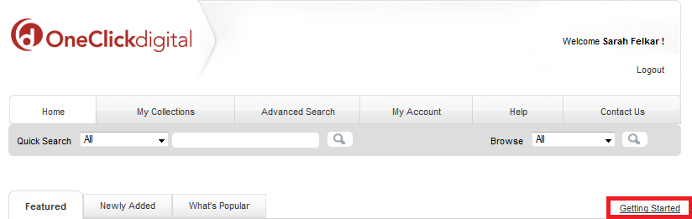

- From the home page click on Getting Started
- Choose the download link
  - Windows or Mac download
- Follow the steps on your screen.
- Now, when you checkout an audiobook it will appear in the OneClickdigital Media Manager.

Searching for Audiobooks
Browse audiobooks by genre by clicking on the Browse drop-down menu, choosing a genre, and then clicking the search icon.

To find a particular book you can use the Advanced Search.
- Click on the Advanced Search tab
- Fill in the information
- Click on Search

Renewing & Returning Audiobooks

To Renew
- Login
- Click on My Collections
- Click on Renew next to the title.
To Return
- Login
- Click on My Collections
- Click on Return Now next to the title

Troubleshooting
Under the Contact Us tab the OneClickdigital website is the company mailing address, phone number and email address are available.

Or you can also visit: westvanlibrary.ca/ask-us for assistance.

