Book Information | Book Description | Accompanying Song or Rhyme
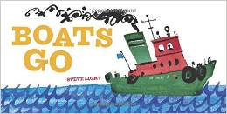  Boats Go by Steve Light (J+FIC) 2015 | Steve Light’s latest, “Boats Go” follows on the success of toddler favourites “Trucks Go” “Trains Go” “Diggers Go” and “Planes Go.” Transportation fans will love toot tooting and putt putting along with a speedboat, tugboat, sailboat and even a fire boat. This extra long board book is perfect for even the youngest readers. | Motorboat motorboat go so slow  Motorboat motorboat go so fast  Motorboat motorboat step on the gas!  Tugboat tugboat go so slow  Tugboat tugboat go slightly faster  Get a move on tugboat!
The Book with No Pictures by B.J. Novak (J+FIC) 2014  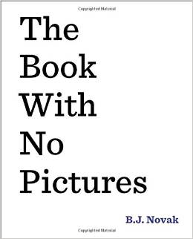 | “It might seem like no fun to have someone read you a book with no pictures...” except “Everything the words say, the person reading the book has to say. No matter what.” Children will love hearing their caregiver “forced” to speak in a robot monkey voice, sing silly songs, and say whole pages of nonsensical sounds, protesting all the while. | A ram sam sam, a ram sam sam  Gooly gooly gooly gooly  and a ram sam sam  (Repeat twice)  A raffi! A raffi!  Gooly gooly gooly gooly  and a ram sam sam!
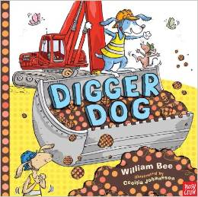  Digger Dog by William Bee (J+FIC) 2014 | Digger Dog loves to dig up bones, the bigger the better. But for the biggest bone in the world, what will Digger Dog need? The biggest digger in the world, of course! All through the story, the diggers get bigger, the hole gets deeper, and there is a fantastic fold-out surprise at the end! | I have a dog and his name is Rags.  He eats so much that his tummy sags,  His ears flip flop and his tail wig wags.  And when he walks, he goes zig zag.  He goes flip flop, wig wag, zig zag.  He goes flip flop, wig wag, zig zag.  He goes flip flop, wig wag, zig zag.  I love Rags and he loves me.
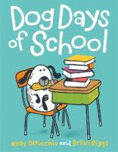  Dog Days of School by Kelly DiPucchio (J+FIC) 2014 | Charlie is so nervous about going to school that he wishes he was a dog so he could stay home like his friendly family pet Norman. Then, overnight in a magical switcheroo he gets his wish and Norman has to go to school in his place. Much hilarity ensues as Charlie and Norman go about their days at home and at school. | One, two, three  Doggie’s got a flea, doggie’s got a flea  And now it’s on me!  It’s on my nose, It’s on my toes,  It’s on my ear, It’s over here  It’s on my tum, It’s on my thumb  One, two, three  Doggie’s got a flea, doggie’s got a flea  And now it’s on me!
Duck, Duck, Moose by Sudipta Bardhan Quallen (J+FIC) 2014  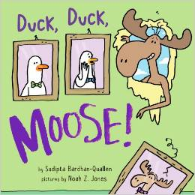 | Duck and Duck are preparing for a party and each step of the way Moose inadvertently messes things up. When he disappears in shame, Duck and Duck must go find him so he can join in the party-which was for him! The slapstick physical humor of Duck, Duck, Moose will have kids giggling! | Play a game of Duck, Duck, Moose!
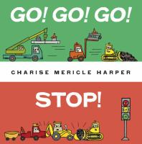  Go! Go! Go! Stop! by Charise Mericle Harper (J+FIC) 2014 | Go! Go! Go! Stop! Is a playful introduction to green and red lights in traffic. Little green can really get things going around town, but when things get a little crazy it’s little red who comes to the rescue. | Tick, tock, tick, tock  Listen to the little clock  Tick, tock, tick tock  Now it’s time for us to stop
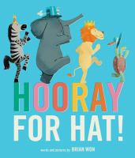  Hooray for Hat! by Brian Won (J+FIC) 2014 | This is a playful and colourful story about the power of friendship. First elephant wakes up grumpy but his mood improves when he receives a hat which gets passed from friend to friend until they all must work together to cheer up giraffe. | On my head, I wear my hat  It is such a silly hat  that my head wiggle waggles to and fro  Where else can my silly hat go?  Place hat on other body parts and sing the song again!
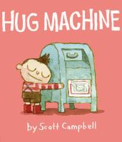  Hug Machine by Scott Campbell (J+FIC) 2014 | With warm illustrations and humorous text this book will have children laughing as the little boy, known as the Hug Machine, stops at nothing to make sure even the most unlikely creatures get a hug. The question at the end of the day is how does the Hug Machine fuel up and who hugs the Hug Machine goodnight? | Pat your head and rub your tummy  Tickle your toes and hug somebody
I’m a Dirty Dinosaur by Janeen Brian (J+BABES) 2014  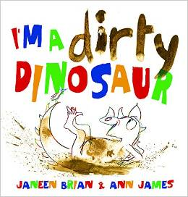 | In a book that has mud as one of the creative mediums, it's a given that the dinosaur is dirty. The prehistoric protagonist is drawn with magic pencil and minimal detail. Slowly, through onomatopoetic, rhyming text he begins to colour himself in with mud. This book will entertain kids in storytime as well as young independent readers. | Oh I wish I was a little bar of soap  Bar of soap!  Oh I wish I was a little bar of soap  Bar of soap!  I'd slippy and I'd slidy over everybody's hidy  Oh I wish I was a little bar of soap  Bar of soap!  Sing to the tune of “If You’re Happy and You Know It”
I Spy in the Sky by Edward Gibbs (J+FIC) 2014  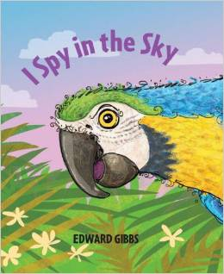 | Up in the sky there are many colorful birds to spy, each of them different. Look through the spy hole and use the clues to guess which one is next. Then turn the page to reveal the creature. Watch as young children quickly become engaged in the game — learning colors and animal facts along the way. | Play a guessing game with something hidden inside a box and use this chant:  Here is a box and here is a lid  I wonder whatever inside is hid?
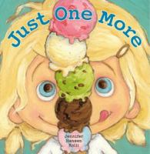  Just One More by Jennifer Hansen Rolli (J+FIC) 2014 | “Ruby was always asking for just one more...” But when she asks for one too many scoops of ice cream, Ruby learns that sometimes “just one” can be good enough. Big bright colourful illustrations portray Ruby with cheekiness, charm, and eagerness to bend the rules as far as her caregiver will let her get away with. | I eat apples- crunch, crunch, crunch  I eat sandwiches- munch, munch, munch,  I eat lollipops- lick, lick, lick  But I eat ice cream quick, quick, quick!
Mine! by Jerome Keane and Susana De Dios (J+FIC) 2014  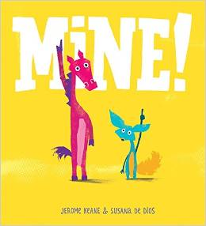 | One of childhood's toughest lessons - learning to share - is explored with side-splitting humour and pure style. Fox and Horse were BORED but then something DID happen: a thing arrived! "It's MINE!" said Horse. "It's MINE!" said Fox. How will they share? Follow Horse and Fox as they eventually learn that playing together is best. | I have super manners. Yes, I do.  I can say "Please," and "Thank You," too.  When I play with friends, I like to share.  That's the way I show I care!  Sing to the tune of “I’m a Little Teapot”
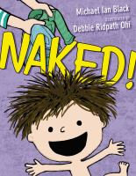  Naked by Michael Black (J+FIC) 2014 | This kid loves being naked... until he finds something even better. Now he realises that everything he liked to do naked is much more fun wearing a cape (and nothing else). Bright and goofy illustrations suit the text perfectly | Baby put your pants on, pants on, pants on, baby put your pants on, 1, 2, 3!  (Repeat verse)  Leg to the left, leg to the right,  Wiggle and jiggle and pull them up tight. (repeat verse)  Baby put your pants on, pants on, pants on, baby put your pants on, 1, 2, 3!  Add more verses with shirt, socks, now you’re all dressed!
Ninja by Arree Chung (J+FIC) 2014  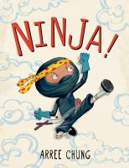 | This little Ninja is at the top of his game until his latest mission leaves his baby sister howling. In a quirky/funny double page spread the ninja says “I am dishonored” as he walks away with his head down. Our hero redeems himself by teaching his baby sister the way of the ninja. | If you’re a ninja and you know it,  Be really quiet. (Shhh!)  If you’re a ninja and you know it,  Be really quiet. (Shhh!)  If you’re a ninja and you know it,  then your face will surely show it.  If you’re a ninja and you know it,  Be really quiet. (Shhh!)  Add more verses like walk on tip toe or say HIYAH!
Number One Sam by Greg Pizzoli (J+FIC) 2014  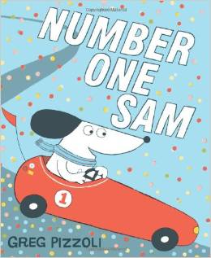 | They're off! Sam is the best race-car driver in history-he is number one at every race! But when his best friend, Maggie, shows that she has racing talent of her own, Sam doesn't know how to handle coming in second place. Will he learn what it truly means to be a winner? | Repeat the first line of each verse three times followed by “won’t you be my darling?”  Bumping up and down in my little red race car, won't you be my darling?  One wheel's off and the axle's broken, won't you be my darling?  Freddies gonna fix it with his hammer, won’t you be my darling?  Lauras gonna fix it with her pliers, won't you be my darling?
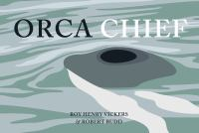  Orca Chief by Henry Roy Vickers (J398) 2015 | This is the third in a series of beautifully illustrated Northwest Coast legends by local author and illustrator. In this story a group of fishermen learn a lesson from the Orca Chief about respecting all the creatures of the sea. While a little long this story could be adapted to a felt story or a shortened telling while showing the gorgeous paintings. | An orca whale, an orca whale  Little sea scallops and an orca whale!  Sea otter, sea otter, little sea scallops, and an orca whale.  Sea otter, sea otter, little sea scallops, and an orca whale.
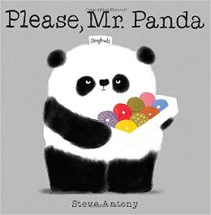  Please, Mr. Panda by Steve Antony (J+FIC) 2014 | What is the proper way to ask Mr. Panda for doughnuts? Patiently and politely, Mr. Panda asks the animals he comes across if they would like a doughnut. A penguin, a skunk, and a whale all say yes, but they do not remember to say "please" and "thank you." Is anyone worthy of Mr. Panda's doughnuts? | You are my little panda bear, little panda bear  I love you, yes I do and all the funny things you do. I love you, yes I do!  You are my little panda bear, panda bears are rare. Yes it’s true, there’s only a few and there’s no other one like you.  I love you, yes I do!
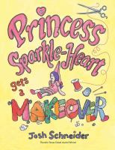  Princess Sparkle-Heart Gets a Makeover by Josh Schneider (2014) | A little girls princess doll gets destroyed by a dog. With mom’s help the doll is fixed and is better than ever! | Flop your arms, flop your feet  Let your hands go free  Be the raggiest rag doll,  That you ever did see!
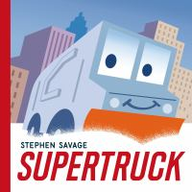  Supertruck by Stephen Savage (J+FIC) 2015 | Supertruck is a humble garbage truck by day but when a snowstorm strikes the city he comes to the rescue! | Hurry, hurry, drive the fire truck (x 3)  Ding, ding, ding, ding, ding!  Try different versions like: turn the corner, put the ladder up or drive the garbage truck.
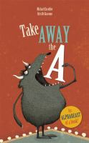  Take Away the A by Michael Escoffier (J+FIC) 2014 | This is a smart and funny alphabet book that would appeal to a slightly older reader than that of your average alphabet book. Each letter is introduced in the context of how its presence or absence can change a word: “Without the B the Bride goes for a Ride, Without the I the Stairs lead to the Stars” and are accompanies by hilarious illustrations. | Loo la la loo la la loo la la la lay  Loo la la loo la la loo la la la lay  Loo la la loo la la loo la la la lay  La la loo la loo la lay  Try using different letter sounds!
Tap Tap! Boom Boom! by Elizabeth Bluemle (J+FIC) 2014  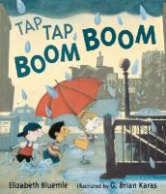 | Tap Tap Boom Boom is a joyful, rhythmic expression of a rainy day in the city. The book was inspired by the authors visit to New York but could just as easily take place in Vancouver or any number of cities. The rhyming text and bold illustration would make this a great choice for storytime. | Rain is falling down. Splash!  Rain is falling down. Splash!  Pitter, patter, pitter, patter  Rain is falling down. Splash!  Sun is peeking out. Peek!  Sun is peeking out. Peek!  Peeking here, peeking there.  Sun is peeking out. Peek!
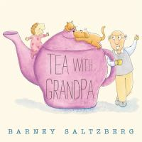  Tea With Grandpa by Barney Saltzberg (J+BABES) 2014 | This is a gentle story about a girl and her grandfather’s regular tea date. In a twist at the end we learn that their tea date is held not in person but over the computer, which introduces technology use in a positive and meaningful way. | Here's a cup and here's a cup  (Hold up right hand and then left hand)  And here's a pot of tea.  (Put hands together to form a pot)  Pour a cup, pour a cup  (Pretend to pour tea into two cups)  And drink some tea with me.  (Pretend to drink tea from your hands)
This Book Just Ate My Dog! by Richard Byrne (J+FIC) 2014  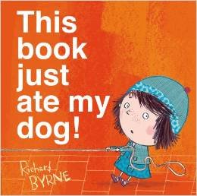 | When her dog disappears into the gutter of the book Bella calls for help. But when the helpers disappear too, Bella realizes it will take more than a tug on the leash to put things right. Cleverly using the physicality of the book, This book just ate my dog! is inventive, ingenious, and just pure kid-friendly fun! | We’re going to shake, shake, shake our sillies out.  Shake, shake, shake our sillies out  Shake, shake, shake our sillies out  And wiggle our waggles away!  Try adding verses with eating verbs like munch or gobble!
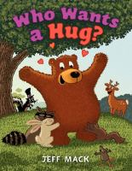  Who Wants a Hug? by Jeff Mack (J+FIC) 2015 | Mr. Bear is adored by all the animals because of his hugs, all except one animal: skunk. Skunk devises plan after plan to try and foil Mr. Bear’s hugs but they fail in hilarious ways and even skunk enjoys a hug at the end. | I have a little heart  And it goes thump, thump, thump  (pat chest three times)  It keeps right on beating,  When I jump, jump, jump  (jump three times)  I get a special feeling, when I look at you.  It makes me want to give you a hug or two.  (give child a hug or have kids hug each other)
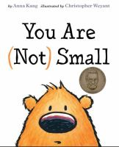  You Are (not) Small by Anna Kang (J+FIC) 2014 | Two creatures argue about who is big and small, until smaller and bigger creatures show up and change the argument altogether. | Do you suppose a giant  Who is tall, tall, tall?  Could ever be a fairy  Who is small, small, small?  But the fairy who is tiny  Will try, try, try  To reach up to the giant  Who is high, high, high!

