How to Use the Mouse and Windows 如何使用鼠标和Windows
Mouse Buttons and Mouse Pointers鼠标键和鼠标指
When using the mouse, whichever way you move your hand is the way that the mouse pointer will move. If you move your hand left, the mouse pointer will move left on the screen.
当你使用鼠标时，鼠标指会跟着您的手的方向一起移动。若您的手向左，鼠标也会跟着向左。
The mouse is used frequently with Windows Operating Systems. The mouse’s default settings are configured for a right-handed person; however, they can be changed to accommodate left-handed people.
若您的电脑使用Windows操作系统，您会经常用到滑鼠。滑鼠的基本配置是设定给右撇子的使用者；可若您是左撇子那也无需操心,可以更改设定让滑鼠更适用于左撇子。

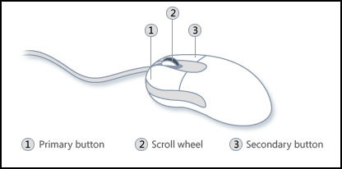
- Left Button: is used for selecting and highlighting and dragging
左键：用来选择，部分明亮，和牵引。
When you are asked to “click”, this always refers to left click; people say “right click” for right clicks
若指示叫您“按”或“按一下”，这是指［按左键］；要您按右键时会说［按右键］。
- Right Button: is used for the Context Menu (Pop Up Menu)
右键：用来按出滑鼠的右键选单。

Tips For Using the Left Click and the Right Click使用滑鼠左右键的技巧
Left Click |  | - Double click to open something (按两次开启档案)
(左键) |  | - Single click to select something. (按一次选择档案)
 |  | - On the internet, single click is used. (当您使用网络时，按一次就好)
Right Click |  | - Tells you what you can do to a particular item (告诉您可以对这个项目作什么行动)
(右键) |  | - Pops up a hidden menu. (显示出隐藏选单)
Busy pointer means that Windows is busy and is currently working to finish the last command that was sent. No other commands can be used at this time. You must wait until the Busy pointer has returned to the Normal Select pointer.
忙碌鼠标告诉您Windows操作系统正在忙着完成上一份工作指示。直到忙碌鼠标便会正常鼠标，您无法给于Windows任何其它工作指示。
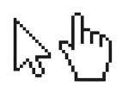
Mouse curser can change: 鼠标会变！
- Arrow (箭头) – for pointing (用来指点)
- Hand (手) – when it is a link to another webpage (当鼠标在会连接到另一个网页的字体上面)
- Capital i (大写的i )- when it is text (当鼠标在文体上面)

Additional Help更多指点
- Go to the Surrey Public Library website: www.surreylibraries.ca
前往Surrey Public Library的网站: www.surreylibraries.ca
- Click on Programs & Services Computers & Technology Totally new to Computers series, & more!
按Programs & Services 然后 Computers & Technology再按Totally new to Computers series & more!
- Scroll down and click on “Mousing Matters Class Activities“
按Mousing Matters Class Activities
- Click on any of the links to different websites for practicing mouse skills
按任何一个链接前往不同的网站练习如何使用滑鼠
Using Windows 使用Windows
The desktop is the very first screen you see after your computer starts. Desktop consists of various icons. Icons are visual representations of some applications or shortcut keys. These icons allow you to run programs from the desktop rather than going to the “Start” button and selecting from a menu. They are shortcut keys for various program applications on a computer.
当电脑开启时，您会在登入后看到桌面。桌面上有许多图示。那些图示代表着电脑上一些程式的捷径，让您可以从桌面上开启程式（另一个方法是按“开始”键然后从出现的选单里找出程式。
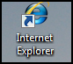
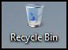
Recycle Bin is a temporary storage place for deleted files. Windows temporarily stores all these deleted files in the Recycle Bin for restoring purposes.
资源回收桶会暂时储存被删除的档案（好便您若想恢复档案）。

Internet Explorer is a web browser.
It is an icon for surfing the Internet.
Internet Explorer是一个网络浏览器，好让您使用来上网。

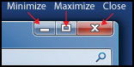

Part II – Managing a Window如何操持视窗
Minimize (缩小) Click it with the left button to minimize an active window. This button puts a program on hold and places it on the taskbar at the bottom of the screen. To re-open the window from the taskbar, click on the box that represents the program you want.
按一下来缩小视窗。这会把程式搁置在荧幕下方的任务揽。若想打开视窗，按一下任务揽里代表程式的小视窗。
Maximize (放大) Click it with the left button to maximize an active window in order to fill the entire computer screen. If the active program's window has been maximized, button will contain two small overlapping boxes. This is a restore button. If you click it once with the left mouse button, the window will no longer cover the entire screen. It has been restored to its original size.
按一下来放大视窗。若视窗已经放到最大，这钮会有两个交叠的框框。这是恢复键；若您按一下，视窗就不会盖住整个荧幕了。
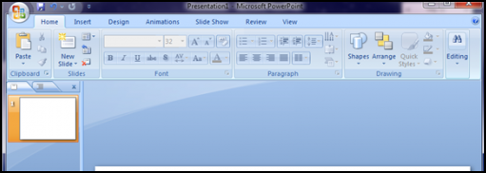
Close (关闭) Click it with the left button to close an active window. 按一下来关闭视窗。
Moving a Window 如何移动视窗
Press and drag the title bar. When you let go that’s where the window will move to.
按下左键（别放开！）然后牵引标题栏。当您放开时，视窗就会移动到您所放开的地点。

