In survival mode the player works to collect resources, build structures, battle mobs, manage hunger, and explore the land in an effort to survive.
Playing Minecraft in Survival Mode

You will first need to build a crafting table out of wood to start your adventure
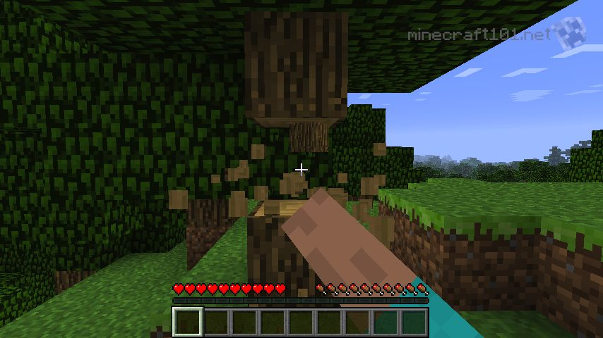
Gathering Materials and Crafting
You can gather materials from the environment by left clicking on objects such as rocks or trees to get wood and stone. Once you have wooden logs you can open your inventory and turn them into planks. Once you have planks you will need four of them to craft a table.
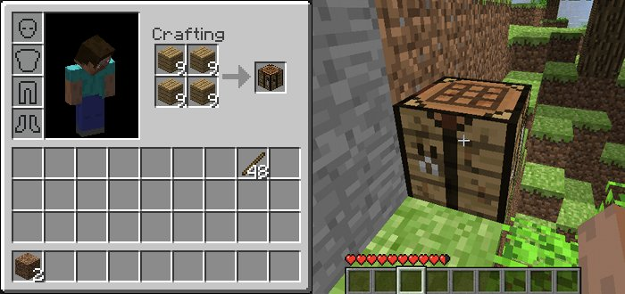
After you have a crafting table you can make several basic tools such as shovels, pickaxes, axes, swords etc. This will allow you to gather better materials more efficiently. You craft items by arranging materials in specific patterns (often the shape of the item you are trying to build) Play around with the crafting table and see what you can build!
Finding Food
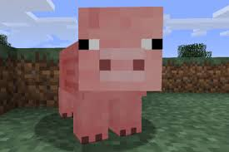
Another important factor when playing in survival is managing hunger. You will need to gather food in order to keep your hunger metre full. If it drops to zero you will start taking damage and eventually die. Alternatively, if you keep the hunger meter full you will regain health faster if you get injured.
You can hunt animals, plant crops or gather apples and mushrooms to eat. Meat hunted from pigs must be cooked in a furnace before you eat it. Bread, soup and other foods can be crafted using a crafting table.
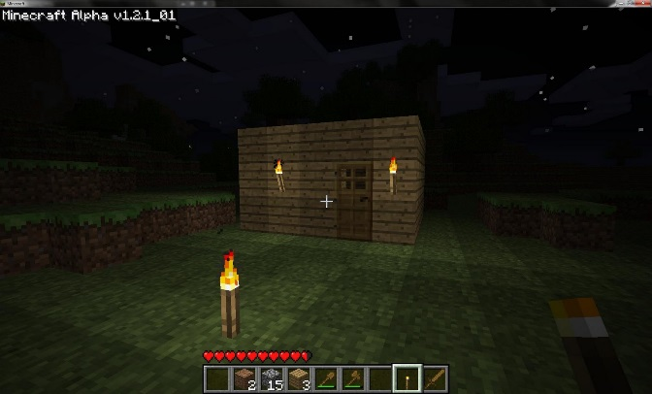
Creating Shelter and Surviving the Night
Minecraft has a consistent day and night cycle. During the night, monsters and other creatures appear that can attack players. Players will need to have a shelter with a light source in order to stay safe. Shelters can be built of any material including dirt if necessary. Torches are creating using coal and sticks. If you cannot find coal before your first night cycle you can create some by burning wooden logs (NOT planks) in a stone furnace. If you build a bed you can use it to sleep through the night and avoid the monsters. The sunlight will destroy most of the monsters.

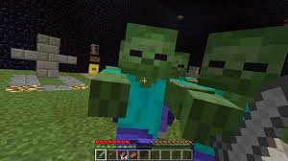
Fighting Mobs
Creatures in the game have different strength levels and will be easier or harder to defeat because if it. You can fight creatures without weapons but the process is very slow and often dangerous if the creature can fight back. Creating a sword early is the best way to protect yourself early in the game. Different monsters will also drop different items and materials when they are killed which allows the player to make new and more powerful tools and items. You can attack mob the same way you gather materials (approach and left click)
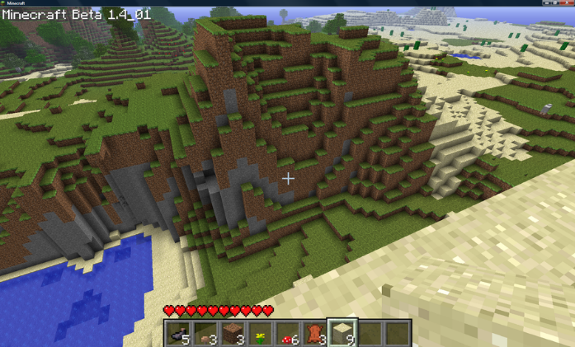
Exploring
Minecraft is a vast world full of amazing places to explore. Players can jump, dig and walk their way to different environments and areas where they can gather different materials and battle a wide variety of creatures. Players can also explore bodies of water but be careful! Players in Minecraft will automatically sink unless the player keeps pressing the jump button to swim. If a player stays under water for too long they will run of air and drown so keep an eye on that breathing metre when you out for a swim!

First Stage Survival Goals
- Build a crafting table
- Make a Pickaxe, sword and shovel
- Build a stone furnace
- Build a shelter
- Gather food
- Make torches
- Upgrade wooden tools to stone tools
- Build a bed

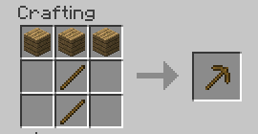
Good luck and happy adventuring!

