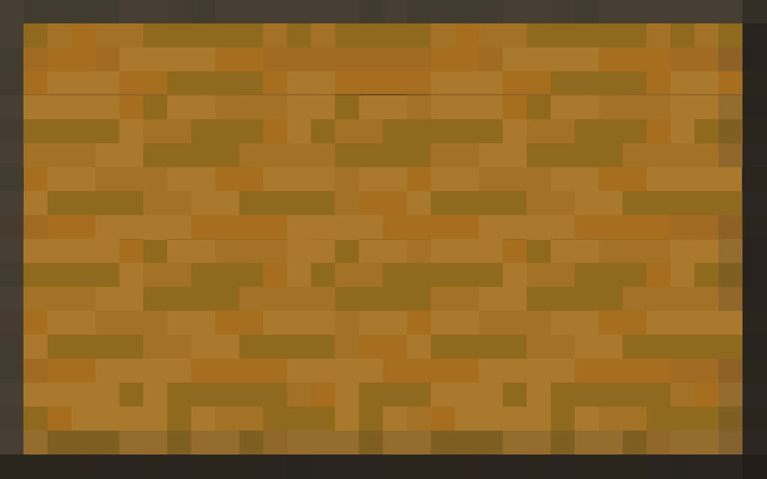

Top/ Back / Bottom

Top/ Back / Bottom

Top/ Back / Bottom

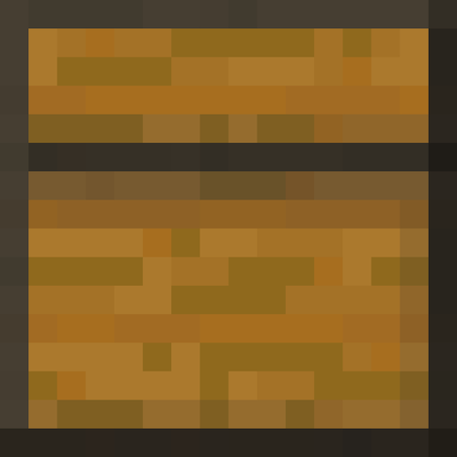

Side

Side

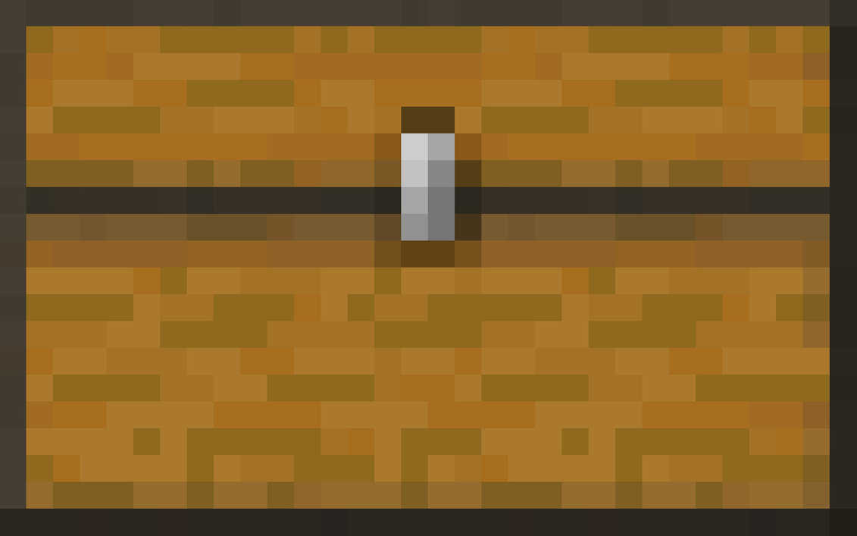

Front

Minecraft Chest Papercraft adapted by Olds Municipal Library.