Microsoft Word 2010 Tips & Tricks教学
Opening a new Microsoft Word document 开启新的Microsoft Word档案

- From the Desktop, double click on the Microsoft Word 2010 icon.
在桌面上按两次Microsoft Word 2010 的捷径。

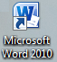
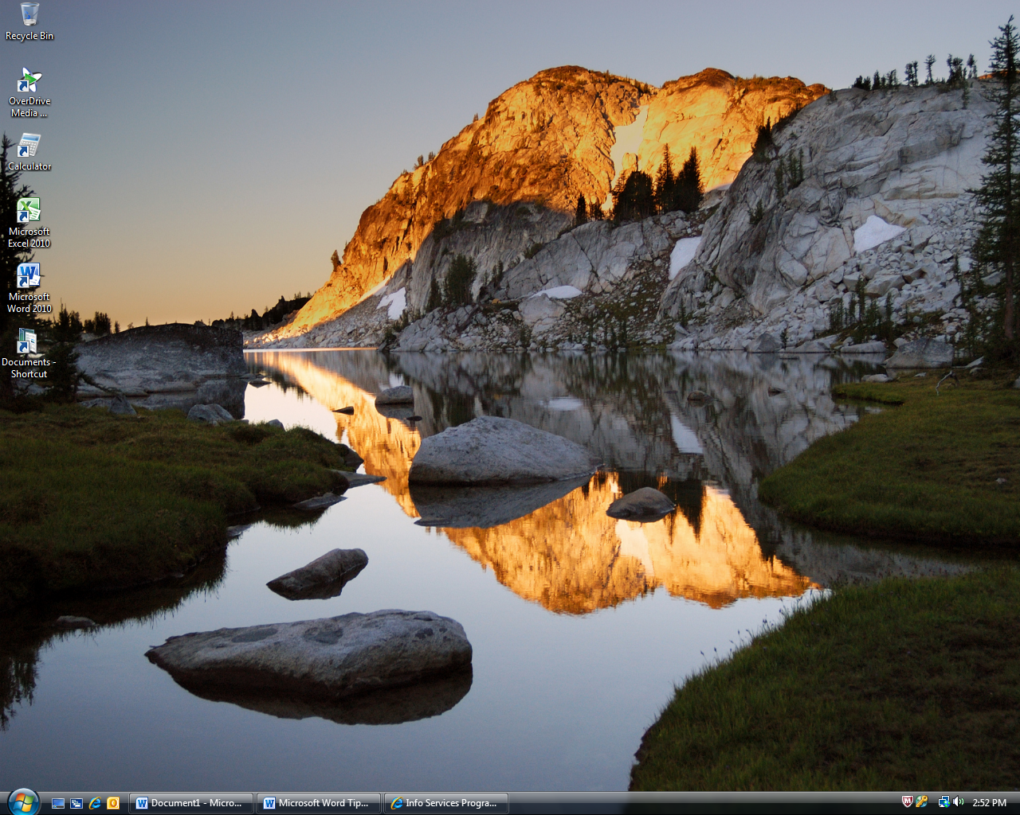

- A new word document will open.
一个新的Word档案会开启。

Home Tab: common text formatting options ［常用］索引标签：文字格式化选项

To format text, click on the Home Tab located at the top of the document page. This tab allows you to bold, centre, underline, cut & paste text, and add bullets and numbers.
在［常用］索引标签内，您可以格式化您的文字。您可以使用粗体，斜体，底线，剪裁并贴上，以及添加项目符号或编号。
Bullets
项目符号
Cut
剪下
Copy
复制
Numbering
编号
Font size
字形大小
Font type
字形
Paste
贴上

Centering text
文字置中
Underline
底线
Italics斜体
Bold
粗体

Bold, Italicize or Underline Text 粗体，斜体，或底线

- Click and hold the left mouse button down, and drag the mouse over the text so that it is highlighted.
按一下您想要开始选取的位置，并按住滑鼠左键，然后将指标拖曳到您想要选取的文字上方。
- In the Home Tab’s Font section, click the Bold, Italics or Underline icon.
在［常用］索引标签的［字形］群组中，按一下［粗体］，［斜体］，或［底线］。

＊Note: these buttons work like an on/off switch. When it’s “on”, it will be orange.
注意：这些按钮跟开关一样。当您“开启”它时，按钮会变橘黄色。

Making text large or small 文字大小

Click & hold the left mouse button down, and drag the mouse over the text so that it is
按一下您想要开始选取的位置，并且按住滑鼠左键，然后将指标拖曳到您想要选取的文字上方。

In the Font section of the Home Tab, click on the arrow on the font size icon and selct a new font size. The bigger the number, the larger your font size will be. You can also use the two buttons beside the font size. One makes the font bigger and the other makes it smaller.
在[常用]索引标签的[字形]群组中，按一下字形大小并选取您想要的大小。数字越大，字形越大。您也可以按一下［放大字形］或［缩小字形］方块，直到［字形大小］方块中显示您想要的大小为止。

Centering Text (Alignment) 置中（对齐）

- Click and hold the left mouse button down, and drag the mouse over the text so that it is highlighted.
按一下您想要开始选取的位置，并按住滑鼠左键，然后将指标拖曳到您想要选取的文字上方。
- In the Home Tab’s paragraph section, click the Centre icon.
在［常用］索引标签的［段落］群组中，按一下［置中］。
Your text will then stay centered in the middle of the page. This is most useful when creating a resume.
您选取的文字将移至文件中间。制作简历是很有用。

Copy, Cut, and Paste Text 复制，剪下，和贴上文字
- Click and hold the left mouse button down, and drag the mouse over the text so that it is
按一下您想要开始选取的位置，并按住滑鼠左键，然后将指标拖曳到您想要选取的文字上方。
- In the Clipboard section of the Home Tab, click on the Copy icon or the Cut icon .
在［常用］索引标签的［剪贴簿］群组中，按一下［复制］或［剪下］。
- Click on the Paste icon to place the text somewhere else in your document.
按一下［贴上］即可把您剪下/复制的文字贴到在文件内您所想要的位置。

Bullets 项目符号
- Click and hold the left mouse button down, and drag the mouse over the text so that it is
按一下您想要开始选取的位置，并按住滑鼠左键，然后将指标拖曳到您想要选取的文字上方。
- In the Paragraph section on the Home Tab, click on the Bullets icon
在［常用］索引标签的［段落］群组中，按一下［项目符号］。

Spacing between lines 段落间距

- Click and hold the left mouse button down, and drag the mouse over the text so that it is highlighted.
按一下您想要开始选取的位置，并按住滑鼠左键，然后将指标拖曳到您想要选取的文字上方。
- In the Paragraph section on the Home Tab, click on the Line Spacing icon
在［段落］群组中，按一下［行距］。
- Choose which spacing you’d like for the area you highlighted.
选择并按下您所想要的行距数。

Saving to Your Computer or USB 储存至电脑或USB

- Click on the File tab, click Save As.
按一下［档案］索引标签，在按一下［另存新档］。
1b.

2.
1a.

Note: You can also save your Word document to a specific folder in your Documents, or to your Desktop for easy access by clicking on the correspondingfolder.
注意：您也可以储存您的档案至一个特定的文件夹，桌面，等等。
3.
5.
4.

- Click on Computer
按一下［电脑］
- Choose your USB (E:)
选取您的USB
- File name: type in a name for your file
档案名称：给您的档案输入一个名称
- Click Save
按一下［储存］

Keyboard Shortcuts 键盘快捷键
The following are some commonly used shortcuts for commands in Microsoft Word.
以下是一些Microsoft Word里常用的快捷键。
Commonly Used Commands 常用指令 | Keyboard Shortcut 快捷键
Open 开启 | CTRL+O
Save 储存 | CTRL+S
Print 列印 | CTRL+P
New 开启新档 | CTRL+N
Help 帮助 | F1
Select All 全选 | CTRL+A
Exit Program 退出程式 | ALT+F4

Formatting Commands 格式指令 | Keyboard Shortcut 快捷键
Bold 粗体 | CTRL+B
Italic 斜体 | CTRL+I
Underline 底线 | CTRL+U
Centre 置中 | CTRL+E
Left Align 靠左对齐文字 | CTRL+L
Right Align靠右对齐文字 | CTRL+R
Justify 文字左右对齐 | CTRL+J

Editing Commands 编辑指令 | Keyboard Shortcut 快捷键
Cut 剪下 | CTRL+X
Copy 复制 | CTRL+C
Paste 贴上 | CTRL+V
Undo 复原 | CTRL+Z

***NOTE: ALWAYS remember to text before making format changes
***注意：切记要先选取您要格式化的文字再按一下格式按钮（粗体，斜体，底线，等等）

