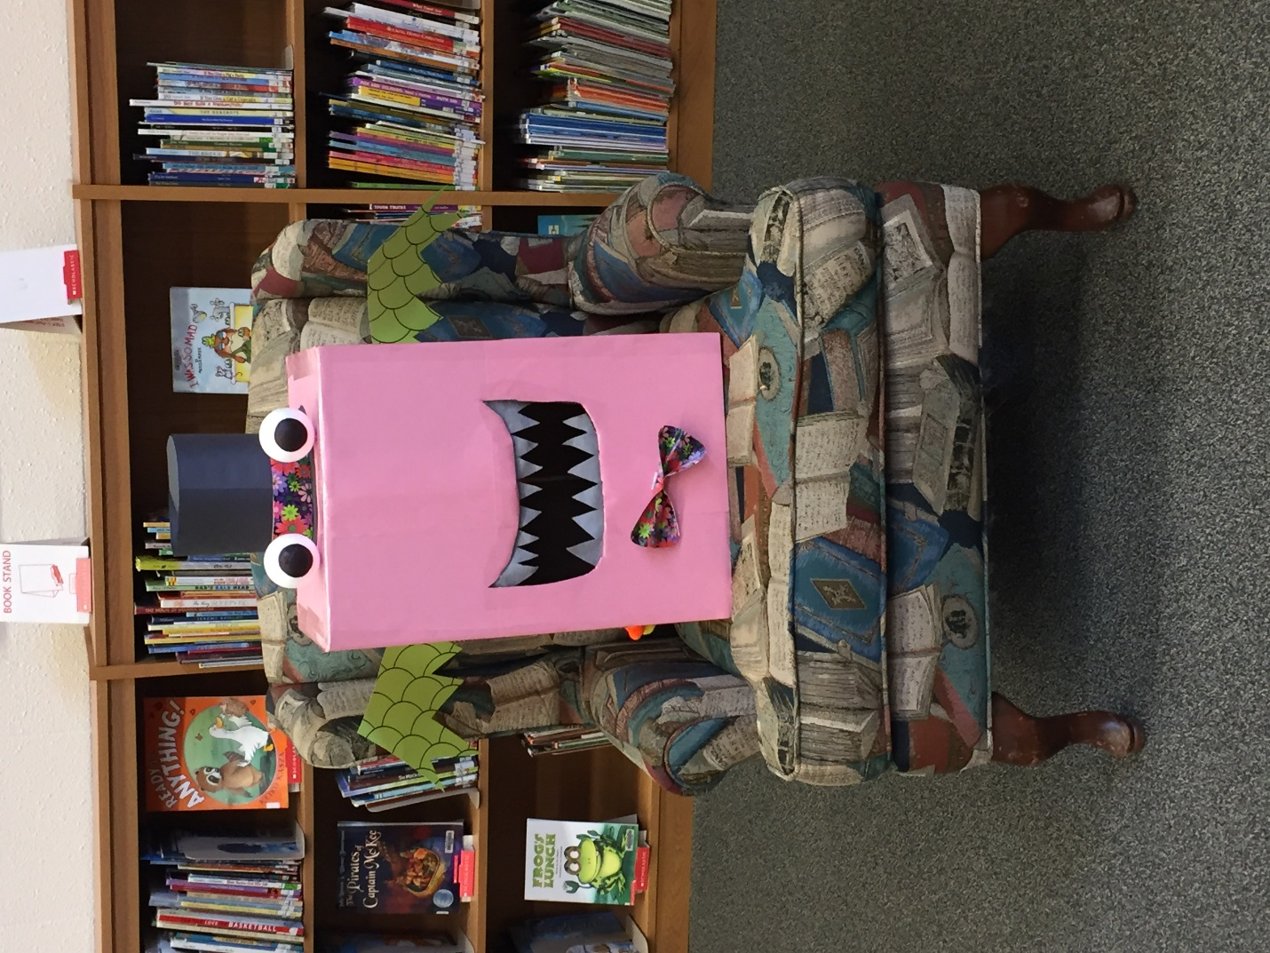
Meet our TD SRC representative: Barnaby Pinkston!
Barnaby loves to help us with some of our toughest decisions, especially regarding prizes and programs for the children. In his spare time, he collects grand prize entry ballots from patrons who are participating in the TD SRC. They can put them right in his mouth and he holds them and keeps them safe for us. Barnaby came to us with no name so we took this issue to Facebook and our wonderful community decided that Barnaby Pinkston was the name for him!

Hope you enjoyed hearing a little bit about Barnaby Pinkston!
Summer Team at Spruce Grove Public Library

