How to Set up and Link Together an eBay and PayPal Account

- At the eBay homepage (www.ebay.ca) click on Register located in the top left corner of the page.

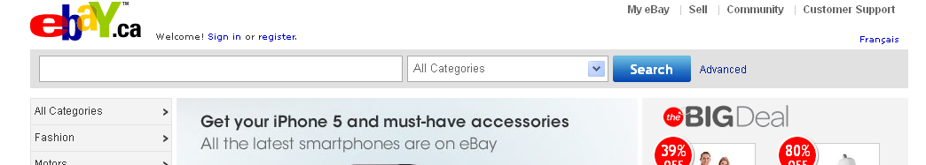

- Next fill out the registration form. For the first part of the form type in your contact information in the appropriate text fields.

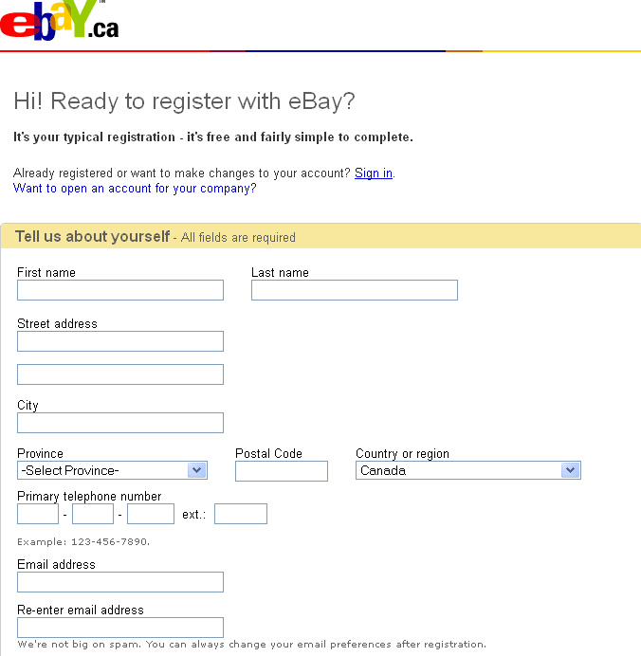

3) Next create a unique user ID and password. You will also need to select a secret question and answer for extra security. Your date of birth is required and you must be 18 years or older to use eBay.

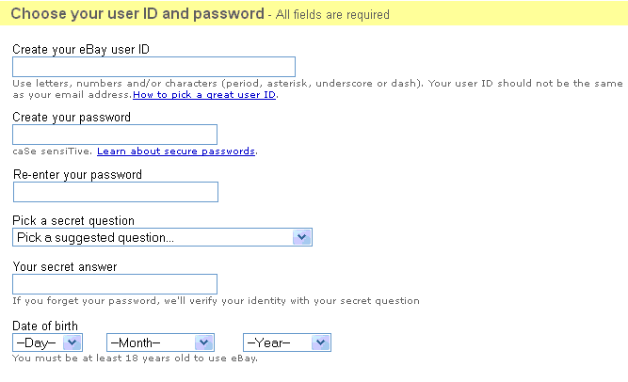
4) Lastly, type in the verification code hidden in the image provided (if you would like a different image click on Refresh the Image). Make sure you agree with the User Agreement and Privacy policy and then click on the small check box. Click Continue when you are finished your registration form.

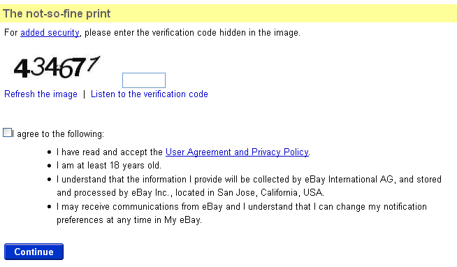

5) A new page will come up stating that you need to confirm your eBay registration through your email. Go to your email inbox (Hotmail, Gmail, whichever email provider you used when signing up to eBay) and open up the confirmation message from eBay. Click on the Activate Now button within the message to complete the registration process.

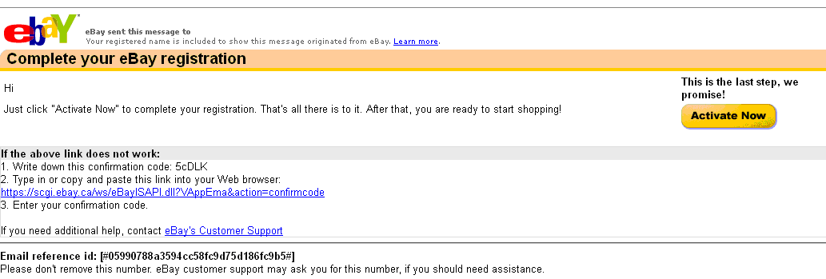

6) Once your account is activated you will be directed to the new member page. It is recommended that you also set up a PayPal account to create more convenient and secure transactions through eBay. You can begin creating a PayPal account by clicking on the link provided on this page (Sign up for PayPal), going to the My Account section in you’re My eBay profile, or you can go directly to the website by typing www.paypal.ca into the address bar.

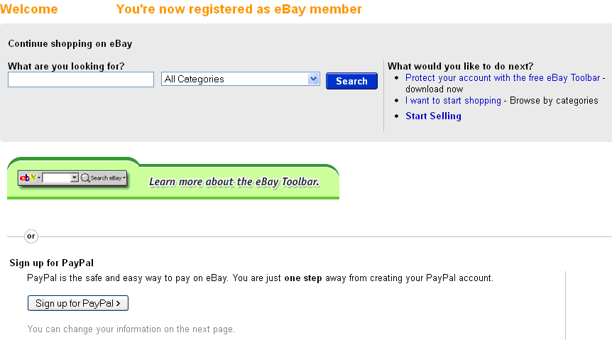

7) Once directed to the Create your PayPal Account page fill out the registration form just as you did when creating your eBay account. When you are finished the form and have read the privacy policies click Agree and Sign Up. Your PayPal account is now linked with your eBay account.

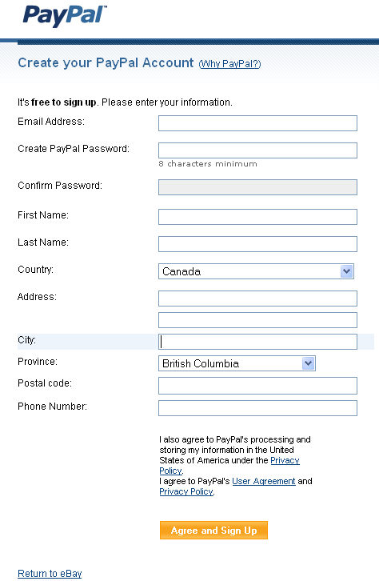

8) Once your account is created you will want to add either a bank account or a credit card/debit card that you will use when selling or buying items from eBay. Click on one of the two links provided after creating your account in order to add your bank account or credit card information.
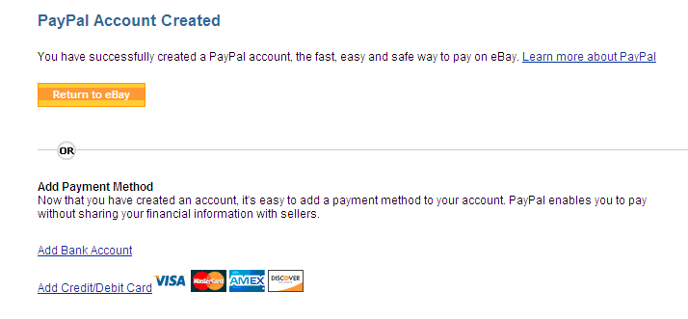

9) If you are adding a bank account you will need the name of your bank, bank transit number, institution number, and account number. You should be able to find all of this information by looking at an up-to-date cheque that is linked to your personal bank account, or get in touch with your personal banking institution. Once all of the information is entered click Continue. PayPal will then run a secure transaction test to make sure everything is correct. This process takes about 3-4 business days to complete and once it is you will be ready to use the bank account within eBay.

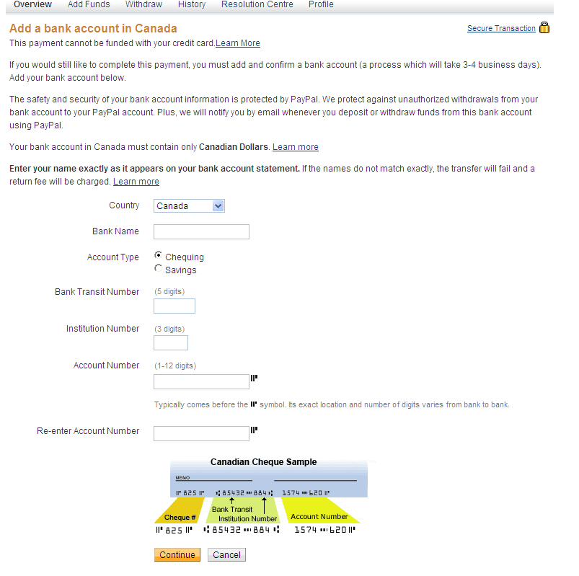

10) If you are adding a credit card or debit card you will need to select the card type, add the card number, expiration date, and card verification number. You also will need to add your address that the card is billed to. Click Add Card when you are done filling out that information. The added card will now be ready to use within eBay.

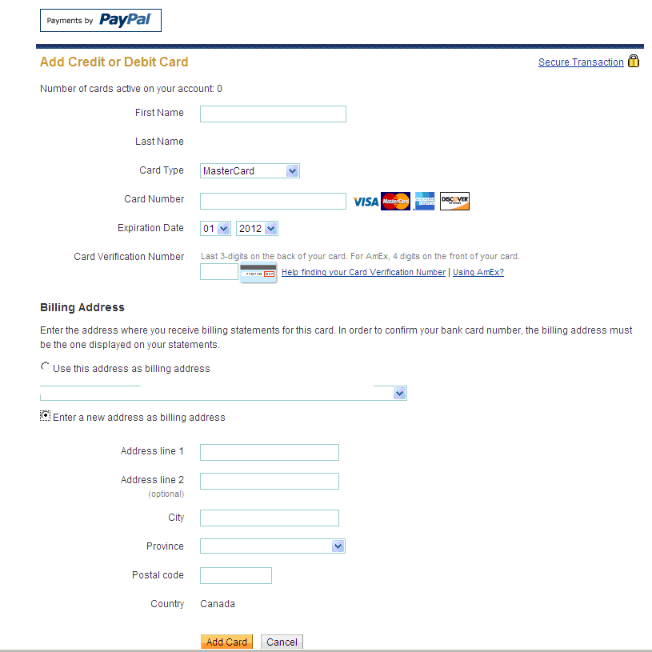

11) To confirm that your eBay and PayPal account are linked together go to the eBay homepage, sign in, and click on My eBay in the upper right corner of the page.

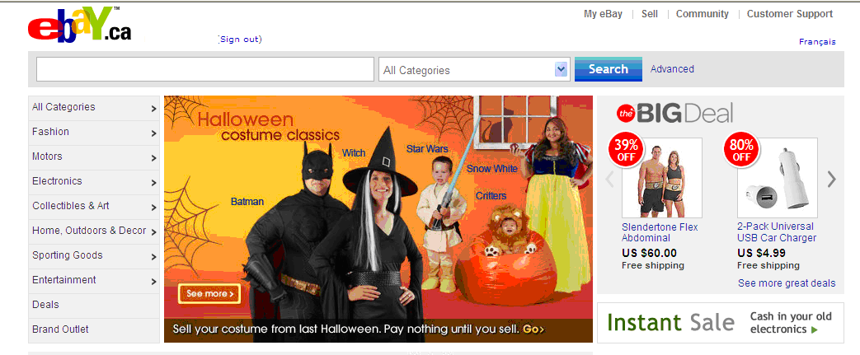

12) You will be directed to your My eBay summary page. Click on Account right underneath your username on the left hand side of the page.

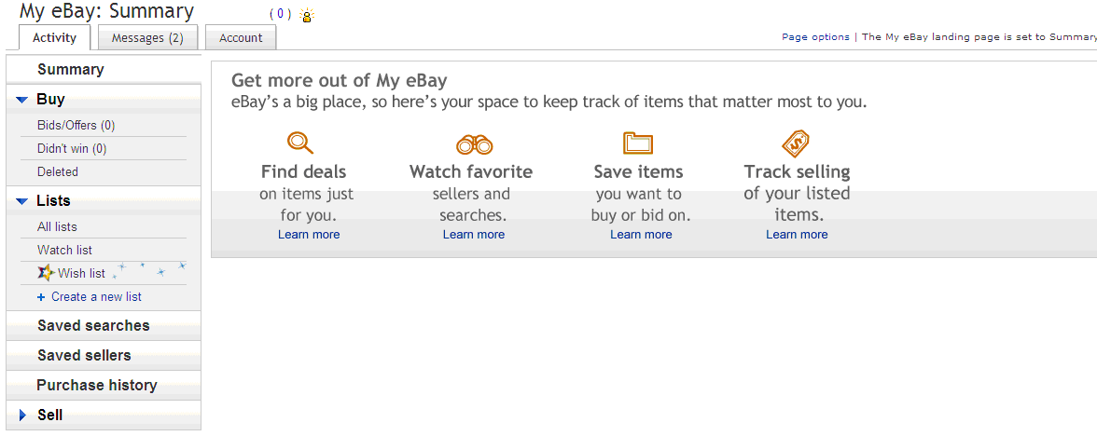

13) You should now be able to see your PayPal account information and a statement saying that your eBay account is linked with your PayPal account.

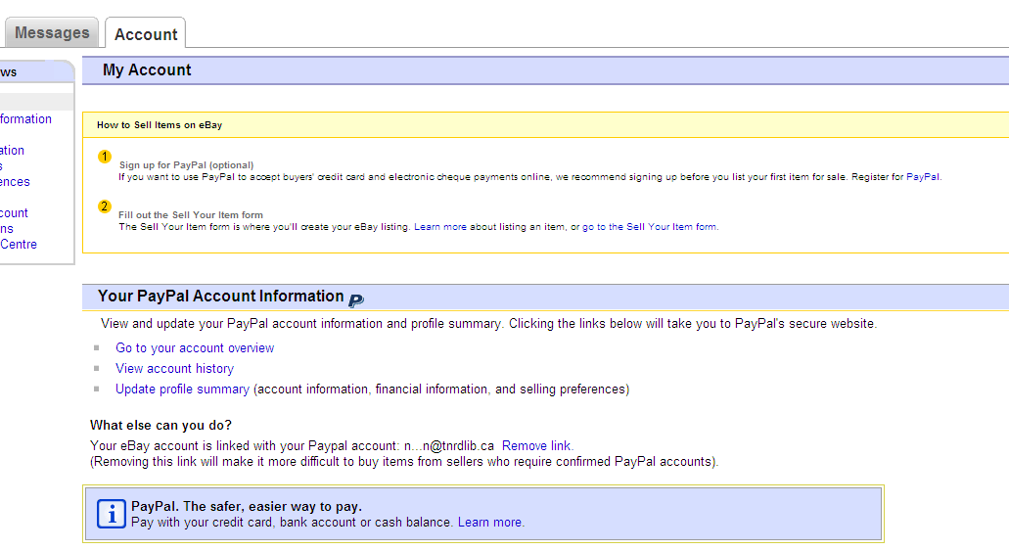

Now you are ready to start buying and selling on eBay! Please refer to the Buying and Selling on eBay instructions for more information.

October 1, 2012

