How to Sell an Item on eBay

- On the eBay homepage (www.ebay.ca) move your cursor onto the word Sell located in the top right corner of the page. In the drop down menu click Sell an Item.

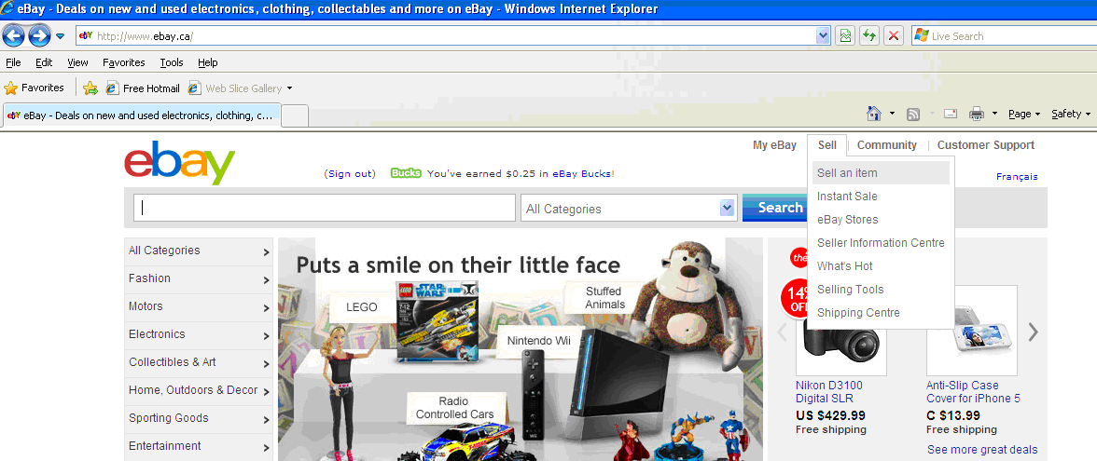

- Next type in a UPC, ISBN, or keywords that describe the item you’re selling. Then click Start Selling.
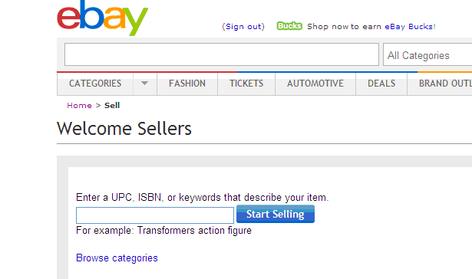

3)

  - A list will then appear of suggested categories that your item will most likely fall under. Click the small box beside a suggested category if you feel it best suits your item. Click Continue when you have made your selection.

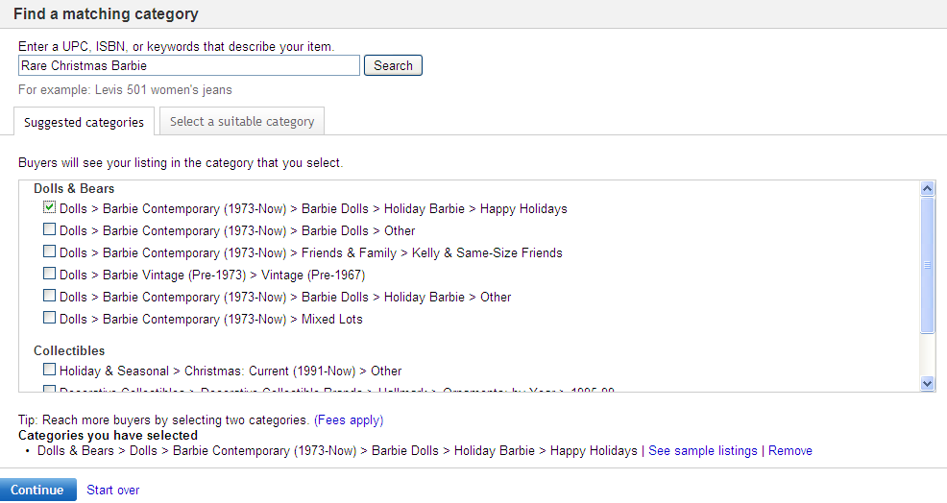

  - If you don’t like any of the suggested categories then click Select a Suitable Category. Start by clicking the most relevant category for your item and then keep going through the sub-category choices until you have created an overall proper category for your item. If you want to start over with your category selecting then click Start Over underneath the choices on the left side. If you are satisfied with your category then click Continue.
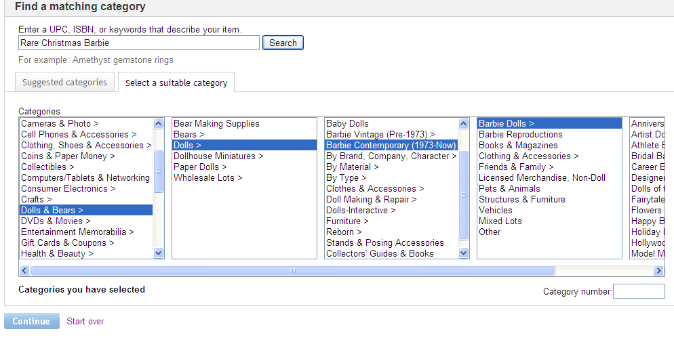

- There are two different ways to proceed with the Creating the Product Listing step.

Here is the first, faster way:

a) Type in a few keywords that describe your item in the provided text field and then click Search to see if eBay already has that item listed somewhere in their catalogue.

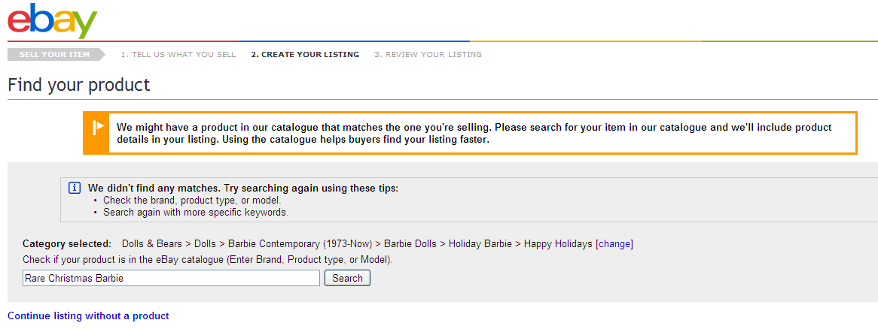

b) A list will appear showing all of the items eBay currently has in its catalogue that may be the same as the one you are selling. If you see one that is a perfect match to what you are selling then click Sell Yours located right underneath the product’s details.
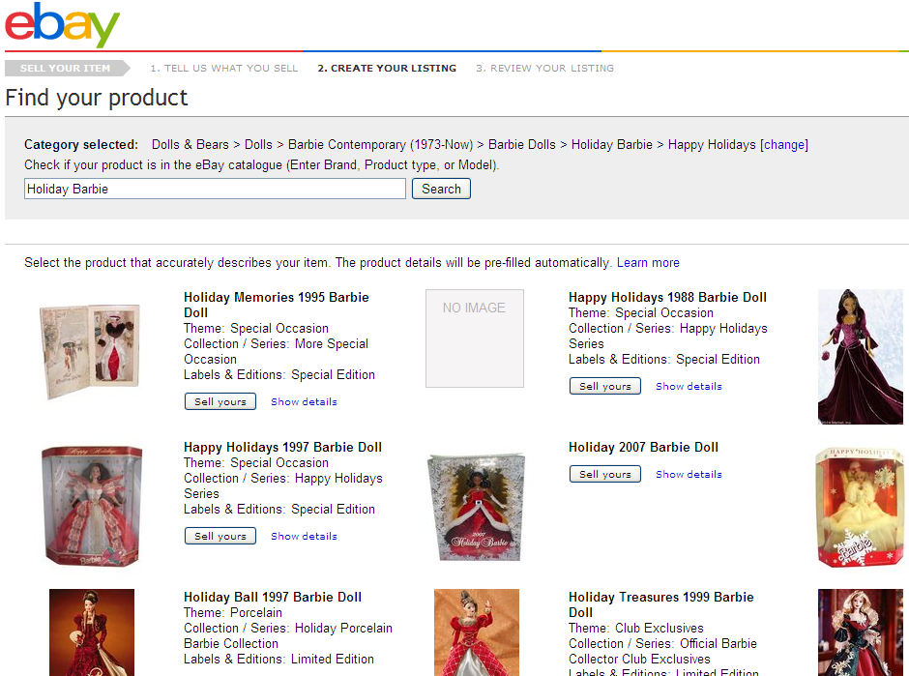

c) The Create your Listing page will appear and you will notice that a lot of the product information is already filled in for you since you’ve selected an existing eBay catalogue product. This will quicken the selling process if you were able to find a matching item. If you didn’t find a matching item or if you would prefer to skip this step all together then please refer to the alternative method described below (Step 5). If you did find a match then proceed to step 6.
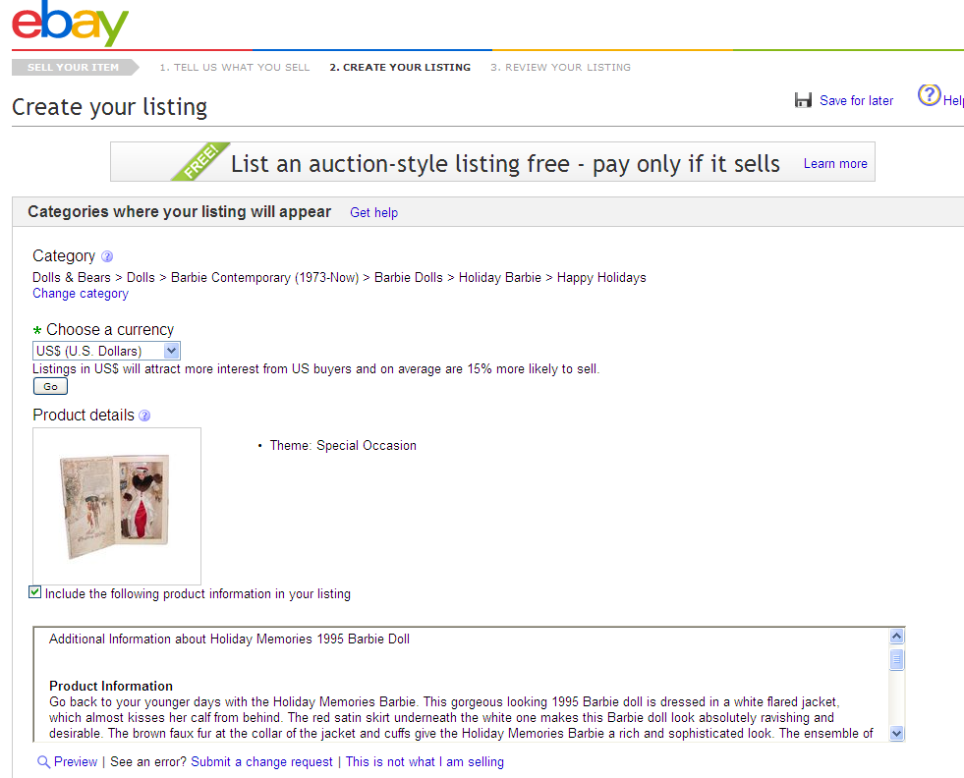

Second way:

a) Rather than search the catalogue (or if you couldn’t find a match) click Continue Listing Without a Product.

6) Now you will need to fill out the product listing details (Again, if you have found a matching product in the catalogue you will not have to fill out as much data as you would if you didn’t find a match). Start by choosing a currency from the Currency drop down menu. Then type in the title of your listing that buyers would enter in an eBay search if they were looking for that item/similar item. Choose the condition (new or used) of the item from the Condition drop down menu.
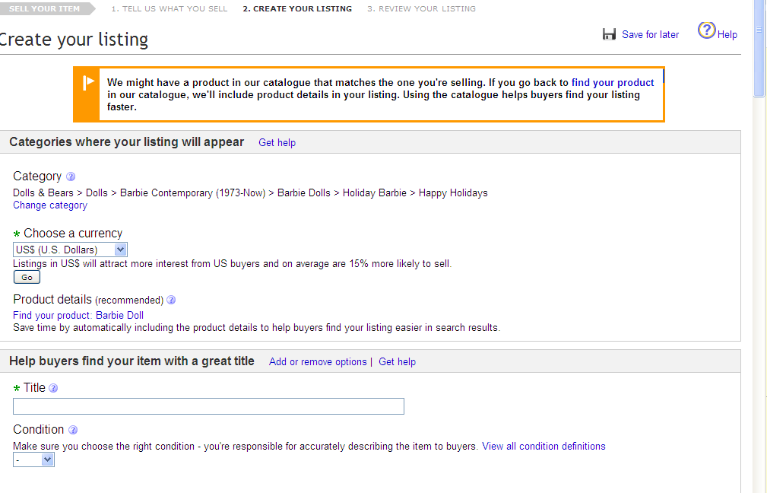
7) You can then choose to type in extra details in the provided text fields such as the brand, model, MPN, recommended age range, and country of the item’s manufacture. You can even add your own specific item detail by clicking Add Your Own Item Specific located underneath the already provided details. (These details are not required but they can help make your item description clearer to buyers.
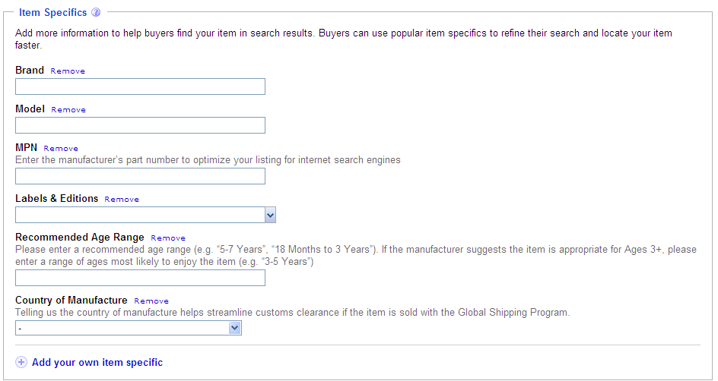

8) You can choose to add a picture of your item by clicking Add Pictures.

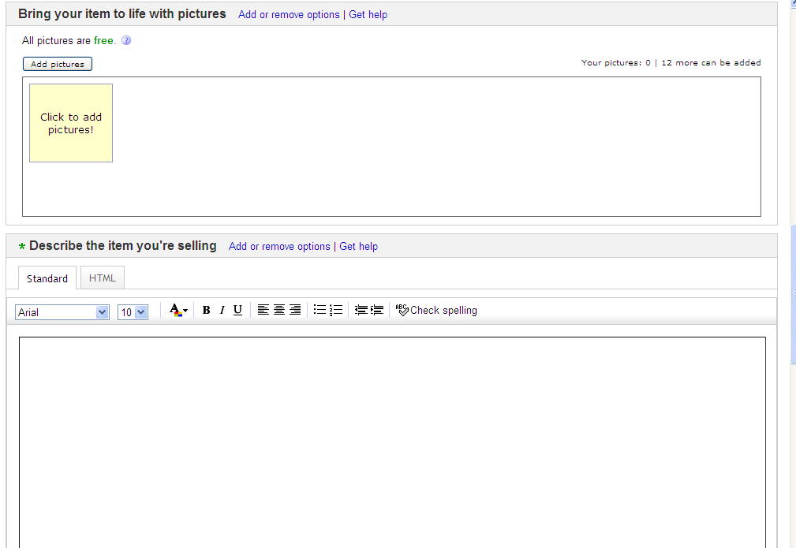

9) Next click Browse. (If you’re having trouble with the Standard Picture Upload option then click on Basic at the top of the window to use the Basic Picture Upload option instead.) *You can add up to 12 pictures of the item for free.

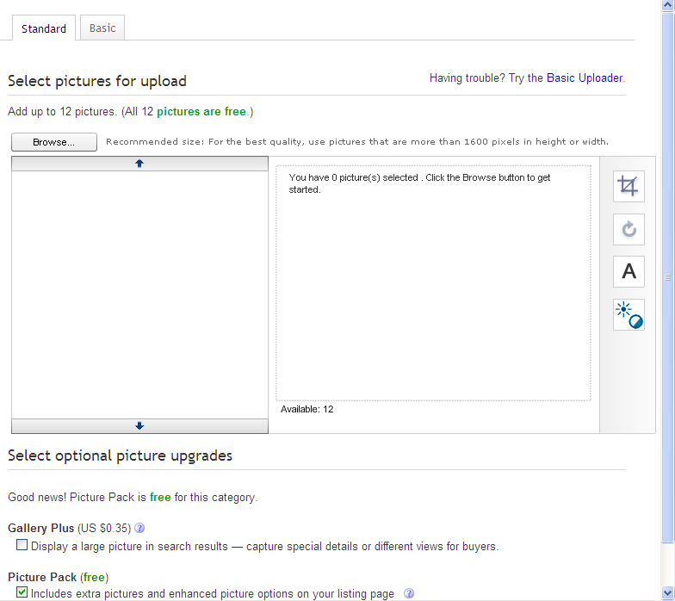

10) Click the picture of your item from whichever folder you saved it in and then click Open.

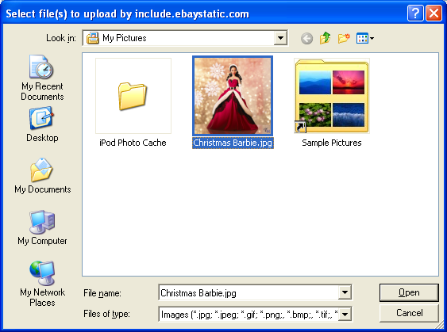

11) You can then alter the picture by changing the contrast, exposure, rotation, or cropping it. To perform those alterations click on the options on the right of the picture. You can also choose to pay a little extra to have an extra large version of the picture included in search results by clicking the box next to Gallery Plus underneath the picture. To continue with uploading the picture for free just click the check box beside Picture Pack (free) and then click Upload.

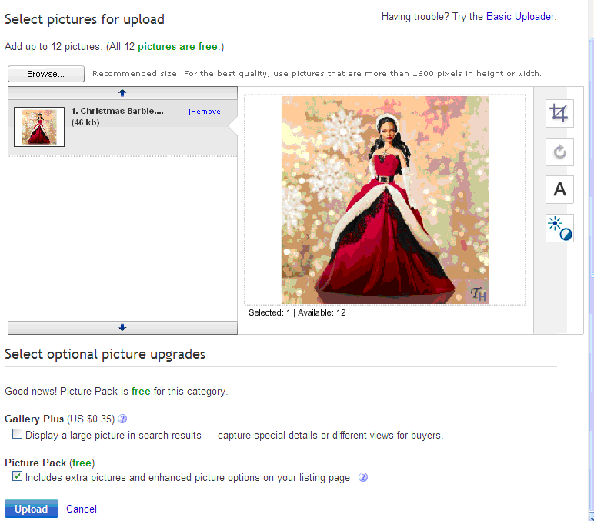
12) You will be directed back to the product listing page. Notice that your selected pictures are now uploaded. Now type in a description of your item in the provided text box underneath the heading Describe the Item You’re Selling.

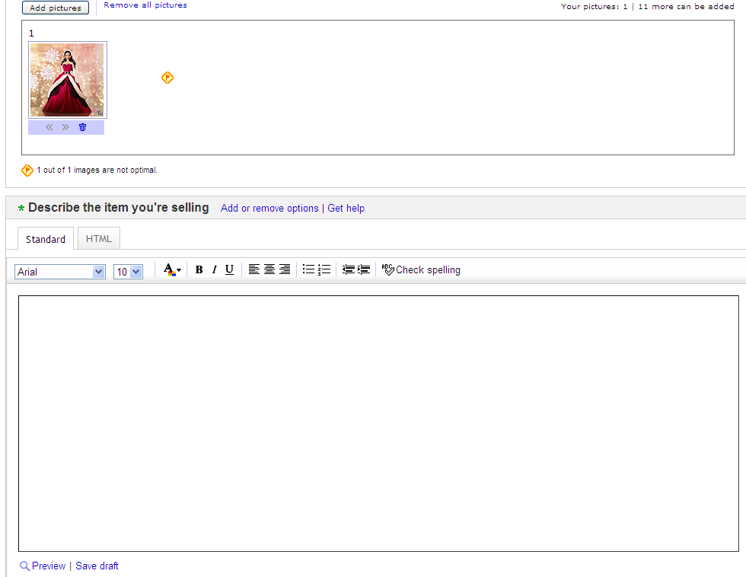

13) Under the Choose How You’d Like to Sell Your Item heading choose whether you want your item to be bid on by clicking Online Auction or to be bought at your own set price by clicking Fixed Price. If you chose to have your item set up for bidding then provide the starting bid price for it by typing in the desired amount in the provided text field. If you chose to set it at a fixed price than do the same thing but type in the set price of it. You can also choose to allow buyers to have the choice between bidding on it or buying it at your own fixed price by filling in both options when you select Online Auction. Then select the quantity of your item (most likely will be 1) and then the duration of your item’s listing. The time duration will depend on whether you choose to auction your item or have a set price for it.

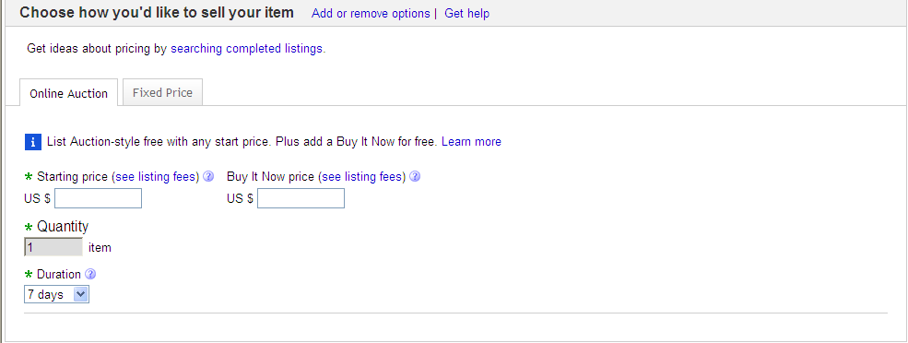

14) Choose how you’d like to be paid by the eBay member who buys your item. (Paypal is probably the most secure and recommended form of payment on eBay) Click on whichever payment option you feel comfortable with and provide the appropriate details for it (PayPal email address, card #, etc.)

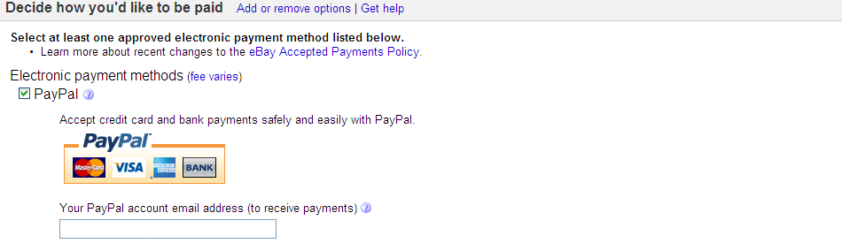

15) Fill in the shipping information for your item by selecting the appropriate shipping details within this section. You will need to set the shipping cost, handling time, which company you will be shipping through, what address you are shipping from, and what locations you are willing to ship to.

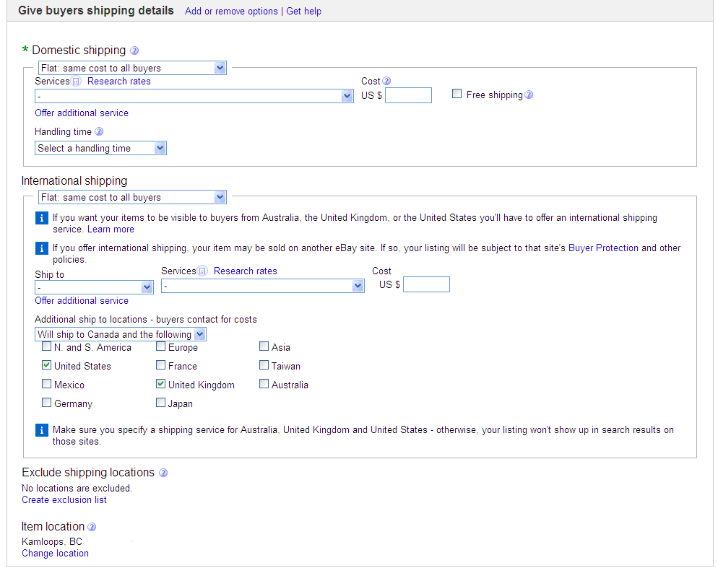

16) Choose your return policy (whether you want people to be able to return the item or not). Then click Continue to proceed to reviewing your listing.

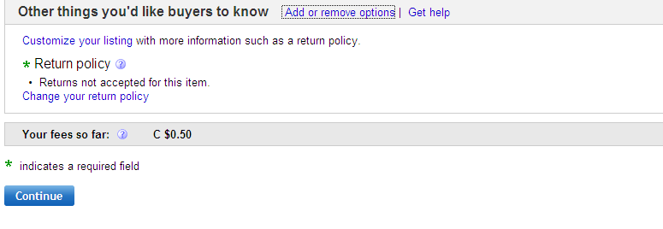

17) You will then need to review all of the information you included in your listing to make sure it’s accurate. eBay will also suggest other ways to promote your ad further which may cost extra so only choose the options that you’re willing to pay for or just keep the listing free all together. Then click Continue. Follow any of the remaining prompts to fully place your ad.

*If you need to end your listing early the best way to proceed is to click Customer Support at the top of the eBay homepage and then click End a Listing Early provided in the Self-Service Tools help section (you may have to type it into the search field if it’s not provided in the list).

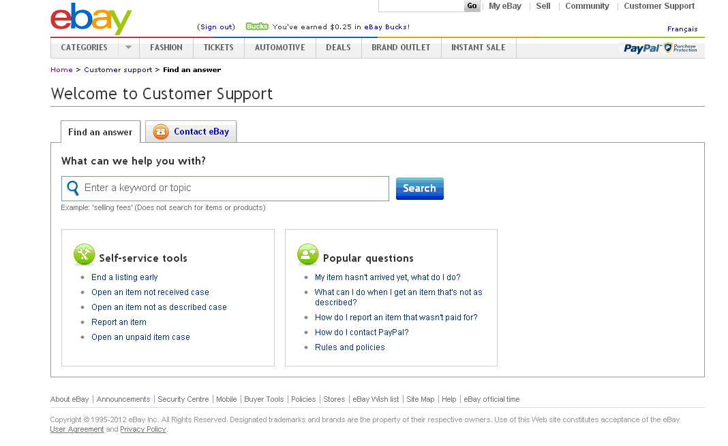
The eBay Customer Support will provide a few details on the matter of ending your listing early (make sure you read the information about what restrictions may apply to your listing). Click End Listing Early to carry on with the process.

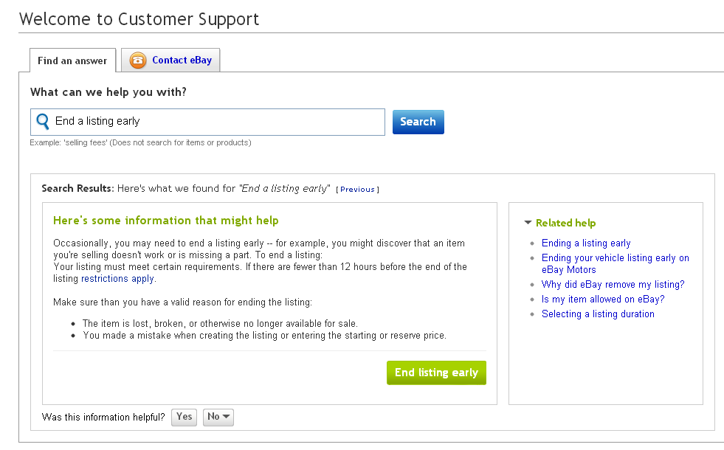
November 5, 2012

