How to Save and Print a Photo from Facebook

- On your Facebook account direct yourself to the picture that you would like to print and save. The picture can be located in a few different places depending on the time of the upload and on who uploaded it (yourself or a Facebook friend). The most common locations are: In the Photo Albums section found on your Profile/Friend’s Profile, in the Newsfeed, or on your Wall/Friend’s Wall. Once you find the picture open it up by clicking on the smaller icon of it.

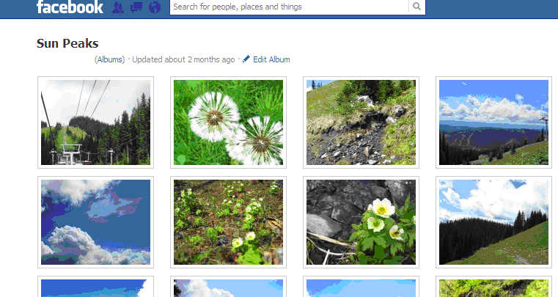

- Once you have the picture open bring your cursor down into the bottom right corner of the picture. This will bring up an Options menu that wasn’t visible before. Put your cursor over the Options heading and then click on the Download option.

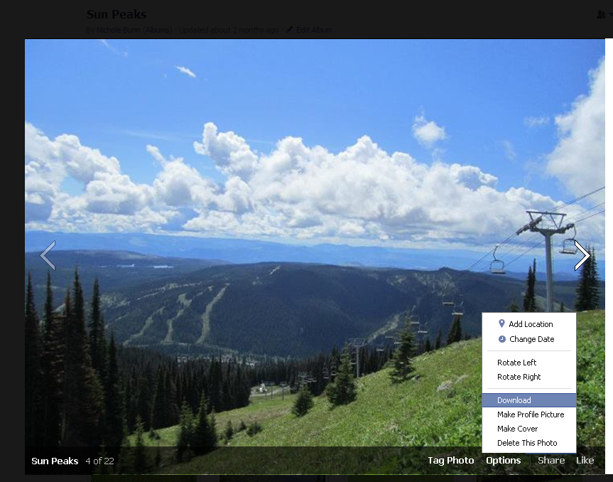

- Depending on what operating system you have (Windows XP, Windows 7, Mac, etc.) your download may directly go to a specified folder on your computer such as Downloads or an option will appear giving you the choice right away as to where you would like to save it. If given this option click on the Save button.

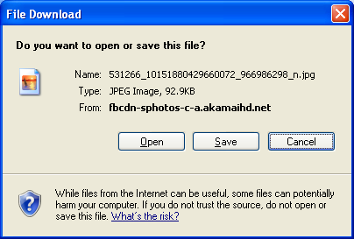

- Another window will then appear that gives you the option to name the picture and then save it to whichever folder you would like. Type the desired name of the picture in the File Name text bar. Choose the folder you would like to save it in by clicking the small arrow next to the Save In options bar and then selecting the desired folder to save it in.

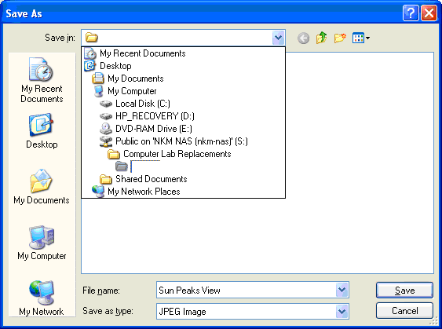

- To print the picture, locate it in the folder that you saved it in and then double click on it. It should then open up in a picture viewer program that is installed on your computer such as Windows Fax and Picture Viewer. With the picture open locate the Print option that will most likely be found underneath the picture or in the File option if there is one. Click on the Print option to print it.
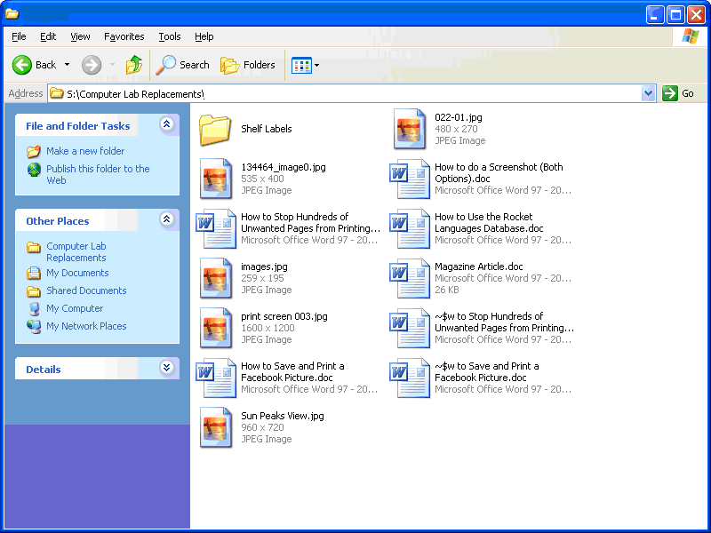
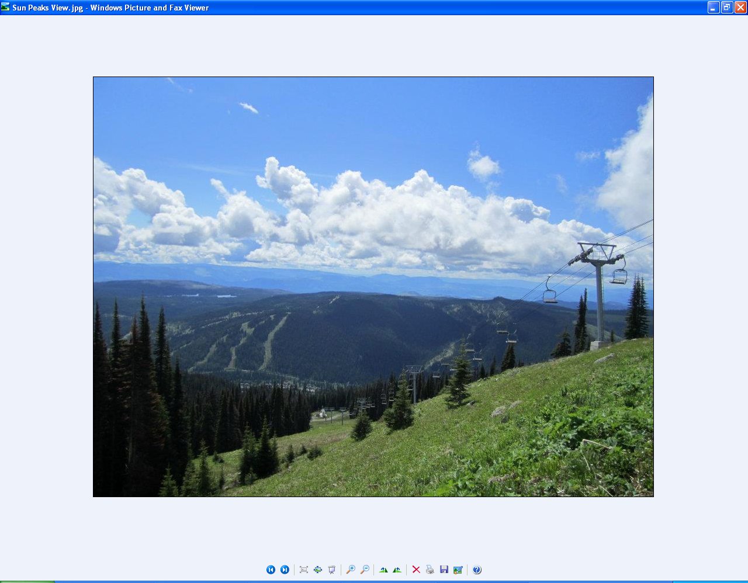

September 10, 2012

