How to Print an Email

These instructions will show you three different ways to print an email from a web-based email service.

- The first option is to use the browser’s print button, located under the file menu at the top of the screen, on the toolbar at the top of the screen, or by using the keyboard shortcut Ctrl+P.

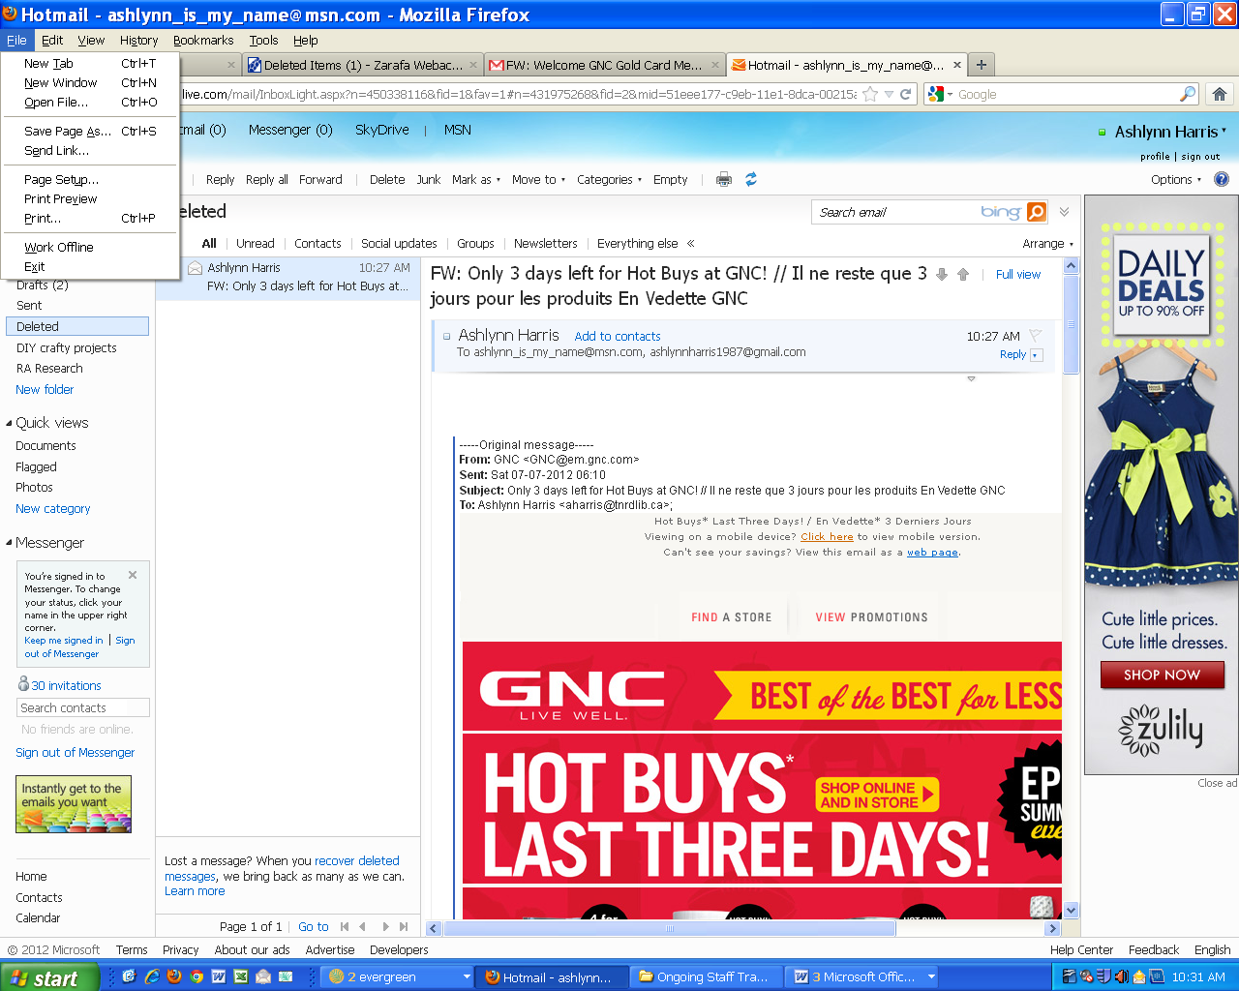

The resulting print will include the menus listed along the top and the side of the screen on your email page (circled below). If you need to scroll over in the screen to see the entire message (see arrow below) then only the visible part of the message will print. For this reason, this is not usually the best option.

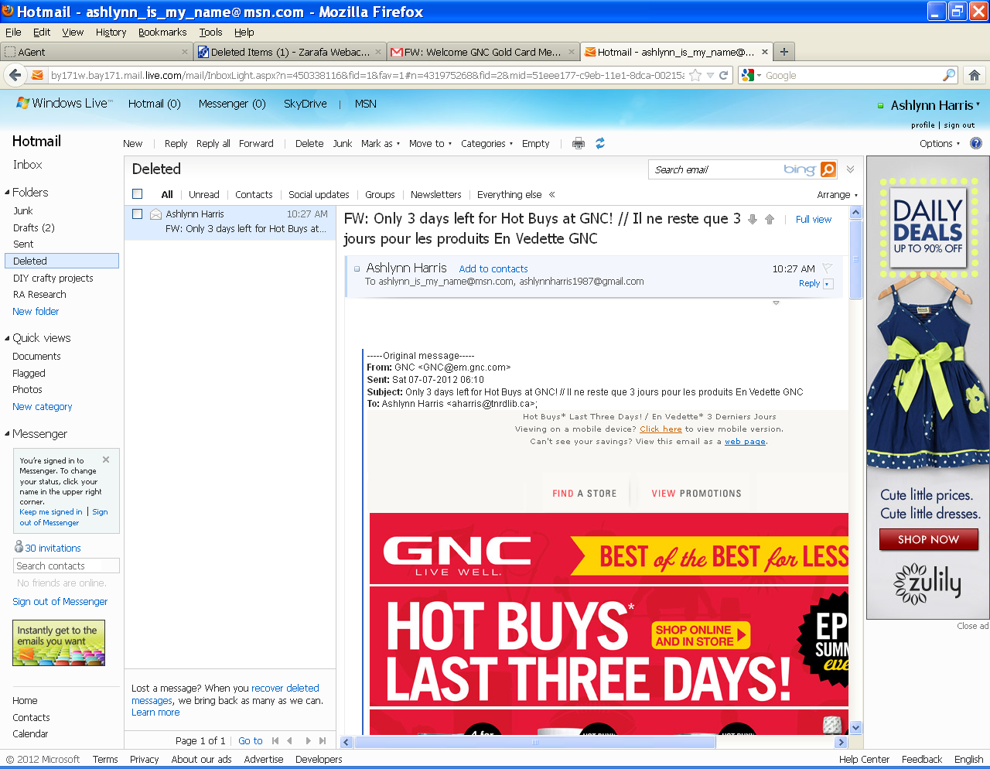

- The second option is to print using the email program’s built in print button. The first example below is Hotmail, the second is Gmail.

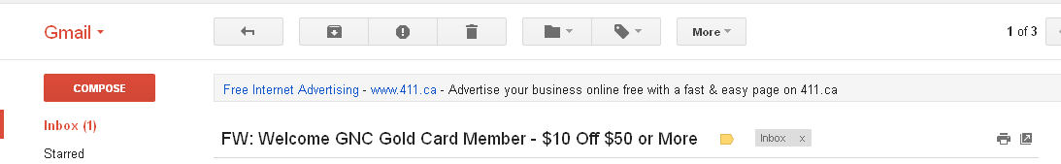

The resulting print will include the email address it was sent from, the email address it was sent to and the time and date it was sent. It will also print the entire message even if you have to scroll over to see it on the screen.

- The last option is to highlight the content of the message, copy it (by selecting copy from the edit menu, by right-clicking and selecting copy or by using the keyboard shortcut Ctrl+C) and then pasting it into a Word document (by selecting paste from the edit menu, by right-clicking and selecting paste or by using the keyboard shortcut Ctrl+V). This is the best option if the content of the message needs to look professional, such as a resume, however some formatting may be lost or distorted in the process.

November 14, 2012

