How to Create a Gmail Account

- Go to www.gmail.com
- Click on Create an Account
- Fill in the information requested.

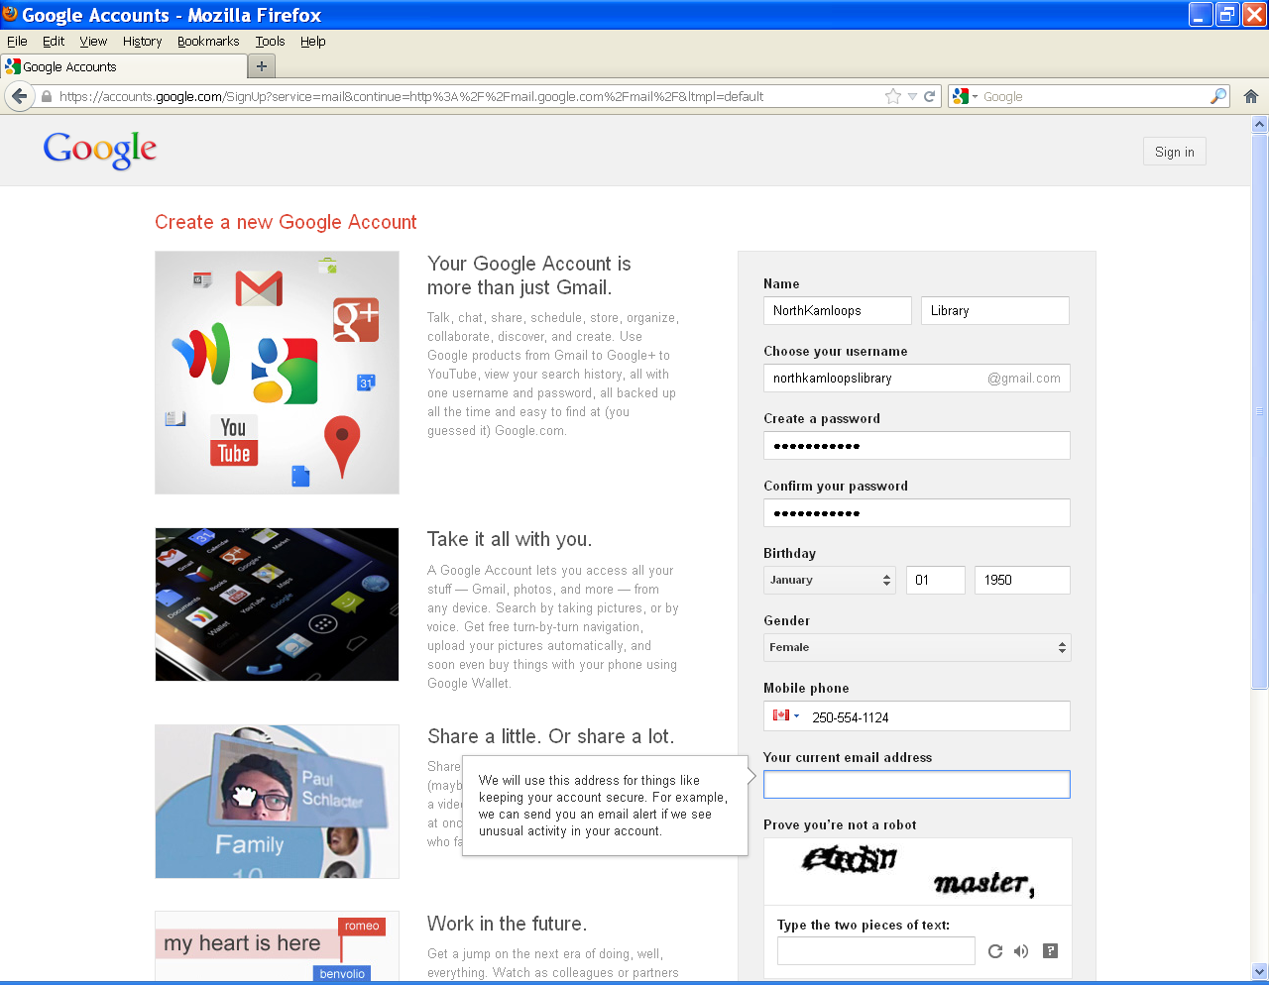

- Regarding the username:
  - It must be unique, if the name is already taken the phrase: Someone already has that username. Try another? will appear in red type under the username box as soon as you click on a new field.

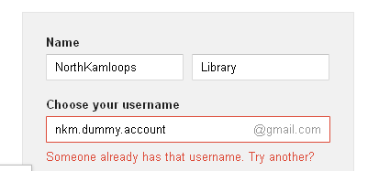

  - Try adding numbers to the end of a desired username if it is already taken (e.g. “JaneDoe123” rather than just “JaneDoe”)
  - The username can only include letters, numbers and periods, not spaces or underscores.
- Regarding the password:
  - It must be at least 8 characters long.
  - It cannot be a dictionary word, although dictionary words with numbers in them do sometimes work for example ‘September’ does not work but ‘S3pt3mb3r’ does.
- When filling in the information remember that:
  - The mobile phone number and current email address fields are optional, but recommended as they make it harder for other people to reset your password and easier for you to reset your own password if they forget it.
  - Impossible to read captchas can be changed with the reload button to the right of the captcha field.

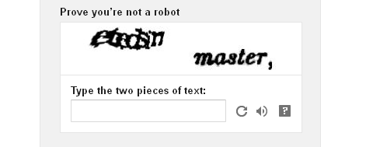

  - Users have to check the box to agree to Google Terms of Service but you can uncheck the box for personalizing +1s if they choose to.

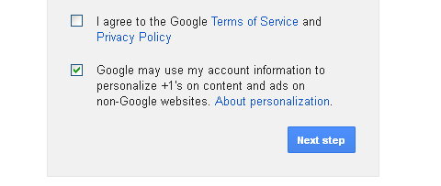

- Click on Next Step. So long as there are no errors, you will be redirected to a Welcome page. If there are errors they will be highlighted in red.

November 14, 2012

