

**Handout for Computer Basics**

**THE KEYBOARD**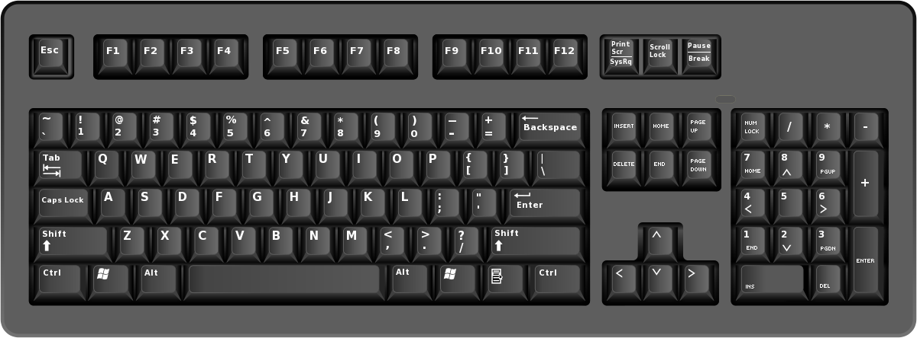

2

3

6

5

4

2

3

1

1. Escape key 4. Space Bar
2. Shift key (There are two) 5. Caps Lock key
3. Enter key (There are two!) 6. Backspace key

**STARTING A PROGRAM FROM A SHORTCUT ICON**

The desktop is the very first screen you see after your computer starts. A shortcut icon with an arrow is normally found on the desktop. These icons allow you to run programs from the desktop rather than going to the “Start” button and selecting from a menu. Shortcuts can be created for programs, files and applications.

This is a shortcut icon for Internet Explorer, which you use for viewing web pages. Note the arrow – this indicates it is a shortcut.



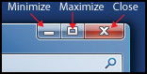

## Managing windows

**Minimize** Click it with the left button to minimize an active window. This button puts a program on hold and places it on the taskbar at the bottom of the screen. To re-open the window from the taskbar, click on the box that represents the program you want.

**Maximize**Click it with the left button to maximize an active window in order to fill the entire computer screen. If the active program's window has been maximized, button will contain two small overlapping boxes. This is a restore button. If you click it once with the left mouse button, the window will no longer cover the entire screen. It has been restored to its original size.

**Close **Click it with the left button to close an active window

**MOVING A WINDOW**

Press and drag the title bar. When you let go that’s where the window will move to.

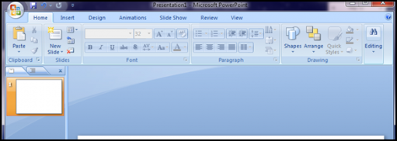

**WHERE DID I SAVE MY FILE?**

When you save a file, it has to be stored somewhere specific, just as with a physical piece of paper located in a file folder in a cabinet. Click on the *Start* button and then on *Computer* to see your Desktop, Documents, Pictures and Music folders:

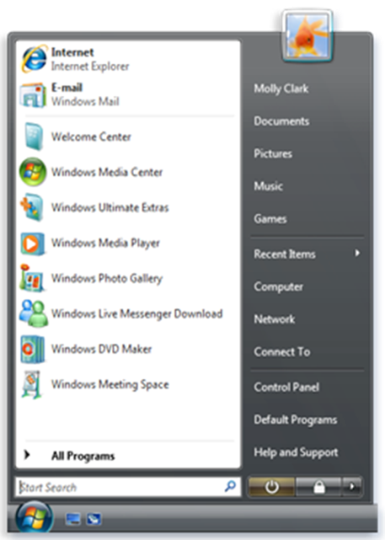

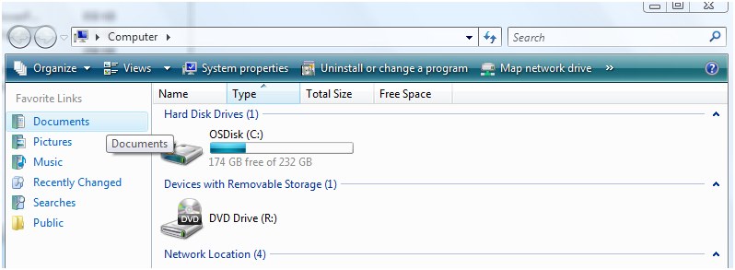

**ADDITIONAL HELP**

Go to the Surrey Libraries website: [www.surreylibraries.ca](http://www.surreylibraries.ca)

Suggested practice links:

* Basic Computer Skills for the Windows Environment
* Teach Parents Tech
* ***Programs & Services***
* ***Learn Online***
  + ***Tech Knowledge***