Getting Started with Google Nexus 10
Google Nexus 10 tablet uses an Android operating system, making it very similar to Samsung Galaxy tablets. The wifi connection on the Nexus tablet is significantly faster than normal wifi.

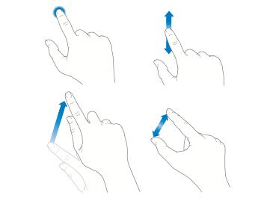Navigating with Hand Gestures
Swipe: to move the screen
Tap: to select or open

Drag: to move an item

Pinch: to make bigger or smaller

Part 1 POWER ON the Nexus tablet, and log on to a wi-fi network.

To turn on the Nexus tablet, press and hold the Power/Lock button on the top of the Nexus tablet until the tablet vibrates slightly, about 2 seconds. Remove your finger from the button while the device starts up. A lock within a circle will appear on the screen; press and drag to the unlock symbol.
Tap the Apps button.
Power/Lock button
Tap the Settings button from the list of Apps. 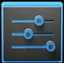
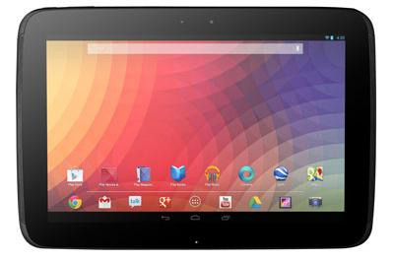

On the left side list, tap Wi-Fi. A list of available networks will appear. When inside Vancouver Public Library, click VPL.

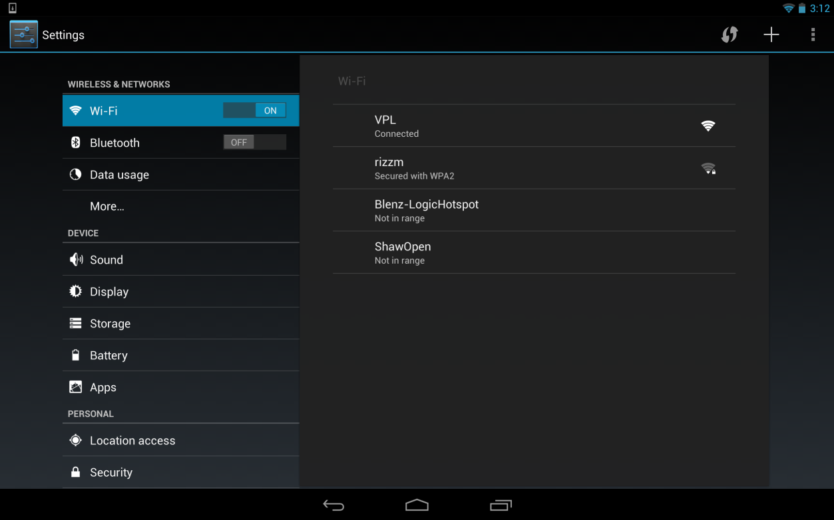

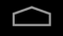Tap the Home button.
Open a web browser, such as Chrome. Type in “vpl.ca” and press return.
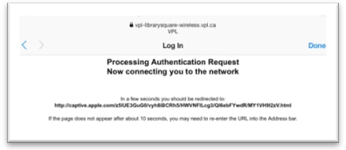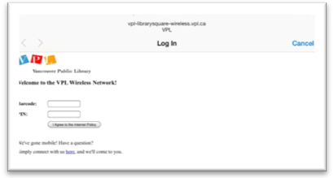A login screen will pop up, asking for your library barcode number and PIN. Tap each space until the keyboard appears, and begin typing in your numbers. (To change the keyboard to numbers, tap the “?123” button on the left side of the keyboard.) Click on I Agree to the Internet Policy when finished typing.
You will see an authentication screen.
You are now ready to use the Internet.

Part 2 Applications Overview
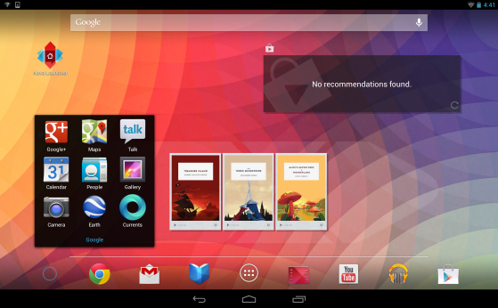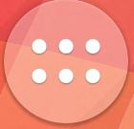 Applications, or Apps, are software programs that cause a device to do specific tasks beyond just running the device. Many apps come standard with the Nexus 10. A few of the basic ones on the bottom of the screen:
- G+ button (expands to show a box of options):
  - Calendar: set your schedule, with reminder alerts
  - Gallery: stores all photos you take with the Nexus 10
  - Camera: take still photos and videos
  - Maps: requires an internet connection, can give directions and store pre-planned maps
- Play Store: allows you to download or purchase apps
- Settings: how to make adjustments to how the tablet operates (click Apps button, then Settings)
- Chrome: the web browser from Google, allows you to connect to the Internet

Part 3 How to download apps
Tap the Google Play Store button. If you know the name of the app you would like, tap the magnifying glass and type the app name in the Search bar at the top left.
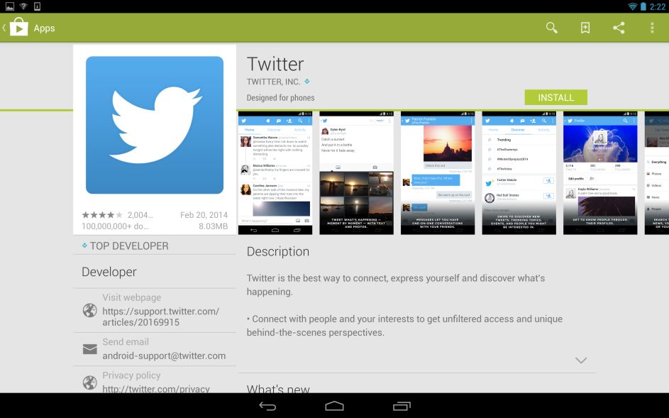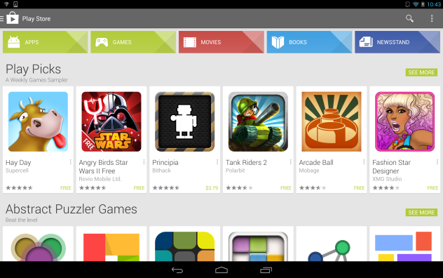

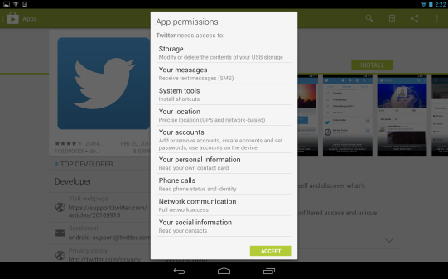From the results, tap an app to see more information. To download the app, tap the INSTALL button (or, if there is a charge, the price button. It will switch to an INSTALL button; tap it again to begin the download process).

A window asking for your permission to access the tablet will pop up. If you allow permission, click on ACCEPT and continue your download.

Part 4 Downloading eBooks
As with other tablet devices, downloading eBooks to the Nexus 10 is relatively easy once the initial set up is done.
To set up the Nexus 10: http://www.overdrive.com/help-videos/#android
To download eBooks from VPL to Go: http://guides.vpl.ca/tablets-and-smartphones

Part 5 How to charge the Nexus tablet, how to tell when it needs to be charged
On the top right corner, the battery life for the Nexus 10 is shown as a battery with a diminishing blue power supply.
The Nexus 10 can be plugged into an external power source or using an USB port on your computer. On your computer, cancel out of any prompt boxes asking to launch a photo program. Do not attempt to register the device to a personal computer.
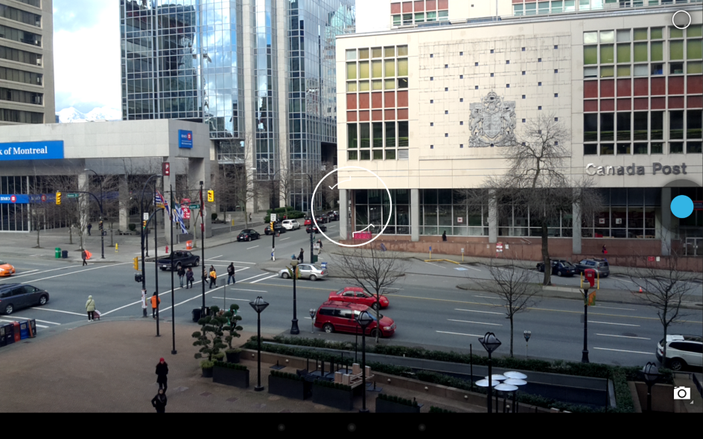Part 6 How to take a picture
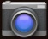 Tap the Camera button.
There are 3 options for images. Tap the camera in the bottom right corner to see:
- Panorama
- Video
- Photo
Tap the camera options listed on the screen. To take a picture, press the blue circle once. It will automatically save in your Gallery app.
To take a panoramic photo, press the blue circle once and slowly turn in a clockwise motion to capture the panoramic view. A small guide will show the camera’s progress and will turn red if the camera moves too quickly.
To record video, press the red circle to begin recording; recording will stop when the red circle is pressed a second time.
Other features by clicking the white circle in the top right corner:
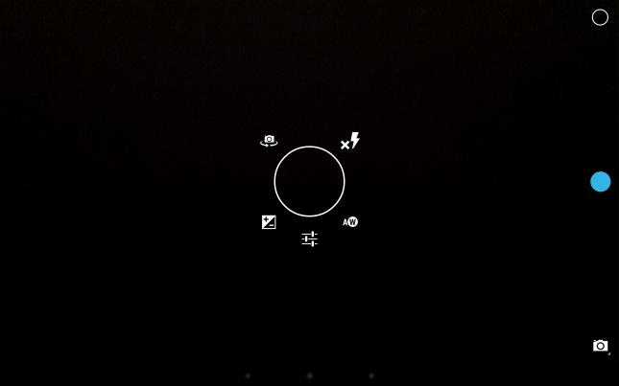
Select from different lenses according to type of shot
Switch the camera from forward facing to take self-shots
Change flash preferences: on, off or auto flash

Adjust the light/dark settings

Adjust settings for scene types and picture size

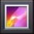Photos are automatically stored in the Gallery app.
To delete photos, go into the Gallery app and click on the image you want to delete. In the top right corner, click on the 3 vertical dots to see the pull down menu. Tap on “Delete” to delete the photo. Confirm you wish to delete the item. Once deleted, the photo will be permanently deleted from the Gallery.

