Getting Started with Instagram

What is Instagram?

“Instagram is a fun and quirky way to share your life with friends through a series of pictures. Snap a photo with your mobile phone, then choose a filter to transform the image into a memory to keep around forever. We're building Instagram to allow you to experience moments in your friends' lives through pictures as they happen. We imagine a world more connected through photos.”

How do find photos and people?

Tap on the magnifying glass icon at the bottom of the screen to browse photos or search for people or photos.

Search using words, or #hashtags. You can filter results by “top”, people (accounts), tags, or places. | 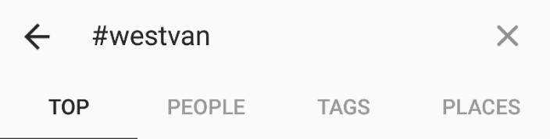
Follow people/accounts by tapping the +Follow button.  Note: You can unfollow an account at any time. | 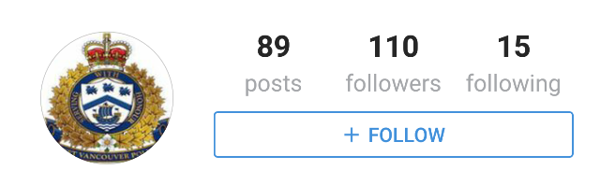

For Help

Official Instagram help: https://help.instagram.com/
How do I add a photo?

Open Instagram and tap on the camera icon

Then you can:
- choose a photo you have taken previously,
- take a photo inside of the app
- Or take a short video

What are filters?

Once you have taken your photo then you can edit it.  Apply filters by tapping on a filter in the lower area of the app. There are  The filters apply layers of colour, softening or sharpening, or other editing layers to your photo to make it “pop”.  Note: By clicking on “Edit” you can get more advanced editing options. | 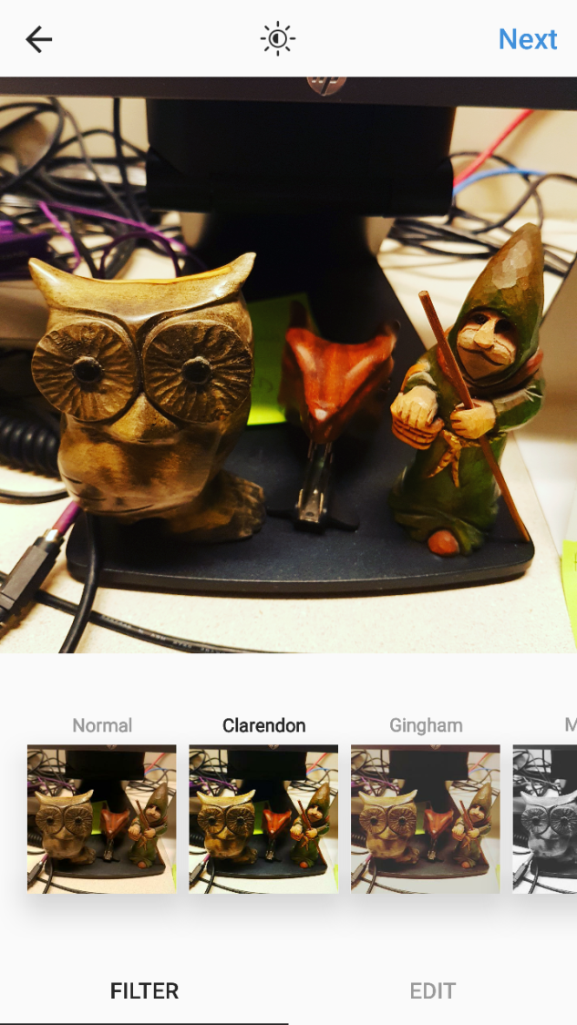
Saving Drafts
You can saved what you have created as a “Draft”
- Tap at the bottom of the screen, then take or upload a photo or video
- Add effects, filters, a caption or your location
- Go back to the filtering and editing step, then tap the back arrow in the top left
- Select Save Draft at the bottom of the screen
Note: If you don't edit the post, tag people or add a caption or location, you won't be able to save the post as a draft.
To see posts you've saved as a draft, tap and then tap Library. Posts will appear at the bottom of the screen below Drafts.

How do I tag & post my photo?
After you have chosen and edited your picture:  - Write a caption  - Add tags to help people interested in the subject of your photo find it. Try  - #westvan  - #sunset #sunrise #dogsofinstagram #catsofinstagram  Tags are preceded by # and have no spaces. | 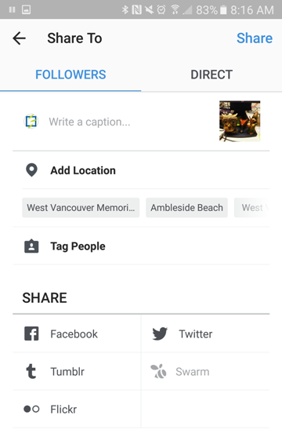
- Choose if you want to add the photo to a map - this will let people know where the photo was taken.
- Choose if you want to share your photo to your other social media accounts.
Find out if people “like” your photos or if someone has subscribed to see your updates by tapping on the Activity icon.

What are all the filters?
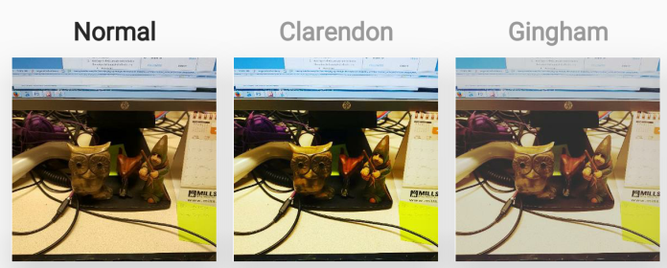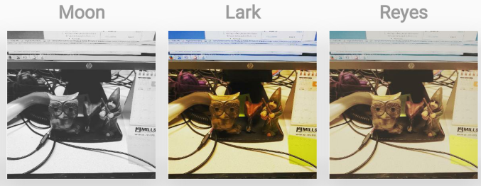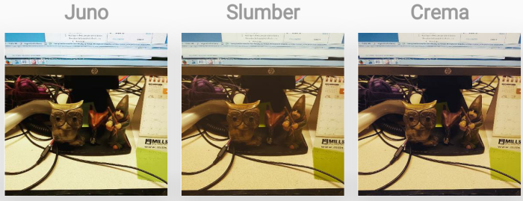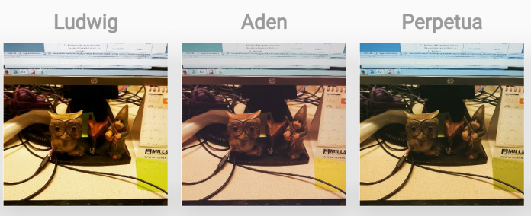
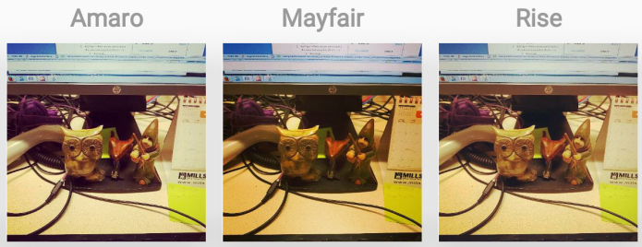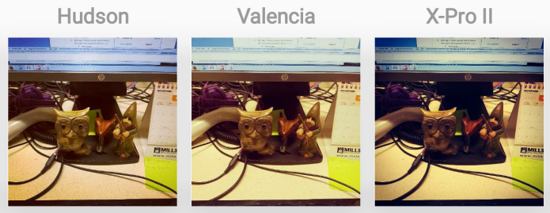
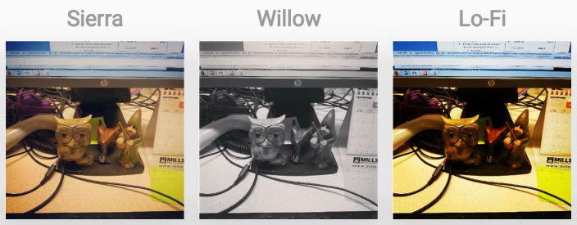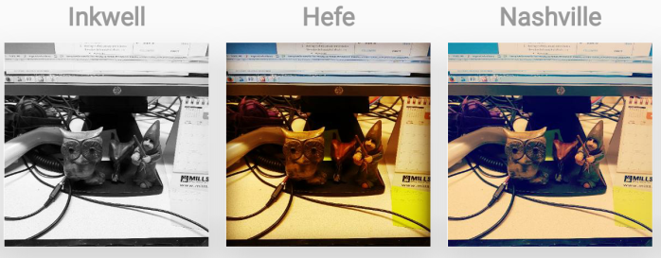
What are all the editing options?
