Financial Post Databases
Financial Post Databases provide in-depth and full-text Canadian industry news and business information. This electronic database is available at any public computer in the Library and off-site through the Library’s Internet site.
From the main page ( http://www.vpl.ca/ ), click on Online Articles, Encyclopedias & More.
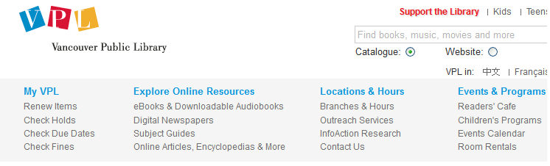

In the alphabetical list, click on F to see the list of databases that start with F. Scroll down to Financial Post Databases and click on it.
When using Financial Post Databases from home, an authentication screen will appear, asking for your library barcode number and PIN number. Your library barcode number can be found on the back of your library card, under the barcode; your PIN number is usually the last 4 digits of your telephone number.

Information Services

April 2014

Here is the homepage of Financial Post Databases: 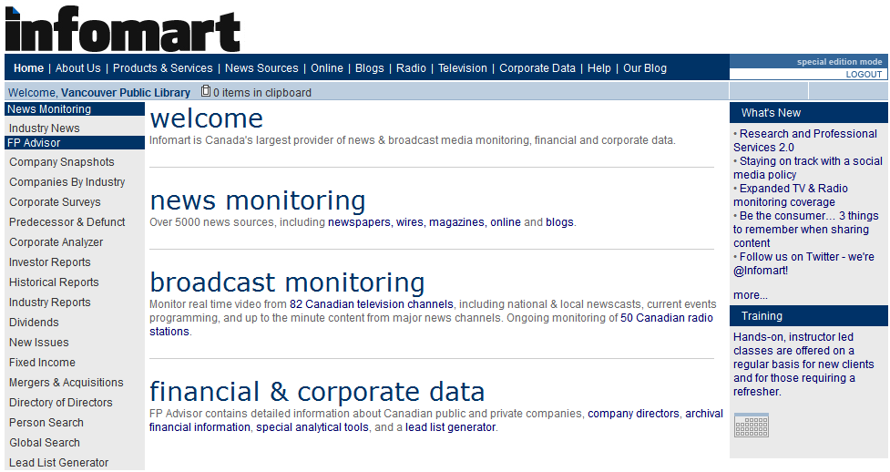
Use the left-hand menu to navigate through the databases.
Industry News
- Select daily from 12 full-text sources including National Post and Vancouver Sun.
- Provide links to Company Snapshots for the top 5 companies in an industry.

Company Snapshots
- Provide a quick snapshot for all publicly traded Canadian and some private companies.
- Use the Company Snapshot Search to find an overview of a specific company, and to find out what other information is available about that company.
Companies by Industry
- Provides financial information on the largest companies in specific industries.
- Use it to browse through lists of companies in a particular industry.
Corporate Surveys
- Includes capsule financial statements, FP 500 rankings by sales, assets and net income.
- Allows you to search on a wide variety of data elements.
Predecessor & Defunct
- Records changes to former publicly traded Canadian companies since 1929 with details of name changes, amalgamations, takeovers, acquisitions and dissolution.
Corporate Analyzer
- Provides detailed financial information such as ratios, financial statement information, price performance and the latest share prices and volumes.
Investor Reports
- Use it to access consensus buy/sell recommendations, projected EPS and cash flow per share, and up to seven years of industry standard ratios.
Historical Reports
- Lists corporate activities including mergers, acquisitions, spin-offs, stock splits/consolidations, annual highs and lows dating back to incorporation for the top currently and formerly traded Canadian companies.
Industry Reports
- Offers financial ratios and analyst recommendations for 33 industries.
- Includes top companies in the industry ranked by total revenue.

Dividends
- Provides information on historical and future dividend payments of all publicly traded Canadian companies dating back to 1998.
New Issues
- Offers information on public offerings and private placements issued by Canadian companies, governments and agencies dating back to 1993.
Mergers & Acquisitions
- Provides information on mergers and acquisitions involving Canadian companies going back to 1994.
Directory of Directors
- Use it to find detailed information on an individual or a list of directors of a specific company.

Person Search
- Use it to find as much information as possible about a specific individual.

Global Search
- Allows you to search all the databases at the same time.

Lead List Generator
- Use it to create targeted lists of contacts. Useful for organizing direct mail campaigns.
Financial Post Databases Practice Exercises:
- Which company in the Publishing Industry has the highest revenue figure? What is the company’s revenue?

- Find out major shareholder, auditors and the latest total long-term debt of Air Canada.

- Find out the key executives of Rogers Communications Inc., its competitors, 52-wk high and low stock price, and the latest news about the company.

- Find out a list of banks with headquarters in Vancouver?

- What became of the Hudson’s Bay Oil and Gas Company?

- Find out the latest consensus recommendation and short position of Harry Winston Diamond Corporation.

- Find out the company with the most current highest quarterly revenue in the Food, Beverage & Tobacco sector.

- Find out how many different types of Canadian Imperial Bank of Commerce shares are traded publicly.

- Find out IPO deals greater than $50,000,000, marketed in Canada, classified under GICS code 40 (Financial) and completed during 2002. RBC Capital Markets was the bookrunner of the deals.

Information Services

April 2014

