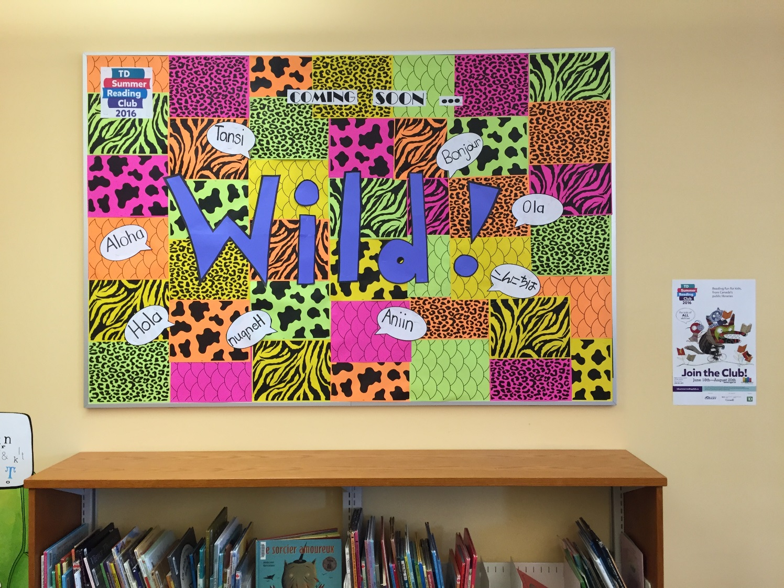

This is our WILD display for this year’s TD Summer Reading Club. We went with wild colours and prints, and ‘hello’ in different languages. We thought this would be a great way to catch everyone’s attention while introducing some of our interpretations of the word WILD. We are planning on keeping this up in the children’s section all summer with only slight alterations as the months pass. The next alteration will be replacing the speech bubbles with pictures of the books on the TD Summer Reads pamphlet.
Thanks!

Summer Team at Spruce Grove Public Library

