





**w w w . s u r r e y l i b r a r i e s . c a**

Insert image in this text box. Get rid of box outline.

**w w w . s u r r e y l i b r a r i e s . c a**

Insert image in this text box. Get rid of box outline.

**Database name**

**Database Name**

____ features information on …..

____ features information on …..

**What you need:**

* A Surrey Libraries’ card
* A computer or device with internet access

Go to: [www.surreylibraries.ca](http://www.surreylibraries.ca)

From the ‘Research and Downloads’ tab, select ‘Databases A to Z’.

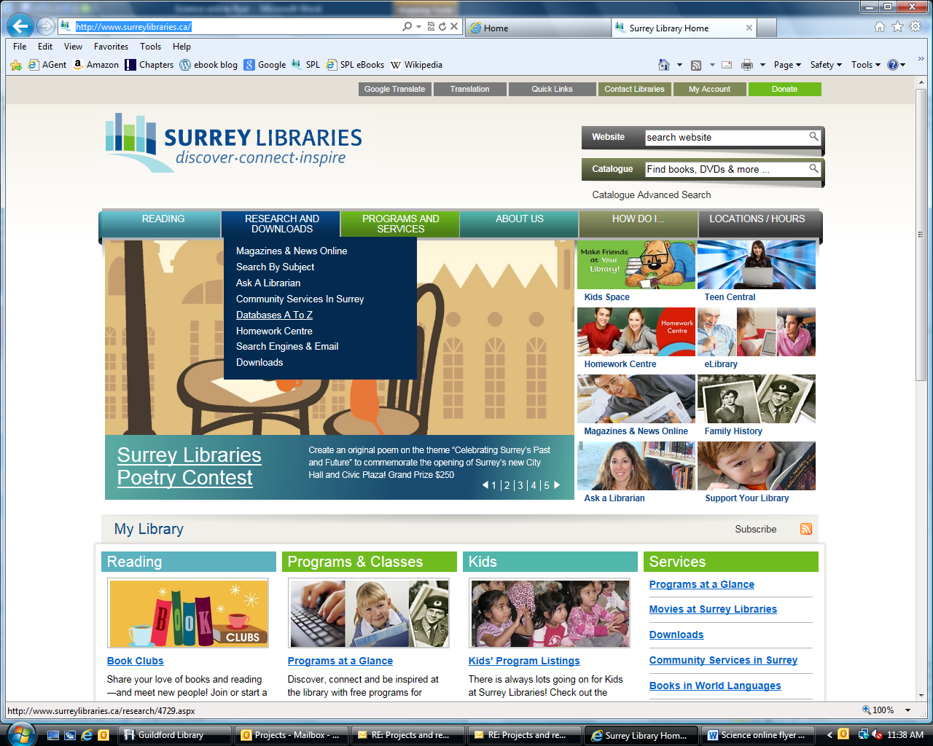

Select ___ from the list, under __.

Enter your library card number and click ‘Login’.

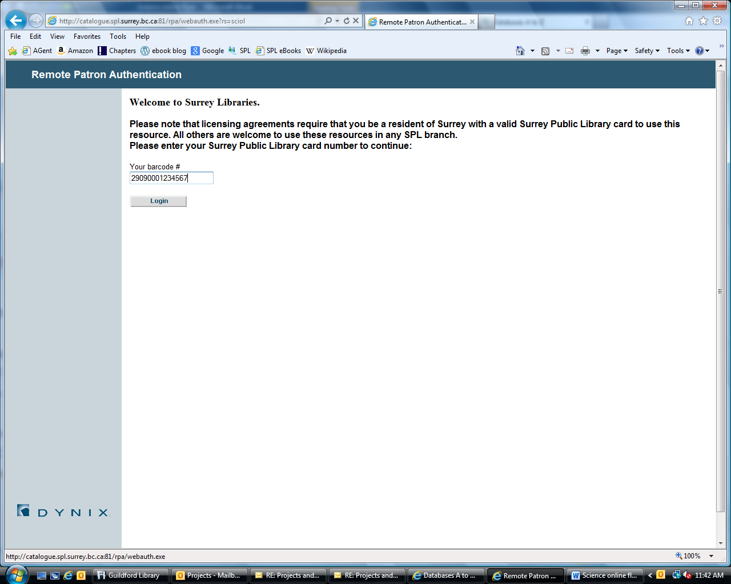

You’re now ready to start using ____!

**Need help?** Click on the help button in the main menu or ask at the information desk.

To create the account, you will be asked for:

* Email address
* Password
* Your name (optional)

A confirmation from ‘RB Digital Portal’ will be sent to your email. Click the link in the email to activate registration of your Surrey Libraries Zinio account!

**Turn over for instructions on Step 2, setting up your Zinio.com account**

**What you need:**

* A Surrey Libraries’ card
* A computer or device with internet access
* OR use in library – instead of above

Go to: [www.surreylibraries.ca](http://www.surreylibraries.ca)

From the ‘Research and Downloads’ tab, select ‘Databases A to Z’.



Select ____ from the list, under __.

Enter your library card number and click ‘Login’.



You’re now ready to start using _____

**Need help?** Click on the help button in the main menu or ask at the information desk.

To create the account, you will be asked for:

* Email address
* Password
* Your name (optional)

A confirmation from ‘RB Digital Portal’ will be sent to your email. Click the link in the email to activate registration of your Surrey Libraries Zinio account!

**Turn over for instructions on Step 2, setting up your Zinio.com account**

See other side for more details about ____ features and subjects

See other side to learn how to access ___ through Surrey Libraries

**w w w . s u r r e y l i b r a r i e s . c a**

[](javascript:void(0))

**What you will find in ____**

* blah
* blah
* b
* b

**Subject Areas (or?):**

* stuff
* stuff
* s
* s

____ helps with/good for/useful for___

**What you will find in ____**

* blah
* blah
* b
* b

**Subject Areas (or?):**

* stuff
* stuff
* s
* s

____helps with/is great for/useful for___

See other side to learn how to access ____ through Surrey Libraries

**w w w . s u r r e y l i b r a r i e s . c a**

See other side to learn how to access ________ through Surrey Libraries

**w w w . s u r r e y l i b r a r i e s . c a**

**Science Online**



**Science Online**

