Getting Started with Pinterest

What is Pinterest?

“Pinterest is a visual discovery tool that people use to collect ideas for their different projects and interests. People create and share collections (called “boards”) of visual bookmarks (called “Pins”) that they use to do things like plan trips and projects, organize events or save articles and recipes.”

What is a Pin?
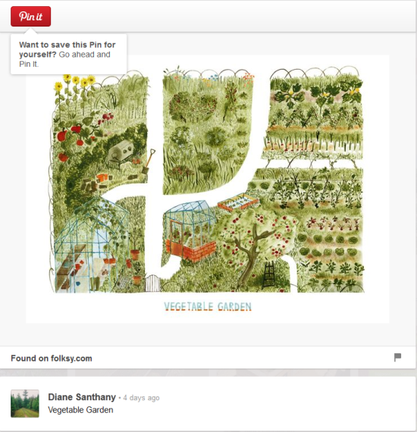 | A Pin is an image or video that you add to Pinterest that links back to the originating website. Pins often lead back to useful information such as an article, recipe, or item you would like to buy.  You can re-Pin other people’s Pins to your own boards, or share a Pin with someone you know.

What is a Board?

Boards are how you organize your Pins!  From “Ideas for the Living Room” to bouquets, puppies, craft patterns, and recipes. Boards will help your organize yourself and inspire others.  You can have up to 350 boards.  You can also have secret boards that only you (and people you invite) can see. Pins on these boards do not show up anywhere in Pinterest. | 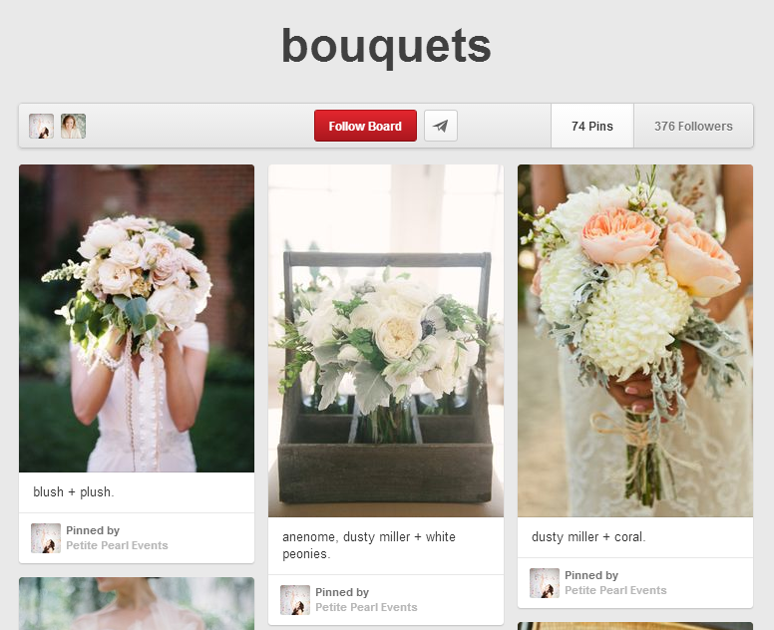
How do I create a Pin?
In Pinterest:
- Click on “Pin It”
- Choose a board to save the Pin to.  - Click on “Pin it” again. | 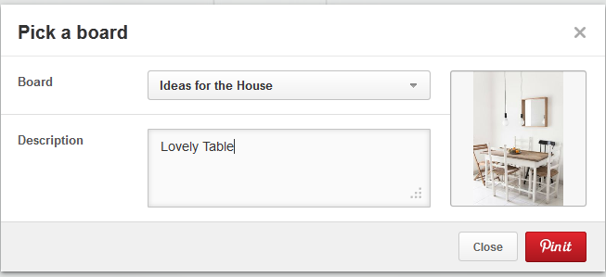
Other ways to Pin:  - Upload your own image  - Adding an image directly from a website | 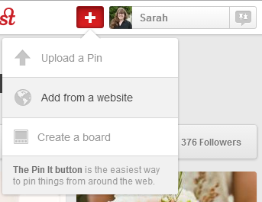

Find Inspiration

A great way to find Pins and inspiration is to follow fellow Pinners and boards!  Look for “Follow” buttons on boards or “Follow All” buttons for Pinners. | 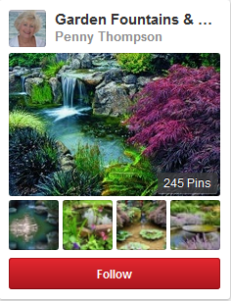

For More Information

Official Pinterest Help: https://help.pinterest.com/

Create an Account

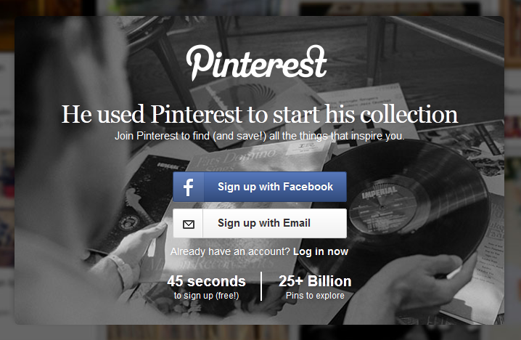 | 1. Click on Sign up with Email
2. Fill in the fields | 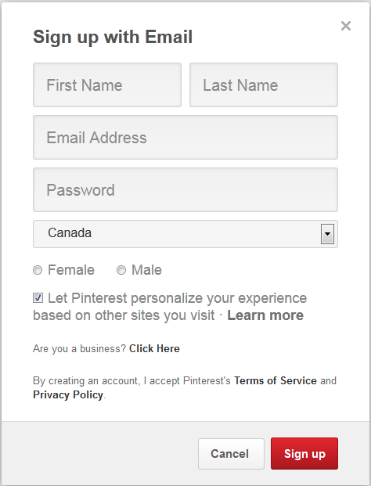
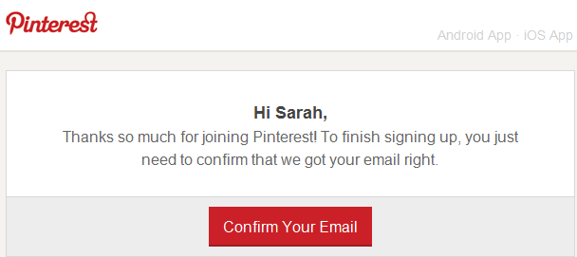 | 3. Check your email for this message.  4. Click on Confirm Your Email
 | And you are ready to start!

