Appy Hour: Music with Naxos

Listen to music from over 800 classical music labels with Naxos Music Library, over 9500 jazz CDs with Naxos Music Library – Jazz, and over 15,000 albums representing 1500 cultural groups with Naxos Music Library - World Music!

Creating an Account

Before using the app, you will need to create a Naxos account via the WVML website.

- Open an internet browser (Google Chrome, Firefox, etc.) and type www.wvml.ca into the address bar.

- Hover your mouse over or tap Research & Learn and then select Music & Video Online

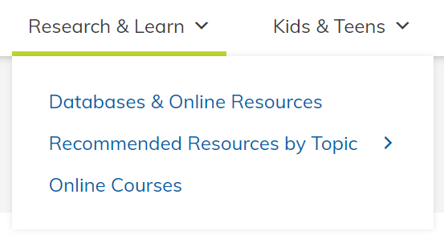

- Either search for Naxos or select Film & Music (streaming)

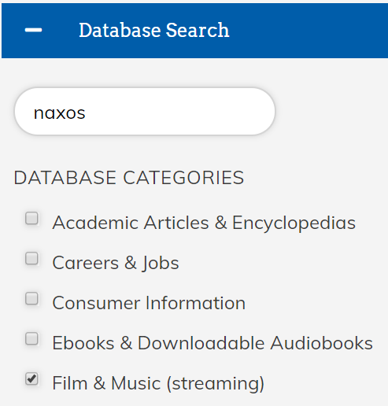
- Scroll down to the Naxos Music Library of your choice and select click here to create an account

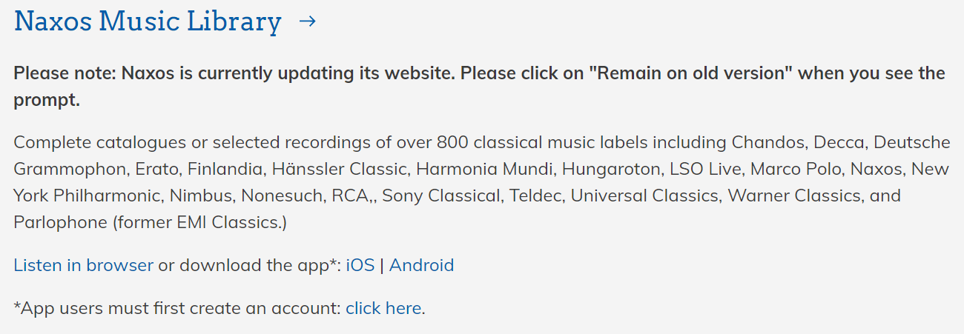

The Naxos Music Libraries are three separate libraries (classic, jazz, world). You will need to create an account for each music library that you would like to use. You can use the same email address and password for each so that it feels like you are using one account :)

- Enter your library card number and PIN on the next window

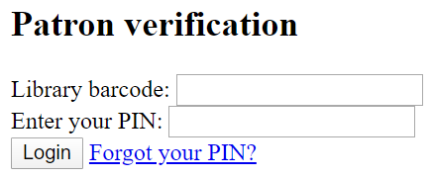

- Then enter your name, email address, select a password, and select Register New Account Now

- Then open your email to confirm your account

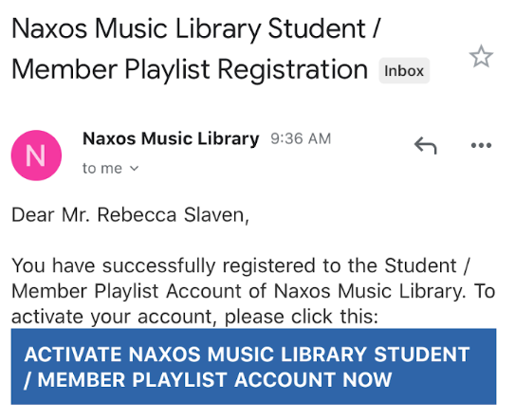
Downloading the Apps

Once you have created an account via the WVML.ca website, download the apps by going to the Google Play Store (Android devices) or the App Store (Apple mobile devices) and searching for Naxos.

The Naxos Music Libraries are three separate apps. You will need to separately download each one that you are interested in.

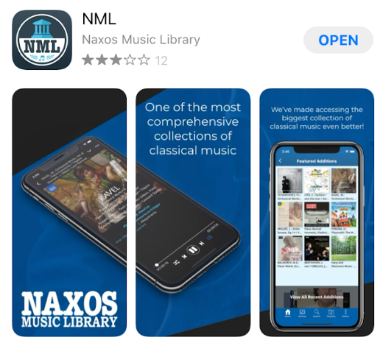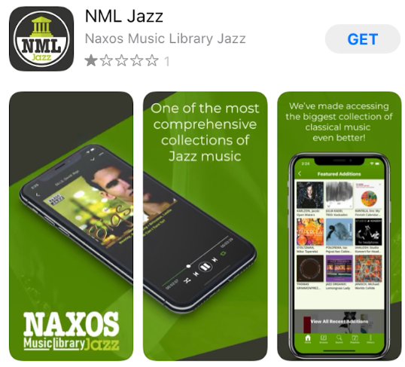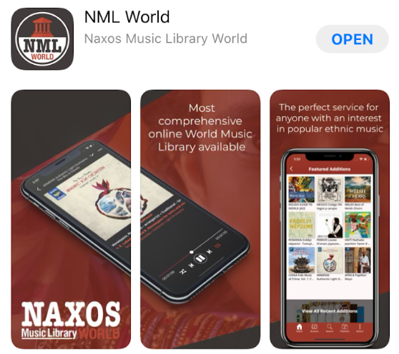

You can also download the Naxos apps by going to the WVML.ca website on your mobile device and selecting iOS (for Apple devices) or Android.

Once the app is open, login using your email address and the password that you selected.

Please note the screen shots on pages 4-6 of this handout were taken using the Naxos Music Library app on an iPhone.

Navigating the App

The app defaults to showing Featured Additions to the collection. Look to the bottom of the screen for the menu.

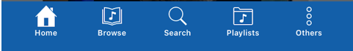

To browse for music by category, select Browse at the bottom of the screen.

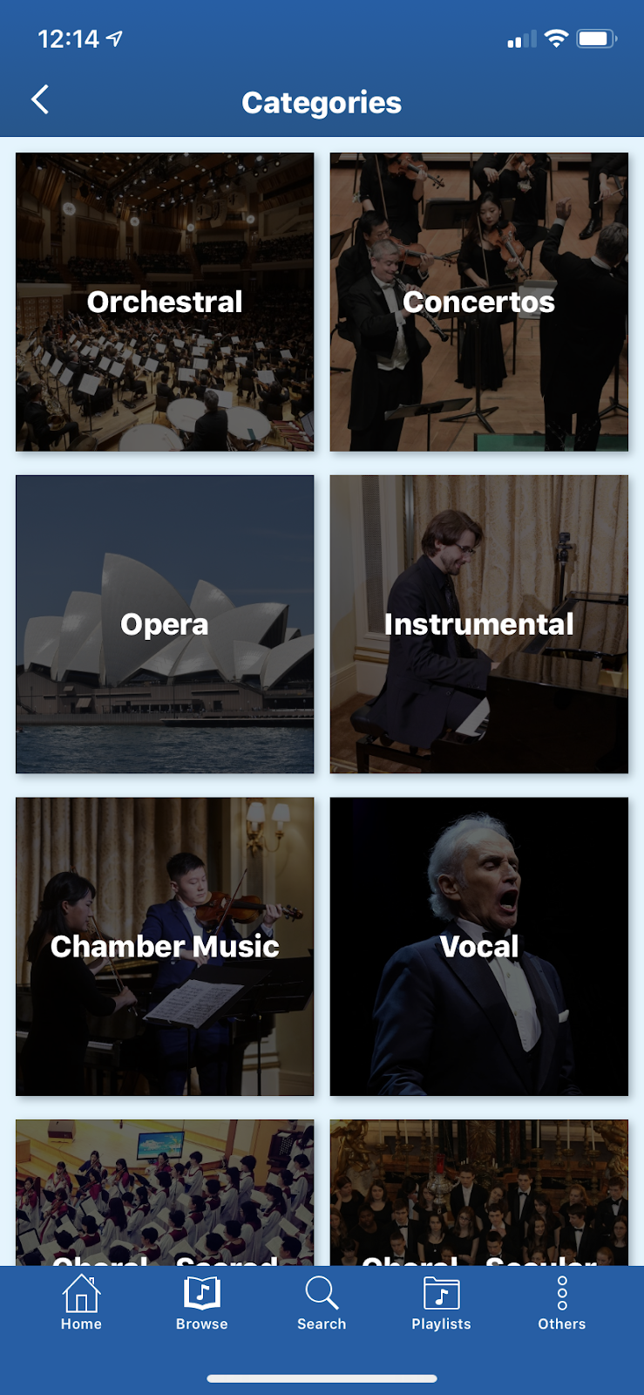

To search for music, select Search at the bottom of the screen.

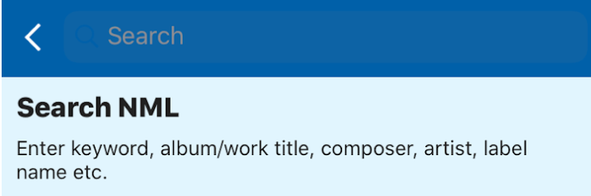

Select Playlists at the bottom of the screen to view existing playlists.

Student Playlists and WVML Playlists are empty.
Naxos Music Library Playlists and Themed Playlists have a number of playlists to choose from.
You can also view Recently Played music and see the music you have downloaded to play when not connected to Wi-Fi or data.
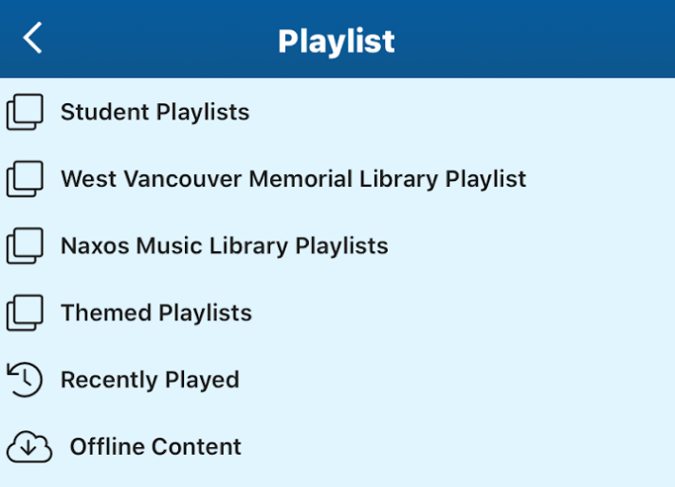

This is also where any playlists you have created will appear. To create a playlist, find the music you would like to add either by browsing or searching.
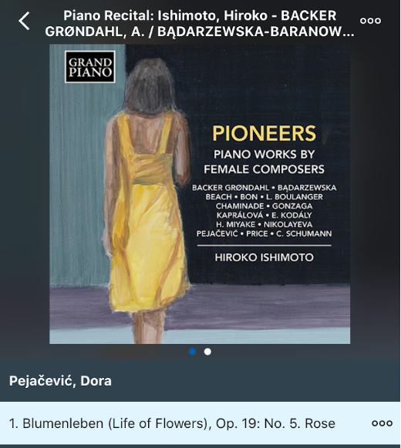
Select the three dots next to the album name to add the entire album.

Or the three dots next to an individual song to add it to a playlist.
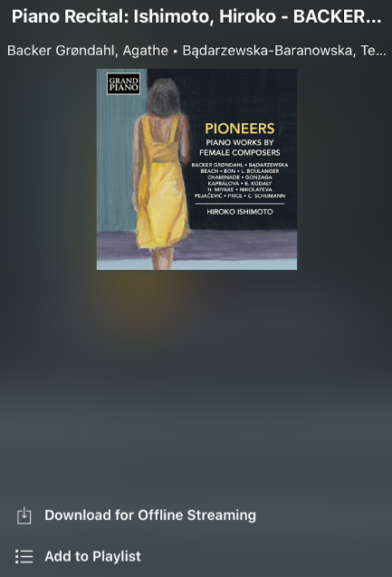
This is also where you can download a song or album to download for offline streaming so that you can listen to it even when not connected to wi-fi or data.

To listen to music once you have found it, tap the song you would like to listen to. The app defaults to auto playing the next song on the album.

Learn More

For more information contact us through LibraryConnect at 604.925.7400 or tech@westvanlibrary.ca

