Getting Started with Listening to Podcasts

What Is a Podcast?

The term podcast was coined in 2004 by a journalist who combined “pod” from iPod and “cast” from “broadcast.” But podcasts can be listened to on all kinds of devices, not just iPods!

A podcast is essentially internet radio on demand. It is auditory content that you can listen to whenever you choose!

Podcasts are similar to radio but there are some key differences:

- Podcasts do not have air times. They have a release date, after which you can listen to them any time.
- Podcasts reach a world-wide audience since they’re available via the internet, rather than a broadcast network.
- Podcasts tend to be on niche, specific topics, that are also timeless because they reach a global audience:
  - For example, CBC or any local news network would likely not have a very large audience for a radio program on the Byzantine Empire or knitting, but there are many podcasts on both of those topics!

What Kinds of Podcasts Are Out There?

There are more than 115,000 English-language podcasts out in the world on every topic imaginable! While there is no New York Times bestseller list equivalent for podcasts, there are a few places you can go to in order to find podcasts that appeal to you.

Your Podcast App
If you’re listening to podcasts from your mobile device (smartphone or tablet), the app built into your device makes it easy for you to browse through by popularity, subject, and more (example taken from Apple’s podcast app):
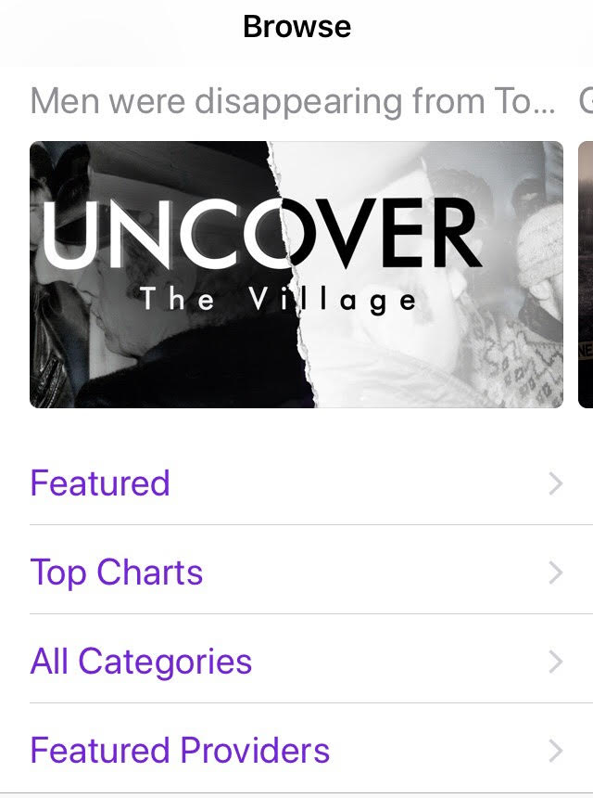
The built in app on Apple devices is just called Podcasts and the built in app on Android devices is called Google Play Music.

Google
Try some Google searches such as:
- New York Times best podcasts
- Best history podcasts
- Best podcasts 2020

via Major Podcast Networks
- National Public Radio https://www.npr.org/programs/
- Chicago’s WBEZ https://www.wbez.org/shows
- Gimlet Media https://www.gimletmedia.com/shows
- Maximum Fun https://www.maximumfun.org/

Word of Mouth
Just like music, books, restaurants, etc., most people find the podcasts they like by hearing about them via conversation with others.

A short list of popular podcasts recommended by Library staff:

This American Life
One of the most popular podcasts of all time – each week, staff choose a theme and put together different kinds of stories on that theme.
https://www.thisamericanlife.org/

The Daily
Produced by the New York Times, a news podcast twenty minutes a day, five days a week, ready by 6 am.
https://www.nytimes.com/column/the-daily

This is That
A Canadian fake news comedy podcast that recently ended but is still available to listen to.
https://www.cbc.ca/radio/podcasts/comedy/this-is-that/

Radiolab
Also one of the most popular podcasts – Radiolab aims at making science accessible to broad audiences.
https://www.wnycstudios.org/shows/radiolab/podcasts

Serial
Serial tells one story – a true story – over the course of a season. It went viral upon its release in 2014.
https://serialpodcast.org/
Reply All
A podcast about the internet, and a favourite of the Technology staff at WVML!
https://www.gimletmedia.com/reply-all

Planet Money
A podcast about “The Economy Explained.”
https://www.npr.org/podcasts/510289/planet-money

99% Invisible
A podcast about all the thought that goes into the things we don’t think about.
https://99percentinvisible.org/

Dan Carlin’s Hardcore History
A podcast centred on deep dives into specific historical events.
https://www.dancarlin.com/

No Such Thing as a Fish
A weekly British podcast series in which writers discuss the best things they’ve found out this week.
https://www.nosuchthingasafish.com/

Quirks and Quarks
Canada’s award winning national science program.
https://www.cbc.ca/radio/podcasts/science-and-tech/quirks-quarks/

How Do I Listen to Podcasts?

The easiest way to listen to a podcast is to use the app that comes automatically installed on your mobile device (smartphone or tablet). Open the app on your device, and you can either search or browse for popular podcasts. When you find a podcast you like, click the Subscribe button to have it on the ready!

Apple Devices
The Apple Podcasts app comes already installed on iPhones and iPads.

Android Devices
The Google Play Music app comes already installed on Android tablets and phones.

Your Computer
If you’re using your computer to listen to podcasts, you can use software like iTunes if you’re on a Mac, or you can go directly to the podcast’s website, no matter what kind of computer you’re using.

For example, if you want to listen to the This Is That podcast, you can Google “This Is That” to get to: https://www.cbc.ca/radio/podcasts/comedy/this-is-that/

Further Information

- The Beginner’s Guide to Podcasts: https://www.wired.com/story/podcasts-beginners-guide/

- A Beginner’s Guide to Getting Into Podcasts: https://www.nytimes.com/2019/01/28/smarter-living/podcast-recommendations-apps.html

- Why Do People Listen to Podcasts in 2020? https://www.listennotes.com/podcast-academy/why-do-people-listen-to-podcasts-in-2020-5/

For more information contact us through LibraryConnect at 604.925.7400 or tech@westvanlibrary.ca

