Connecting to a MinecraftEdu Server
1) Run the MinecraftEdu launcher found in the gaming folder on the desktop.
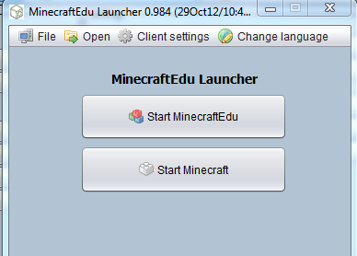
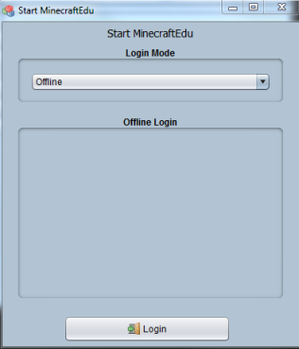
2) Click the “Start MinecraftEdu” button.
3) Make sure that the “Login Mode” is set to “Offline”. Next click the “login” button at the bottom.
4) Enter your name (it must be at least three characters long) and select a gender and then click continue.
login mode
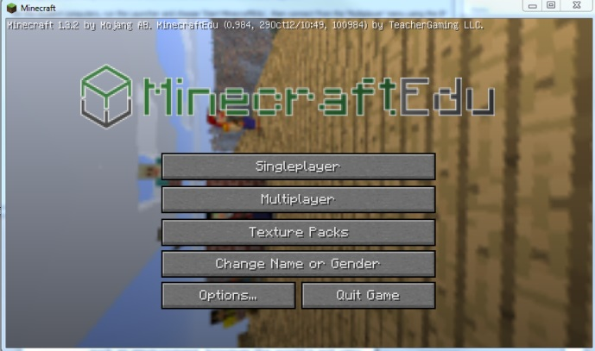
5) You will now see the main “MinecrafEdu” menu. Select the multiplayer button.

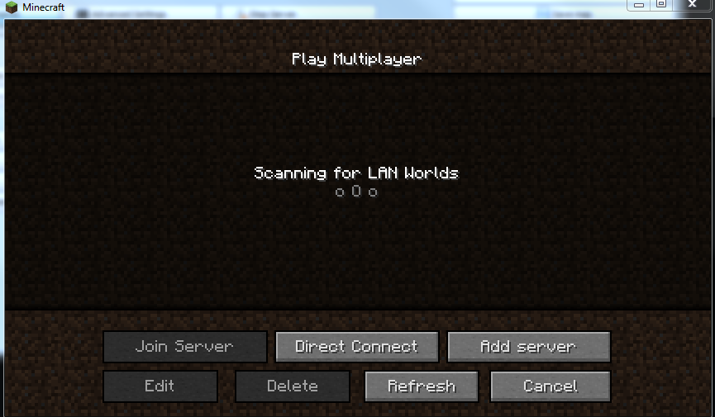
6) You will now see the “Multiplayer” screen. Select the “Direct Connect” button at the bottom.

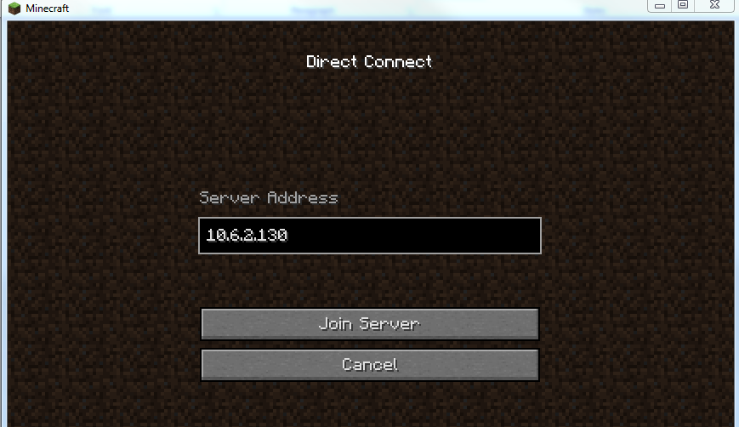
7) You will now see the “Direct Connect” screen. Enter the ip address you recorded from the Minecraft Server window and click the “Join Server Button.”
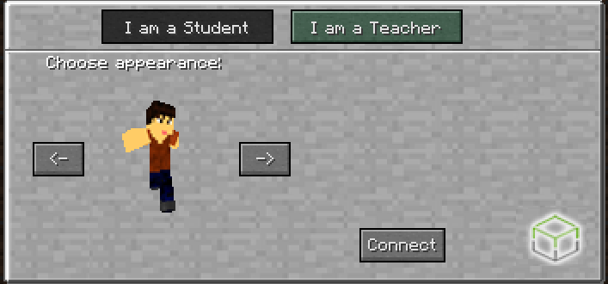
8) Select whether you are a student or teacher and choose your appearance. If you select the teacher button, you will be prompted with the teacher password you set when you set up the MinecraftEdu server. (All program participants should select “Student” whereas anyone running the program should select “Teacher”)

9) Click the “Connect” button.
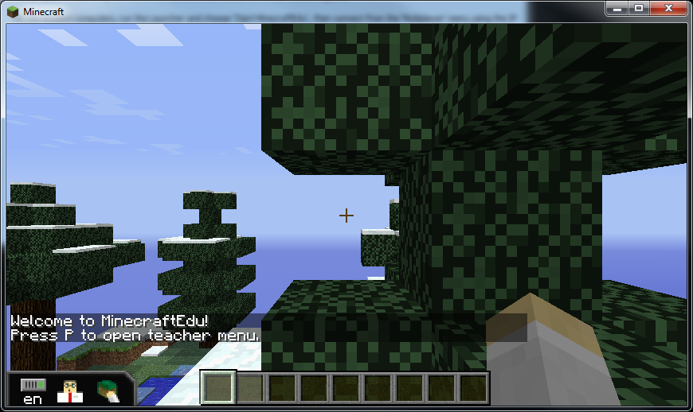
Congratulations! You have joined your MinecraftEdu server!

For more information visit the MinecraftEdu wiki: http://minecraftedu.com/wiki/

