

# Design Document:

# Connect Online with Voice and Video

## Class Description

Learn how to keep in touch with family and friends using popular online services like Skype, WhatsApp, Facetime and Google Hangouts.

## Digital Life Skills Curriculum Theme

Use: baseline technical skills, including the ability to use common and specialized technologies, software and platforms. These enable participation in the digital economy, society and culture.

## Audience

Adult

## Course Length

90 minutes

## Maximum Class Size:

16

## Training Method

Instructor-led lecture/demo

## Purpose

To enable learners to keep in touch with family and friends using their choice of popular online services (Skype, Facetime, Google Hangouts, and WhatsApp)

## Staff Requirements

Number of staff members: 1

Other requirements:

* iPad
* Handout: [DWV-#1339937-Connect Online with Voice Video Activity Sheet](PCDOCS://DWV/1339937/1)

Software requirements:

* Skype
  + You’ll need to know the associated email address and password
* WhatsApp
  + Not currently enabled on iPad
* Google Hangouts
  + You’ll need to know the associated email address and password
* Facetime
  + You’ll need to know the associated email address and password

## Patron Requirements

* None

## Learning Objectives

By the end of the session(s), learners will be able to:

* Make an informed choice about which online service(s) they would like to use
* Sign up for an account with the online service(s) of their choice
* Make a voice and / or video call using the online service(s) of their choice

## Assessment Technique(s)

Successful completion of class activities

## Intro / Content Outline (3 mins)

* Welcome. Introduce self (write name on whiteboard/flipchart if possible)
* Point out activities / objectives on handout

## Talking Points, Topics, and Activities (85 mins, includes approximately 30 mins for questions)

1. Make an informed choice about which online service(s) they would like to use(20 mins)
   * Common between all four services
     + Require a high-speed Internet connection to work
     + Require speakers and microphone (either built-in to your device or separate)
     + Require a webcam (either built-in or separate) to make video calls
     + Don’t use your minutes from your cellular plan; use your data plan (when not on a Wi-Fi connection)
     + The best way to decide which one(s) to use may be to use the one(s) that your friends and family are on
   * Skype
     + FREE program
     + FREE way to make international calls
     + Can be used on a computer or mobile device
     + Can be used to make phone calls, video calls, group calls
     + Interactions are encrypted unless they involve the phone network (PSTN)
   * WhatsApp
     + App for desktop computers, and smart phones; other mobile devices including iPad and iPod Touch are not currently supported
     + FREE way to make international calls
     + Can be used for text messaging, voice and video calls; three-way group calling is coming soon
     + Offers end-to-end encryption
     + Owned by Facebook
   * Facetime
     + Can only be used on Apple products; available on newer iOS devices (iPhone 4 or later; iPad 2 or later; iPod 4th generation or later)
     + Free via Wi-Fi connection; uses cellular data over a 3G, 4G, 5G connection
     + Can be used for two-way voice and video calls
     + Offers end-to-end encryption
   * Google Hangouts
     + Can be used on a computer or mobile device
     + FREE way to make local and long distance calls in Canada and most of the US via wireless connection
     + There is a cost for placing calls outside of Canada and the US
     + You need to have a Google account to use Google Hangouts
     + Can be used to make phone calls, video calls, group calls
     + Data is encrypted in transit only; this means Google has access to your data

**ACTIVITY 1**: Walk participants through Activity #1 on *Activity Sheet* (reinforce the learning points in this section).

* If you have an **Android** device, which service(s) are not available to you?
  + *Facetime is only available on newer iOS devices*
* If you want to make an **international call** to Iran, which service will charge you?
  + *Google Hangouts; Skype if the call is placed over the phone lines*
* If making **group calls** is important, which service(s) are best for you?
  + *Skype and Google Hangouts*
* If **encryption** is a priority for you, which service(s) are most secure?
  + *Facetime and WhatsApp; Skype provided the call is made over a wireless network*

## Sign up for an account with the online service(s) of their choice(15 mins)

* Skype
  + If you already have a @hotmail.com account or @outlook.com account, you have a Skype account
  + If you don’t you can sign up at [**http://web.skype.com**](http://web.skype.com/)
  + Click “Create new account”
  + Follow steps to create account
    - Username – the name people will use to find you on Skype
  + You’ll be phoned or emailed and given a code. Enter that code once you receive it
* WhatsApp
  + You need to create a WhatsApp account by following the prompts
  + You need to agree to the Terms of Service and Privacy Policy
  + You can connect your WhatsApp account to your Facebook profile; this is optional
* Facetime
  + Facetime automatically detects your phone number for iPhones
  + You need to have an Apple ID to use Facetime
* Google Hangouts
  + Sign up for a Google account; if you have Gmail, you already have one

**ACTIVITY 2**: Walk participants through Activity #1 on *Activity Sheet* (reinforce the learning points in this section).

* If you have an account with Google (Gmail, YouTube), you already have access to ____________ *(Google Hangouts)*
* If you have an Apple ID, you don’t need an additional account to access ____________________ *(Facetime)*
* If you already have a @hotmail.com account or @outlook.com account, you have a __________ account. If you don’t you can sign up at ______________________ *(Skype,* [*http://web.skype.com*](http://web.skype.com)*)*
* No matter what email accounts you have, you need to specifically create an account with this service _________________ *(WhatsApp)*

## Make a voice and / or video call with the online service(s) of their choice(50 mins)

* Skype
  + You can find people to Skype with using their name, username, email address, or phone number (Note: the information you can search is the information your contacts have provided to Skype, so if you sign up with your married name (vs. your maiden name), for example, people who search your maiden name won’ t be able to find you; same with home vs. mobile phone numbers; accounts shared between couples/families
  + Demonstrate different ways to look for people
    - Name / Username
    - Email address
    - Phone number
    - Note: Contacts **no longer** need to accept your request before they become contacts (like friends on Facebook)
  + Demonstrate making a test call **Echo/Sound Test Service** (tests Internet connection, volume, equipment); see also <https://www.gcflearnfree.org/skype-2016/making-voice-calls-with-skype/1/>
  + Call button
  + Ending calls
  + Answering calls
  + Video call button
  + Ending calls (the same as with voice calls)
  + Answering calls
  + You can call to a phone with Skype, but this costs money
  + Where to get help with Skype (<https://support.skype.com/en/faq/FA12046/how-can-i-get-support-for-skype>)
* WhatsApp
  + How to make a voice call from contacts; how to answer a call <https://www.gcflearnfree.org/whatsapp/voice-calls/1/>
* Facetime
  + To Facetime someone, they must be in your contacts on your Apple device. You can add / remove contacts via the contacts app
  + Search for people by name, phone number or email
  + If a contact you’d like to Facetime is not on an Apple device, the phone and video call buttons will be greyed out
* Google Hangouts
  + On computers, you can access Google Hangouts from your Gmail account (bottom left of the page); you can also download the extension for Chrome (not compatible with other browsers)
  + You can download an app on mobile devices
  + How to make a phone call <https://support.google.com/hangouts/answer/3187125?hl=en&ref_topic=6386410>
  + How to make a video call

<https://support.google.com/hangouts/answer/3110347?hl=en&ref_topic=6386410>

**ACTIVITY 3**: Walk participants through Activity #1 on *Activity Sheet* (reinforce the learning points in this section).

|  |  |
| --- | --- |
| **Skype** | |
| What would you tap to make a **voice call?** *(phone icon)*  What would you tap to make a **video call?** *(video camera icon)*  Where does this particular J K Rowling live? *(Australia)*  If you wanted text J K, how would you do it? How would you add a photo to your message? *(+ to start a text; camera icon at bottom right to insert a photo)* | cid:1611a2d4e96ee18b22a1 |
| **WhatsApp** | |
| On **WhatsApp**, you can place a voice or video call by tapping this icon at the top of the screen. *(phone+)* | cid:1611a39ba7c525ec62b2 |
| What would you tap to place a **voice call**? *(Phone icon)*  What would you tap to place a **video call**? *(Video camera icon)*  What does the status “Hey there! I am using WhatsApp.” mean? *(It can mean that the person is using WhatsApp and hasn’t yet changed their default status. It can also mean that the person has used WhatsApp in the past and is not an active user.)* |  |

|  |  |
| --- | --- |
| **Facetime** | |
| To start a **Facetime** call, simply enter the name, email address, or phone number of the iOS user you’d like to Facetime. | cid:1611a4cc2787f31022e2 |
| Is this contact on an **Apple device**? How can you tell? *(No. The call and video options are greyed out.)* |  |

|  |
| --- |
| **Google Hangouts** |

From your Gmail account, you have two ways to access Google Hangouts. What are they? *(Icon at bottom left; choose Hangouts from the app menu on the right)* 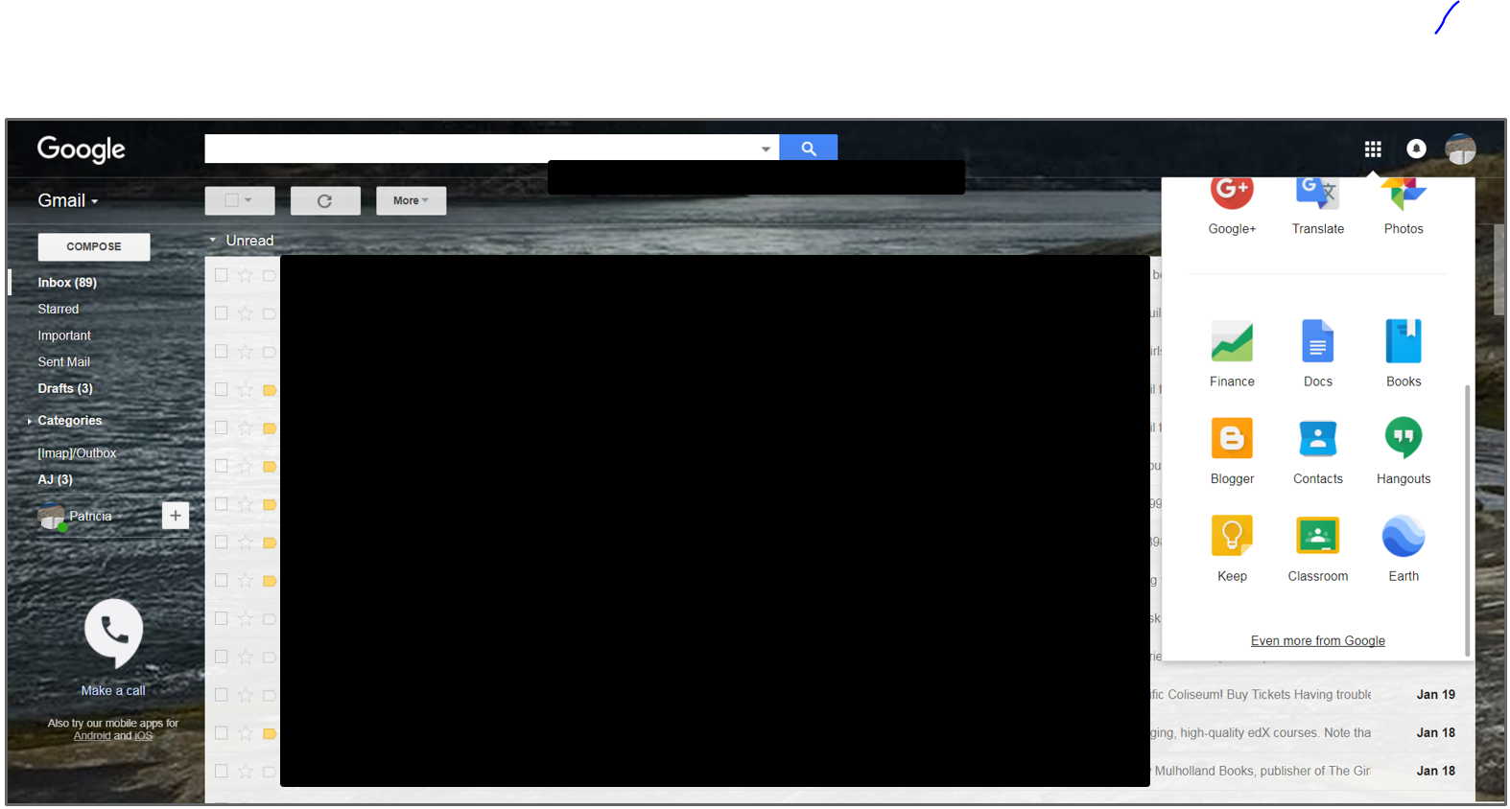

If you click on the Google Hangouts app, you’ll be taken to a new tab (below). How can you make a call from this screen? *(Use the video call and phone call buttons as desired)*

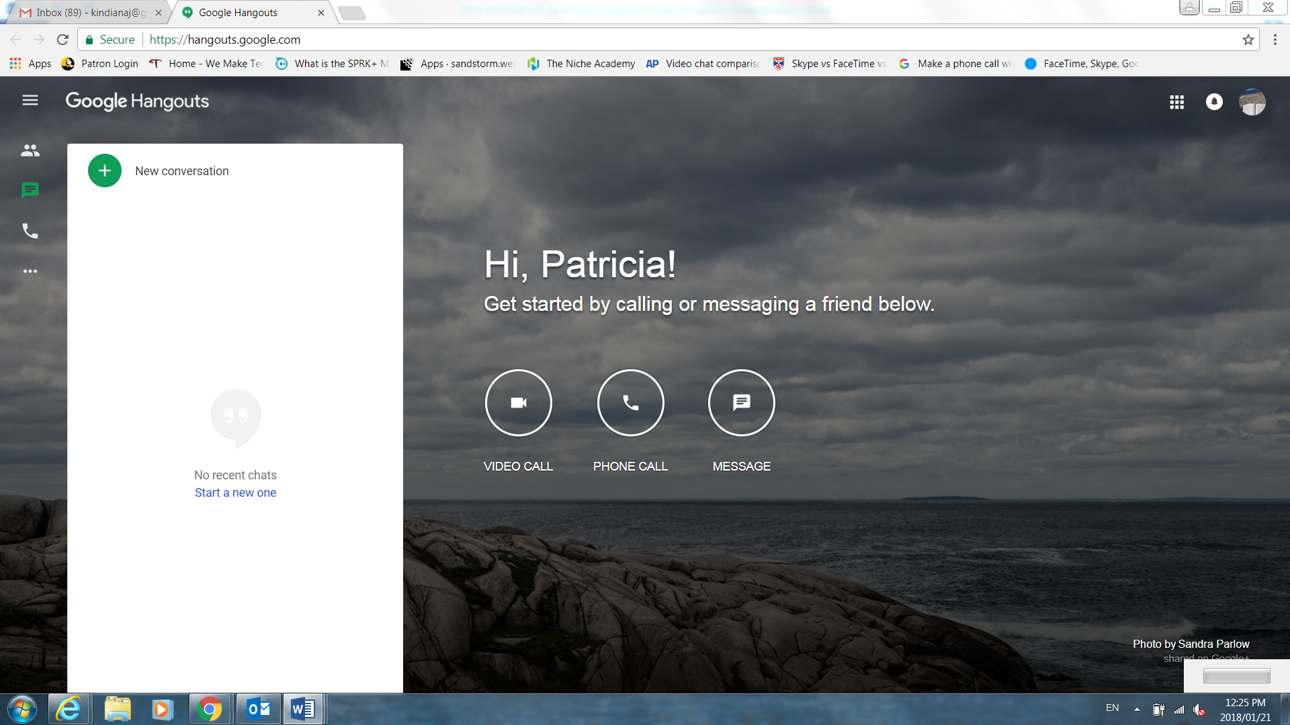

## Wrap Up/Closing (2 mins)

* Highlight the upcoming technology classes and share the types of topics that will be covered
* Ask if there are outstanding questions
* Thank participants for coming and ask them to complete the class survey before leaving