Vancouver Public Library
After-School Drop-In for 8-12 Year-Olds
Choose Your Own Adventure Story Writing Program Report

Date

Branch >

Program description
Today’s program was ‘‘Choose Your Own Adventure’ Story Writing.’ This was a workshop style program based on the ‘Choose Your Own Adventure’ books (of which I had a few copies set out). Everyone got a blank booklet, a flowchart for planning their short story and a couple of story starters to choose from. I brought a short ‘Choose Your Own Adventure’ story that I had written as an example, entitled “The Mysterious Hallway at the Back of the Library.” I also printed several copies of my story for kids who didn’t want to write their own.

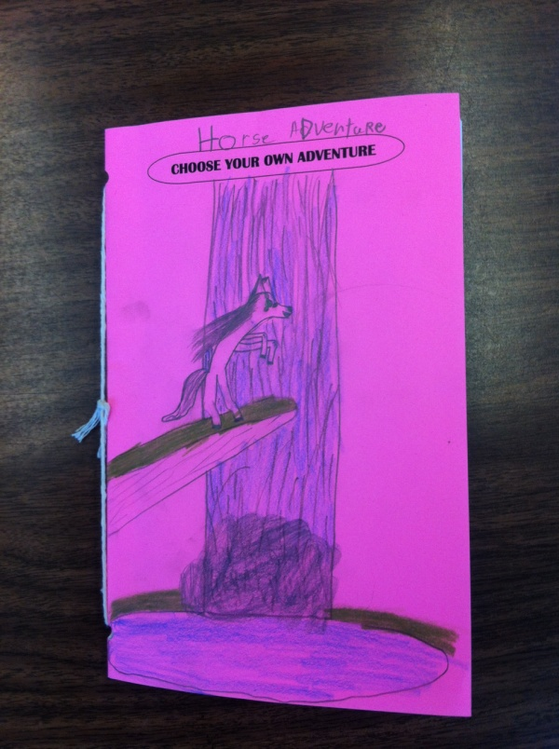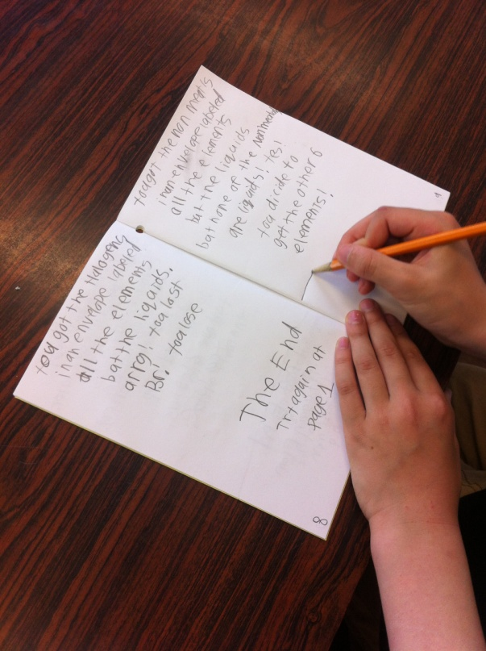

Attendance > |  | 7
Observations
Among the 7 attendees today, there was a range in level of participation. The oldest (10) had come prepared with a story outline and spent the entire program writing what turned out to be a 20 page story (more than double what I had laid out on the story planning worksheet). His sister and another girl needed some coaching and encouragement, but finished their stories in time for prizes at the end. One family, with a 7 and 4 year old, came in the middle and used the blank booklets to draw stories in. I helped the 7 year old write in the text to accompany her illustrations.
Feedback
Today, while discussing upcoming programs, one of my regulars mentioned that she never used to come to the library until she started attending the After-School Drop-In. She said she hadn’t known that the library had programs for kids her age and asked why there weren’t more.

VPL staff  (name(s)) |  |  |  | Reported by:

