Build a Book

For ages: 7-12
Registration Limit: 20
Program Length: 1.5 hours

Description:
Children design and make books based on a variety of fun styles such as zigzag, origami, concertina, envelope, peek-in and Storybird.

Delivery:
The facilitator discussed and demonstrated how the participants could create various fun styles of paper books such as zigzag, origami, concertina, envelope and peek-in (see attached photos below). The participants spent 45 minutes creating their own paper books.
Then the facilitator introduced Storybird to the participants by having them work together as a group to create a simple story. The participants learned how to log in, create, save, share and publish a story. Following this demonstration, the participants used iPads to start writing and illustrating their own stories. Each participant was assigned a username and password to use. The participants spent 45 minutes creating their own digital stories.
The participants left the program with the paper books they had made as well as usernames and passwords to continue creating Storybird books at home or at the library using the public internet access computers.

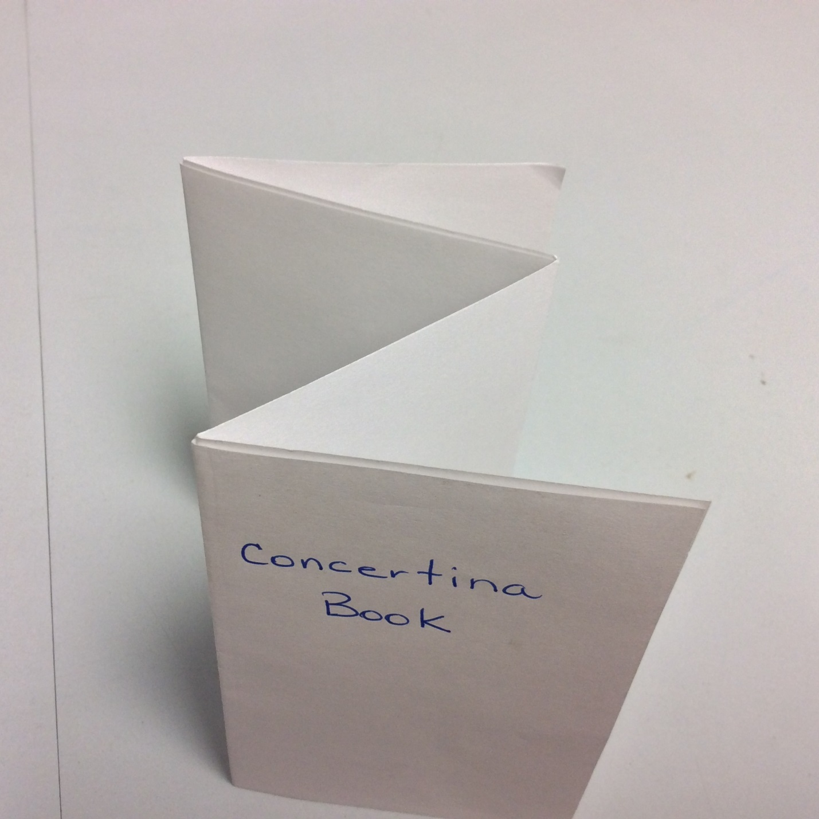
Figure 1 Concertina Book

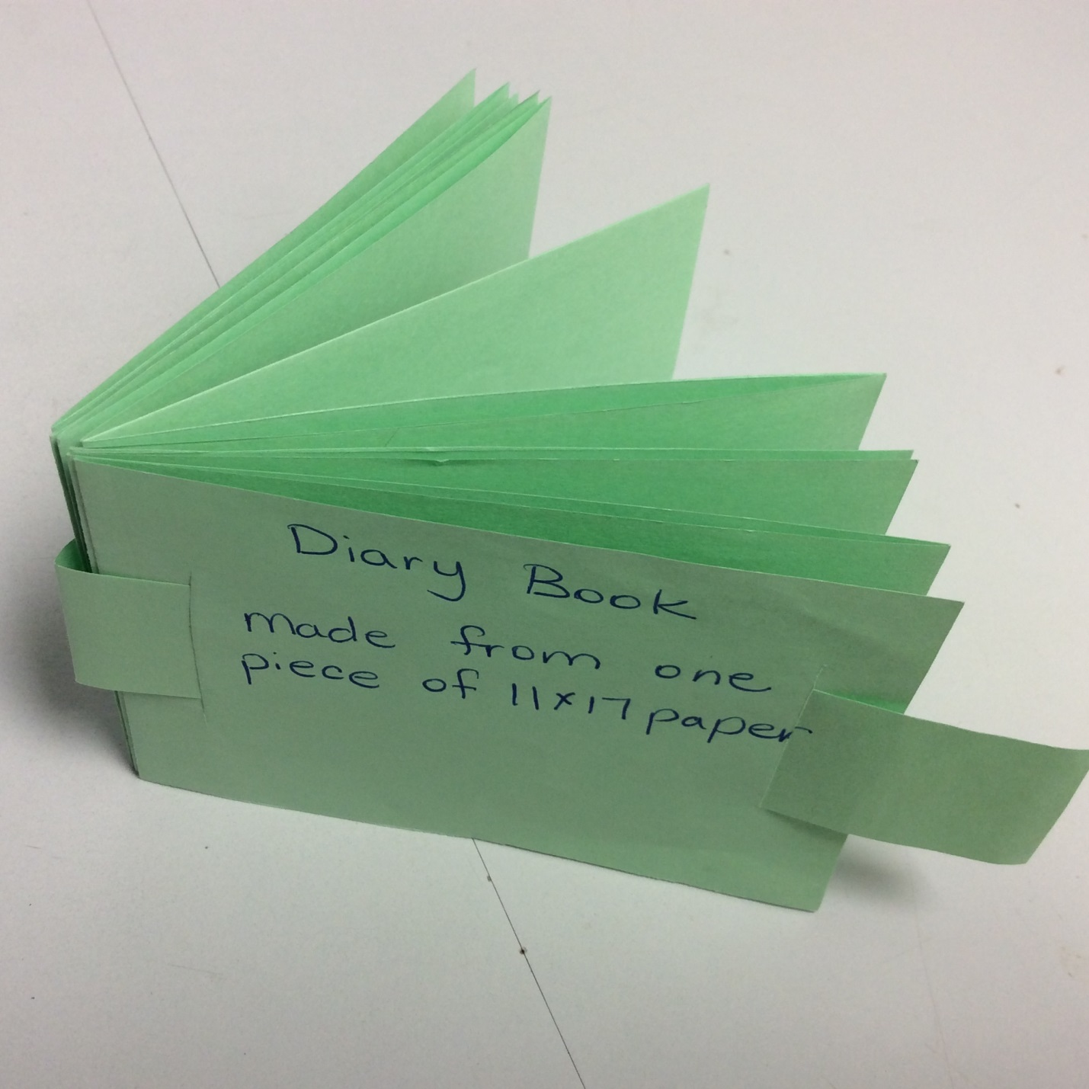
Figure 2 Diary Book

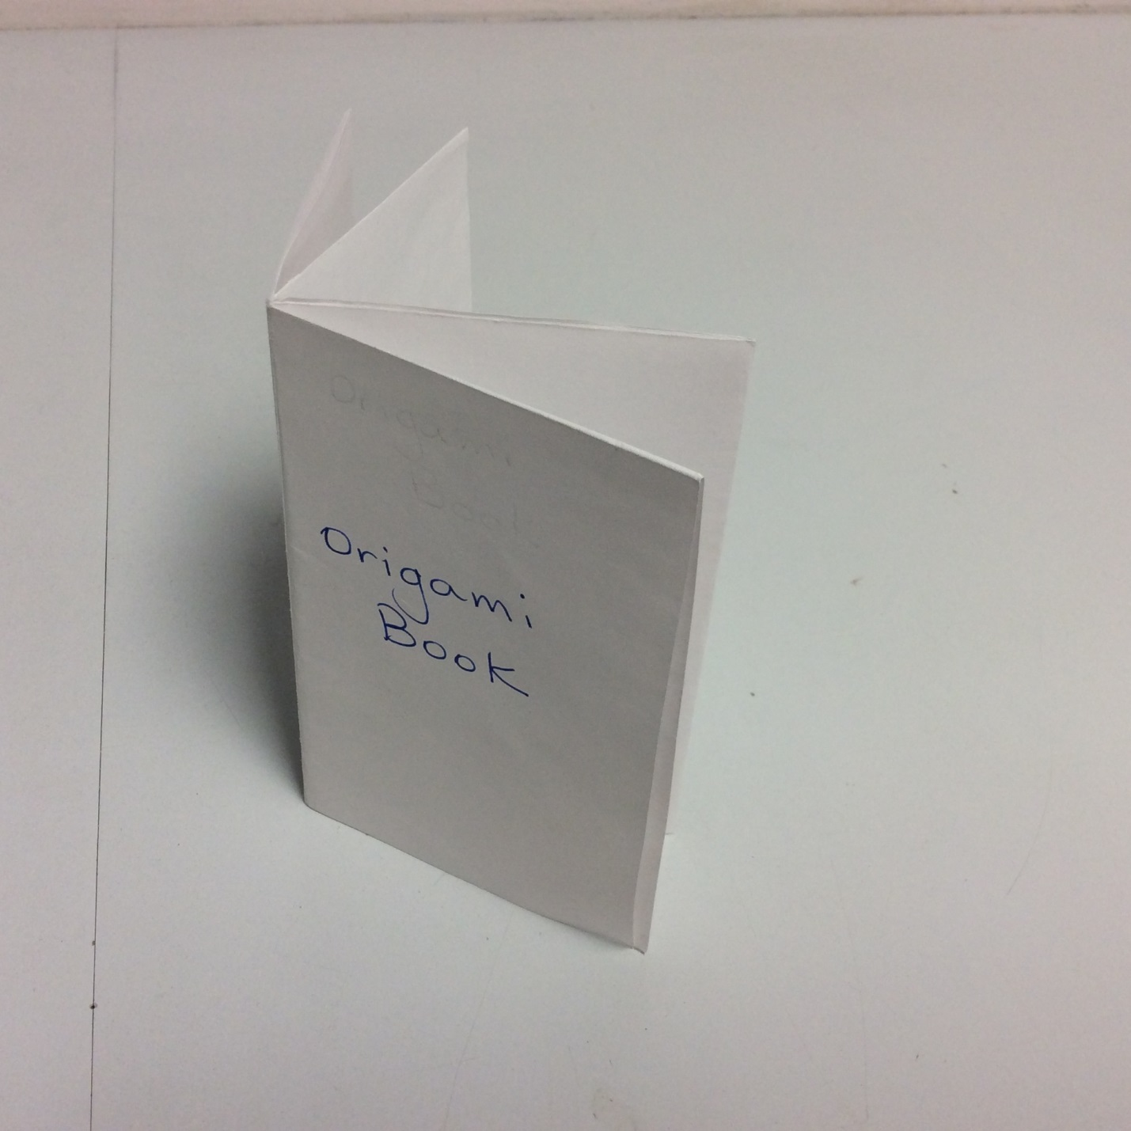
Figure 3 Origami Book

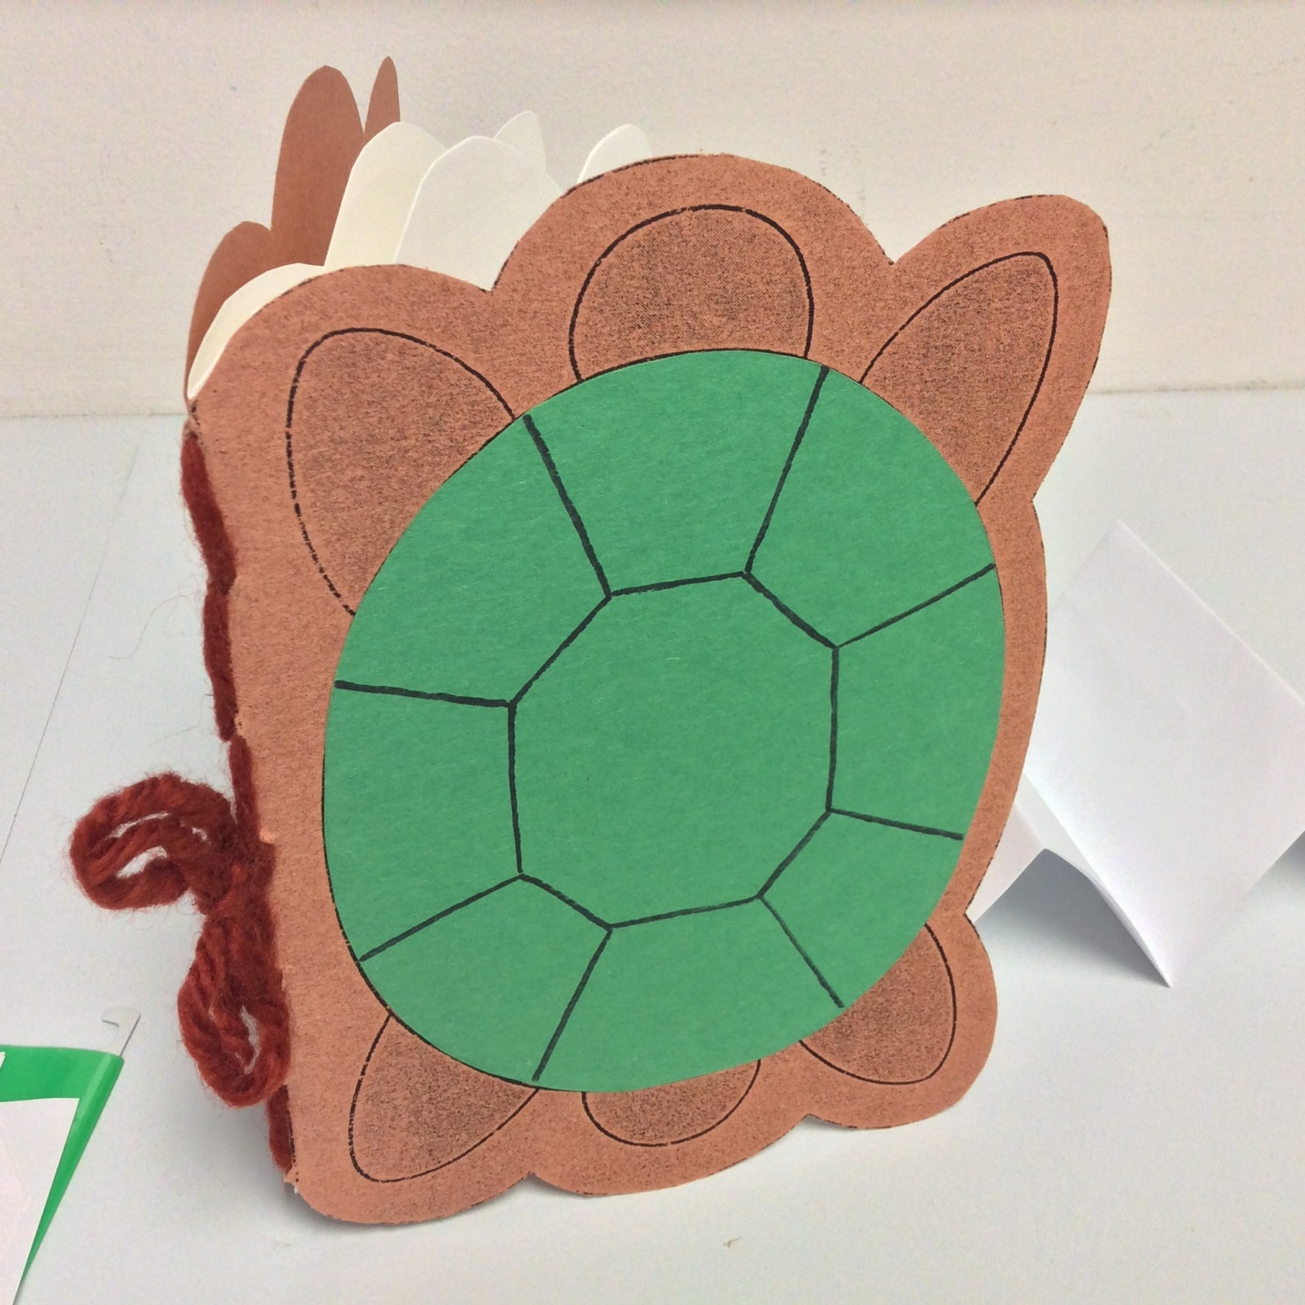
Figure 4 Turtle Shaped Book

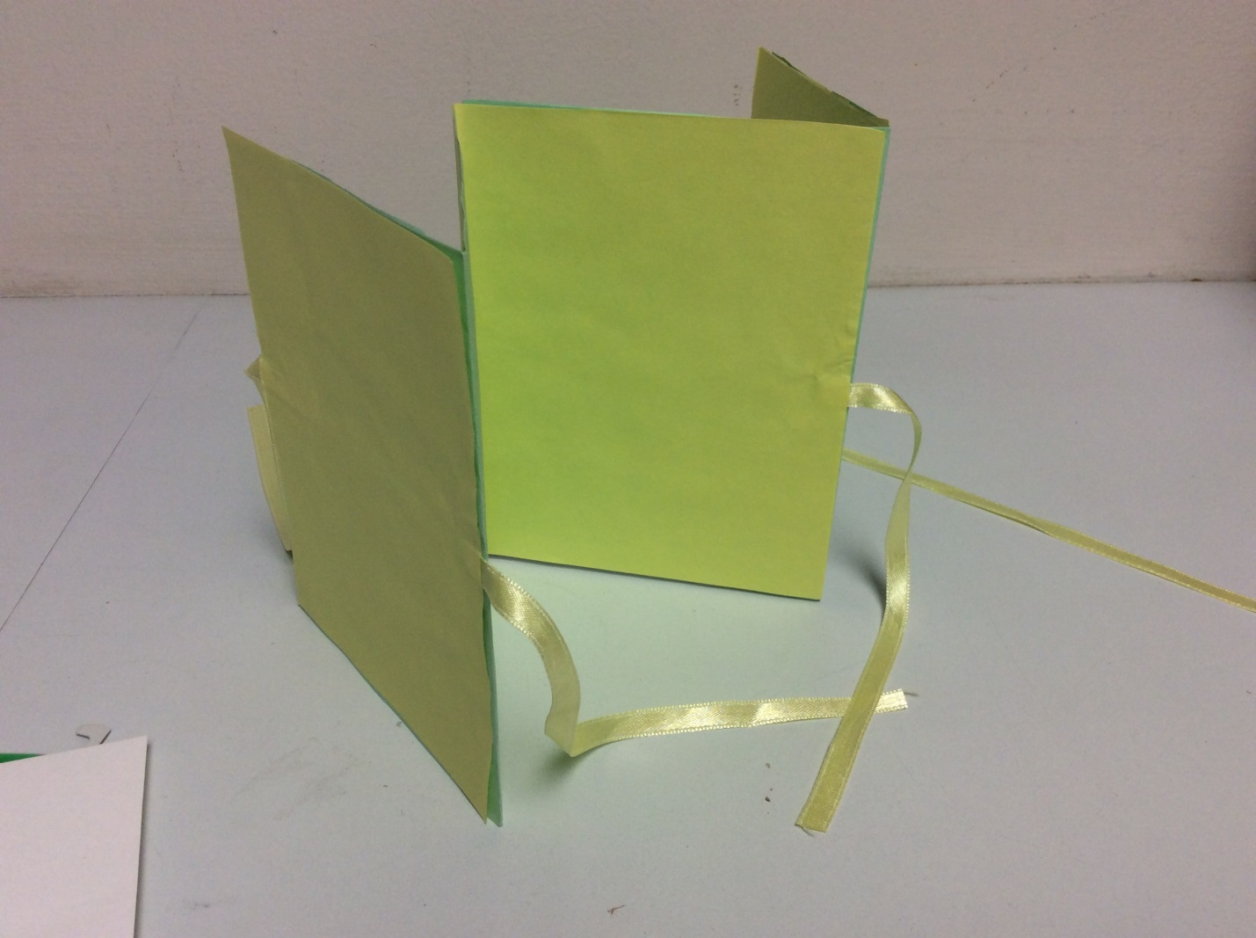
Figure 5 Zig Zag Book

