**Basic Computer Skills (基本电脑技巧)**

**Part 2**

1. **Finding your Files (寻找档案)**

Click on the **Start Vista Button** 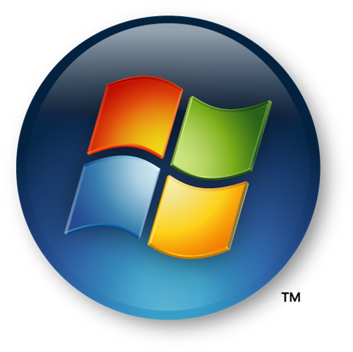 in the lower left corner, then on **Computer**. The following window will pop up:  
在左下角，按**Start Vista Button，**然后按**Computer，**会冒出以下视窗：

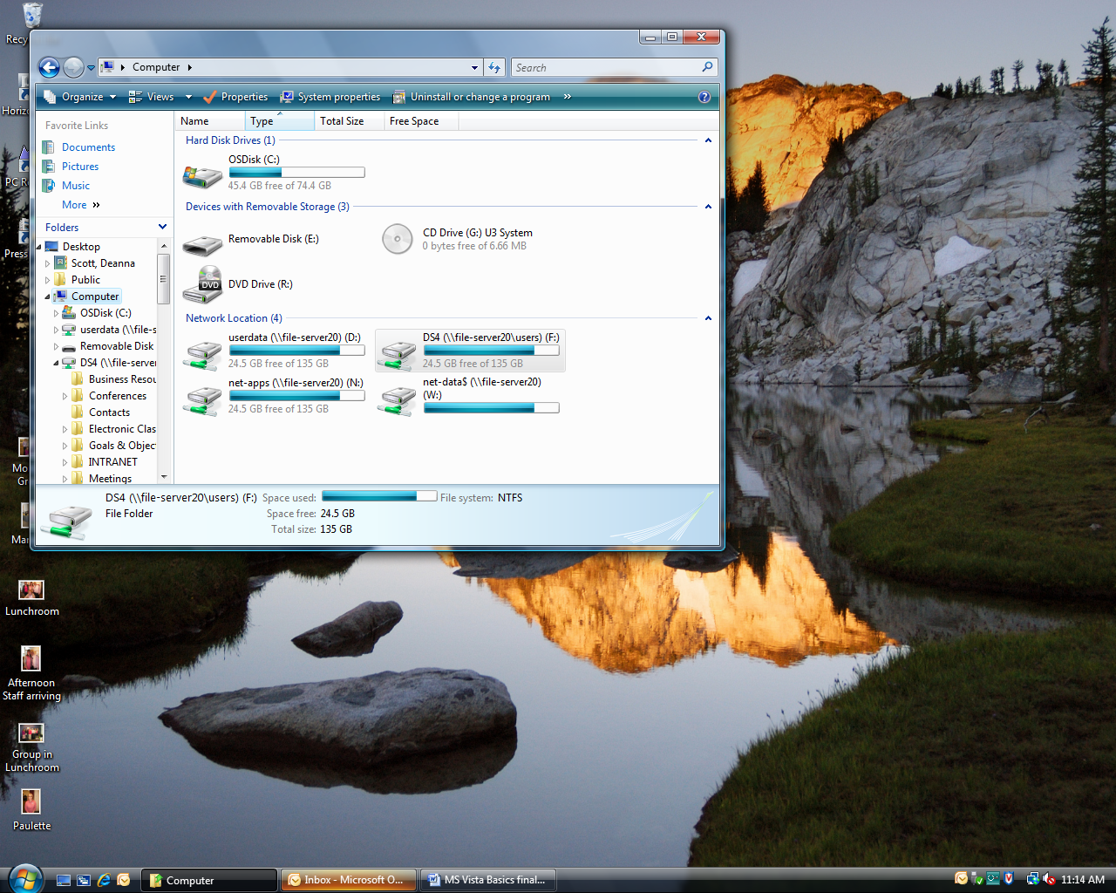 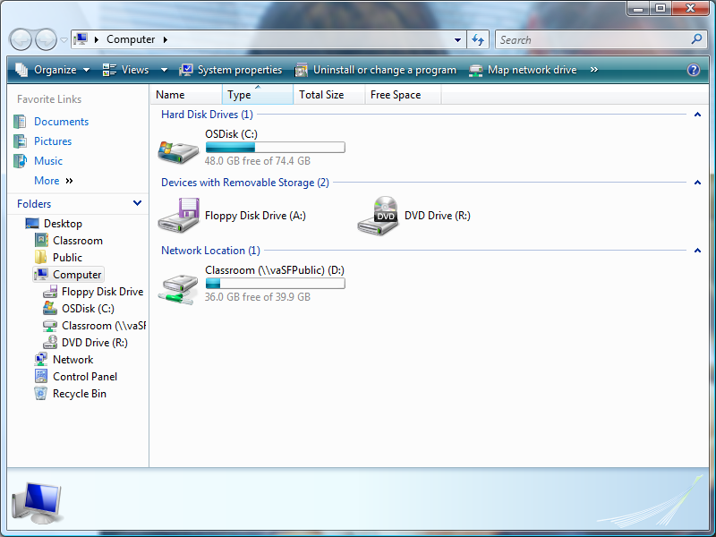

This lists other places on your computer where files & information are stored.

这里列出在您电脑上其它可以储存档案和资料的位置。

文件

圖片

音樂

Files saved on to your hard drive are usually found here.  
您储存在电脑上的档案通常会在这。

You can store files here on a USB.  
您可以储存档案在USB上。

1. **Safely Removing your Removable Device (安全移除装置)**

Click on the Green Arrow in the bottom right corner and click on “Safely remove USB Mass Storage Device.  
在右下角按有绿色箭头的图示，并按Safely remove USB Mass Storage Device。

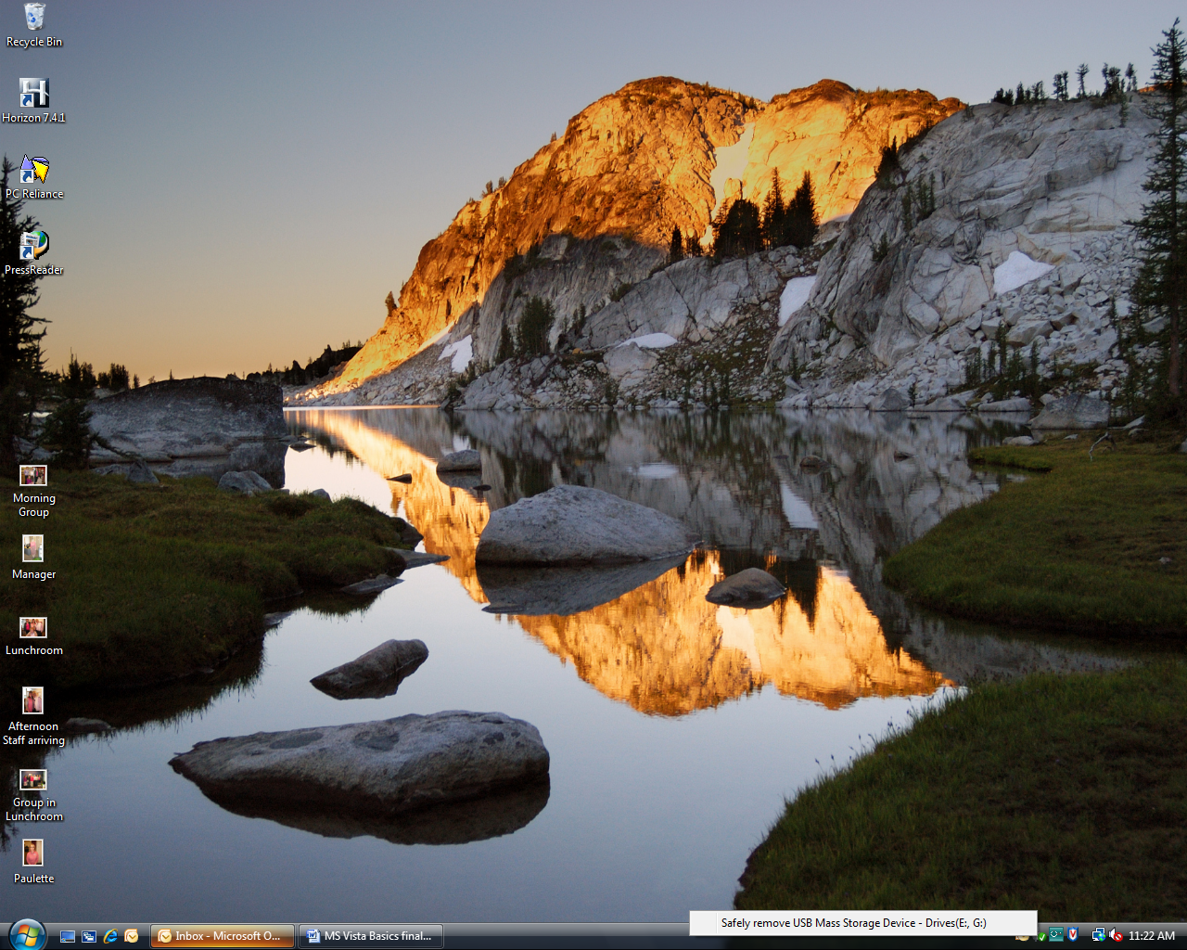

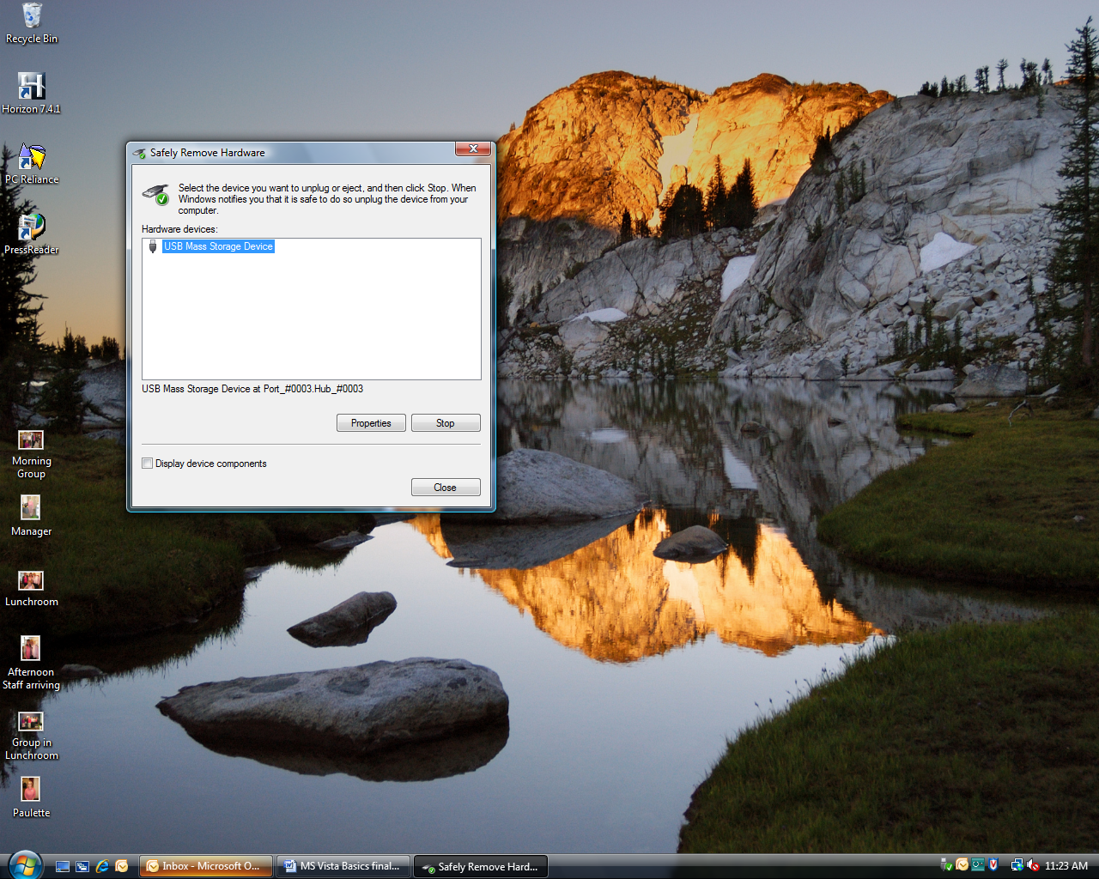

The following window might pop up, click on **Stop**:

若冒出这个视窗，按Stop。

1. 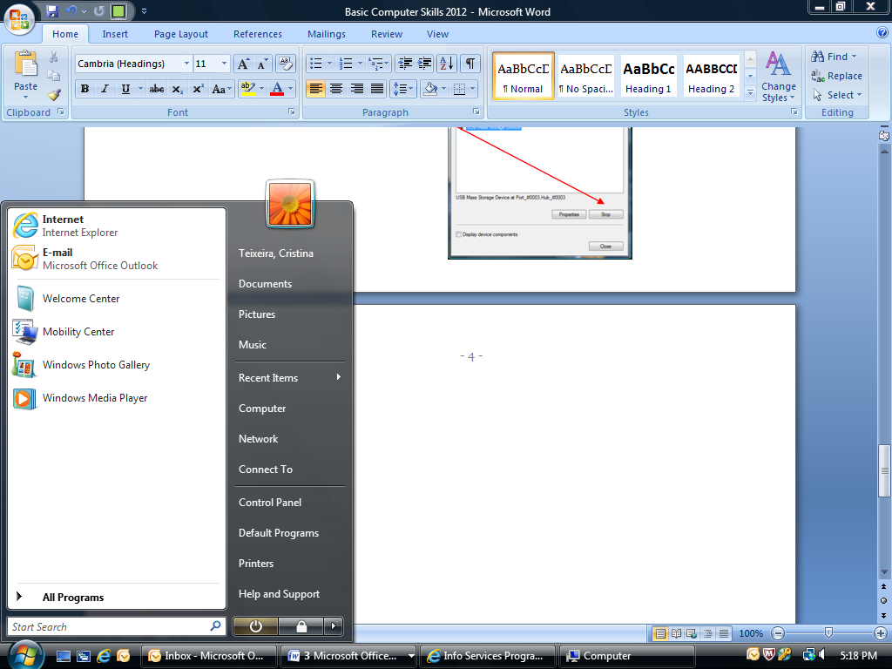**Control Panel (控制台)**

Adjust your computer’s personal settings here   
这里可调整/更改电脑装置/设定。

Select from one of these categories to change your settings.

从以下项目选择即可更改装置。

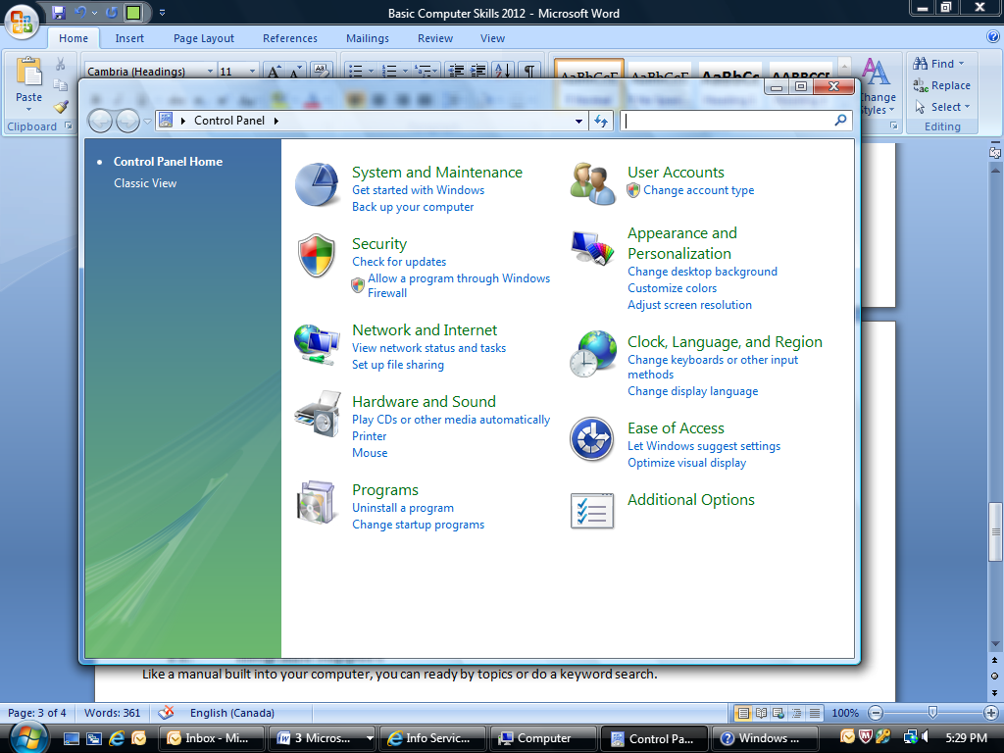

1. **Help and Support (帮助)**

Like a manual built into your computer, you can research by topic or do a keyword search.  
像一个装进电脑的说明书，您可以依照主题或关键词来做搜索。

Get help on a specific topic by using the **Search Help**, or browse topics by using the **Table of Contents.**按进Help and Support后，您可浏览目录或使用搜索。

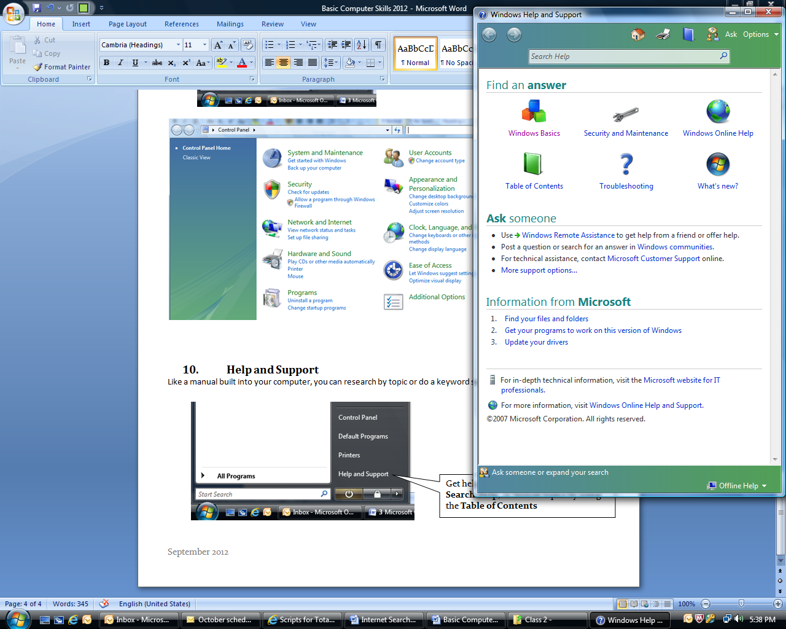

**Windows Basics** is a great way to learn and review. Find it in Help and Support.  
Windows Basics是一个很有帮助的程式。您可以在Help and Support里找到。