Basic Computer Skills (基本电脑技巧)
Part 1
- Getting Started (新手开始)
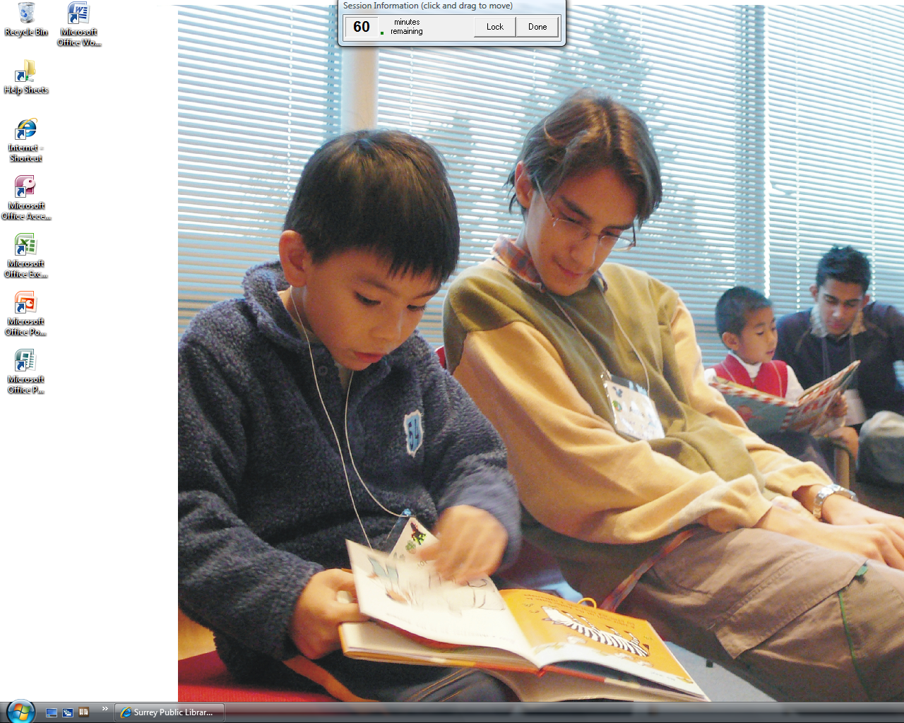
您也可以按Vista的开始键，打开选单来寻找以及开启程式。
- The desktop is the very first screen you see after your computer starts.
当您刚开启电脑时，您看到的第一个屏幕叫桌面。
- Desktop contain icons.
桌面上有图标。
- Icons are shortcuts to programs, files or places.图标是开启程式或资料夹的捷径。
- Double click to open an icon.
按两次即可开启图标。
You can also click on the Vista Start Button to access programs from the Start Menu.

- Start Menu (开始选单)
The top 2 programs are always the same.
最上方的两个程式是默认程式；永远都一样。
Access your files here under Computer.
可通过Computer寻找以及开启资料当。
The lower left area lists programs recently used.
左下方会列出常用的程式。

To search for a file or program, type it in the Start Search Bar.
若想寻找程式或档案，可输入于Start Search 栏。

All Programs displays a list of all the programs installed on the PC.
按All Programs会显示出电脑上所安装的所有程式。

Managing Windows (使用视窗)
Close (关闭)

Closes and exits active window.
离开并且关闭视窗。

Maximize (放大)/Restore (恢复)

Window fills entire screen or restores to original size.
使视窗放大填满荧幕或恢复至原本大小。

Minimize (缩小)

Shrinks window to Task Bar
缩小并隐藏视窗至工作列。
- Place the cursor on the window corner until double arrow cursor //appears.
移动滑鼠标至视窗边缘直到双箭头出现。
- Enlarge - click and drag the mouse down and/or right.
若要放大－按并牵引滑鼠下/右。
- Reduce - click and drag the mouse up and/or left.
若要缩小－按并牵引滑鼠上/左。
***To click and drag, press and hold down the mouse, moving in the direction you want

Resizing (調整大小)
- Press and drag the title bar (My Computer).
按下并牵引标题栏。
- Release when you’ve moved it to where you want the window to be
当您放开，视窗就会移动并留在您所放开的地点。

Moving a Window (移动视窗)

Taskbar (工作列)
The taskbar shows you every page, file, or program that you have open.
Click on the buttons to see the window appear or disappear.
［工作列］显示每一个您所开启的文件夹，档案，或程式。按一下即可打开或隐藏您的程式视窗。

